VISVESVARAYA TECHNOLOGICAL UNIVERSITY
“JnanaSangama”, Belgaum -590014, Karnataka.

LAB REPORT
on
Database Management Systems (23CS3PCDBM)
Submitted by
BRAMHA ANILKUMAR BAJANNAVAR(1BM23CS071)
in partial fulfillment for the award of the degree of
BACHELOR OF ENGINEERING
in
COMPUTER SCIENCE AND ENGINEERING

B.M.S. COLLEGE OF ENGINEERING
(Autonomous Institution under VTU)
BENGALURU-560019
Sep-2024 to Jan-2025

B. M. S. College of Engineering,
Bull Temple Road, Bangalore 560019
(Affiliated To Visvesvaraya Technological University, Belgaum)
Department of Computer Science and Engineering

CERTIFICATE
This is to certify that the Lab work entitled “Database Management Systems (23CS3PCDBM)” carried out by BRAMHA ANILKUMAR BAJANNAVAR (1BM23CS071), who is bonafide student of B. M. S. College of Engineering. It is in partial fulfillment for the award of Bachelor of Engineering in Computer Science and Engineering of the Visvesvaraya Technological University, Belgaum during the year 2022. The Lab report has been approved as it satisfies the academic requirements in respect of a Database Management Systems (23CS3PCDBM) work prescribed for the said degree.

Prof Kayarvizhy N  Associate Professor  Department of CSE, BMSCE | Dr. Kavitha Sooda  Professor HOD  Department of CSE, BMSCE

Index
Sl.  No. | Date | Experiment Title | Page No.
1 | 4/10/24 | Insurance Database | 4-9
2 | 11/10/24 | More Queries on Insurance Database | 10-11
3 | 18/10/24 | Bank Database | 12-19
4 | 25/10/24 | More Queries on Bank Database | 20-23
5 | 8/11/24 | Employee Database | 23-29
6 | 15/11/24 | More Queries on Employee Database | 30-32
7 | 22/11/24 | Supplier Database | 33-38
8 | 20/12/24 | NO SQL – Student Database | 39-41
9 | 20/12/24 | NO SQL - Customer Database | 42-43
10 | 20/12/24 | NO SQL – Restaurant Database | 44-48

Insurance Database
Question
(Week 1)
- PERSON (driver_id: String, name: String, address: String)
- CAR (reg_num: String, model: String, year: int)
- ACCIDENT (report_num: int, accident_date: date, location: String)
- OWNS (driver_id: String, reg_num: String)
- PARTICIPATED (driver_id: String,reg_num: String, report_num: int, damage_amount: int)
- Create the above tables by properly specifying the primary keys and the foreign keys. - Enter at least five tuples for each relation
- Update the damage amount to 25000 for the car with a specific reg_num (example 'K A053408' ) for which the accident report number was 12.
- Add a new accident to the database.
- To Do
- Display Accident date and location
- Display driver id who did accident with damage amount greater than or equal to Rs.25000

Schema Diagram
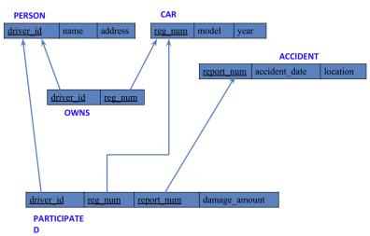

Create database
create database Insurance_Bramha071;
use Insurance_Bramha071;

Create table
create table person (
driver_id varchar(10),
name varchar(20),
address varchar(20),
primary key(driver_id)
);

create table car (
reg_num varchar(10),
model varchar(10),
year int,
primary key (reg_num)
);

create table accident(
report_num int,
accident_date date,
location varchar(20),
primary key (report_num)
);

create table owns(
driver_id varchar(10),
reg_num varchar(10),
primary key (driver_id , reg_num),
foreign key(driver_id) references person(driver_id),
foreign key(reg_num) references car(reg_num)
);

create table participated (
driver_id varchar(10),
reg_num varchar(10),
report_num int,
damage_amount int,
primary key (driver_id, reg_num, report_num),
foreign key (driver_id) references person(driver_id),
foreign key (reg_num) references car(reg_num),
foreign key (report_num) references accident(report_num)
);

Structure of the table

desc person;
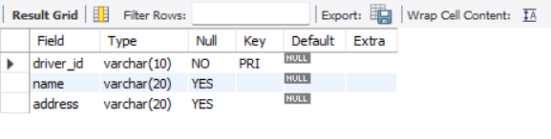
desc car;
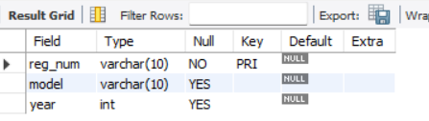

desc accident;
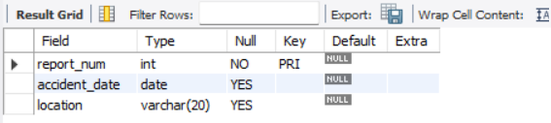

desc owns;
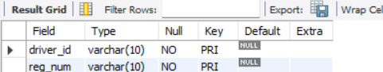

desc participated;
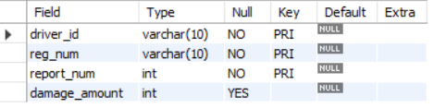

Inserting Values to the table

insert into person
values(‘a01’,’richard’,’srinivasnagar’),
(‘a02’,’pradeep’,’rajajinagar’),
(‘a03’,’smith’,’ ashoknagar’),
(‘a04’,’venu’,’NRcolony’),
(‘a05’,’jhon’,’hanumanthnagar’);
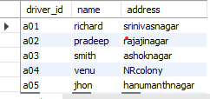

insert into car
values ('KA052250', 'indica',1990),
('KA031181','lancer',1957),
('KA095477','toyota',1998),
('KA053408','honda',2008),
('KA041702','audi',2005);
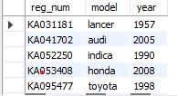

insert into accident
values(11,'2001-01-03','mysoreroad'),
(12,'2002-02-04','southendcircle'),
(13,'2021-01-03','bulltempleroad'),
(14,'2017-02-08','mysoreroad)'),
(15,'2004-03-05','kanakpuraroad');
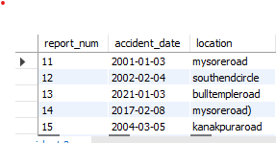

insert into owns
values('a01','KA052250'),
('a02','KA053408'),
('a03','KA031181'),
('a04','KA095477'),
('a05','KA041702');
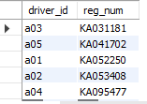

insert into participated
values('a01','KA052250',11,10000),
('a02','KA053408',12,50000),
('a03','KA031181',13,25000),
('a04','KA095477',14,3000),
('a05','KA041702',15,5000);
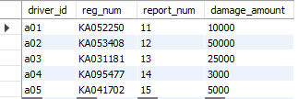

Queries

- Update the damage amount to 25000 for the car with a specific reg-num (example 'KA053408' ) for which the accident report number was 12.
update participated set damage_amount=25000
where reg_num='KA053408' and report_num=12;
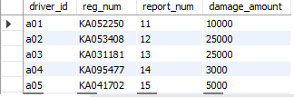

- Add a new accident to the database.

insert into accident
values (16,'2015-03-08','domlur');
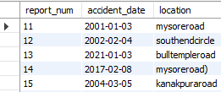

- Display Accident date and location

select accident_date ,location from accident;
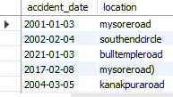
- Display driver id who did accident with damage amount greater than or equal to Rs.25000

select driver_id from participated
where damage_amount>=25000;
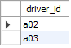

WEEK -02
- PERSON (driver_id: String, name: String, address: String)
- CAR (reg_num: String, model: String, year: int)
- ACCIDENT (report_num: int, accident_date: date, location: String)
- OWNS (driver_id: String, reg_num: String)
- PARTICIPATED (driver_id: String,reg_num: String, report_num: int, damage_amount: int)
Schema Diagram


*select * from car
order by year asc;
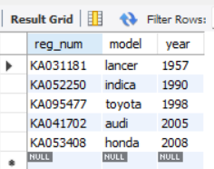

select count(report_num)
from car c , participated p
where c.reg_num=p.reg_num and c.model='lancer';
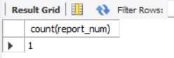

select count(driver_id)
from accident a,participated p
where a.report_num=p.report_num and a.accident_date like '__08%';
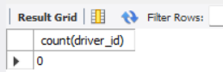

select avg(damage_amount) as 'average' from participated;
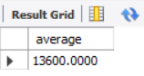

select name
from person a ,participated p
where a.driver_id=p.driver_id and p.damage_amount >(select avg(damage_amount) from participated);
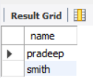

select max(damage_amount) from participated;
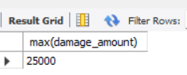

BANK ACCOUNT
QUESTION
(WEEK 3)

- Create the above tables by properly specifying the primary keys and the foreign keys.

- Enter at least five tuples for each relation.

- Display the branch name and assets from all branches in lakhs of rupees and rename
The assets column to 'assets in lakhs'.

- Find all the customers who have at least two accounts at the same branch (ex.SBI_residencyroad).

- Create a view which gives each branch the sum of the amount of all the loans at the branch.

SCHEMA DIAGRAM
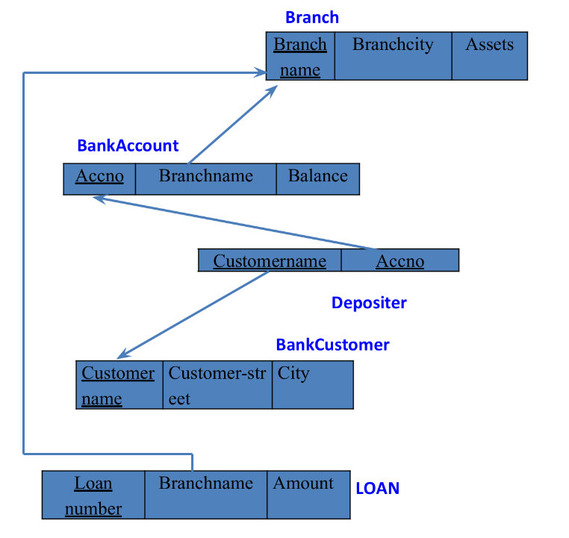

CREATE DATABASE

create database _cs084;
use Bramha_cs071;

CREATE TABLES

create table branch (
branchname varchar(50),
branchcity varchar(50),
assests int ,
primary key (branchname));

create table bankcustomer(
customername varchar(50),
customer_street varchar(50),
city varchar(50),
primary key(customername));

create table bankaccount (
accno int,
branchname varchar(50),
balance int,
primary key (accno),
foreign key (branchname) references branch (branchname));

create table depositer(
customername varchar(50),
accno int,
primary key (customername, accno),
foreign key (customername) references bankcustomer(customername),
foreign key (accno) references bankaccount(accno));

create table loan(
loannumber int,
branchname varchar(50),
amount int,
primary key (loannumber),
foreign key (branchname) references branch (branchname));

STRUCTURE OF TABLE

desc branch;
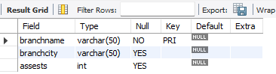
desc bankaccount;
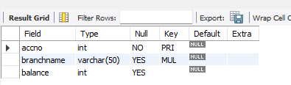

desc depositer;
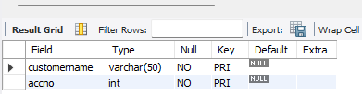

desc bankcustomer;
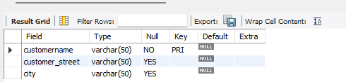

desc loan;
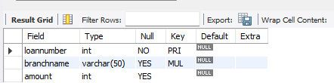

INSERTING VALUES INTO THE TABLE

insert into branch
values('SBI-chamrajpet','banglore', 50000),
('SBI-residencyroad','banglore',10000),
('SBI-shivajiroad','bombay',20000),
('SBI-parlimentroad','delhi',10000),
('SBI-jantarmantar','delhi',20000);
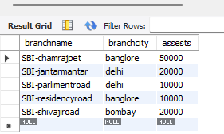

insert into bankcustomer
values('avinash','bull-temple-road','banglore'),
('dinesh','bannergatta-road','banglore'),
('mohan','nationalcollege-road','banglore'),
('nikil','akbar-road','delhi'),
('ravi','prithviraj-road','delhi');
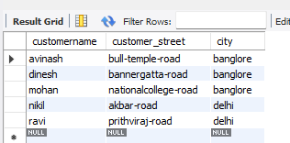

insert into bankaccount
values(1,'SBI-chamrajpet',2000),
(2,'SBI-residencyroad',5000),
(3,'SBI-shivajiroad',6000),
(4,'SBI-parlimentroad',9000),
(5,'SBI-jantarmantar',8000),
(6,'SBI-shivajiroad',4000),
(8,'SBI-residencyroad',4000),
(9,'SBI-parlimentroad',3000),
(10,'SBI-residencyroad',5000),
(11,'SBI-jantarmantar',2000);
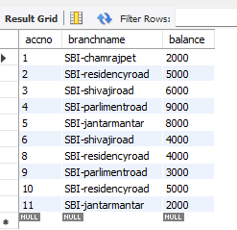

insert into depositer
values('avinash',1),
('dinesh',2),
('nikil',4),
('ravi',5),
('avinash',8),
('nikil',9),
('dinesh',10),
('nikil',11);
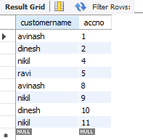

insert into loan
values(1,'SBI-chamrajpet',1000),
(2,'SBI-residencyroad',2000),
(3,'SBI-shivajiroad',3000),
(4,'SBI-parlimentroad',4000),
(5,'SBI-jantarmantar',5000);
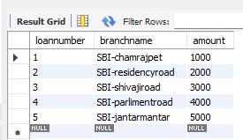

QUERIES

- Display the branch name and assets from all branches in lakhs of rupees and rename the assets column to 'assets in lakhs'.

select branchname,assests as 'assets in lakhs'
from branch;
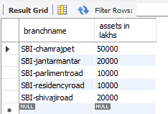

- Find all the customers who have at least two accounts at the same branch (ex.SBI_ResidencyRoad).

select d.customername
from bankaccount b, depositer d
where b.accno=d.accno and branchname='SBI-residencyroad'
group by customername
having count(*)>=2;
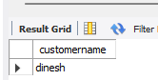

- Create a view which gives each branch the sum of the amount of all the loans at the branch.

create view loan_info as
select b.branchname, sum(l.amount)
from branch b , loan l
where b.branchname=l.branchname
group by l.branchname;
select * from loan_info;
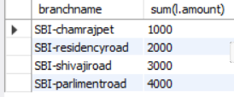

WEEK -04

- Retrieve all branches and their respective total assets

select branchname, assests
from branch;
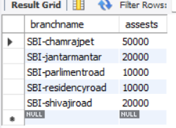

- List all customers who live in a particular city

select customername
from bankcustomer
where city=”Delhi”;
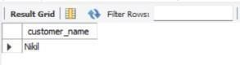

- List all customers with their account numbers

select customername ,accno
from depositer ;
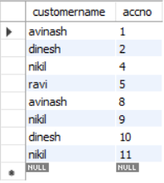
- Find all the customers who have an account at all the branches located in a specific city (Ex. Delhi).

select c.customername
from bankcustomer c, depositer d, bankaccount a, branch b
where c.customername=d.customername and d.accno=a.accno and a.branchname=b.branchname and b.branchname=all(select b.branchname
from branch b
where b.branchcity='delhi');
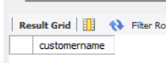

- Find all customers who have accounts with a balance greater than a specified amount (5000)

select c.customername, b.balance
from bankcustomer c, bankaccount b, depositer d
where d.accno=b.accno and c.customername=d.customername and b.balance>5000;
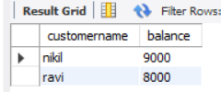

- List all branch who have both a loan and an account

select distinct(b.branchname)
from branch b, bankaccount a, loan l
where b. branchname=a.branchname and b.branchname=l.branchname;
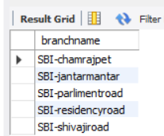

- Get the number of accounts held at each branch

select branchname , count(*)
from bankaccount
group by branchname;
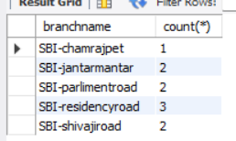

- Find all branches that have no loans issued

select b.branchname
from branch b
where b.branchname not in(select branchname
from loan);
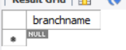

- Retrieve the branch with the smallest total loan amount

select branchname ,min(amount)
from loan
group by branchname
order by min(amount)
limit 1;
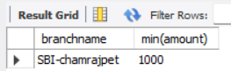

EMPLOYEE DATABASE
(WEEK -05)
QUESTION

1. Using Scheme diagram, Create tables by properly specifying the primary keys and the foreign keys.
2. Enter greater than five tuples for each table.
3. Retrieve the employee numbers of all employees who work on project located in Bengaluru, Hyderabad, or Mysuru
4. Get Employee ID’s of those employees who didn’t receive incentives
5. Write a SQL query to find the employees name, number, dept, job_role, department location and project location who are working for a project location same as his/her department location.

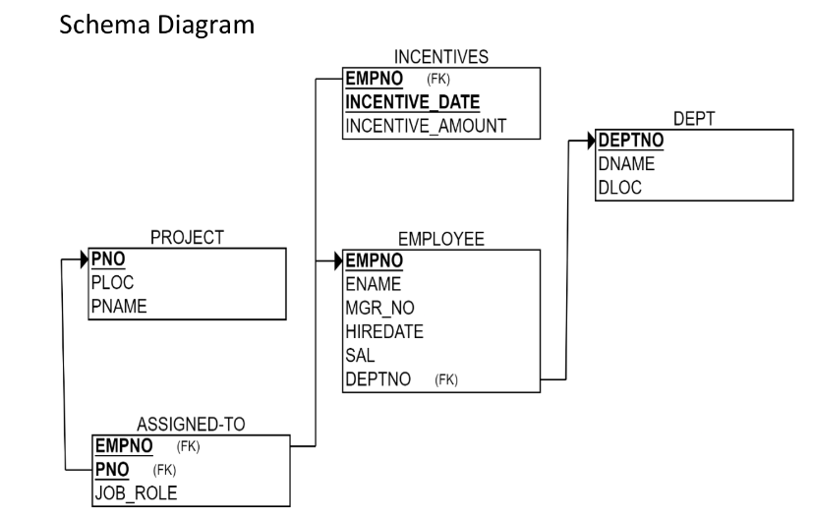
CREATE DATABASE
Create database Bramha_071;
Use database Bramha_071;

CREATE TABLES
create table project(
pno int,
ploc varchar(50),
pname varchar(50),
primary key (pno));

create table dept(
deptno int primary key,
dname varchar(50),
dloc varchar(50));

create table employee(
empno int primary key,
empname varchar(50),
mgr_no int,
hiredate date,
sal int,
deptno int,
foreign key (deptno) references dept (deptno));

create table incentives(
empno int ,
incentive_date date ,
incentive_amt int,
primary key(empno,incentive_date),
foreign key (empno) references employee (empno));

create table assigned_to(
empno int,
pno int,
job_role varchar (50),
primary key (empno, pno),
foreign key (empno) references employee(empno),
foreign key (pno) references project (pno));

STRUCTURE OF TABLE
Desc project;
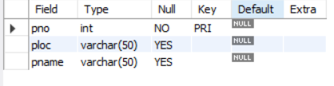
desc dept;
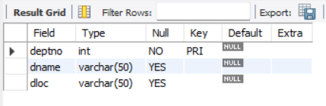
Desc employee;
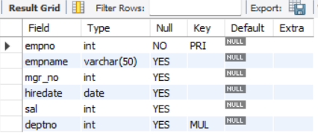
Desc assigned_to;
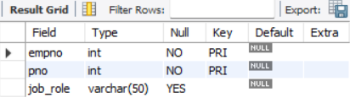
INSERT TO TABLE
insert into project
values(01,'bengaluru','pascalai'),
(02,'hyderbaad','p1m'),
(03,'mysuru','p2m'),
(04,'chennai','p3m'),
(05,'delhi','p4m');
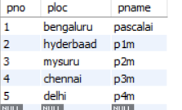
insert into dept
values(01,'sales','bengaluru'),
(02,'it','hyderabad'),
(03,'hr','mysuru'),
(04,'finance','delhi'),
(05,'production','chennai');
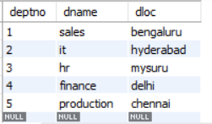
insert into employee
values (101,"Dinesh",111,"2021-11-01",50000,1),
(102,"Dhanush",112,"2024-01-01",70000,2),
(103,"Daivya",113,"2024-01-01",80000,3),
(104,"Aditya",114,"2023-08-11",65000,1),
(105,"Arun",111,"2022-06-07",35000,2);
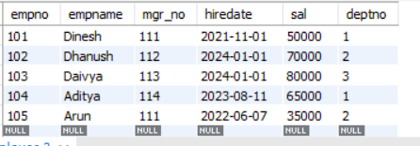
insert into incentives
values(4,'2020-11-12',3000),
(8,'2015-07-30',4000),
(7,'2010-10-14',5000),
(7,'2015-07-24',7000),
(2,'2020-11-30',3000);

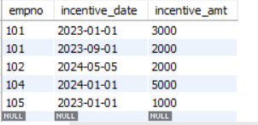
insert into assigned_to
values(101,02,'assistant'),
(101,01,'manager'),
(102,02,'head'),
(103, 03,'manager'),
(104,05,'developer');
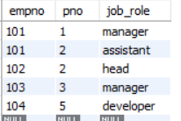

QUERIES
- Retrieve the employee numbers of all employees who work on project located in Bengaluru, Hyderabad, or Mysuru

select e.empno
from employee e, assigned_to a
where e.empno=a.empno and a.pno in(select pno
from project
where ploc in ('bengaluru' ,' hyderabad',' mysuru'));
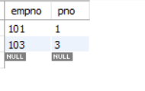

- Get Employee ID’s of those employees who didn’t receive incentives
select empno from employee
where empno not in (select distinct empno from incentives);

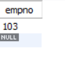

- Write a SQL query to find the employees name, number, dept, job_role, department location and project location who are working for a project location same as his/her department location.

select e.empno, e.empname, d.deptno, a.job_role, d.dloc ,p.ploc
from employee e, project p, assigned_to a, dept d
where e.empno=a.empno and p.pno=a.pno and e.deptno=d.deptno and d.dloc=p.ploc;
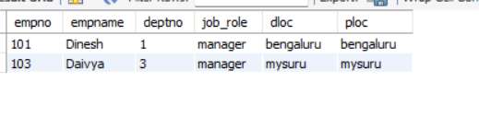

(WEEK-06)

- List all employees along with their project details (if assigned)
select e.empname, p.*
from employee e , project p, assigned_to a
where e.empno=a.empno and p.pno=a.pno;
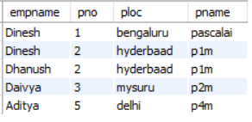

- Find all employees who received incentives, along with the total incentive amount

select i.empno, e.empname, sum(i.incentive_amt) as total_incentive
from incentives i, employee e
where i.empno=e.empno
group by empno;
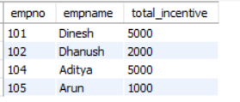

- Retrieve the project names and locations of projects with employees assigned as 'Manager'

select p.pname, p.ploc
from project p
where pno in (select pno from assigned_to a where job_role='manager');
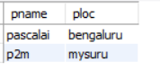

- List departments along with the number of employees in each department

select d.dname, count(e.empno)
from dept d, employee e
where d.deptno =e. deptno
group by d.dname;
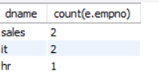

- Find employees who have not been assigned to any project

select e.empno, e.empname
from employee e
where not exists (select 1 from assigned_to a where e.empno=a.empno);
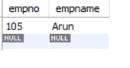

- List all employees along with their department names and location

select e.empname , d.deptno, d.dloc
from employee e , dept d
where e.deptno=d.deptno;
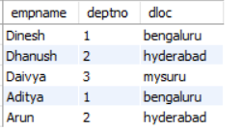

- Retrieve the details of employees who work under a specific manager

select *
from employee e
where mgr_no=111;
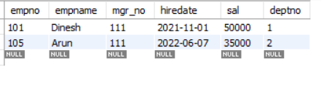

- List all projects that have employees assigned and the number of employees on each project:

select p.pname, count(e.empno)
from project p, assigned_to e
where e.pno=p.pno
group by p.pname;
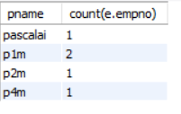

- List the total number of incentives given to each employee and the sum of incentives for each

select empno, count(incentive_date) as number_of_times, sum(incentive_amt) as total_amt
from incentives
group by empno;
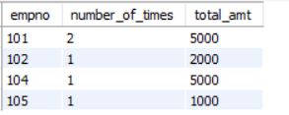

- Retrieve all employees who have the role of 'Developer' on any project

select e.empno, e.empname
from employee e
where e.empno in (select empno from assigned_to where empno=e.empno and job_role='developer');
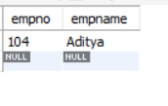

- Display the department-wise average salary of employees:

select deptno , avg(sal) as average
from employee
group by deptno;
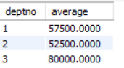
SUPPLIERS DATABASE
(WEEK -07)
QUESTION

- Using Scheme diagram, Create tables by properly specifying the primary keys and the foreign keys.
- Insert appropriate records in each table.
3. Find the pnames of parts for which there is some supplier.
- Find the snames of suppliers who supply every part.
- Find the snames of suppliers who supply every red part.
- Find the pnames of parts supplied by Acme Widget Suppliers and by no one else
- Find the sids of suppliers who charge more for some part than the average cost of that part (averaged over all the suppliers who supply that part)
- For each part, find the sname of the supplier who charges the most for that part

Schema Diagram:
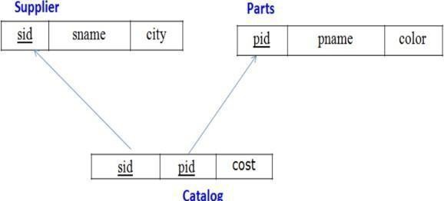

Create Database:
create database supp;
use supp;

Create Tables:
create table Supplier(
s_id int primary key,
s_name varchar(30), city varchar(30)
create table Parts( p_id int primary key, p_name varchar(30), color varchar(30));

create table Catalog( s_id int,
p_id int, cost float,
foreign key(s_id) references Supplier(s_id), foreign key(p_id) references Parts(p_id));

Structure of the Table:
desc Supplier;
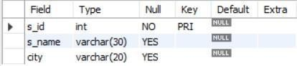
desc Parts;
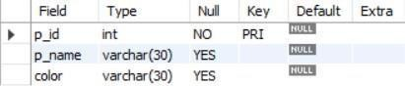
desc Catalog;

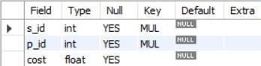

Inserting Values to the tables:

insert into Supplier values
(10001, 'Acme_Widget', 'Bangalore'),
(10002, 'Johns', 'Kolkata'),
(10003, 'Vimal', 'Mumbai'),
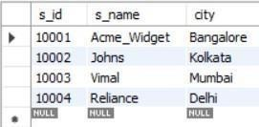
(10004, 'Reliance', 'Delhi'); select * from Supplier;

insert into Parts values (20001, 'Book', 'Red'),
(20002, 'Pen', 'Red'),
(20003, 'Pencil', 'Green'),
(20004, 'Mobile', 'Green'),
(20005, 'Charger', 'Black');
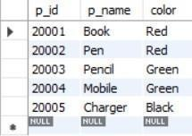

insert into Catalog values (10001, 20001, 10),
(10001, 20002, 10),
(10001, 20003, 30),
(10001, 20004, 10),
(10001, 20005, 10),
(10002, 20001, 10),
(10002, 20002, 20),
(10003, 20003, 30),
(10004, 20003, 40);

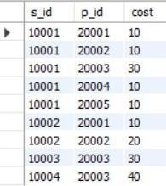

Queries:

Find the pnames of parts for which there is some supplier.
select distinct p.p_name
from Supplier s, Catalog c, Parts p where s.s_id = c.s_id and
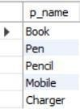
p.p_id = c.p_id and c.s_id is not null;

Find the snames of suppliers who supply every part.
select distinct s_name
from Supplier s, Catalog c, Parts p where s.s_id = c.s_id
group by s.s_id, s.s_name
having count(distinct c.p_id)=(select count(*) from Parts p);
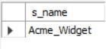

Find the snames of suppliers who supply every red part.
select distinct s_name
from Supplier s, Catalog c, Parts p where s.s_id = c.s_id and
c.p_id in (select p_id from Parts p where p.color = 'Red')
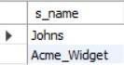

Find the pnames of parts supplied by Acme Widget Suppliers and by no one else
select distinct p_name from Supplier s, Parts p, Catalog c where p.p_id in (select c.p_id from Catalog c, Supplier s where
s.s_id = c.s_id and s.s_name = 'Acme_Widget') and
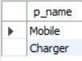
p.p_id not in (select c.p_id from Catalog c, Supplier s where s.s_id = c.s_id and s.s_name != 'Acme_Widget');

Find the sids of suppliers who charge more for some part than the average cost of that part (averaged over all the suppliers who supply that part)
create view Average(p_id, Average_Product_Cost) as select c.p_id, avg(cost)
from Catalog c group by c.p_id;
select c.s_id from Catalog c, Average a where c.p_id = a.p_id and c.cost>(a.Average_Product_Cost)
group by c.p_id, c.s_id;
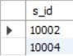

For each part, find the sname of the supplier who charges the most for that part
select distinct s.s_name, c.cost, c.p_id from Catalog c, Supplier s where s.s_id = c.s_id and
c.cost in (select max(cost) from Catalog c group by c.p_id);

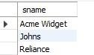

NO SQL STUDENT DATABASE
(WEEK -08)
QUESTION

- Perform the following DB operations using MongoDB.
- Create a database “Student” with the following attributes Rollno, Age, ContactNo, Email-Id.
- Insert appropriate values
- Write query to update Email-Id of a student with rollno 10.
- Replace the student name from “ABC” to “FEM” of rollno 11.

Create Database:
db.createCollection("Student");

Inserting Values to the tables:
db.Student.insert({RollNo:1,Age:21,Cont:9876,email:"antara.de9@gmail.com"});
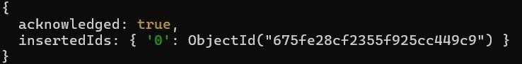

db.Student.insert({RollNo:2,Age:22,Cont:9976,email:"anushka.de9@gmail.com"});
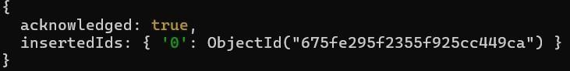

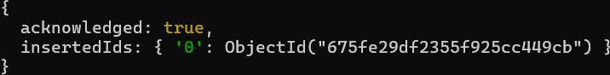
db.Student.insert({RollNo:3,Age:21,Cont:5576,email:"anubhav.de9@gmail.com"});

db.Student.insert({RollNo:4,Age:20,Cont:4476,email:"pani.de9@gmail.com"});
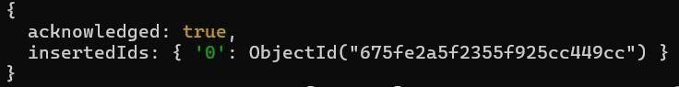

db.Student.insert({RollNo:10,Age:23,Cont:2276,email:"rekha.de9@gmail.com"});
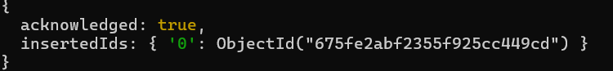

Queries:

db.Student.find()
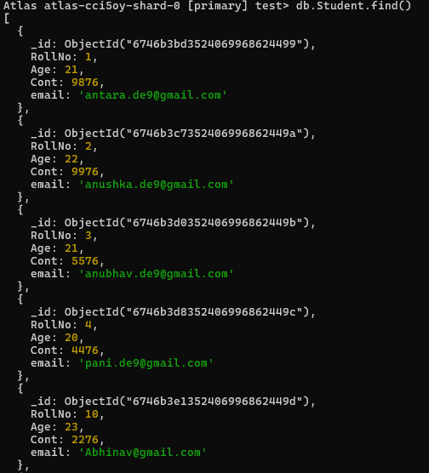

Write query to update Email-Id of a student with rollno 10.
db.Student.update({RollNo:10},{$set:{email:"Abhinav@gmail.com"}})
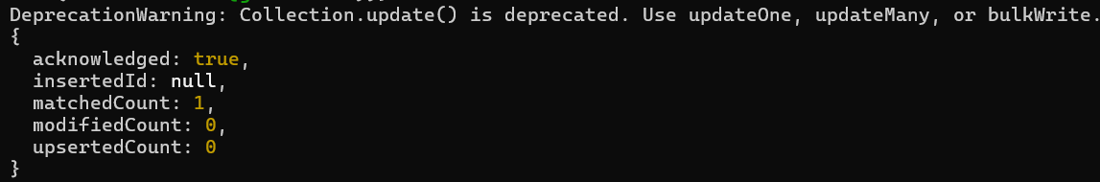

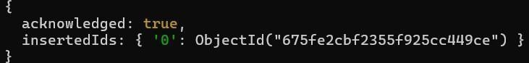
Replace the student name from “ABC” to “FEM” of rollno 11. db.Student.insert({RollNo:11,Age:22,Name:"ABC",Cont:2276,email:"rea.de9@gmail. c om"});

db.Student.update({RollNo:11,Name:"ABC"},{$set:{Name:"FEM"}})
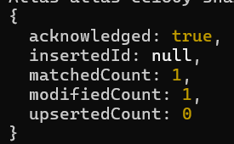
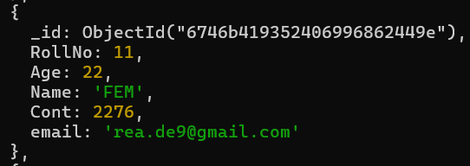

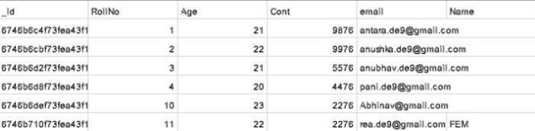
Import a given csv dataset from local file system into mongodb collectio

NO SQL CUSTOMERS DATABASE
(WEEK -09)
QUESTION

  - Create a collection by name Customers with the following attributes. Cust_id, Acc_Bal, Acc_Type
  - Insert at least 5 values into the table

  - Write a query to display those records whose total account balance is greater than 1200 of account type ‘Z’ for each customer_id.

  - Determine Minimum and Maximum account balance for each customer_id.

  - Export the created collection into local file system

  - Drop the table

  - Import a given csv dataset from local file system into mongodb collection.

Create Database:
db.createCollection("Customer");
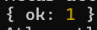

Inserting Values to the tables:
db.Customer.insertMany([{custid: 1, acc_bal:10000, acc_type:"Saving"},
{custid: 1, acc_bal:20000, acc_type: "Checking"}, {custid: 3, acc_bal:50000, acc_type: "Checking"}, {custid: 4, acc_bal:10000, acc_type: "Saving"}, {custid: 5, acc_bal:2000, acc_type: "Checking"}]);

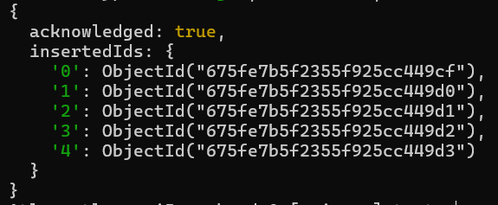

Queries:

Write a query to display those records whose total account balance is greater than 1200 of account type ‘Z’ for each customer_id.
db.Customer.find({acc_bal: {$gt: 12000}, acc_type:"Checking"});
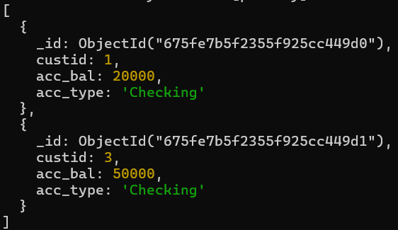

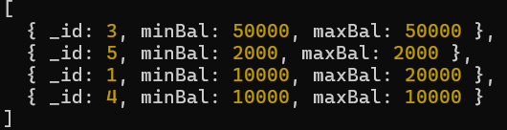
Determine Minimum and Maximum account balance for each customer_id. db.Customer.aggregate([{$group:{_id:"$custid", minBal:{$min:"$acc_bal"}, maxBal:{$max:"$acc_bal"}}}]);

db.Customers.drop()

Import a given csv dataset from local file system into mongodb collection.
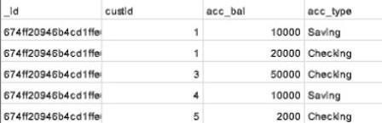

NO SQL RESTAURANTS DATABASE
(WEEK-10)
QUESTION

- Write a MongoDB query to display all the documents in the collection restaurants.

- Write a MongoDB query to arrange the name of the restaurants in descending along with all the columns.

- Write a MongoDB query to find the restaurant Id, name, town and cuisine for those restaurants which achieved a score which is not more than 10.

- Write a MongoDB query to find the average score for each restaurant.

- Write a MongoDB query to find the name and address of the restaurants that have a zipcode that starts with '10'.

Create Database:
db.createCollection("restaurants");

Inserting Values to the tables:
db.restaurants.insertMany([{ name: "Meghna Foods", town: "Jayanagar", cuisine: "Indian", score: 8, address: { zipcode: "10001", street: "Jayanagar"}},{ name: "Empire", town: "MG Road", cuisine: "Indian", score: 7, address: { zipcode: "10100", street: "MG Road"}},{ name: "Chinese WOK", town: "Indiranagar", cuisine: "Chinese", score: 12, address: { zipcode: "20000", street: "Indiranagar" }},{ name: "Kyotos", town: "Majestic", cuisine: "Japanese", score: 9, address: { zipcode: "10300", street: "Majestic"
}},{ name: "WOW Momos", town: "Malleshwaram", cuisine: "Indian", score: 5, address: { zipcode: "10400", street: "Malleshwaram"}}])

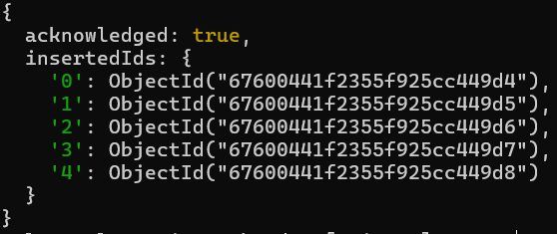

Queries:

Write a MongoDB query to display all the documents in the collection restaurants.
db.restaurants.find({})
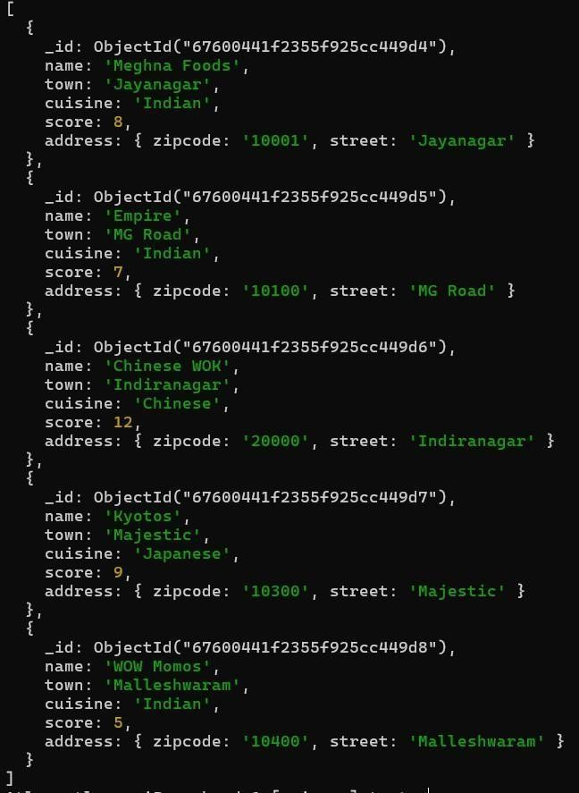

Write a MongoDB query to arrange the name of the restaurants in descending along with all the columns
db.restaurants.find({}).sort({ name: -1 })
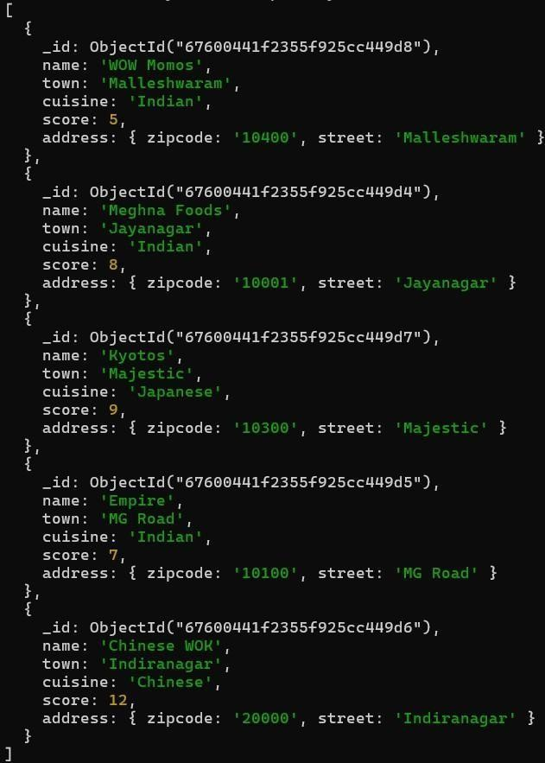

Write a MongoDB query to find the restaurant Id, name, town and cuisine for those restaurants which achieved a score which is not more than 10.
db.restaurants.find({ "score": { $lte: 10 } }, { _id: 1, name: 1, town: 1, cuisine: 1 })
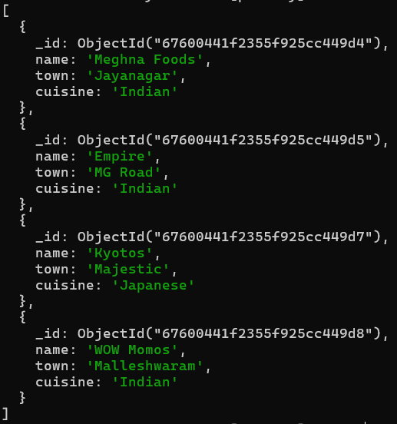

Write a MongoDB query to find the average score for each restaurant.
db.restaurants.aggregate([ { $group: { _id: "$name", average_score: {
$avg:"$score"}}}])
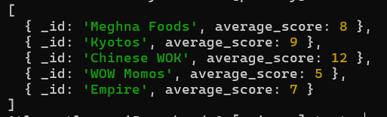

Write a MongoDB query to find the name and address of the restaurants that have a zipcode that starts with '10'.
db.restaurants.find({ "address.zipcode": /^10/ }, { name: 1, "address.street": 1, _id: 0 })
