VISVESVARAYA TECHNOLOGICAL UNIVERSITY
“JnanaSangama”, Belgaum -590014, Karnataka.


LAB REPORT

on

Machine Learning (23CS6PCMAL)

Submitted by
Bramha Anilkumar Bajannavar (1BM23CS071)

in partial fulfillment for the award of the degree of

BACHELOR OF ENGINEERING
in

COMPUTER SCIENCE AND ENGINEERING


B.M.S. COLLEGE OF ENGINEERING
(Autonomous Institution under VTU)

BENGALURU-560019

Sep-2024 to Jan-2025

B.M.S. College of Engineering,
Bull Temple Road, Bangalore 560019
(Affiliated To Visvesvaraya Technological University, Belgaum)
Department of Computer Science and Engineering


CERTIFICATE

This is to certify that the Lab work entitled “Machine Learning (23CS6PCMAL)” carried out by Bramha Anilkumar Bajannavar (1BM23CS071), who is bonafide student of B.M.S. College of Engineering. It is in partial fulfillment for the award of Bachelor of Engineering in Computer Science and Engineering of the Visvesvaraya Technological University, Belgaum. The Lab report has been approved as it satisfies the academic requirements in respect of an Machine Learning (23CS6PCMAL) work prescribed for the said degree.

Dr. Kavitha Sooda Professor & HOD
Department of CSE, BMSCE
Rashmi H
Assistant Professor Department of CSE, BMSCE

Index
Sl.  No. | Date | Experiment Title | Page No.
1 | 21-2-2025 | Write a python program to import and export data using Pandas library functions | 4-6
2 | 3-3-2025 | Demonstrate various data pre-processing techniques for a given dataset | 7-12
3 | 10-3-2025 | Implement Linear and Multi-Linear Regression algorithm using appropriate dataset | 13-18
4 | 17-3-2025 | Build Logistic Regression Model for a given dataset | 19-20
5 | 24-3-2025 | Use an appropriate data set for building the decision tree (ID3) and apply this knowledge to classify a new sample. | 21-24
6 | 7-4-2025 | Build KNN Classification model for a given dataset. | 25-26
7 | 21-4-2025 | Build Support vector machine model for a given dataset | 27-29
8 | 5-5-2025 | Implement Random forest ensemble method on a given dataset. | 30-31
9 | 5-5-2025 | Implement Boosting ensemble method on a given dataset. | 32-34
10 | 12-5-2025 | Build k-Means algorithm to cluster a set of data stored in a .CSV file. | 35-37
11 | 12-5-2025 | Implement Dimensionality reduction using Principal Component Analysis (PCA) method. | 38-39

Github Link:
https://github.com/BramhaBajannavar/ML_Lab

Program 1
Write a python program to import and export data using Pandas library functions
Screenshot
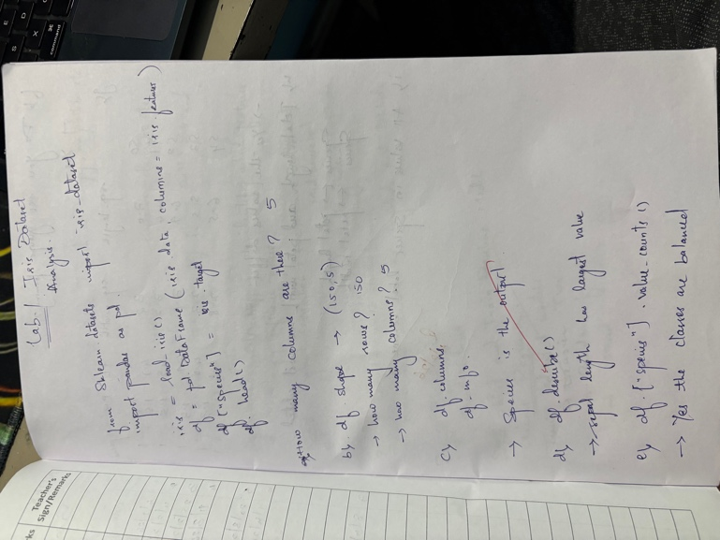
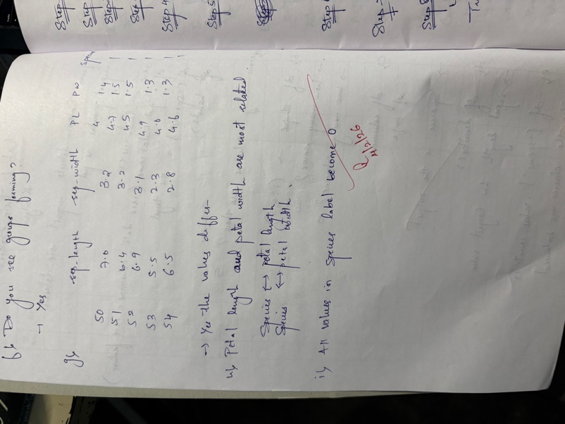

Code:

#!/usr/bin/env python
# coding: utf-8

# <a href="https://colab.research.google.com/github/BramhaBajannavar/ML_Lab/blob/main/LAB1_iris_dataset.ipynb" target="_parent"><img src="https://colab.research.google.com/assets/colab-badge.svg" alt="Open In Colab"/></a>

# In[ ]:

from sklearn.datasets import load_iris
import pandas as pd

# In[ ]:

iris = load_iris()
df = pd.DataFrame(iris.data, columns=iris.feature_names)
df["species"] = iris.target
df.head()

# Observation Question: How many columns are there?
#
#
# 5

# In[ ]:

df.shape

# Observation Questions
# • How many rows (examples)? 150
# • How many features? 5

# In[ ]:

df.columns
df.info()

# Which column is the output?

# In[ ]:

df.describe()

# Which feature has the largest values? sepal length

# In[ ]:

df["species"].value_counts()

# Are classes balanced? yes

# In[ ]:

import matplotlib.pyplot as plt

plt.scatter(df['sepal length (cm)'] , df['petal length (cm)'])
plt.xlabel("sepal length")
plt.ylabel("petal length")
plt.show()

# Do you see groups forming? yes

# In[ ]:

df[df['species'] == 0].head()

# In[ ]:

df[df['species'] == 1].head()

# Do feature values differ? yes

# In[ ]:

df.corr()

# In[ ]:

df.sort_values(by="petal length (cm)").head()

Program 2

Demonstrate various data pre-processing techniques for a given dataset

Screenshot:

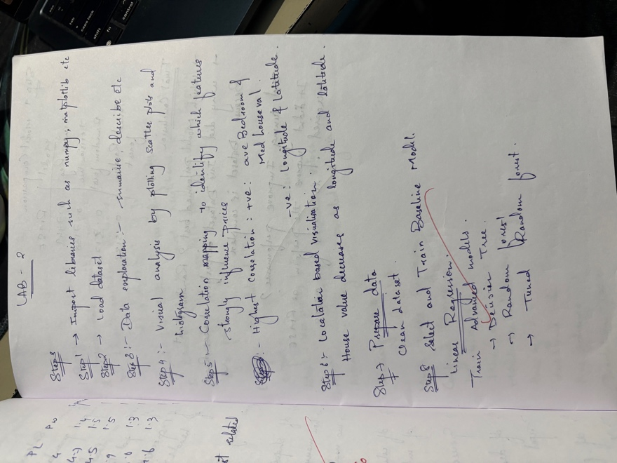
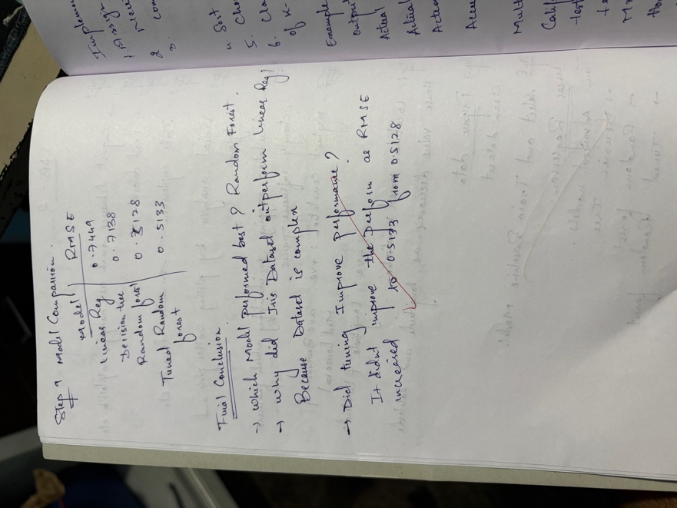

Code:

#!/usr/bin/env python
# coding: utf-8

# <a href="https://colab.research.google.com/github/BramhaBajannavar/ML_Lab/blob/main/LAB2_houseprice_prediction.ipynb" target="_parent"><img src="https://colab.research.google.com/assets/colab-badge.svg" alt="Open In Colab"/></a>

# In[2]:

import numpy as np
import pandas as pd
import matplotlib.pyplot as plt
import seaborn as sns
from sklearn.datasets import fetch_california_housing
from sklearn.model_selection import train_test_split, GridSearchCV
from sklearn.preprocessing import StandardScaler
from sklearn.linear_model import LinearRegression
from sklearn.tree import DecisionTreeRegressor
from sklearn.ensemble import RandomForestRegressor
from sklearn.metrics import mean_squared_error, mean_absolute_error, r2_score

#

# In[3]:

# Load California housing dataset
housing = fetch_california_housing(as_frame=True)
# Create DataFrame
df = housing.frame
# Display basic info
df.head()
df.shape
df.info()

# In[4]:

df.describe()
# Check missing values
df.isnull().sum()

# In[6]:

plt.figure(figsize=(8, 5))
sns.histplot(df["MedHouseVal"], bins=30, kde=True)

plt.xlabel("Median House Value")
plt.ylabel("Frequency")
plt.title("Distribution of House Prices")

plt.tight_layout()
plt.show()

# In[7]:

plt.figure(figsize=(8, 5))
sns.scatterplot(x=df["MedInc"], y=df["MedHouseVal"], alpha=0.5)

plt.xlabel("Median Income")
plt.ylabel("Median House Value")
plt.title("Income vs House Price")

plt.tight_layout()
plt.show()

# In[9]:

plt.figure(figsize=(10,8))
sns.heatmap(df.corr(), annot=True, cmap="coolwarm")
plt.title("Feature Correlation Heatmap")
plt.show()

# In[10]:

plt.figure(figsize=(8, 6))

plt.scatter(
df["Longitude"],
df["Latitude"],
c=df["MedHouseVal"],
cmap="viridis",
s=5
)

plt.colorbar(label="House Value")
plt.xlabel("Longitude")
plt.ylabel("Latitude")
plt.title("House Prices by Location")

plt.tight_layout()
plt.show()

# In[12]:

df['RoomsPerHousehold'] = df['AveRooms'] / df['HouseAge']

# In[13]:

X = df.drop("MedHouseVal", axis=1)
y = df["MedHouseVal"]

X_train, X_test, y_train, y_test = train_test_split(
X, y, test_size=0.2, random_state=42
)

# In[14]:

scaler = StandardScaler()
X_train_scaled = scaler.fit_transform(X_train)
X_test_scaled = scaler.transform(X_test)

# In[15]:

lin_reg = LinearRegression()
lin_reg.fit(X_train_scaled, y_train)
y_pred_lr = lin_reg.predict(X_test_scaled)
rmse_lr = np.sqrt(mean_squared_error(y_test, y_pred_lr))
mae_lr = mean_absolute_error(y_test, y_pred_lr)
r2_lr = r2_score(y_test, y_pred_lr)
rmse_lr, mae_lr, r2_lr

# In[16]:

dt = DecisionTreeRegressor(random_state=42)
dt.fit(X_train, y_train)

y_pred_dt = dt.predict(X_test)
rmse_dt = np.sqrt(mean_squared_error(y_test, y_pred_dt))
rmse_dt

# In[17]:

rf = RandomForestRegressor(random_state=42)
rf.fit(X_train, y_train)
y_pred_rf = rf.predict(X_test)
rmse_rf = np.sqrt(mean_squared_error(y_test, y_pred_rf))
rmse_rf

# In[19]:

# param_grid = {
# "n_estimators": [50, 100],
# "max_depth": [None, 10, 20],
# "min_samples_split": [2, 5]
# }

# grid_search = GridSearchCV(
# rf,
# param_grid,
# cv=3,
# scoring="neg_mean_squared_error"
# )

# grid_search.fit(X_train, y_train)

# best_model = grid_search.best_estimator_
# y_pred_best = best_model.predict(X_test)

# rmse_best = np.sqrt(mean_squared_error(y_test, y_pred_best))
# rmse_best

from sklearn.ensemble import RandomForestRegressor
from sklearn.model_selection import RandomizedSearchCV
from sklearn.metrics import mean_squared_error
import numpy as np

# Initialize Random Forest with all CPU cores
rf = RandomForestRegressor(random_state=42, n_jobs=-1)

# Smaller parameter grid for faster search
param_grid = {
"n_estimators": [50, 100], # fewer trees
"max_depth": [10, 20], # avoid None for speed
"min_samples_split": [2] # single option
}

# RandomizedSearchCV instead of GridSearchCV for speed
random_search = RandomizedSearchCV(
rf,
param_distributions=param_grid,
n_iter=5, # try only 5 random combinations
cv=3,
scoring="neg_mean_squared_error",
n_jobs=-1,
random_state=42,
verbose=2 # see progress
)

# Optional: sample dataset if very large (uncomment if needed)
# X_train_small = X_train.sample(10000, random_state=42)
# y_train_small = y_train.loc[X_train_small.index]
# random_search.fit(X_train_small, y_train_small)

# Fit on full training data
random_search.fit(X_train, y_train)

# Get best model and predictions
best_model = random_search.best_estimator_
y_pred_best = best_model.predict(X_test)

# Calculate RMSE
rmse_best = np.sqrt(mean_squared_error(y_test, y_pred_best))
print("Best Random Forest RMSE:", rmse_best)

# In[20]:

results = pd.DataFrame({
"Model": [
"Linear Regression",
"Decision Tree",
"Random Forest",
"Tuned Random Forest"
],
"RMSE": [rmse_lr, rmse_dt, rmse_rf, rmse_best]
})

results

Program 3

Implement Linear and Multi-Linear Regression algorithm using appropriate dataset

Code:

#!/usr/bin/env python
# coding: utf-8

# <a href="https://colab.research.google.com/github/BramhaBajannavar/ML_Lab/blob/main/LAB2_houseprice_prediction.ipynb" target="_parent"><img src="https://colab.research.google.com/assets/colab-badge.svg" alt="Open In Colab"/></a>

# In[2]:

import numpy as np
import pandas as pd
import matplotlib.pyplot as plt
import seaborn as sns
from sklearn.datasets import fetch_california_housing
from sklearn.model_selection import train_test_split, GridSearchCV
from sklearn.preprocessing import StandardScaler
from sklearn.linear_model import LinearRegression
from sklearn.tree import DecisionTreeRegressor
from sklearn.ensemble import RandomForestRegressor
from sklearn.metrics import mean_squared_error, mean_absolute_error, r2_score

#

# In[3]:

# Load California housing dataset
housing = fetch_california_housing(as_frame=True)
# Create DataFrame
df = housing.frame
# Display basic info
df.head()
df.shape
df.info()

# In[4]:

df.describe()
# Check missing values
df.isnull().sum()

# In[6]:

plt.figure(figsize=(8, 5))
sns.histplot(df["MedHouseVal"], bins=30, kde=True)

plt.xlabel("Median House Value")
plt.ylabel("Frequency")
plt.title("Distribution of House Prices")

plt.tight_layout()
plt.show()

# In[7]:

plt.figure(figsize=(8, 5))
sns.scatterplot(x=df["MedInc"], y=df["MedHouseVal"], alpha=0.5)

plt.xlabel("Median Income")
plt.ylabel("Median House Value")
plt.title("Income vs House Price")

plt.tight_layout()
plt.show()

# In[9]:

plt.figure(figsize=(10,8))
sns.heatmap(df.corr(), annot=True, cmap="coolwarm")
plt.title("Feature Correlation Heatmap")
plt.show()

# In[10]:

plt.figure(figsize=(8, 6))

plt.scatter(
df["Longitude"],
df["Latitude"],
c=df["MedHouseVal"],
cmap="viridis",
s=5
)

plt.colorbar(label="House Value")
plt.xlabel("Longitude")
plt.ylabel("Latitude")
plt.title("House Prices by Location")

plt.tight_layout()
plt.show()

# In[12]:

df['RoomsPerHousehold'] = df['AveRooms'] / df['HouseAge']

# In[13]:

X = df.drop("MedHouseVal", axis=1)
y = df["MedHouseVal"]

X_train, X_test, y_train, y_test = train_test_split(
X, y, test_size=0.2, random_state=42
)

# In[14]:

scaler = StandardScaler()
X_train_scaled = scaler.fit_transform(X_train)
X_test_scaled = scaler.transform(X_test)

# In[15]:

lin_reg = LinearRegression()
lin_reg.fit(X_train_scaled, y_train)
y_pred_lr = lin_reg.predict(X_test_scaled)
rmse_lr = np.sqrt(mean_squared_error(y_test, y_pred_lr))
mae_lr = mean_absolute_error(y_test, y_pred_lr)
r2_lr = r2_score(y_test, y_pred_lr)
rmse_lr, mae_lr, r2_lr

# In[16]:

dt = DecisionTreeRegressor(random_state=42)
dt.fit(X_train, y_train)

y_pred_dt = dt.predict(X_test)
rmse_dt = np.sqrt(mean_squared_error(y_test, y_pred_dt))
rmse_dt

# In[17]:

rf = RandomForestRegressor(random_state=42)
rf.fit(X_train, y_train)
y_pred_rf = rf.predict(X_test)
rmse_rf = np.sqrt(mean_squared_error(y_test, y_pred_rf))
rmse_rf

# In[19]:

# param_grid = {
# "n_estimators": [50, 100],
# "max_depth": [None, 10, 20],
# "min_samples_split": [2, 5]
# }

# grid_search = GridSearchCV(
# rf,
# param_grid,
# cv=3,
# scoring="neg_mean_squared_error"
# )

# grid_search.fit(X_train, y_train)

# best_model = grid_search.best_estimator_
# y_pred_best = best_model.predict(X_test)

# rmse_best = np.sqrt(mean_squared_error(y_test, y_pred_best))
# rmse_best

from sklearn.ensemble import RandomForestRegressor
from sklearn.model_selection import RandomizedSearchCV
from sklearn.metrics import mean_squared_error
import numpy as np

# Initialize Random Forest with all CPU cores
rf = RandomForestRegressor(random_state=42, n_jobs=-1)

# Smaller parameter grid for faster search
param_grid = {
"n_estimators": [50, 100], # fewer trees
"max_depth": [10, 20], # avoid None for speed
"min_samples_split": [2] # single option
}

# RandomizedSearchCV instead of GridSearchCV for speed
random_search = RandomizedSearchCV(
rf,
param_distributions=param_grid,
n_iter=5, # try only 5 random combinations
cv=3,
scoring="neg_mean_squared_error",
n_jobs=-1,
random_state=42,
verbose=2 # see progress
)

# Optional: sample dataset if very large (uncomment if needed)
# X_train_small = X_train.sample(10000, random_state=42)
# y_train_small = y_train.loc[X_train_small.index]
# random_search.fit(X_train_small, y_train_small)

# Fit on full training data
random_search.fit(X_train, y_train)

# Get best model and predictions
best_model = random_search.best_estimator_
y_pred_best = best_model.predict(X_test)

# Calculate RMSE
rmse_best = np.sqrt(mean_squared_error(y_test, y_pred_best))
print("Best Random Forest RMSE:", rmse_best)

# In[20]:

results = pd.DataFrame({
"Model": [
"Linear Regression",
"Decision Tree",
"Random Forest",
"Tuned Random Forest"
],
"RMSE": [rmse_lr, rmse_dt, rmse_rf, rmse_best]
})

results

Program 4

Build Logistic Regression Model for a given dataset
Screenshot:
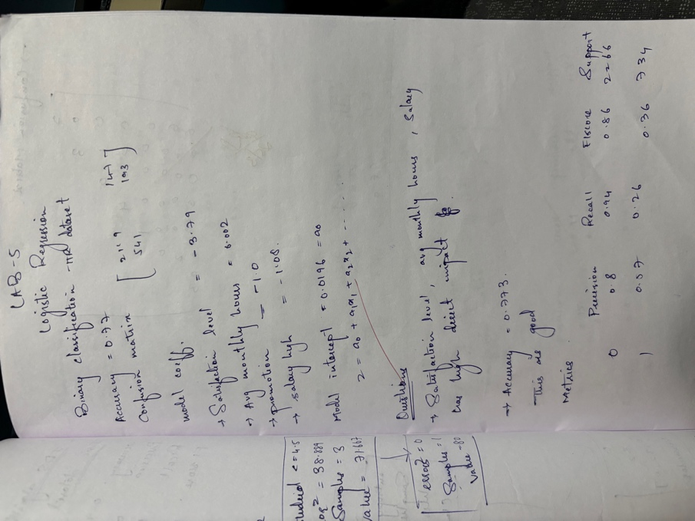
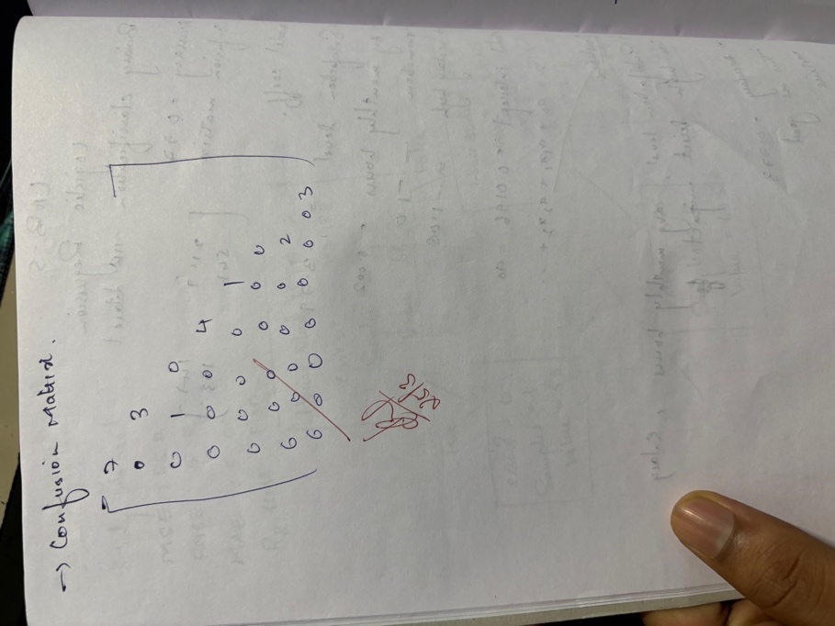

Code:

#!/usr/bin/env python
# coding: utf-8

# <a href="https://colab.research.google.com/github/BramhaBajannavar/ML_Lab/blob/main/LAB5_Random_forsest.ipynb" target="_parent"><img src="https://colab.research.google.com/assets/colab-badge.svg" alt="Open In Colab"/></a>

# In[1]:

import pandas as pd
import numpy as np

from sklearn.model_selection import train_test_split
from sklearn.ensemble import RandomForestClassifier
from sklearn.metrics import accuracy_score, classification_report, confusion_matrix

df = pd.read_csv("https://raw.githubusercontent.com/rolandmueller/titanic/main/titanic3.csv")

print("First 5 rows:")
print(df.head())

df = df[["pclass", "sex", "age", "fare", "survived"]]

df["sex"] = df["sex"].map({"male": 0, "female": 1})

df["age"] = df["age"].fillna(df["age"].mean())
df["fare"] = df["fare"].fillna(df["fare"].mean())

print("\nAfter preprocessing:")
print(df.head())

X = df.drop("survived", axis=1)
y = df["survived"]

X_train, X_test, y_train, y_test = train_test_split(
X, y, test_size=0.2, random_state=42
)

model = RandomForestClassifier(
n_estimators=100,
max_depth=None,
random_state=42
)

model.fit(X_train, y_train)

y_pred = model.predict(X_test)

print("\nAccuracy:", accuracy_score(y_test, y_pred))

print("\nClassification Report:")
print(classification_report(y_test, y_pred))

print("\nConfusion Matrix:")
print(confusion_matrix(y_test, y_pred))

feature_importance = pd.Series(
model.feature_importances_,
index=X.columns
)

print("\nFeature Importance:")
print(feature_importance.sort_values(ascending=False))

Program 5

Use an appropriate data set for building the decision tree (ID3) and apply this knowledge to classify a new sample.
Screenshot:

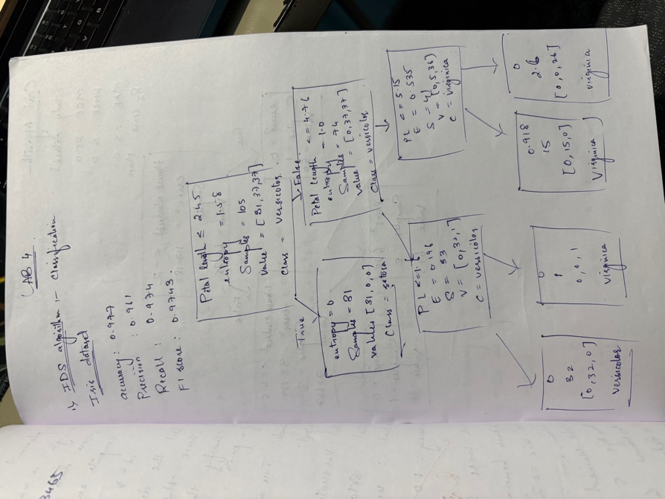
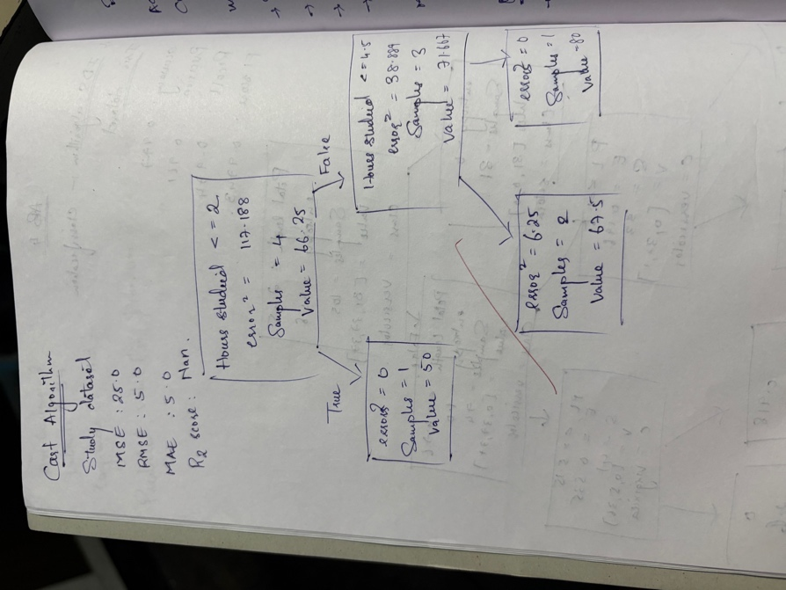

Code:

#!/usr/bin/env python
# coding: utf-8

# <a href="https://colab.research.google.com/github/BramhaBajannavar/ML_Lab/blob/main/LAB4_Random_forewst.ipynb" target="_parent"><img src="https://colab.research.google.com/assets/colab-badge.svg" alt="Open In Colab"/></a>

# In[1]:

import numpy as np
import matplotlib.pyplot as plt

from sklearn.datasets import load_iris, load_breast_cancer, load_diabetes
from sklearn.model_selection import train_test_split
from sklearn.tree import DecisionTreeClassifier, DecisionTreeRegressor, plot_tree

from sklearn.metrics import accuracy_score, precision_score, recall_score, f1_score
from sklearn.metrics import mean_squared_error, mean_absolute_error, r2_score

# ==============================
# 1. IRIS DATASET (Entropy - Classification)
# ==============================

iris = load_iris()
X = iris.data
y = iris.target

X_train, X_test, y_train, y_test = train_test_split(
X, y, test_size=0.3, random_state=42
)

clf = DecisionTreeClassifier(
criterion="entropy", # ID3 style
max_depth=3,
random_state=42
)

clf.fit(X_train, y_train)

pred = clf.predict(X_test)

print("\n===== IRIS DATASET METRICS =====")
print("Accuracy:", accuracy_score(y_test, pred))
print("Precision:", precision_score(y_test, pred, average='macro'))
print("Recall:", recall_score(y_test, pred, average='macro'))
print("F1 Score:", f1_score(y_test, pred, average='macro'))

# Tree Visualization
plt.figure(figsize=(12,7))
plot_tree(
clf,
feature_names=iris.feature_names,
class_names=iris.target_names,
filled=True
)
plt.title("Decision Tree (ID3 using Entropy) - Iris Dataset")
plt.show()

# ==============================
# 2. BREAST CANCER DATASET
# ==============================

cancer = load_breast_cancer()

X = cancer.data
y = cancer.target

X_train, X_test, y_train, y_test = train_test_split(
X, y, test_size=0.3, random_state=42
)

clf2 = DecisionTreeClassifier(
criterion="entropy",
max_depth=4,
random_state=42
)

clf2.fit(X_train, y_train)

pred = clf2.predict(X_test)

print("\n===== BREAST CANCER METRICS =====")
print("Accuracy:", accuracy_score(y_test, pred))
print("Precision:", precision_score(y_test, pred))
print("Recall:", recall_score(y_test, pred))
print("F1 Score:", f1_score(y_test, pred))

# Tree Visualization
plt.figure(figsize=(16,8))
plot_tree(
clf2,
feature_names=cancer.feature_names,
class_names=cancer.target_names,
filled=True
)
plt.title("Decision Tree (Entropy) - Breast Cancer Dataset")
plt.show()

# ==============================
# 3. DIABETES DATASET (CART Regression)
# ==============================

diabetes = load_diabetes()

X = diabetes.data
y = diabetes.target

X_train, X_test, y_train, y_test = train_test_split(
X, y, test_size=0.3, random_state=42
)

reg = DecisionTreeRegressor(
criterion="squared_error", # CART regression
max_depth=4,
random_state=42
)

reg.fit(X_train, y_train)

pred = reg.predict(X_test)

print("\n===== DIABETES REGRESSION METRICS =====")

mse = mean_squared_error(y_test, pred)
rmse = np.sqrt(mse)

print("MSE:", mse)
print("RMSE:", rmse)
print("MAE:", mean_absolute_error(y_test, pred))
print("R2 Score:", r2_score(y_test, pred))

# Regression Tree Visualization
plt.figure(figsize=(16,8))
plot_tree(
reg,
feature_names=diabetes.feature_names,
filled=True
)
plt.title("Regression Tree (CART) - Diabetes Dataset")
plt.show()

Program 6

Build KNN Classification model for a given dataset.

Screenshot:

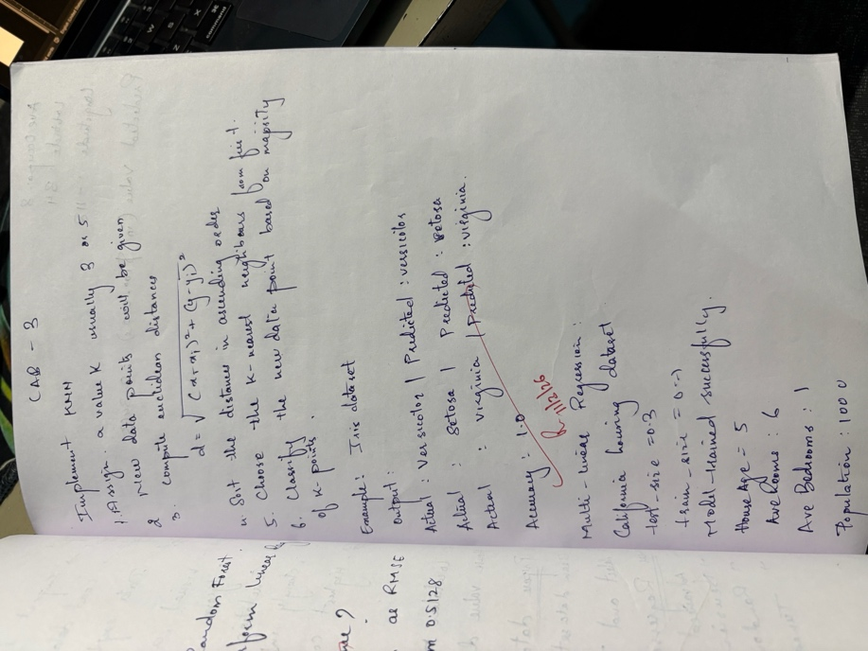
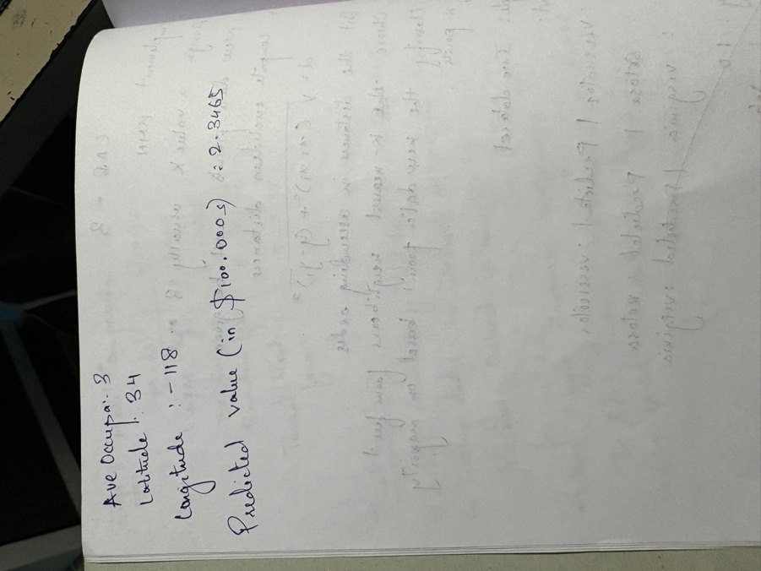

Code:

#!/usr/bin/env python
# coding: utf-8

# <a href="https://colab.research.google.com/github/BramhaBajannavar/ML_Lab/blob/main/LAB3_KNN.ipynb" target="_parent"><img src="https://colab.research.google.com/assets/colab-badge.svg" alt="Open In Colab"/></a>

# In[1]:

import numpy as np
from sklearn.datasets import load_iris
from sklearn.model_selection import train_test_split
from collections import Counter

# In[2]:

# 1️⃣ Load dataset
iris = load_iris()
X = iris.data
y = iris.target
target_names = iris.target_names

# 2️⃣ Train-test split
X_train, X_test, y_train, y_test = train_test_split(
X, y, test_size=0.2, random_state=42
)

# 3️⃣ Euclidean distance
def euclidean_distance(x1, x2):
return np.sqrt(np.sum((x1 - x2) ** 2))

# 4️⃣ KNN classifier
def knn_predict(X_train, y_train, new_point, k=5):
distances = []

for i in range(len(X_train)):
distance = euclidean_distance(new_point, X_train[i])
distances.append((distance, y_train[i]))

# Sort by distance
distances.sort(key=lambda x: x[0])

# Take k nearest neighbors
k_nearest = distances[:k]

# Get labels
k_labels = [label for _, label in k_nearest]

# Majority vote
return Counter(k_labels).most_common(1)[0][0]

# 5️⃣ Classify test set
predictions = []

for point in X_test:
predicted_label = knn_predict(X_train, y_train, point, k=3)
predictions.append(predicted_label)

predictions = np.array(predictions)

# 6️⃣ Show classification results
for i in range(5): # show first 5 results
print("Actual:", target_names[y_test[i]],
"| Predicted:", target_names[predictions[i]])

# 7️⃣ Compute accuracy
accuracy = np.sum(predictions == y_test) / len(y_test)
print("\nAccuracy:", accuracy)

Program 7

Build Support vector machine model for a given dataset

Screenshot:

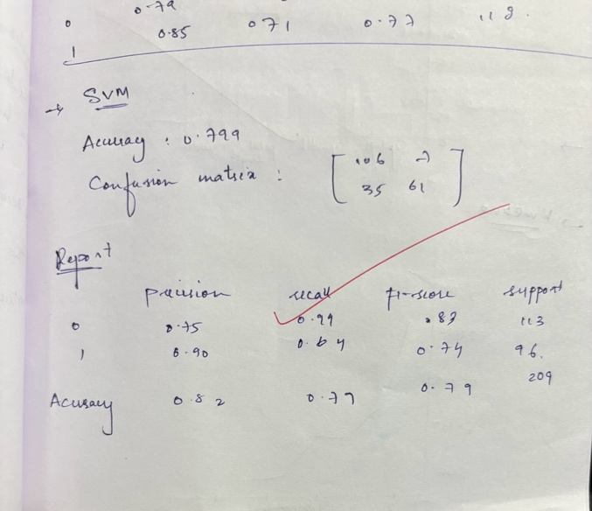

Code:

#!/usr/bin/env python
# coding: utf-8

# In[1]:

import pandas as pd
from sklearn.model_selection import train_test_split
from sklearn.preprocessing import StandardScaler
from sklearn.svm import SVC
from sklearn.metrics import confusion_matrix, classification_report

# In[2]:

url = "https://raw.githubusercontent.com/rolandmueller/titanic/main/titanic3.csv"
df = pd.read_csv(url)

# In[3]:

df = df[['pclass','sex','age','fare','survived']]

# In[4]:

df = df.dropna()

# In[5]:

df['sex'] = df['sex'].map({'male': 0, 'female': 1})

# In[6]:

X = df[['pclass','sex','age','fare']]
y = df['survived']

# In[7]:

X_train, X_test, y_train, y_test = train_test_split(X, y, test_size=0.2)

# In[8]:

scaler = StandardScaler()
X_train = scaler.fit_transform(X_train)
X_test = scaler.transform(X_test)

# In[9]:

model = SVC(kernel='rbf')
model.fit(X_train, y_train)

# In[10]:

y_pred = model.predict(X_test)

# In[11]:

print("Accuracy:", model.score(X_test, y_test))
print("\nConfusion Matrix:\n", confusion_matrix(y_test, y_pred))
print("\nClassification Report:\n", classification_report(y_test, y_pred))

# In[

Program 8

Implement Random forest ensemble method on a given dataset.

Screenshot:

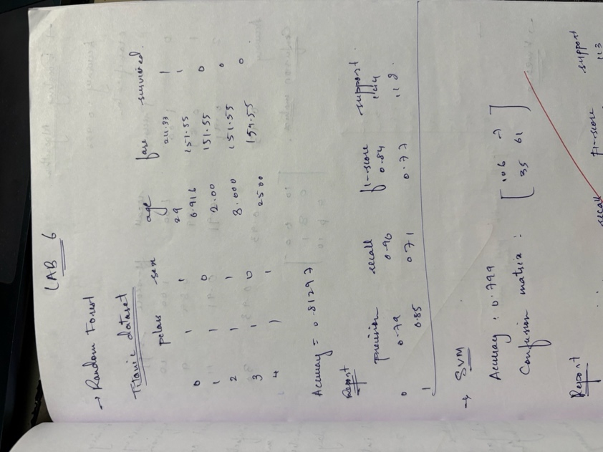

Code:

#!/usr/bin/env python
# coding: utf-8

# <a href="https://colab.research.google.com/github/BramhaBajannavar/ML_Lab/blob/main/LAB5_Random_forsest.ipynb" target="_parent"><img src="https://colab.research.google.com/assets/colab-badge.svg" alt="Open In Colab"/></a>

# In[1]:

import pandas as pd
import numpy as np

from sklearn.model_selection import train_test_split
from sklearn.ensemble import RandomForestClassifier
from sklearn.metrics import accuracy_score, classification_report, confusion_matrix

df = pd.read_csv("https://raw.githubusercontent.com/rolandmueller/titanic/main/titanic3.csv")

print("First 5 rows:")
print(df.head())

df = df[["pclass", "sex", "age", "fare", "survived"]]

df["sex"] = df["sex"].map({"male": 0, "female": 1})

df["age"] = df["age"].fillna(df["age"].mean())
df["fare"] = df["fare"].fillna(df["fare"].mean())

print("\nAfter preprocessing:")
print(df.head())

X = df.drop("survived", axis=1)
y = df["survived"]

X_train, X_test, y_train, y_test = train_test_split(
X, y, test_size=0.2, random_state=42
)

model = RandomForestClassifier(
n_estimators=100,
max_depth=None,
random_state=42
)

model.fit(X_train, y_train)

y_pred = model.predict(X_test)

print("\nAccuracy:", accuracy_score(y_test, y_pred))

print("\nClassification Report:")
print(classification_report(y_test, y_pred))

print("\nConfusion Matrix:")
print(confusion_matrix(y_test, y_pred))

feature_importance = pd.Series(
model.feature_importances_,
index=X.columns
)

print("\nFeature Importance:")
print(feature_importance.sort_values(ascending=False))

Program 9

Implement Boosting ensemble method on a given dataset.

Screenshot:

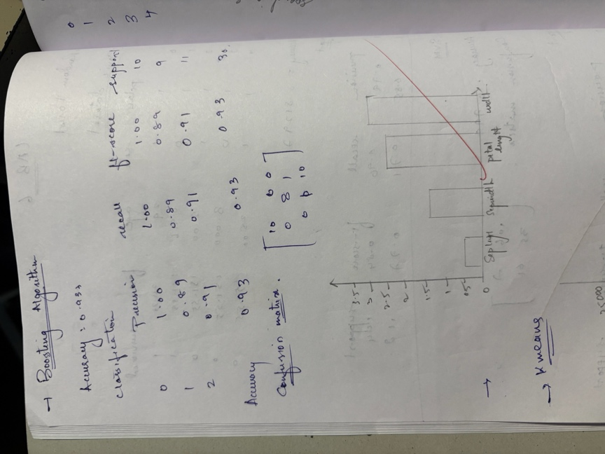

Code:

#!/usr/bin/env python
# coding: utf-8

# <a href="https://colab.research.google.com/github/BramhaBajannavar/ML_Lab/blob/main/Boosting.ipynb" target="_parent"><img src="https://colab.research.google.com/assets/colab-badge.svg" alt="Open In Colab"/></a>

# In[1]:

from sklearn.datasets import load_iris
from sklearn.model_selection import train_test_split
from sklearn.ensemble import AdaBoostClassifier
from sklearn.metrics import accuracy_score, confusion_matrix, classification_report
import matplotlib.pyplot as plt
import pandas as pd

# In[5]:

iris = load_iris()
X = iris.data
y = iris.target
feature_names = iris.feature_names

# In[6]:

X_train, X_test, y_train, y_test = train_test_split(
X, y, test_size=0.2, random_state=42
)

# In[7]:

model = AdaBoostClassifier(
n_estimators=50,
learning_rate=1.0,
random_state=42
)

# In[8]:

model.fit(X_train, y_train)

# In[9]:

y_pred = model.predict(X_test)

# In[10]:

acc = accuracy_score(y_test, y_pred)
print("Accuracy:", acc)
print("\nClassification Report:")
print(classification_report(y_test, y_pred))

# In[11]:

cm = confusion_matrix(y_test, y_pred)
print("\nConfusion Matrix:")
print(cm)

# In[12]:

importance = pd.Series(model.feature_importances_, index=feature_names)
print("\nFeature Importance:")
print(importance)

# In[13]:

importance.plot(kind='bar')
plt.title("AdaBoost Feature Importance")
plt.ylabel("Importance Score")
plt.show()

Program 10

Build k-Means algorithm to cluster a set of data stored in a .CSV file.

Screenshot:

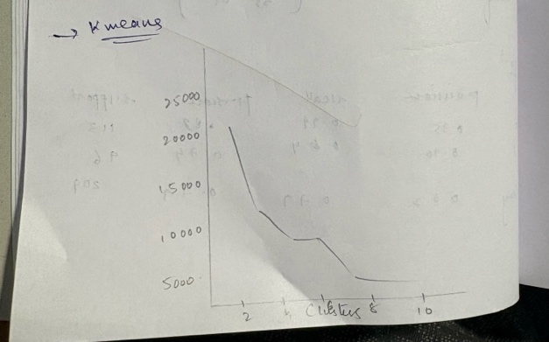
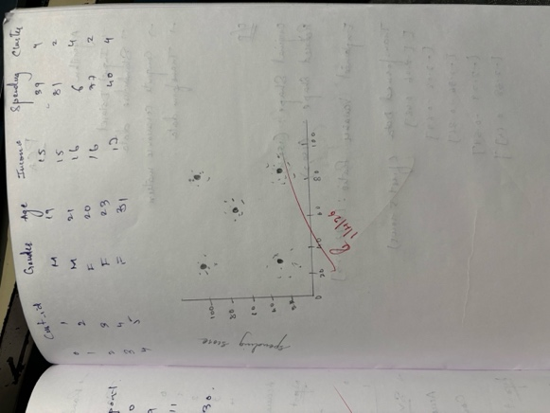

Code:

#!/usr/bin/env python
# coding: utf-8

# <a href="https://colab.research.google.com/github/BramhaBajannavar/ML_Lab/blob/main/LAB8_K_Means.ipynb" target="_parent"><img src="https://colab.research.google.com/assets/colab-badge.svg" alt="Open In Colab"/></a>

# In[ ]:

get_ipython().system('pip install kagglehub')

import kagglehub
import pandas as pd
import numpy as np
import matplotlib.pyplot as plt
from sklearn.cluster import KMeans

# In[ ]:

path = kagglehub.dataset_download("abdallahwagih/mall-customers-segmentation")

print("Path to dataset files:", path)

# In[ ]:

import os
print(os.listdir(path))

# In[ ]:

df = pd.read_csv(path + "/Mall_Customers.csv")
df.head()

# In[ ]:

df.info()
df.describe()

# In[ ]:

X = df[['Annual Income (k$)', 'Spending Score (1-100)']]

# In[ ]:

wcss = []

for i in range(1, 11):
kmeans = KMeans(n_clusters=i, random_state=42)
kmeans.fit(X)
wcss.append(kmeans.inertia_)

plt.plot(range(1,11), wcss)
plt.title('Elbow Method')
plt.xlabel('Number of clusters')
plt.ylabel('WCSS')
plt.show()

# In[ ]:

kmeans = KMeans(n_clusters=5, random_state=42)
y_kmeans = kmeans.fit_predict(X)

# In[ ]:

df['Cluster'] = y_kmeans
df.head()

# In[ ]:

plt.scatter(X.iloc[:,0], X.iloc[:,1], c=y_kmeans, cmap='rainbow')
plt.scatter(kmeans.cluster_centers_[:,0], kmeans.cluster_centers_[:,1], s=200, c='black')
plt.xlabel('Annual Income')
plt.ylabel('Spending Score')
plt.title('Customer Segments')
plt.show()

Program 10

Implement Dimensionality reduction using Principal Component Analysis (PCA) method.

Screenshot:

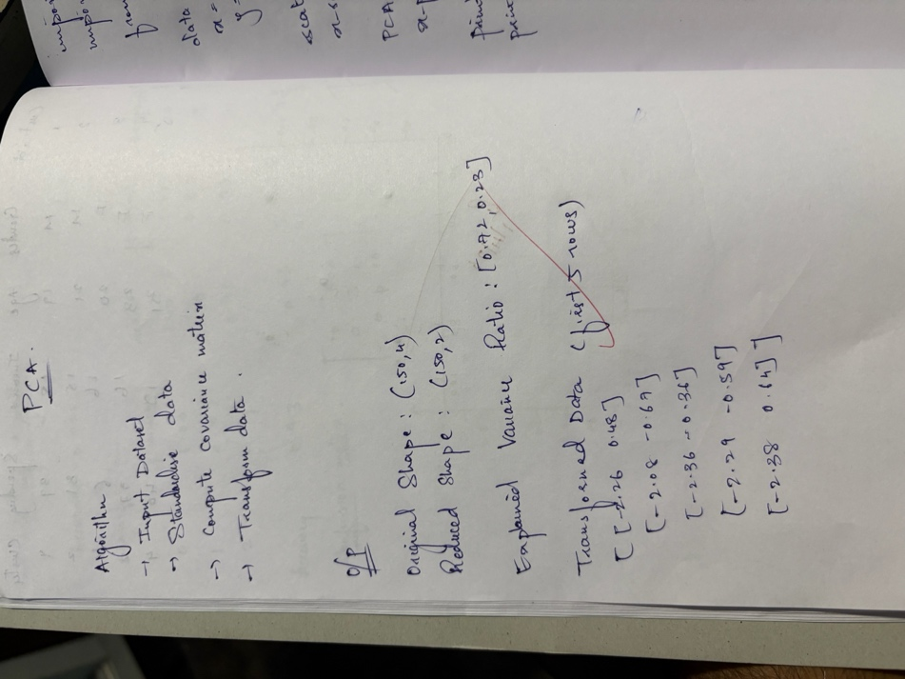
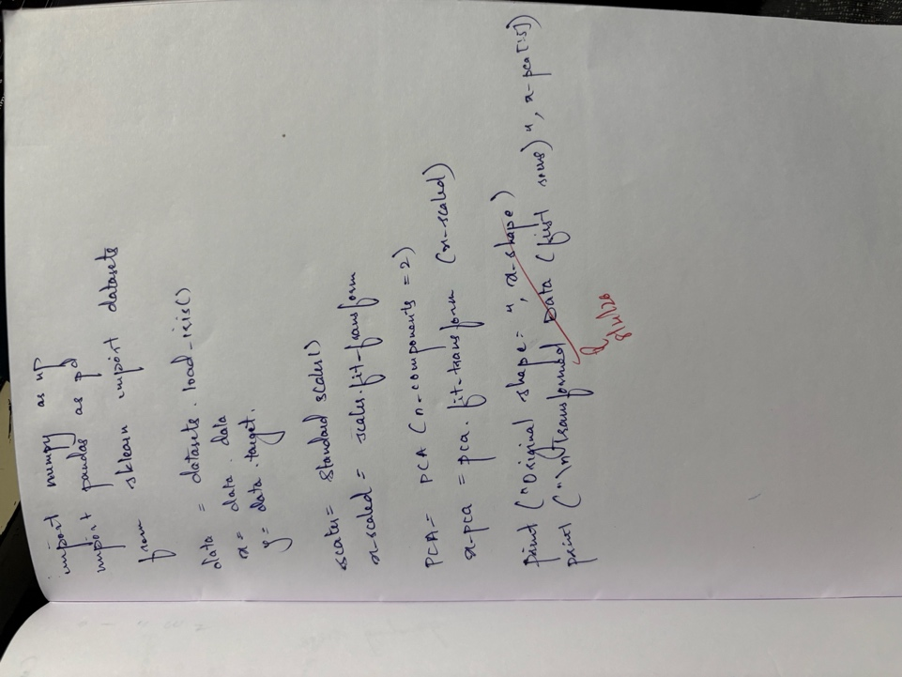
Code:

#!/usr/bin/env python
# coding: utf-8

# <a href="https://colab.research.google.com/github/BramhaBajannavar/ML_Lab/blob/main/LAB9.ipynb" target="_parent"><img src="https://colab.research.google.com/assets/colab-badge.svg" alt="Open In Colab"/></a>

# In[1]:

# -*- coding: utf-8 -*-
"""Untitled3.ipynb

Automatically generated by Colab.

Original file is located at
https://colab.research.google.com/drive/1jg0E7jtVdjoygyNr95WFP8ZksSV2RbHD
"""

# 🚢 Titanic Survival Prediction using SVM (All-in-One)

import pandas as pd
from sklearn.model_selection import train_test_split
from sklearn.preprocessing import StandardScaler
from sklearn.svm import SVC
from sklearn.metrics import confusion_matrix, classification_report

# STEP 1: Load dataset
url = "https://raw.githubusercontent.com/rolandmueller/titanic/main/titanic3.csv"
df = pd.read_csv(url)

# STEP 2: Select relevant columns
df = df[['pclass','sex','age','fare','survived']]

# STEP 3: Handle missing values
df = df.dropna()

# STEP 4: Convert categorical to numeric
df['sex'] = df['sex'].map({'male': 0, 'female': 1})

# STEP 5: Define features and target
X = df[['pclass','sex','age','fare']]
y = df['survived']

# STEP 6: Train-test split
X_train, X_test, y_train, y_test = train_test_split(X, y, test_size=0.2)

# STEP 7: Feature scaling (VERY IMPORTANT for SVM)
scaler = StandardScaler()
X_train = scaler.fit_transform(X_train)
X_test = scaler.transform(X_test)

# STEP 8: Train SVM model
model = SVC(kernel='rbf')
model.fit(X_train, y_train)

# STEP 9: Predictions
y_pred = model.predict(X_test)

# STEP 10: Evaluation
print("Accuracy:", model.score(X_test, y_test))
print("\nConfusion Matrix:\n", confusion_matrix(y_test, y_pred))
print("\nClassification Report:\n", classification_report(y_test, y_pred))

