**NXTFolio – Iteration 5**

# Team Members

* Balmaseda del Campo, Vicente – Scrum Master
* Fletcher, Lance
* Jain, Ayushri – Product Owner
* Li, Baichuan
* Li, Wenyuan
* Price, Niah

# Links

**GitHub:** <https://github.com/vibalcam/match-my-fashion-public-CodeCreators>

**Pivotal Tracker**: <https://www.pivotaltracker.com/n/projects/2630237>

**New Pivotal Tracker:** <https://www.pivotaltracker.com/n/projects/2635646>

**Heroku Deployment**: <http://nxt-folio.herokuapp.com/>

# Client Meeting

**Customer Meeting:** Zoom, Thursday, 6pm

# Completed User Stories & Tasks

## Country/state/city database rollback

Although the database was a success, the number of rows was higher than what the current tier of Heroku supports. After talking with the client, we decided to rollback to the previous way of working with countries/states/cities. However, we maintained the models, controllers, and javascript code for future use.

## Automatic cucumber and rspec testing on push

With the app getting bigger and ready for production, we believe that passing tests should be a top priority. To make it easier to run the tests and to check whether a pull request with new changes breaks previous functionality, we have created two GitHub actions which run cucumber tests and rspec tests respectively. The cucumber action uses a Docker instance with the webdriver, like the one used locally to run the tests. These actions are run every time a push is made to master or that a pull request is created. This is also useful for the reviewer of the pull request since it saves time by showing the test results without checking out the pull request and running them locally.

## Automate country/state/city update

In order to make it easier to update the country/state/city database, we created a rake task that clears the database and reseeds it with the updated json file. The json file is obtained from a GitHub repo that has this information accessible for free in json format and that it is updated every few months. The task is “rake db:reset_countries”.

## Improved search algorithm

Initially the search engine could only search for profile’s profession, name, and location, now the keyword in the search engine text filed can match profile’s highlights, specialization, prof details, compensation and bio. Also, the search engine now can block some keywords which is “stop words” like “able, like, he, she...”, and the empty search will render the current page without list all the profiles.

In addition, the searching result will be rated by the following rating logic, and then sorted from high to low based on profession, location, name...

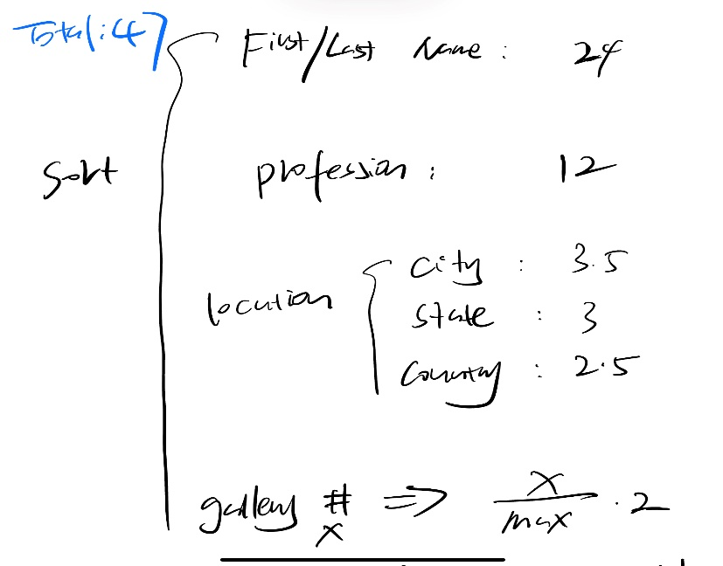

## Extra seeding

With the addition of more search related updates, the app needs more fake users and galleries to check how these features are working. The client asked to create 200 fake users and to give each one a random job (previously only users of type “Model” were generated). Given that 200 fake users cannot be created manually, we opted for automating the creation of fake users and galleries. Now we can easily create an arbitrary number of fake users and galleries that cover multiple jobs.

## Mobile UI

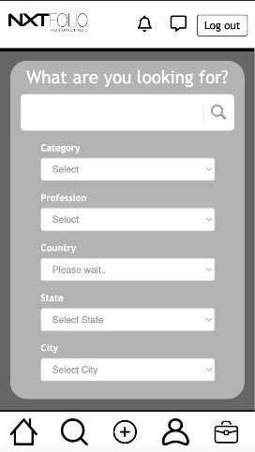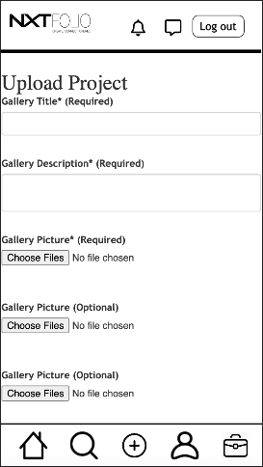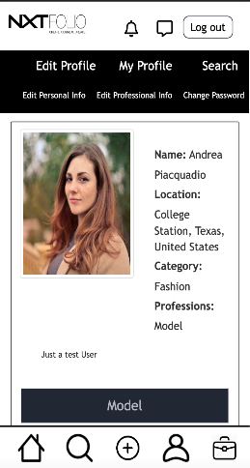

(iPhone SE Dimensions)

Mobile navigation bar has been updated with a create project and job button feature. The client asked for the layout to replicate the layout of other creative sites such as “Creatively”. While in mobile view, the profile button that was once in the header has been moved to the footer. Users can now quickly navigate from the home page, search page, create page, profile page and job page. The function of the job button must be added later due to the recent finish of the feature. Currently, the button does not have a route. If the button is up and running before the end of the semester, this document will be updated as it becomes available.

## CRM

As per the earlier discussions with client and CRMNXT team, changes were made to the application to track user activities along with test case and pull request. However, the pull request is not accepted due to the recent comments from Professor about correct implementation of CRM. This activity is on hold until the CRMNXT team informs us of the changes that we should make at our end.

## Minor Fixes

The client asked for basic fixes in UI – 1. remove unnecessary space before search results 2. decrease font size of "projects you might be interested in" 3. don’t show collaborated galleries if not there 4. personal website link should not be visible as text, it should be hyperlink only 5. Three subcategories should be visible on large screens on home page. There are no test cases for this work.

## Full GitHub/Heroku Migration

After the last iteration we successfully migrated the application within GitHub so that the owner’s GitHub account was the full owner of the project. While this was a step in the correct direction, we also needed to make sure Heroku was pulling from the new GitHub repo. We have also been in coordination with the other FashioNXT groups to make sure their repositories and Heroku deployments are setup properly.

## S3-Bucket Migration

The AWS S3 bucket service which stores user images for the application was initially setup using one of our personal accounts. In an effort to make the application as independent of us as possible the S3-Bucket has been switched over to an account owned by the project owner.

**Job Management System**

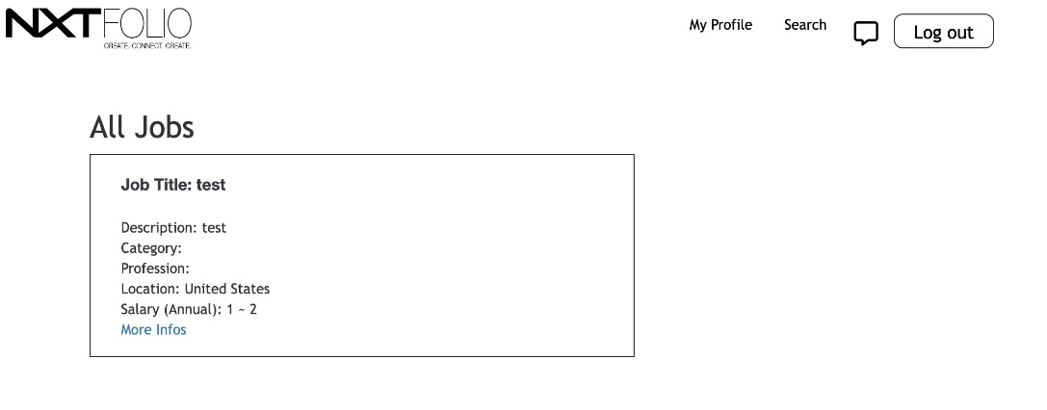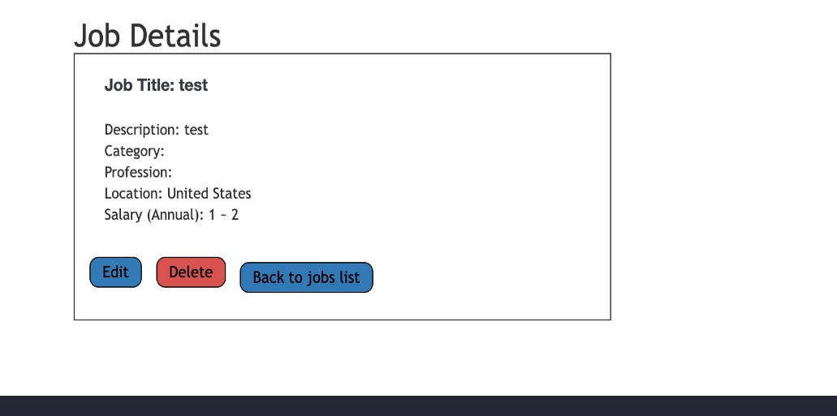

We finished the job management system. We can add a new job, show all jobs you created, edit a specific job, and delete the jobs.

**Job Search**

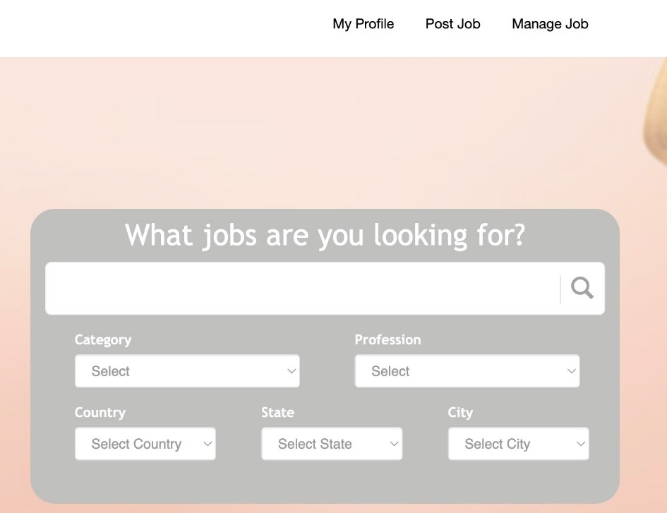

We finish the basics of the job search system. And we are working to improve the algorithms and also the UIs.

**Initial coverage report generated on 14th April 2023 -**

**Current coverage report generated on 29th April 2023 -**

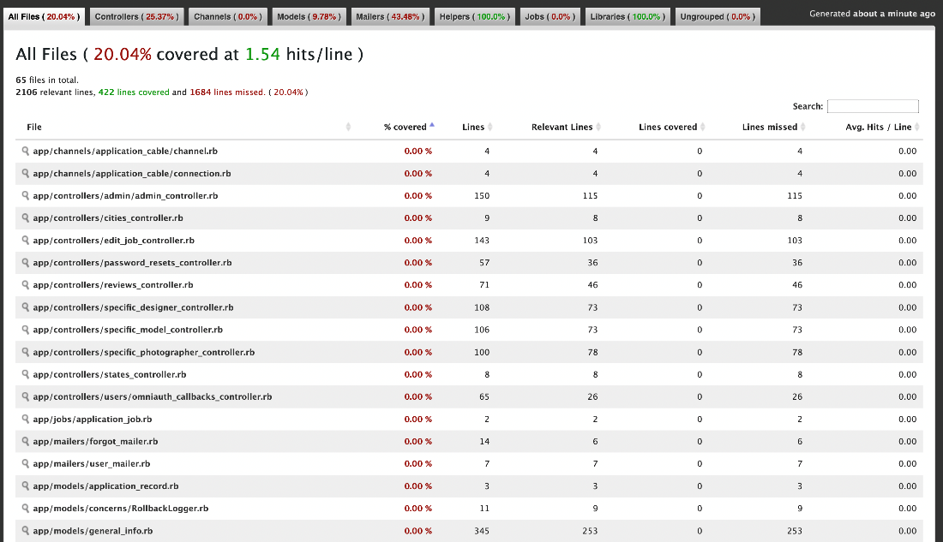

The coverage has decreased. Test cases which passed before are failing now because of the country, state, city situation.

# Tests

## Follow Feature Tested

The follow feature has now been tested by doing acceptance testing through cucumber. The tests evaluate the follow and unfollow abilities, and ensure the actions are reflected in the followers/following lists.

**Search engine improve (features/search_algorithm.feature)**

The users can see the search results in sorted order, based on locations, professions, and so on. Also, the keyword can match more information of a profile. If the keyword is a stop word, there will be no result. If the parameters and keyword is empty, the search engine will not work. (2 happy paths, 2 sad paths)

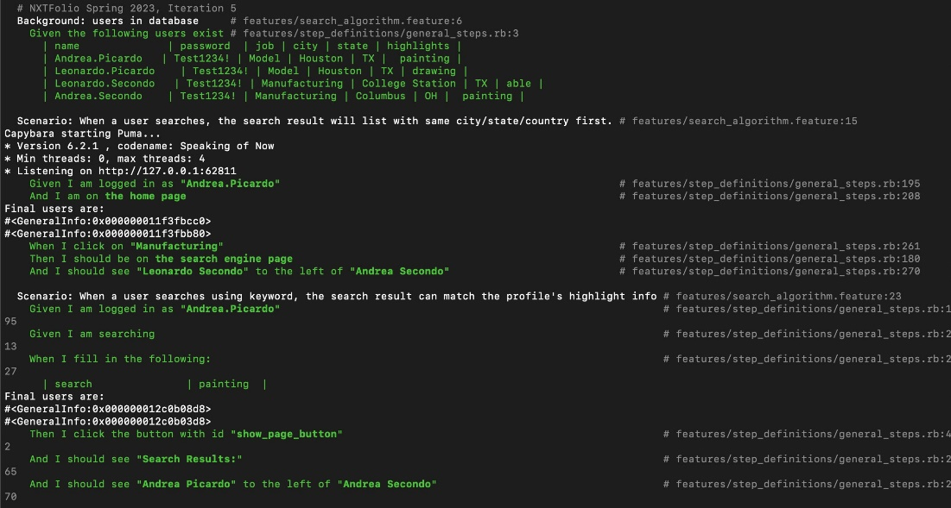

# 

# Design diagram for this iteration

We have updated the diagram with the new features added. It can be found in the tar together with this report. We added the job search system and job management system to the corresponding location on the design diagram. We have improved the search engine for profiles, now the search engine can match profile’s highlights, specialization, compensation and bio, and the results will be sorted based on current user’s info.