Noah Branch
COSC 366
Course Project
Friday December 6 2019

Password manager
Project goal
- The goal of the project is to build a Password manager that meet the following standards
  - Online / Web storage of passwords
  - Option to store passwords only locally
  - Easy to navigate User Interface
  - Able to run locally on machine
  - Passwords stored online and/or locally will be encrypted using AES-CBC mode
  - Be able to easily see passwords for different accounts and copy paste it

The goal of the project was taken more as a challenge on my behalf. It was a way to improve my knowledge of nodejs, html, and css. While the main goal was for school I also have different exterior goals for the project. I was a bit ambitious with my goals for this project and as a result did not implement everything that was intended such as the UI is miss leading. Some buttons and links do not do what you think they should do.

Tools Used
- The tools used are as follows
  - Programming languages
    - Node.js, HTML, CSS
  - Semantic-ui
    - This had pre-made buttons and stylized imput fields and div tags. That way I did not have to create my own styles.
  - Electron
  - FireBase
Majority of the project’s logic was written in Node.js without any external libraries installed. Node.js handles the Cryptography, button, and input logic. HTMl and CSS was more for the look and feel of the pages themselves. Semantic-ui, as stated above handled exactly how certain elements of the application looked. Using Semantic-ui I was able to layout what I wanted and where I wanted it. Electron essentially runs a HTML page natively on your computer. Which is why Node.js works better with it as oppose to vanilla JavaScript.

The Plan,Challenges, and What happened
The User Interface
I intended the password manager to be able to be used by anyone that needed one. It was supposed to be easy and simple to use. Allowing users to store passwords locally, online or both. I started out by deciding how I wanted the UI to look. Since I don not have much experience with web design or any type of front end experience I usually use something like a premade bootstrap template and take out, put in, rearrange as needed using their custom themes. This time I opted for using Semantic-ui which can be used similarly to bootstrap. This allowed me a bit more freedom. Semantic-ui does not have full premade templates they instead have menu layouts, premade customized buttons, views, input fields and more. The only thing I had to do was determine how and where I wanted to put them in my UI. This was honestly one of the hardest things to do. Getting things exactly where I wanted proved to be a real pain, especially since I had little experience with this type of thing. Most of my time was spent tweaking how the UI itself looked. Semantic-UI even had source code for certain animations for how certain things appeared on screen.

The Cryptography
Other than than Setting up how the UI looked, implementing the cryptography was the next difficult thing, mainly because I was still learning aspects of Node.js on top of this. For starters there are many different external libraries for using cryptography in Node.js along with key derivation functions. I ended up using the crypto library that comes standard with Node.js. It did everything every other library did. It allowed me int use AES-CBC mode. The program would send out a warning if you tried to use other certain modes. The library had key derivation functions so I could create a usable key from the users string password. There was no need to install anything else.

The Database
I used Googles Firebase Database to store information on the web. There API, for the most part is well documented and allowed me to create a user sign up, sign in, home page to display data from Firebase, as well as easy functions to use to sign users out. Firebase stores data in a JSON tree so the issue with Firebase is that downloading the data can be slow depending on how well nested the data is. I could have used SQL, but given that the accounts and the users were the only relationships I needed Firebase worked well. I was also only storing simple strings. The information stored was as follows:
1. User email (plaintext)
2. The Salt used to derive the key from the user password (plaintext)
3. The user ID (plaintext)
4. Then I had a tab called Account
A. Under the Account tab we had all the Accounts the user had subscribed to.
(The names used were test names)
a. Under each user account we have a tab titled encrypted data and IV
I. Encrypted data had the name of the account (again), the email used for that account, the password used for that account, and an optional username. As you can see all that data is encrypted.
II. Next is the IV used to encrypt that data

Below is how the data and user accounts are laid out in the database

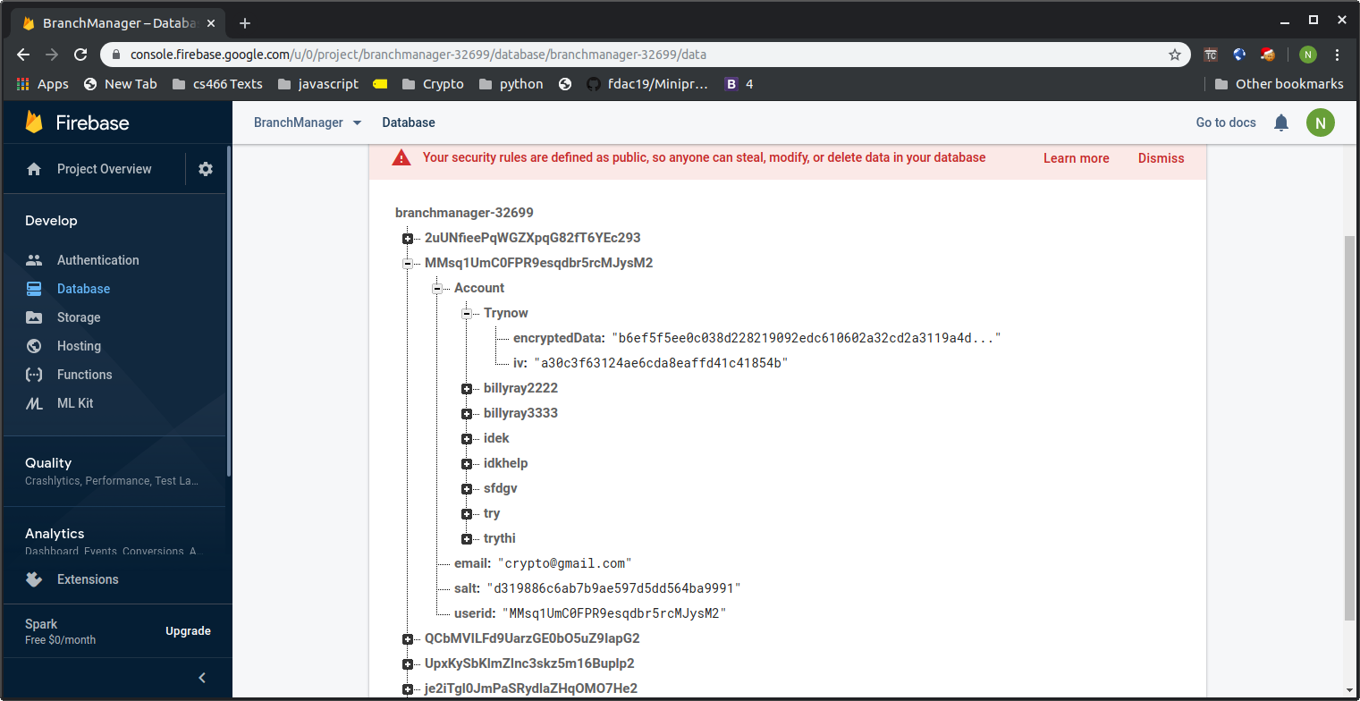

Under user ID MMsq1U….. we can see his email “Crypto@gmail.com” the salt used, the userid, and all the accounts he subscribed to.

Conclusions, what I learned , what I would like to improve on.
I started working on this the minute it was announced and although I didn’t completely finish the application it was a fun challenge and I am proud of the work I put in. I had the most fun working on this project out of any project in my college career . I was able to learn a bit more about Nodejs and work a bit more with Googles Firebase. This wasn’t my first time implementing cryptography as I had to actually rewrite cbc mode using AES blocks. However, this was the first time I got to completely use CBC mode in a library and I see why I should use library instead of implementing cryptography yourself.
If I had more time and what I do plan to do in the future is work on the UI, and adding a local database to store account information if users do not want to store information online. I would also like to add password sharing which would involve asymptotic cryptography.

