Source: <http://norden.diva-portal.org/smash/get/diva2:704251/FULLTEXT01.pdf>

**# Recommended intakes of macronutrients**

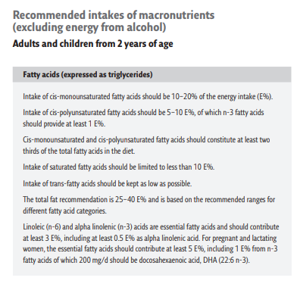

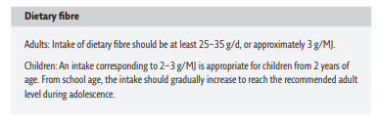

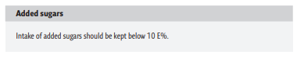

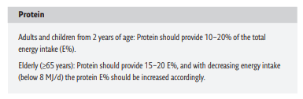

**# Recommended intake of vitamins and minerals**

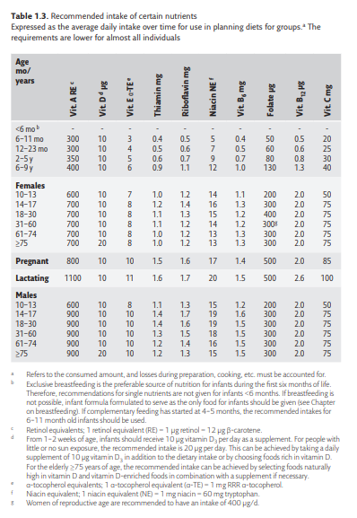

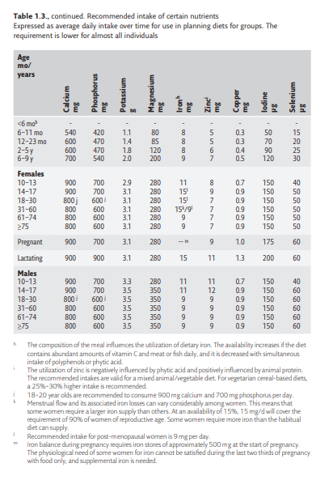

**# Recommendations for planning diets for heterogeneous groups**

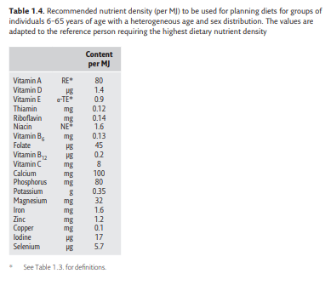

**# Reference values for energy intake**

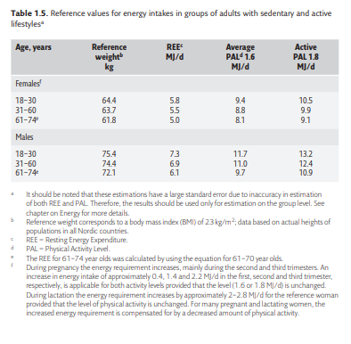

**# Reference values for assessing nutrient intakes**