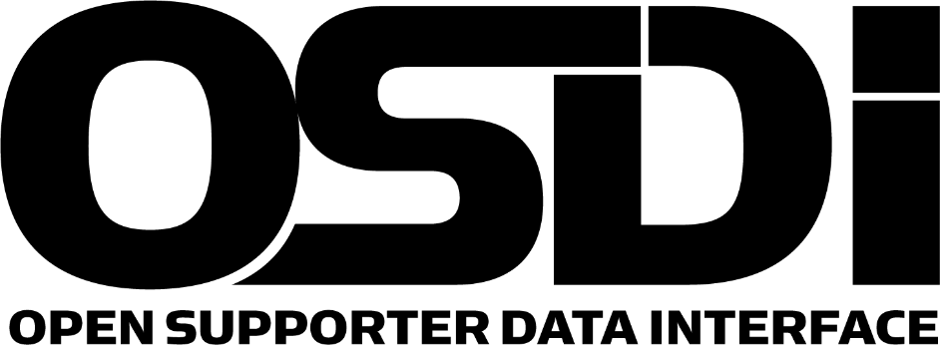

Find Out More

http://opensupporter.org

info@opensupporter.org

The Open Supporter Data Interface (OSDI) effort seeks to define an API and data structures for interoperability among products in the cause-based, campaign and non-profit marketplace. The existence of a common API will reduce customer costs related to moving data between different systems, lower integration costs and enhance the ability of innovators to create products for the marketplace.

## Problem

The API will define interfaces including but not limited to resources representing people, donations, questions, tags, and events. The group will determine the order in which to define resource models and which version of the API to include them in.

Today, customers often seek to use a variety of digital tools from different vendors to build their optimal solution. Systems such as CRMs, email blasters, donation management systems, social media tools, voter engagement tools, and volunteer management tools may come from different vendors. However, in order to keep the data consistent, customers often need to do frequent manual imports and exports of data via mechanisms such as CSV files. Sometimes options are unavailable or are so complex that the systems remain inconsistent and valuable data are lost.

Systems typically contain a common set of resources, including, but not limited to people (supporters), addresses, donations, events, or social actions. For example, each product typically represents a person differently. How addresses are handled varies from system to system and in some cases, even the field names are different.

There is no competitive advantage for vendors to model a person differently. The difference merely serves as a cost to customers in the form of added complexity, data loss during transfer, and extra staff & volunteer time.

## Benefits of a Common API

Customers, digital and tech directors, technology consultants

* Less manual and error-prone data import/export
* Staff and Volunteer data entry time savings
* Better ability to pick and choose technology products and use them together
* Multi-Vendor solutions mean less headaches

Technology Application Developers

* Write platform integration code once rather than per platform means less dev hours spent
* Data consistency across platforms reduces cost
* Can spend more resources on new customer features rather than integration code

Platform Vendors

* Ability to integrate means an easier sell to customers who already use another platform.
* Common API across vendors enables a larger app ecosystem for your platform