# My Term Project

author: My Name

I rename the file replacing "MyName" in the MyName_TermProject.Rmd file name to my name.

Note: Select the Packages tab (lower right) > Install > knitr, ggplot2, to install the needed packages.

Basic idea behind R markdown (Rmd): code + narrative = scientific report (computer language [R] + authoring language [MD])

### 1. Introduction

Here is where I type a description of my dataset.

### 2. Get the Data

Here is where I show the code used to get the data in R.

L = 'http://myweb.fsu.edu/jelsner/data/FLMonthlyT.txt'  
df = read.table(L, header = TRUE)  
head(df)

## Year Jan Feb Mar Apr May Jun Jul Aug Sep Oct Nov Dec Annual  
## 1 1895 58.8 51.3 64.5 67.9 75.1 79.4 80.8 80.9 79.0 71.2 64.6 56.3 69.2  
## 2 1896 55.5 57.8 62.5 70.4 76.8 79.7 81.2 81.8 79.2 71.7 69.6 57.1 70.3  
## 3 1897 54.3 62.7 69.4 69.7 73.9 82.0 81.9 81.5 77.0 72.3 66.2 60.4 70.9  
## 4 1898 60.1 57.5 67.4 67.8 76.1 80.8 81.4 80.6 79.9 71.7 65.3 56.6 70.4  
## 5 1899 59.1 58.3 65.7 67.4 78.0 80.2 80.7 82.0 78.2 73.1 65.6 58.7 70.6  
## 6 1900 55.7 58.2 62.5 69.5 75.4 79.3 81.5 82.2 80.2 75.7 64.6 59.0 70.3

### 3. Graph the Data

Here is where I show the code used to make a graph of the data. Make sure you label the axes appropriately.

library(ggplot2)  
ggplot(df, aes(x = Year, y = Annual)) +  
 geom_line() +   
 ylab("Temperature Anomaly (C)")

## Warning: Removed 1 rows containing missing values (geom_path).

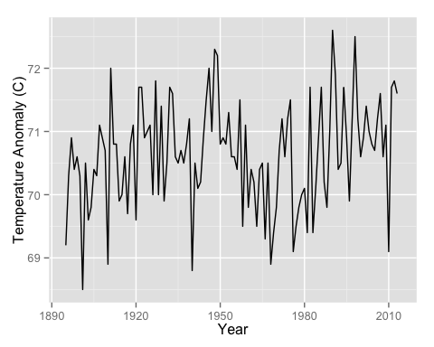

### 4. Draw a Trend Line

Here is where I show the code to add a trend line to the graph.

ggplot(df, aes(x = Year, y = Annual)) +  
 geom_line() + geom_smooth() +  
 ylab("Temperature Anomaly (C)")

## geom_smooth: method="auto" and size of largest group is <1000, so using loess. Use 'method = x' to change the smoothing method.

## Warning: Removed 1 rows containing missing values (stat_smooth).  
## Warning: Removed 1 rows containing missing values (geom_path).

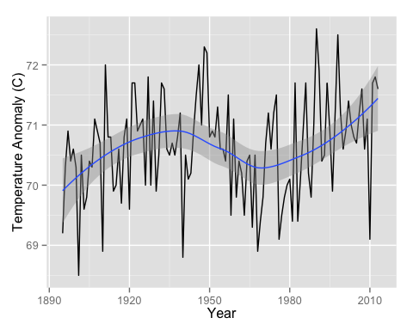

### 5. Describe the Graph

Here is where I write a few sentences describing the graph and trend line.