**Tropical Update | Wed 10/1/2025 12 PM ET**

**Hurricane Imelda**

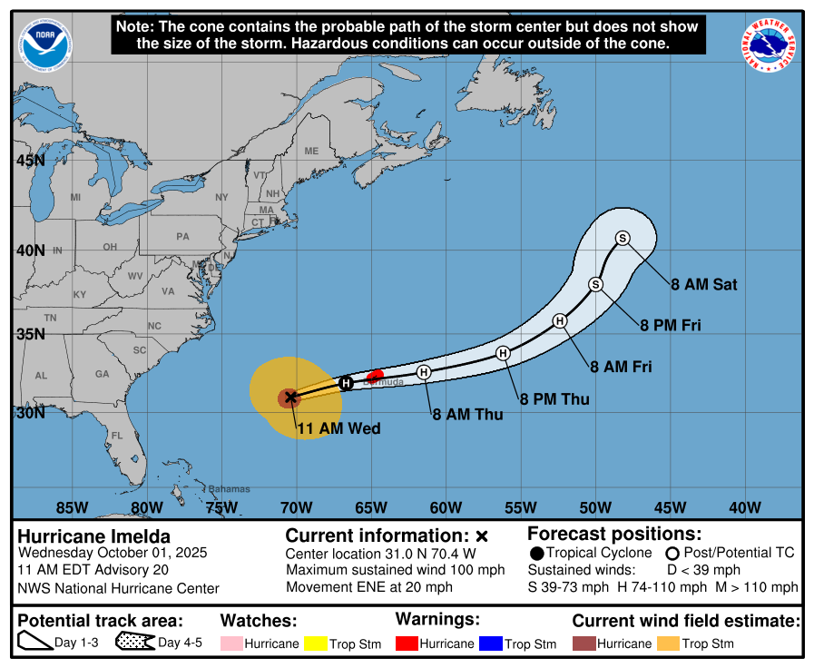

**Overview:**

At 11 AM EDT, the center of Hurricane Imelda was near 31.0 N, 70.4 W, moving east northeast near 21 mph. Maximum sustained winds are 100 mph and the minimum central pressure is 966 mb. Imelda will accelerate east northeast today, bringing the core near Bermuda this afternoon or evening, then away from the island on Thursday.

**Watches and Warnings:**

• Bermuda: Hurricane Warning.

**Forecast Discussion:**

Reconnaissance this morning indicates Imelda is strengthening. Crews found a closed, circular eyewall with central pressure near 966 mb and peak flight-level winds around 110 mph, supporting an advisory intensity of 100 mph. The hurricane is moving quickly east-northeast ahead of a deep-layer trough over the western Atlantic.

Through tonight, guidance agrees the core will pass near or over Bermuda, with conditions deteriorating this afternoon and evening. Beyond the Bermuda pass and once extratropical transition begins, track confidence decreases. Most global models capture the post-tropical low within the trough and carry it northeast across the North Atlantic, while the GFS remains an outlier that misses the capture and diverges well to the east by day five. The official forecast leans toward a consensus weighted more heavily to ECMWF and Google DeepMind solutions.

Despite increasing southwesterly shear, the improved inner-core structure and possible positive interaction with the trough could allow some additional strengthening before Bermuda. Extratropical transition is expected within about 24 hours, followed by gradual weakening as the wind field expands. Large swells and dangerous marine and rip current conditions will persist across much of the central and western Atlantic for several days.

Source: National Hurricane Center, Hurricane Imelda Discussion Number 20

**Impacts**

• Bermuda, today into Thursday: Hurricane conditions expected by this evening, with tropical storm conditions likely this afternoon. Rainfall 2 to 4 inches, a dangerous storm surge causing coastal flooding in onshore wind areas, and large, damaging waves. Expect power outages and tree damage.

• U.S. East Coast, next few days: Long period swells from Imelda will create dangerous surf and rip currents along much of the coast. Minor coastal flooding is possible at high tide in a few prone spots.

• Bahamas, today: Improving weather as the center moves away, but rough surf and rip currents will linger.

**Preparedness Tips**

• Bermuda: Finish preparations now. Secure loose items, shelter away from windows, and charge phones and backup power.

• U.S. beaches: Follow local flags and advisories. Stay off piers and jetties, and swim near lifeguards only.

**Next Update: 3 pm**

* Weather Man Bran