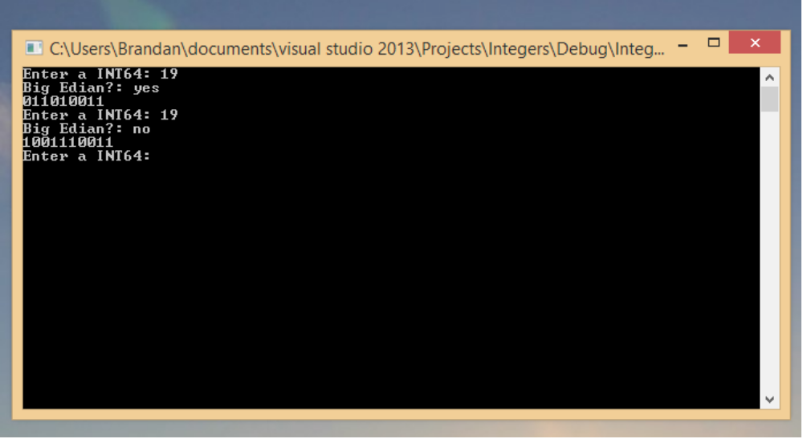
I couldn't really find a program or service online that I could use it to cross check this... but based on my assumptions it seems correct. The only interesting thing thats different is the format for answering the Big Edian question, its yes or no. Also I dont think I spelled Edian wrong throughout the program.

The program converts the number to binary, then I assume it converts to Big edian correctly then it converts that to Hexadecimal. I don't know what you mean by 'enter multiple numbers at once'.

The known issues and limitations are:
- may or may not return the right answer
- may or may not work with negatives

