**Python Assignment No:-1**

1. What are the differences between operators and values in the following?

*

'hello'

-87.8

-

/

+

6

**Ans:**-Operators are the special symbol in python that carry out arithmetic and logical computation . The Value that the operator operate on is called operands.

There so many operator category in python:

1. Arithmetic Operator(+,-,*,/,//,**)
2. Logical Operator (AND, OR, NOT)
3. Relational Operator(<,>,<=,>=,==,!=)
4. Assignment Operator(=)
5. Identity Operator(IS, ISNOT)
6. Membership Operator (IN,NOTIN)

**Type of value is depend upon the type of Identifier

2. What is the difference between string and variable?

spam

'spam'

**Ans**:- **String**:-It is the collection of characters enclosed with single code or double code in python like ‘spam’.

**Variable:-** It is the example of identifier whose value can be fixed or vary according to the requirement. As its name suggest its value can be change. There are two types of Variables:

1. Local Variable
2. Global Variable

3.. Describe three different data forms

Ans:-Data forms are nothing , it is only the data type of any value in python.

There are so many data types in Python:

Number:- Integer, Float, Complex, Boolean

Sequence:- String, Tuple, Set, List

Mapping:- Dictionary

**Python List:-** [List](https://www.programiz.com/python-programming/list) is an ordered sequence of items. It is one of the most used data type in Python and is very flexible. All the items in a list do not need to be of the same type.

Example:- a = [5,10,15,20,25,30,35,40]

print(a)

**Python Tuple:-** Tuple is an ordered sequence of items same as a list. The only difference is that tuples are immutable. Tuples once created cannot be modified.

**Example:-** t = (5,'program', 1+3j)

Print(t)

**Python Dictionary:-** Dictionary is an unordered collection of key-value pairs . It is generally used when we have a huge amount of data. Dictionaries are optimized for retrieving data. We must know the key to retrieve the value.

Example:- d = {1:'value','key':2}

type(d)

<class 'dict'>

4. What makes up an expression? What are the functions of all expressions?

Ans:- In Python, operators are special symbols that designate that some sort of computation should be performed. The values that an operator acts on are called operands. A sequence of operands and operators, like a + b - 5 , is called an expression. Python supports many operators for combining data objects into expressions.

An expression is a combination of values, variables, operators, and calls to functions. Expressions need to be evaluated. If you ask Python to print an expression, the interpreter evaluates the expression and displays the result.

A function is a block of code which only runs when it is called. You can pass data, known as parameters, into a function. A function can return data as a result.

5. In this chapter, assignment statements such as spam = 10 were added. What's the difference between a declaration and an expression?

Ans:-Declaration:- It is simply a python statement in which any type of value is assign in Variable/Identifier . Declaration or assignment statement is almost same.

Expression:- It is the simply a python statement . When we execute the statement on any translator it will the some result as a output.

6. After running the following code, what does the variable bacon contain?

bacon = 22

bacon + 1

Ans:-After executing above code, the result is:

23

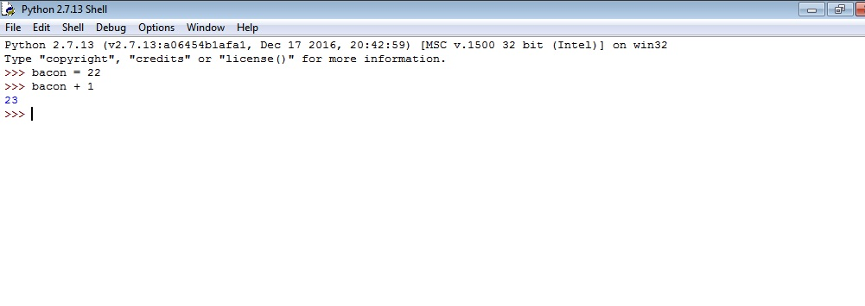

7. What should the values of the following two terms be?

'spam' + 'spamspam'

'spam' * 3

Ans:- The value of the following two term be:-

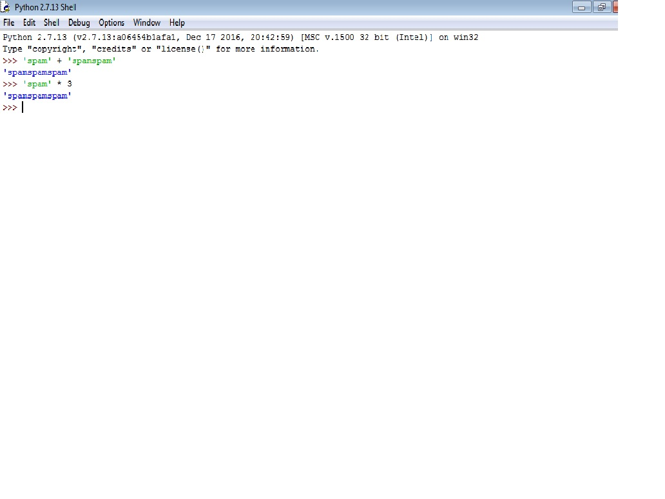

8. Why is it that eggs is a true variable name but 100 is not?

Ans:-Yes eggs is a true variable name but 100 is not because any variable in python should start from a character or string , not with a integer value.

Some example of creating variable:-

**The following are examples of valid variable names**: -age, gender, x25, age_of_hh_head.

**The following are examples of invalid variable names**: - age_ (ends with an underscore); 0st (starts with a digit);

9. Which of the following three functions may be used to convert a value to an integer, a floating-point number, or a string?

Ans:- **int() function:-**

It converts the specified value into an integer number. The int() function returns an integer object constructed from a number or string x, or return 0 if no arguments are given.

**Python float() Function:-**

The float() function converts the specified **value** into a floating point number.

**Str( ) Function:-**

In Python an integer can be converted into a string using the built-in str() function. The str() function takes in any python data type and converts it into a string. But use of the str() is not the only way to do so.

10. What is the error caused by this expression? What would you do about it?

'I have eaten ' + 99 + ' burritos.'

Ans:-It gives an error ,because “+” operator can only concatenate the same type of value i. e. “string”. But in above code 99 is integer number so its generate error.

