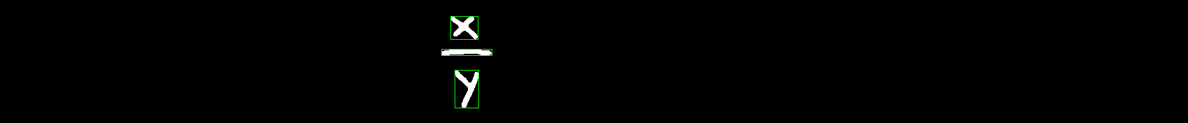

Some thoughts about arranging the locations to generate math expression tree

The segmentation code (with classifier) returns the following data:

1. x (it may also be recognized as a “times” * symbol)
2. dash (it does not know whether it should be a minus sign(-), or fraction line, or even part of a equal sign(=))
3. y

The above example shows that even a well-trained classifier(or human eyes) CANNOT recognize each single part of this equation solely. Another problem to solve is that we got 3 bounding rects, but how is their order? How to use all of these 3 rects to generate math expression tree?

A RNN approach

(****First get a description of RNN and LSTM)

What input and output we finally want using RNN (let’s first take a look at the ideal results of rnn on the above equation):

We start from the upper corner rect (which contains x)

x1,y1,x2,y2 is the bounding rect

let [bounding rect] be a vector: (x1, y1, x2, y2)

|  |  |
| --- | --- |
| X (input) | Y (output) |
| [bounding rect: 0] literal: x | [bounding rect: 1] operator: frac |
| [bounding rect: 1] operator: frac | [bounding rect: 2] literal: y |

Then we got a sequence x->frac->y

Writing a parser of the above sequence, we want get frac(x,y) (x, y are the children of frac)

The input (x) is a vector (x1, y1, x2, y2, label) indicating the bounding box of latest symbol detected, the output (y) is a vector (x1, y1, x2, y2, label) of the same dimension, which is the next expected bounding rect location and symbol name(label).

Traing of this RNN

From the training set we have the bounding rect of each elements of the equation and we can normally feed it into the LSTM RNN and train it by back propagation.

The Hybrid approach