My Journal Notes on the Project

Unknown Date:

void|driveLeft|tells robot to Drive Left robot.driveLeft()

void|driveRight|tells robot to Drive Right robot.driveRight()

had to reset project tested prompt method in prompt enum, going to display DONE prompt more cleanly and also, I have to break up [Grab your reader’s attention with a great quote from the document or use this space to emphasize a key point. To place this text box anywhere on the page, just drag it.]

internally parsed prompts better I am using recursion to handle the complex formatting🡪

is on the innermost level tokens of |, then tokens of newlines, then tokens of double newlines while this format is complicated, it is both computer and human readable

**Example of Method Formatting**

Working on a field by field prompter, handling initial conditions before loop does simplify code

Sunday: I am only allowing allowed characters, to hide which characters I am using for parsing and also exclude strange characters I haven't thought of

replacing all instances of scanner read next line with my validating looping method

it seems like using an enum for prompting is too complicated, I will just use methods

I am handling special cases manually, simplifies my methods and makes code more readable

using interface to save code enums can implement interfaces

I don't know how to do static methods with instance methods, converting static methods to instance methods. I'm tired of retyping my responses when testing prompts creating enums and interfaces similar to how I can test my ArduinoClassClient Scanner example, putting prompts and user responses into an enum for the ArduinoClassPrompter

Ok, with the print streams and enums, I can now just run a test instead of manually typing in test input for ArduinoClassPrompts and now debugging is so easy! I am now at the point where I can prompt field by field and try to generate the Arduino class, but I found methods are missing | character set breakpoints as you work with debugger, maybe directly from runtime exception found a parsing error in variables, explains why only header file had it, I’ve got an extra newline in variables I fixed that error which was missing |, but methods had extra newline, I removed it with substrings Now test runs correctly, but public methods aren't showing up To Do: not do substring by flipping with fencepost solution, fix public methods, unit test error corrections public methods was newline issue, now adding constructor line now that I added constructor, class basically has correct structure! I switched order of private and public methods in body file, which puts constructor at top and puts most visible methods at top too line by line unit test passed!

cutting down unused code, saving in text file  
​  
Created Arduino class maker GitHub repository so I can actually delete unused code and know it is backed up

May 23 I am working on the program that converts an existing Arduino sketch until a library, which required a lot of background code work. I modified the MiniScanner class to display an error with the word that was looked for, and the Arduino Class generators to allow method parameters of null if blank. The methodParser class handles the work of converting a method into the format the code generator uses, and I want the program to automatically generate an example sketch The sketch parser should also be able to tell which methods are public vs private by looking for which methods are in the setup and loop methods The parsedMethod class has fields even though I could have the whole thing be one big to string The SketchParser class currently can read a sketch into the code representing the header, variables, public and private methods, loop and setup, but they aren't formatted into the format the Arduino class generator needs

Now the SketchParser method can convert my sketch into a fairly well formatted list of header comment, variables and methods, next step is separating private and public methods and parsing variables. The variables parsing will become fairly interesting/complicated, because they should all go to a constructor. This means that the sketch to library program is forcing me to add some features like adding constructor and adding method parameters. The method correctly decided that wifiConnect and run server where public methods I am using replaceAll String method a lot, very useful in reformatting sketch I am writing ParseVariable method with test cases to convert code of variable declaration to parsable format. This is complicated because data types and values can be more than one word, and arrays are in form type name [], and variables don't have to be initialized

5/24 10:51 PM: Working on Arduino parser and unit tests, I got test to pass when variable is declared not initialized, still failing Linked List switch nodes (I wrote linked list to iterate over variables which can have multiple words like const char) and eliminating extra vertical bars. passed extra vertical bars test using String.replace instead of String replace all?

5/25 10:48: I want to integrate this project into the wider Arduino Environment by reformatting and compiling files before they are parsed. This would allow me to standardize text before I have to parse it, and return an error in advance if program doesn't compile. Also, I want to eventually make a pull request to have the automatic class generator be part of the Arduino ide. Relevant links: [1] Arduino Command Line Interface <https://github.com/arduino/Arduino/blob/master/build/shared/manpage.adoc> [2] Jar files already part of Arduino <https://github.com/arduino/Arduino/tree/master/arduino-core/lib> [3] How to create a jar file in eclipse <http://www.skylit.com/javamethods/faqs/createjar.html>

May 27, 2019 10:34 AM: I looked up who else is working on an Arduino Class Generator on the Arduino developers’ group, no one there is. I'm working on passing more of the VariableParser unit tests, so I wrote a MiniScanner get Rest

method to help. Also, else statements are useful in avoiding something right before exiting a loop. In that scheme, use Boolean loop control variable as condition. Set variable in loop, and use else statement to do whatever should be done while looping is chugging

but not when it is about to exit. This is a more subtle version of a break statement.

12:58 PM: Working on LinkedList switch method for variable parser, I wrote a state method that handles null pointer exceptions, and made setter methods private to force it use

1:13 PM: Arduino Auto format inserts spaces but doesn't remove them, I'll have to do that on my own, which should be using the MiniScanner class internally

3:07 PM May 28, 2019: I got the MiniScanner to allow it to ignore multiple tokens in input, but now a lot of other unit tests fail

6:58 PM: I spent a lot of time today trying to get rid of scanner errors, put the project on GitHub so I wouldn't have to redo my work again

11:00 PM I got all unit tests to pass, and having project on GitHub with commits on passing tests makes it so much easier to keep project moving forward with unit tests passing, and creating branches is useful. In the SketchParser class, I am working on an autogenerated constructor based on variables. Before that, I am preparing the program to handle the https://www.arduino.cc/en/Hacking/LibraryTutorial Morse code sketch as is so I can post it to the Arduino developers forum. The challenges so far with that have been to reformat the newline brackets style of coding into the same line and to create to do comments when comments are missing, which is what I'm doing now.

May 29, 2019 10:37 AM: last night, I got the SketchParser class to produce keyword, example file, body, and header for the ESPServer and Morse classes. The shaky parts are automatic constructor generation and how the sketch file doesn't call based on object. In addition, I posted my project idea on the GitHub developers forum, and I got a response from someone to share my GitHub link, although I haven/t decided whether to keep my code private yet.

7:18 PM: I got the generator to change method calls in example sketches to be an object method, like converting dash(); to morse.dash(). Also, I got the GUI to be useful, now the user can click on

RUNme.jar, and this window pops up🡪

The user can enter the name of the class and location of the correct Arduino sketch.

Then, when the button is pressed, the following windows pop up (next page).

Future work: Integrate this into the Arduino IDE: <https://github.com/arduino/Arduino/wiki/Building-Arduino>, research whether I should publish this program.

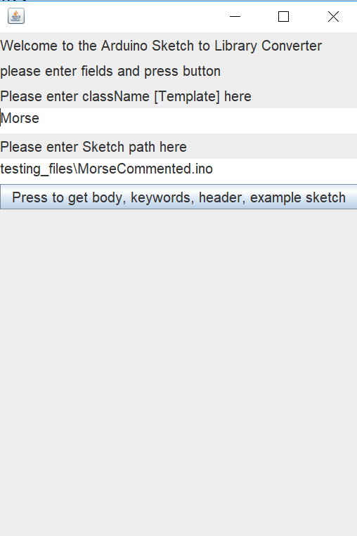

**User input interface, runMe.jar**

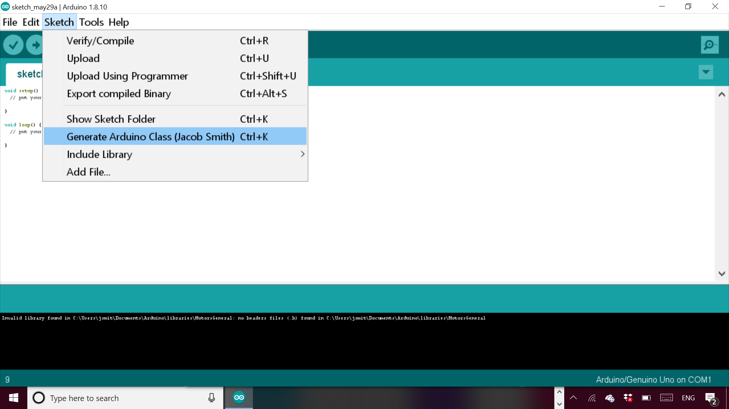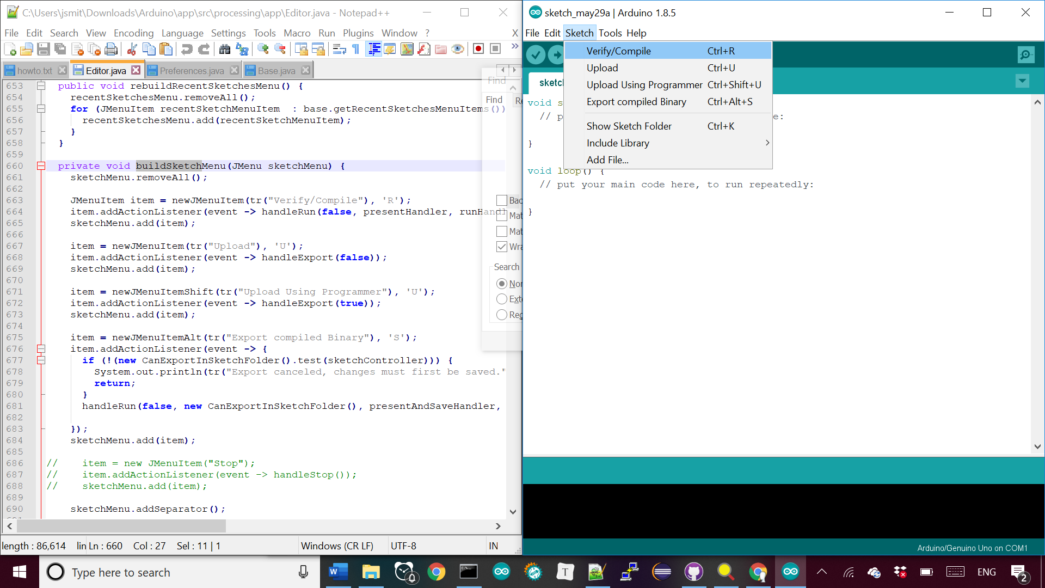

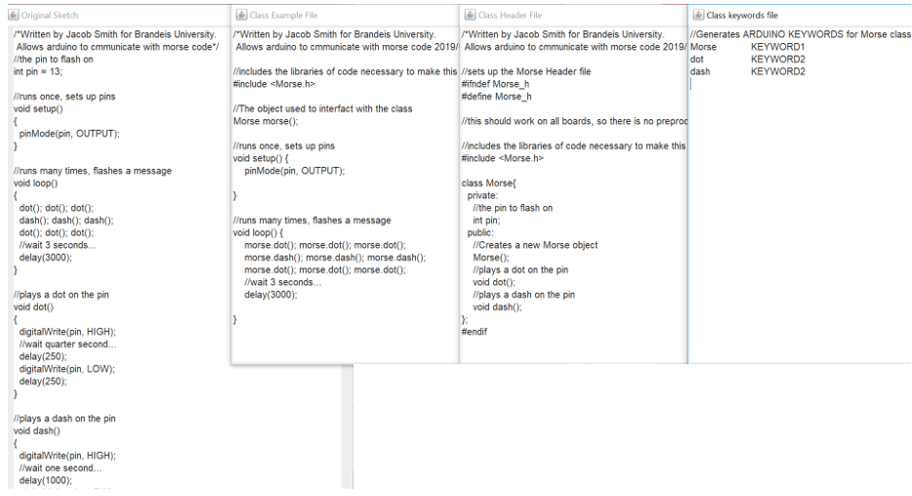

(TOP) Generated Example, Header, keywords, and original sketch. From runme.jar

(BOTTOM) Generated JDK error message because FJD must be 32 bit

<https://www.mkyong.com/ant/how-to-install-apache-ant-on-windows/>

<https://github.com/arduino/Arduino/issues/3276>

May 30 1:00 AM: I can now compile and run the Arduino application; everything is in the Editor class. I can now add a menu option called generate Library, and I’m trying to use the tab creation feature to generate all the correct files at once. Then, I need to add the relevant classes into the Arduino folders.

May 30 2:52 PM: Trying to automatically create files in Arduino ide, relevant functions: Addfile Sketch.java line 311, SketchFile.java line 94, EditorTab.java createTextArea line 146, EditorTab.

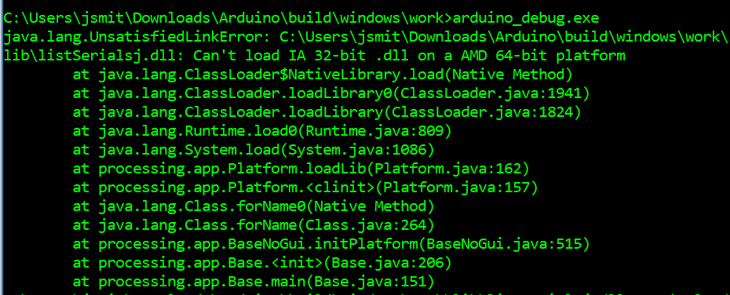

(Middle)🡪 The menu option to generate Arduino Class.

(Bottom)🡪 The area of the Editor class in the Arduino IDE that I will be modifying for the GUI.

Line 93,

Arduino Tabs are just a way of breaking up a sketch <https://forum.arduino.cc/index.php?topic=206078.0>, Nice tutorial for library creation <http://arduino.land/FAQ/content/7/43/en/breaking-a-sketch-into-multiple-files.html>

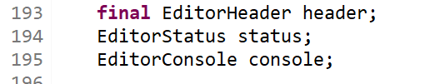

Editor.java line 193 status field which is sued to display messages

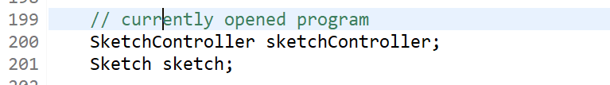

**Editor.java line 199 Public**

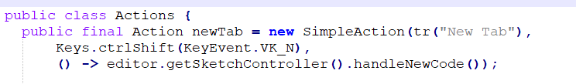

**Editor Header.Java Line 88**

<https://github.com/sudar/Arduino-Makefile> More control of Arduino Compiler

SketchControler.java 136, nameCode

Sketch Controller Line 598 import Library

Sketch Controller upload line 598, some boards have a password!

Using sketchContoller code avoids java exceptions and lets you create new tab.

11:00 PM: I am writing a script to compile the Arduino ide, so I don’t have to repeat a manual task by going to a certain directory and deleting the dll file. The dll file gets a wired error access is denied, when the real error is that the file is already running

12:50 AM: I can now generate tabs for the .cpp,.h, keywords.txt, and example file.ino files. I am now getting the string of the file name and file contents to pass to my Arduino class generator.

2:41 AM: I can now set the text of the files and save automatically, now I will abstract the code into a method that takes the four strings of the body, text, keywrods, and example files, the only unknown inputs

Build method sketch controller.java.

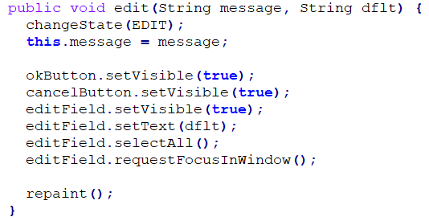

EditorStatus.java line 147, the method used to get the file name, which I want to set automatically

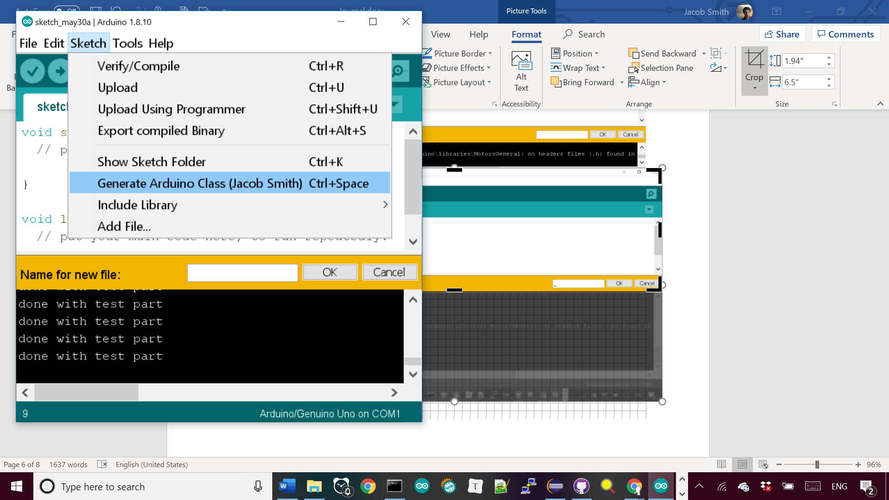

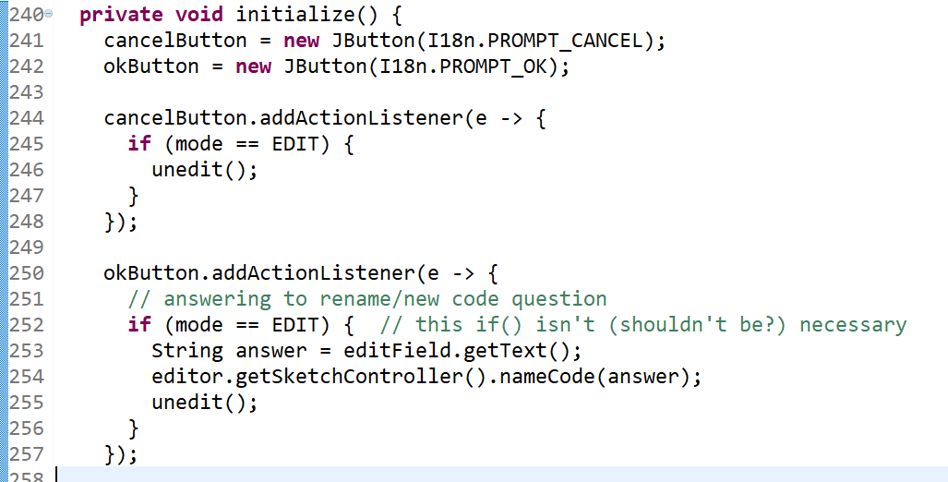

**Initialize Method of Editor Status.java line 240, shows how ok button is wired to create a new tab**

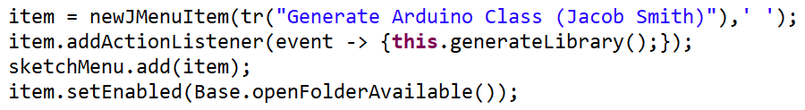

**↑Arduino IDE showing the new menu option, file name dialogue, and console printout**

**Editor Java Line 697, showing how keyboard shortcut finally works 🡪**

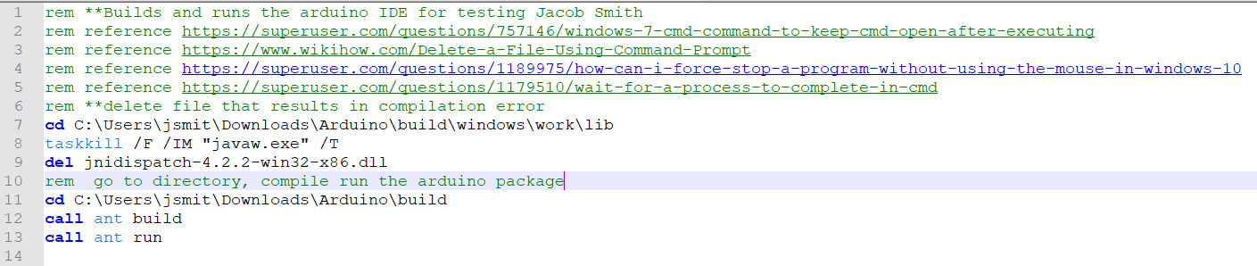

**↑RunArduino.bat file to compile and run the Arduino package automatically.**



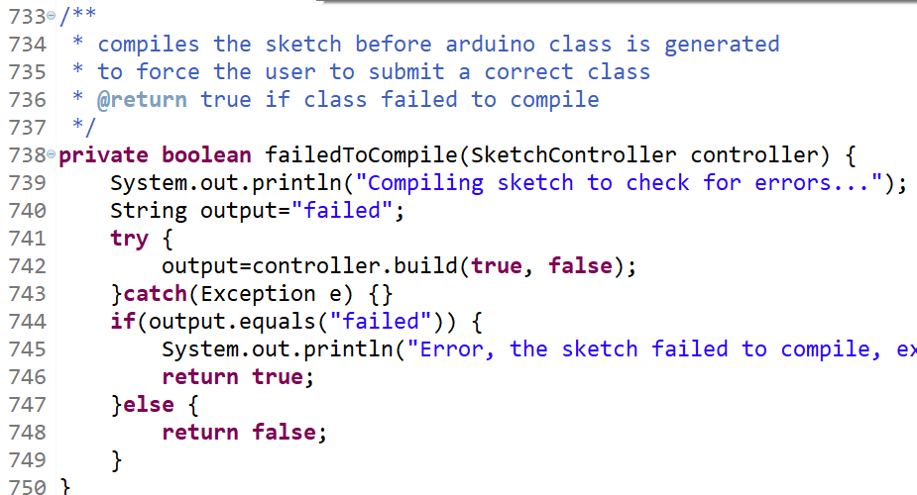

(TOP) My FailedToCompile method in Editor.java to stop generation of library if sketch doesn’t compile.(BOTTOM) usage of method in generate library client code to stop method if compilation fails with screenshots of ide in both use cases.

4:46 AM: I wrote this method🡪 to stop library generation if sketch doesn’t compile, it is based on the build method of SketchController class which returns null if the build failed.

Currently, the messages aren’t displayed after the couple seconds it takes to compile the program, probably because I’m not calling a repaint method.

I am working on abstracting the inputs and outputs of the sketch generator interface in the same manner as this method, notice how it is one method that can be used easily and doesn’t rely on global variables.

I’m trying to do this for setting the texts of the tabs, which was complicated because they are automically alphabetized, but I’m creating them in alphabetical order now.

I’m making methods static before I put them in their own class



