Predictive Analysis of Weather Data via Diffusion Maps, Spectral Clustering, and SOMETHING

Branden Keck, Johns Hopkins University

**Abstract**—Weather analysis

**Index Terms**—Stochastic Differential Equations, Diffusion Maps, Spectral Clustering, Weather, Data

—————————— ◆ ——————————

# 1 Introduction

Weath

## 1.1 Diffusion Maps

Diffusion maps are a dimensionality reduction technique which is beneficial in data analysis due to its applicability to nonlinear data. Additionally, diffusion maps are commonly used to discover underlying properties of a data set that would not necessarily be revealed by other dimensionality reduction techniques [1]. **More here?**

The first step in implementing a diffusion map is to develop a kernel. The kernel acts as a measure of similarity between two data points and is often denoted as follows [2]:

The measure of “similarity” between two data points can be defined in a variety of ways. A common similarity measure is Euclidean distance in instances where data points can be described in terms of their coordinates in a Euclidean space R^n. However, sometimes overall similarity should account for other data attributes such as color of pixels in an image [3].

## 1.2 K-Means Clustering

asdf

## 1.3 Predictive Analysis

asdf

# 2 Methods

## 2.1 Development of Python Model

A Python script was developed to p

The kernel developed for this model is the same as that developed by Farbman et. al. [3]:

*)*

# 3 Results

# 4 Results

Although a conclusion may review the main points of the paper, do not replicate the abstract as the conclusion. A conclusion might elaborate on the importance of the work or suggest applications and extensions. Authors are strongly encouraged not to reference multiple figures or tables in the conclusion—these should be referenced in the body of the paper.

**Acknowledgment**

The authors wish to thank A, B, C. This work was supported in part by a grant from XYZ.

**References**

1. J. de la Porte, et. al. “An Introduction to Diffusion Maps.”
2. Ronald R. Coifman and Stephane Lafon. “Diffusion Maps.”
3. Zeev Farbman, et. al. “Diffusion Maps for Edge-Aware Image Editing.”
4. Shai Gepshtein and Yosi Keller. “Image Completion by Diffusion Maps and Spectral Relaxation”

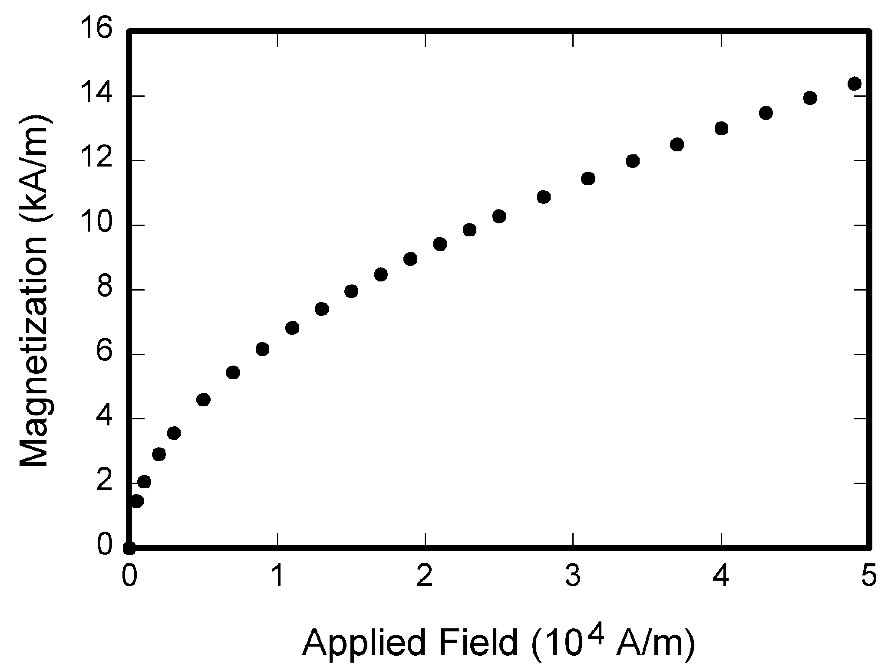

Fig. 1. Magnetization as a function of applied field. Note that “Fig.” is abbreviated. There is a period after the figure number, followed by one space. It is good practice to briefly explain the significance of the figure in the caption.