Multi Year Stock Analysis

We were asked to analyze the data of stock performance over 3 years. This information can be used to make an informed decision on which stock(s) would be the best bet to invest in or stay away from.

To analyze this data, I looped through the worksheets and extracted the yearly change, percent change and total stock volume for each ticker symbol. I used if statements to obtain these results and also to color the positive (green) and negative (red) yearly changes.

Once this information was displayed, I then used more if statements to extract the highest percent yearly change, the lowest percent change, and the stock with the greatest total volume.

The results were as follows:

2014:

* Greatest percent increase: DM 5581.16%
* Greatest percent decrease: CBO -95.73%
* Greatest total stock volume: BAC 21595474700

2015:

* Greatest percent increase: ARR 491.30%
* Greatest percent decrease: KMI.W -98.59%
* Greatest total stock volume: BAC 21277761900

2016:

* Greatest percent increase: SD 11675.00%
* Greatest percent decrease: DYN.W -91.49%
* Greatest total stock volume: BAC 27428529600

The data shows that BAC has had the highest volume for 3 years in a row. This shows stability of the stock. DM, APR, and SD had the greatest percent increase over the 3 years which shows growth in the right direction. CBO, KMI.W, and DYN.W had the highest decrease over the 3 years which shows a decrease in growth and sub-performance.

2014

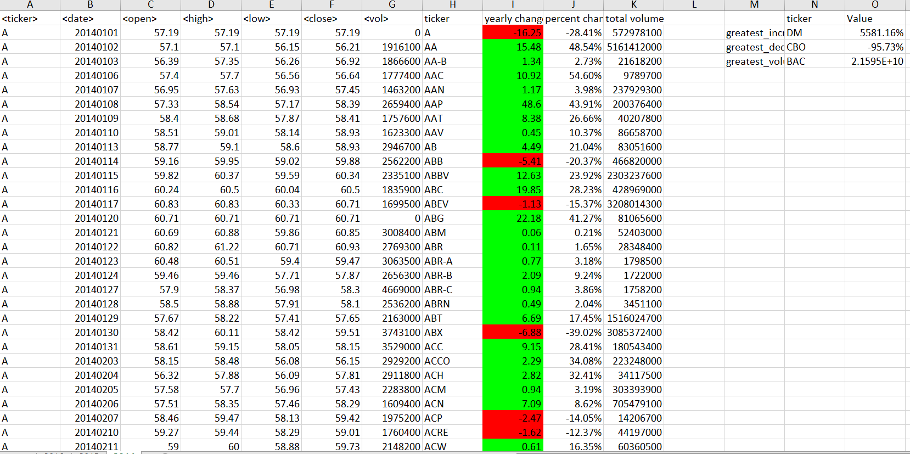

2015

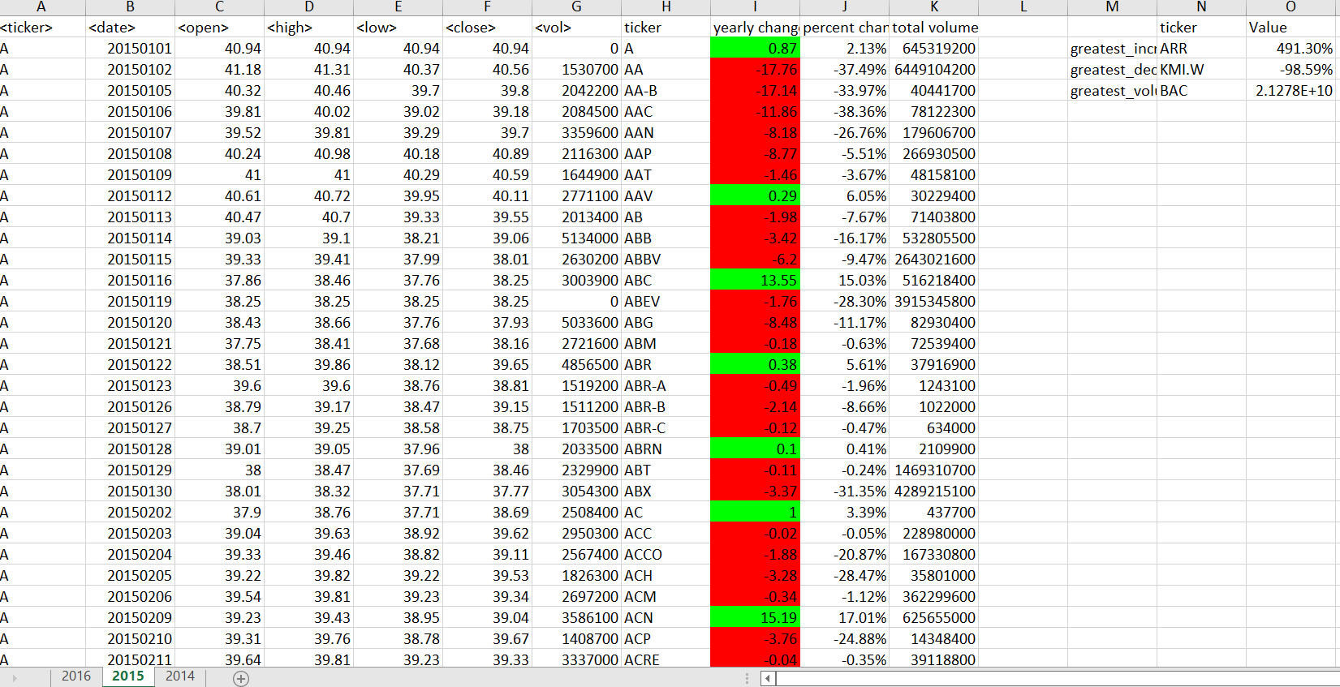

2016

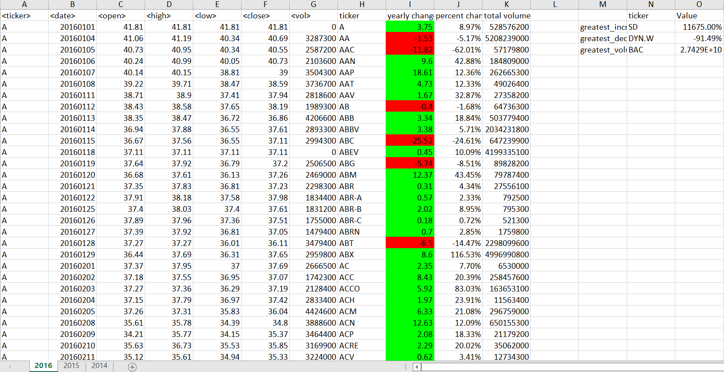

Upon further review of the data, I also found that SD had the greatest percentage increase over the 3 years with an increase of 11657.00%. I also looked at the 2nd highest volume and percent increase and total volume.

The results were as follows:

2014:

2nd greatest percent increase: STWD

2nd greatest total volume – CHK

2015:

2nd greatest percent increase: CHK

2nd greatest total volume: GE

2016:

2nd greatest percent increase: KFG

2nd greatest total volume: GE

Based on this information, the data shows that CHK and GE were repeat offenders with greatest total volume and greatest percentage increase. This shows that these stocks’ performance is strong and has consistently been strong in their numbers.

After my analysis, I would recommend any of the high performing stocks I mentioned. Especially BAC and SD, with DM, CHK, and GE closely following.