CARIBBEAN CHARTER CATAMARAN
Recommended Strategic Model & Solution
Absentee Ownership • Bareboat-Only • Y1 Solvency Engineered
Target Asset: 2019 Leopard 40 (Araume IV) — BVI Inventory
Prepared for: Partner Review & Go / No-Go Decision
Prepared: April 22, 2026
CONFIDENTIAL — For internal partnership review only.

Index
Navigate the document by section. Headings are listed with their purpose so reviewers can skip to the parts they care most about.
§ | Section | What It Contains
1 | Executive Summary | One-page synthesis. What we recommend, why, and what it costs.
2 | Strategic Framing | Three scale pathways (solo / fleet / platform) and why we start at solo.
3 | Recommended Capital Stack | How the $330K project gets funded. SBA + F&F + owner + working capital buffer.
4 | Recommended Operating Model | Absentee bareboat structure. Management company selection. Day-to-day ownership model.
5 | Recommended Revenue Stack | Layered revenue streams beyond weekly bareboat. Uplift path from $91K to $152K.
6 | Recommended Risk Engineering | Hurricane, insurance, partnership, operational. How we convert catastrophic into known costs.
7 | Financial Model | Monthly occupancy ranges, cash flow waterfall, running treasury curve. Charts + tables.
8 | Scenario Analysis | Base / Low / High / Survival-Optimized comparison. Hurricane-hit stress test.
9 | 36-Month Execution Roadmap | Phase-by-phase timeline from LOI through fleet-scale decision.
10 | Negotiation Playbook | Nine value levers beyond sticker price. How to structure the offer letter.
11 | Ugly Truths | The risks and weaknesses in this plan that require conscious acceptance.
12 | Decision Framework | The four questions that determine go / no-go. Red flags that should kill it.
A | Appendix A: Glossary | Plain-language definitions of every term used in this document.
B | Appendix B: Full Monthly Treasury Table | Detailed month-by-month cash flow and running balance for reference.
C | Appendix C: Data Sources & Methodology | Where the numbers came from and how we built the model.

1. Executive Summary
The opportunity is real. The Moorings E-List and other post-program catamaran inventories have softened in pricing for the first time in a decade. Historically-high barriers to entry (capital, insurance access, dockage, brand) now have a window. The challenge is that a single boat is not a large business — it is a validation vehicle. Treated as such, it can become the seed of something bigger.
This plan makes the single-boat deal survive Y1 under conservative assumptions while preserving the option to scale to a small fleet (Years 2-3) or acquire an existing independent operator (Years 3-5).

The Recommended Model — Nine-Line Summary
Target asset | 2019 Leopard 40 'Araume IV' — BVI — listed $309K, negotiate to $285K
Total project cost | $330K ($285K purchase + $20K prep + $25K working capital reserve)
Cash at close (owner equity) | $105K (raised from personal + HELOC / SBLOC / margin)
Financing | $180K SBA 7(a) + $45K F&F subordinated note
Close date | November 1, 2026 (NOT August — deliberately skips dead-season burn)
Loan structure | Interest-only first 12 months, then P&I amortization
Operations | Hybrid management via Conch Charters / Nanny Cay tier (25-30% cut)
Revenue stack | Bareboat + day-captain add-on + long-term off-season + damage waiver
Y1 outcome (base case) | Never negative treasury · Ends Y1 with +$73K reserve

The Single Decision
Before reading further, agree on this: is the goal to own a lifestyle asset that pays its own bills and gives you four weeks of BVI sailing a year (outcome: $15-30K/yr distribution), or is the goal to build a fleet (outcome: $75-200K/yr distribution by Y4 plus platform optionality)? Both are valid. The capital stack, risk tolerance, and three-year roadmap differ materially between the two. This document assumes the second answer — we are building a validation vehicle, not buying a toy — but the same plan works for either exit.

2. Strategic Framing — Why This Model, Not Other Models
You correctly identified that the stranded-fleet market represents a rare opportunity in a historically closed industry. Four business models exist at different scales. We are starting at Level 1 with explicit roadmaps to Level 2 and Level 3.
Lvl | Business Type | Capital In | Annual Distribution | What It Actually Is
1 | Solo Boat | $100-150K cash | $15-30K | Lifestyle asset. Proves operating model. Pays its own bills.
2 | Small Fleet (2-3) | $250-400K cash | $60-90K | Part-time income stream. Geographic diversification. Shared ops overhead.
3 | Regional Operator (5-8) | $700K-1.2M | $200-400K | Real business. On-island manager. Own brand.
4 | Platform / Roll-Up | $3-5M | $1-2M+ | Actual 'huge business.' Software + services + fleet. 5-10 year play.

Why Not Jump Directly to Level 2 or 3?
- Unproven operational model. You have no direct charter ops experience. One boat validates the absentee + bareboat stack before you bet $500K on it.
- Unproven partnership dynamics. 50% of small business partnerships fail in their first 3 years. One-boat scale lets you discover working differences before the losses are existential.
- Better boat inventory coming. The 2020-2021 E-List cohort will hit the market in 2027-2028 at similar discounts. Patience pays.
- Capital efficiency. SBA loans stack better after you have 18-24 months of operational track record. The second loan will be cheaper than the first.

Why Not Stay at Level 1 Forever?
- Unit economics. Single-boat management overhead is disproportionate. Insurance, compliance, marketing, and dock fees all have fixed components that spread poorly over one income stream.
- Hurricane concentration. One boat in BVI is 100% exposure to one weather system. Two boats across two jurisdictions (BVI + Grenada) is meaningful diversification.
- Exit options narrow. A single 7-year-old catamaran sells for 60-70% of purchase price at exit. A small operator with booking history, customer list, and infrastructure sells at a multiple of EBITDA.

3. Recommended Capital Stack
The capital stack is the single most important decision in the plan — more important than the boat itself. Mispriced capital kills otherwise-viable charter operations; the stories of 'we lost the boat in the hurricane' are usually 'we couldn't service the debt after the hurricane knocked us offline for 5 months.' This stack is designed to survive 12 months of zero revenue and still service its obligations.
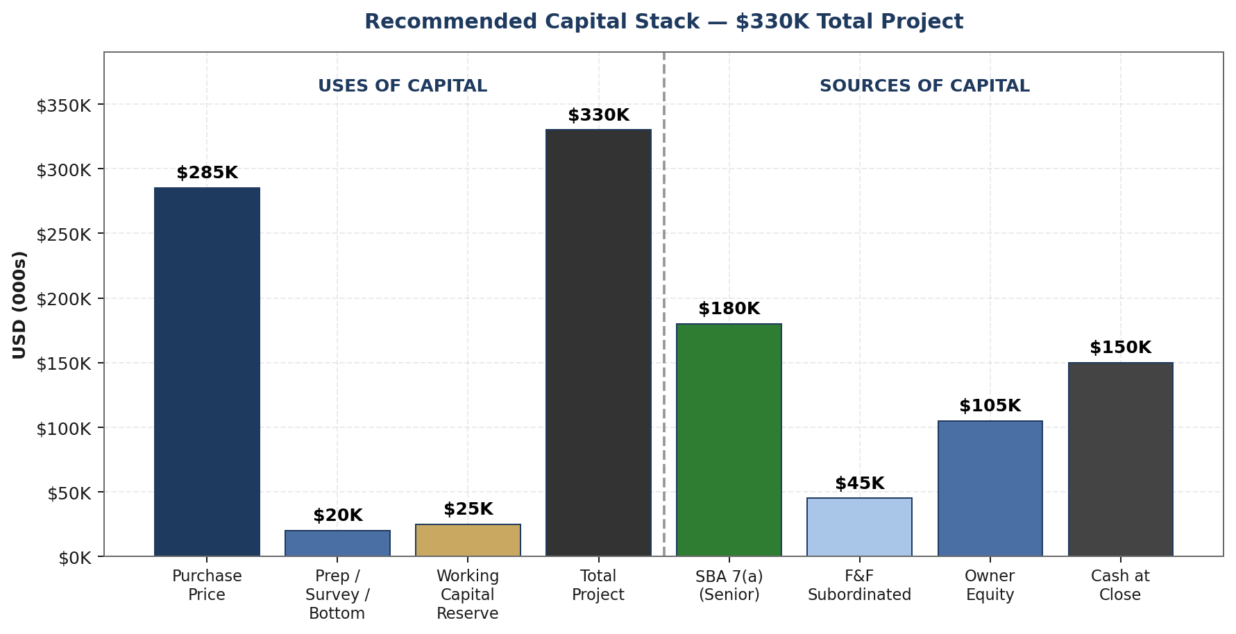
Figure 1 — The $330K total project funded through layered debt, subordinated notes, and owner equity. Working capital ($25K) is treated as a project cost, not an afterthought.

3.1 The Four Components

Component 1: SBA 7(a) Loan — $180K @ 8.5% / 15-year term
- Primary senior financing. Amortized over 15 years; interest-only for the first 12 months (critical for Y1 survival).
- Requires both partners as personal guarantors. Both partners must have credit scores of 680+ and clean 3-year tax returns.
- Can include up to 20% working capital tranche — we are using this explicitly to fund the $25K buffer.
- Closing timeline: 75-90 days. Must start the application process before LOI is signed.
- Approved SBA lenders for marine: Newtek, Live Oak Bank, Harbor One. Avoid local banks — they do not understand charter economics.

Component 2: Friends & Family Subordinated Note — $45K @ 6% / 5-year term
- Subordinated to SBA (second lien). Bullet-style payments with a balloon at year 5, or amortized at $870/month.
- Not 'equity' — it is debt. Must be structured as a formal promissory note with Operating Agreement alignment.
- Should come from accredited investors if securities compliance applies in your state. Consult counsel.
- Rate compromise: 6% is above safe-savings return for the lender, below hard-money rate. Fair to both sides.

Component 3: Owner Equity — $105K
- Split between partners per operating agreement (50/50 or per capital contribution ratio). Determine BEFORE you sign anything.
- Can be sourced from: cash savings, HELOC draw (8-9%), SBLOC / margin (6-8%), crypto-collateralized loan (8-10%), sale of other assets.
- Sourcing impacts tax and risk posture. Cash is cleanest; leveraged equity amplifies downside if the business fails.
- Each partner personally guarantees their share of the sources they pledge. HELOCs put homes at risk.

Component 4: Working Capital Reserve — $25K
- NOT optional. This is the survival buffer. Funded at close, held in a separate business bank account.
- Can be drawn from SBA working capital tranche (preferred — reduces cash-in-at-close).
- Covers: first 3 months operating expenses, first unexpected repair, first guest damage event, first haul-out overage.
- Rule: never let working capital drop below $15K. If it does, stop taking new bookings until the reserve is rebuilt.

3.2 Cash-In-At-Close Math
Line Item | Amount | Notes
Owner equity required | $105,000 | Real cash needed at closing table
F&F note (if pre-closed) | $45,000 | Reduces owner cash requirement
Effective personal cash-out (per partner, 50/50 split) | $52,500 | Plus closing costs (~$3K) and first month's dues
Translation: each partner needs to come up with about $55-60K in actual cash by closing day, not counting ongoing personal guarantees on the SBA loan.

4. Recommended Operating Model
Since neither partner is relocating to the BVI, every operational function must be delegated or automated. The operating model we recommend is a hybrid: contract with a mid-sized BVI charter management company for physical operations while retaining direct pricing and booking control.

4.1 The Management Company Decision
Tier | Example Operators | Mgmt Cut | Owner Keeps Control Of | Best For
Full Outsource | Dream Yacht Worldwide, Horizon, Navigare | 35-40% | Almost nothing — checks arrive monthly | Passive owners, zero involvement
Hybrid (RECOMMENDED) | Conch, Nanny Cay, VIP Yacht, TMM | 25-30% | Pricing, calendar, premium weeks, brand | Absentee owners who want margin
Owner Direct | Boatsetter + local dock manager | 8-15% | Everything — but booking funnel is yours to build | Year 2+ once brand established

4.2 What the Management Company Handles
- Check-in / check-out and guest orientation briefing (mandatory 2.5-hour bareboat briefing)
- Between-charter turnover: cleaning, linen change, provisioning coordination
- Routine maintenance: engine oil, sail inspection, bottom cleaning, watermaker, electronics
- Emergency response: breakdowns, groundings, weather evacuation, medical incidents
- Insurance claim coordination and guest damage recovery
- BVI Business License, customs renewal, VAT compliance
- OTA listings (Boatsetter, GetMyBoat, Navigare Direct) under management's brand

4.3 What You Retain
- Pricing and discount decisions (weekly rate, seasonal pricing, dynamic discounts)
- Calendar block-outs for owner use (typically 4-6 weeks/year)
- Capital decisions: when to haul out, what to upgrade, when to sell
- Optionality to build a direct-booking brand in Y2+ (see 4.5). Not required, not built in Y1.

4.4 Why Hybrid Over Full Outsource
The fundamental trade-off between tiers is margin vs effort. Given the 'partner won't quit his day job' constraint, this deserves an honest comparison:
Tier | Mgmt Cut | Y1 Owner Effort | Y1 Revenue Impact | Best For
Full Outsource | 35-40% | ~0 hrs/wk. Monthly check arrives. | ~$75-85K net | Partners with truly zero operational bandwidth
Hybrid (RECOMMENDED) | 25-30% | ~2-5 hrs/wk. Pricing, calendar, capex approvals. | ~$91K net | Absentee partners willing to handle light admin remotely
The difference — roughly $10-15K/yr in owner margin — is the reward for 2-5 hours of weekly effort that can be done from a phone. Both paths work financially; the hybrid path simply keeps more of the revenue in the partnership. If at any point the partnership cannot sustain even the light admin of the hybrid model, upgrading to full outsource is a simple contract amendment, not a restart.

4.5 The Bareboat-Only Constraint — How We Make It Work
Bareboat is the entire market we are serving — guests sail their own charter. This keeps crew overhead at zero but restricts the addressable market to ASA/RYA-certified sailors (roughly 15-20% of would-be charter guests). We extend reach without hiring crew through:
- Day captain add-on: Optional paid captain from a rotating pool of 3-4 BVI freelance captains at $450-$650/day. Guest books bareboat, opts into captain at checkout. You capture 15-25% markup on the captain rate as booking fee.
- Delivery service: Paid delivery between bases for non-sailing buyers of full-week charters. $1,500-$3,000 per delivery leg.
- Sailing school affiliation: Partner with a BVI sailing school to offer 'learn-to-charter' weeks. Guest learns and gets certified. School pays you a charter rate plus instruction surcharge.

5. Recommended Revenue Stack
Weekly bareboat alone produces an acceptable but marginal outcome. Layering additional revenue streams on top of the same asset generates 50-70% more income without proportionally more risk. The stack is the difference between 'hobby that breaks even' and 'business that scales.'
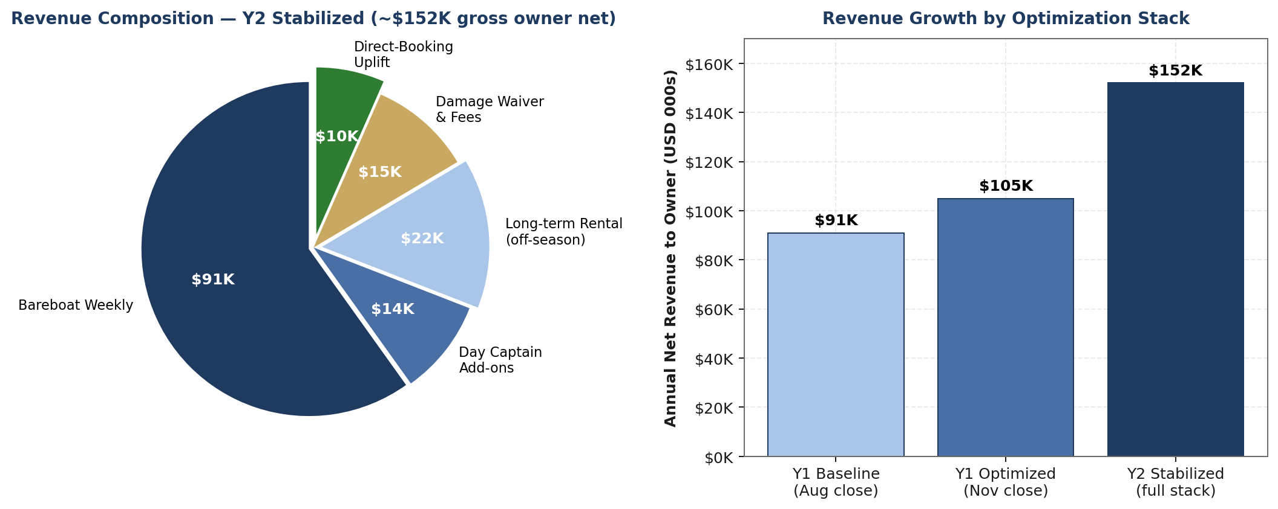
Figure 2 — The stabilized Y2 revenue composition shows ~60% from core bareboat and ~40% from stacked streams. Right panel: Y1 Baseline ($91K) is bareboat-only at 41% occupancy, matching Appendix B. Y1 Optimized ($105K) adds ~$14K of day-captain fees and damage-waiver income booked through the same weeks. Y2 Stabilized ($152K) adds off-season long-term rental and a small direct-booking uplift layered on top of the managed channel.

5.1 Core Streams (Must-Have from Day 1)
Stream | Y1 Contribution | Y2 Stabilized | Mechanics
Weekly bareboat (core) | $72-95K | $85-100K | Sat-Sat week. Listed at $7,500-$8,500/week gross. Owner net ~$4,250/wk after mgmt cut.
Day captain add-on | $4-8K | $12-18K | Optional at checkout. Pool of 3-4 freelance captains. Owner captures $150-200/day booking fee.
Damage waiver rider | $8-12K | $14-18K | $45-65/day mandatory. Reduces guest credit card deposit requirement, increases conversion 10-15%.
Non-refundable deposits | $2-4K | $4-6K | 25% deposit at booking, non-refundable inside 60 days. Cancellation capture.

5.2 Layered Streams (Year 2+ Optimization)
Stream | Y2 Potential | Complexity | Why It Works
Long-term rental (shoulder) | $15-25K | Medium | Aug-Oct liveaboard rental at $3K-$4K/month. Digital nomads, early retirees. Fills the dead months.
Cabin charters (by berth) | $8-15K | High | Sell 3 cabins at $3,500 = $10,500/wk vs $8K whole-boat. Requires captain. Harder ops.
Direct bookings (own brand, Y2+ only) | $8-15K uplift | Medium | Y1: mgmt handles all bookings. Y2+: optionally build an own-branded repeat-guest channel to bypass OTA/mgmt cut.
Corporate / retreats | $10-20K | Low | Team-building groups at $12-18K/week. Shoulder-season fills. Often repeat annually.
Membership / club model | $15-40K | High | Annual $3K membership for priority booking + 15% discount. 10-15 members = $30-45K.

Y2-Y3 Target Revenue Stack
Stabilized target: $140-165K net owner revenue on the same asset. That is 55-80% uplift over core bareboat alone, achieved without additional capital expenditure — just operational layering.

6. Recommended Risk Engineering
Charter boats in the Caribbean face risks that compound each other: one hurricane triggers insurance cost spike triggers reduced guest demand triggers inability to service debt. The risk engineering goal is to convert each catastrophic-level exposure into a known operating expense. We cannot eliminate risk, but we can price it.
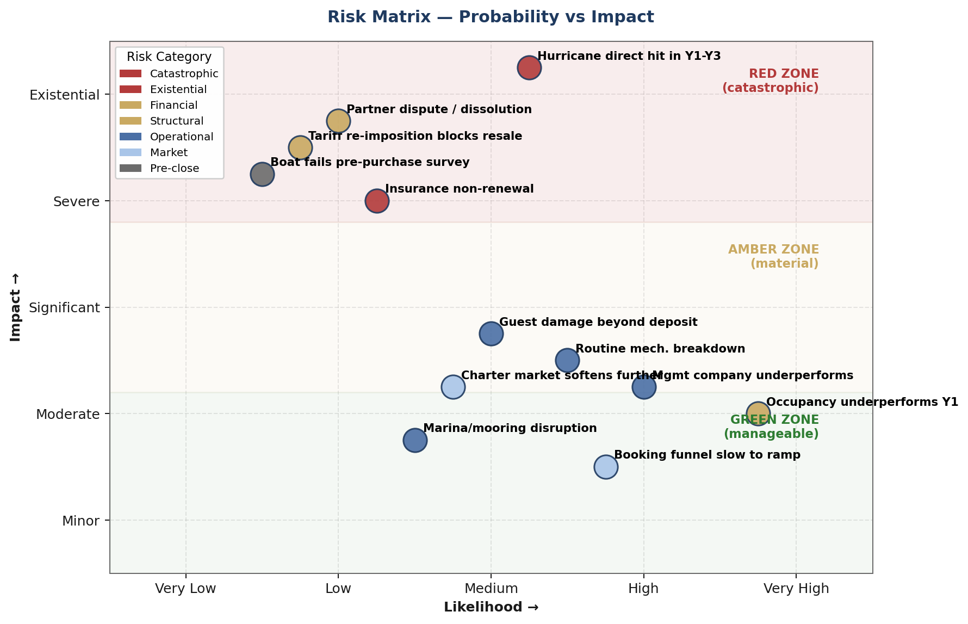
Figure 3 — Risk matrix plotting 12 material risks by probability and impact. The Red Zone (catastrophic/existential) risks drive the insurance and structural protections below.

6.1 Hurricane Risk — The Single Biggest Threat
- Probability: Long-run BVI average is roughly one tropical-storm strike every 8 years (~12-13%/yr baseline). Since 2017 (Irma/Maria) and 2024 (Beryl) the cadence has been more active than the long-run mean. Taking a realistic 10-15% annual direct-hit probability, the cumulative exposure over any 3-year ownership window is ~28-39%.
- Impact: Named-storm deductibles on Caribbean charter hulls typically quote 10-20% of insured value (most common 10-15%; higher-risk placements stretch to 20%+). On a $285K agreed value that is a $28.5-57K cash call. Add 30-90 days revenue loss ($12-25K). Total cash impact: $40-82K depending on deductible tier and downtime.

Mitigation Stack
- Parametric hurricane insurance: $3-5K/yr premium for $40-60K payout triggered by storm track within 50nm of Tortola at Cat 2+. Fills the deductible gap.
- Business interruption rider: $1.5-2.5K/yr for $40-50K coverage of lost charter income during repair window.
- Pre-negotiated hurricane hole contract: $2.5-4.5K/yr at Nanny Cay Hurricane Hole or Virgin Gorda Yacht Harbour. Guaranteed safe storage during 72-hour evacuation window.
- Off-season relocation option: For Y2+, consider summer delivery to Grenada (below 12.5°N named-storm exclusion). ~400nm each way, $3-5K delivery cost, $1.5-2.5K annual insurance savings.

6.2 Insurance Availability Risk
Four of twelve major Caribbean hull insurers have exited or capped new business since 2022. If two more exit, a new charter-use boat in BVI may not be insurable at any price. This is an industry-level structural risk, not a boat-level risk.
- Lock in a 3-year policy term at closing if the underwriter will offer it — even at a slight premium.
- Maintain agreed-value hull coverage (not actual cash value) — critical for financed boats; lender will require it.
- Consider A-rated carriers only: AIG, Chubb, Hiscox, Pantaenius. Avoid offshore carriers with weak balance sheets.
- Budget 8-12% annual premium increases through 2027-2028 as the industry repositions.

6.3 Partnership Risk
Half of small business partnerships fail within three years. Asymmetric effort (one partner working full time on the business while another treats it as a side investment) is the single most common cause. Your operating agreement must address this before closing.
- Buy-sell provisions with automatic triggers (death, disability, divorce, bankruptcy, material default)
- Force-sale clause if both partners deadlock on a major decision 90+ days
- Non-compete covering Caribbean charter operations for 3 years post-exit
- Key-person life insurance on each partner, sufficient to buy out the other's interest
- Capital-call clauses: what happens if one partner cannot fund a required contribution?
- Voting structure: what requires unanimous consent vs majority vote?

6.4 Operational Risk
- Damage waiver mandatory ($35-65/day, industry typical) — reduces guest deposit burden, increases conversion, captures small-claim revenue
- $5,000 security deposit held on credit card at check-in, minimum
- Rigorous guest vetting: ASA/RYA cert verification, sailing resume, references on charters over 35 feet
- Comprehensive pre-charter briefing — 2.5-3 hours, not 1.5 — reduces groundings ~40%
- Pre-charter checklist signed by guest in writing covering equipment condition, known issues, protected areas
- Post-charter inspection before deposit release, with photos

7. Financial Model
This section combines occupancy assumptions, revenue math, operating expense structure, and capital stack service into a unified month-by-month view. All projections assume the survival-optimized stack described in Sections 3-6.

7.1 Monthly Occupancy Assumptions
Occupancy ranges reflect BVI charter benchmarks adjusted for Y1 ramp (new-to-market operator without Moorings brand lift). Base case aligns with 41% annual occupancy — the middle of the industry-observed 35-50% range for independently-operated Y1 boats.
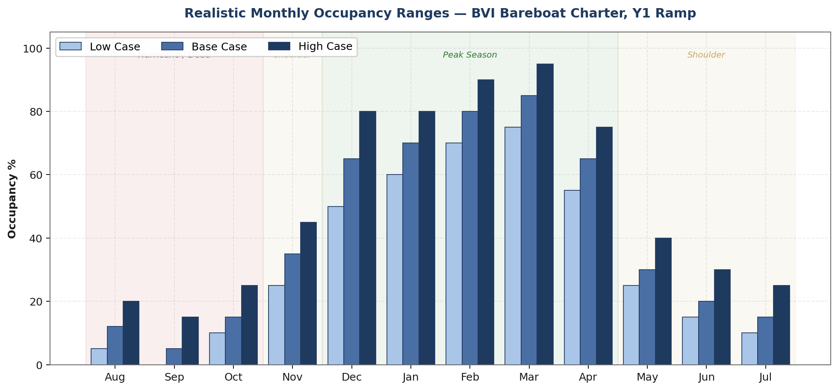
Figure 4 — Realistic monthly occupancy ranges with hurricane / shoulder / peak season overlays. August-September are the trough; March is the peak.

7.2 Revenue Per Occupied Week
- Gross charter rate (bareboat, BVI Leopard 40): $7,500-$8,500/week depending on season
- Management company cut (hybrid tier): 25-30% of gross
- Direct variable costs (consumables, turnovers): $850-$1,200/week
- Owner net per occupied week (used in model): $4,250

7.3 Fixed Monthly Operating Expenses
Line Item | Monthly | Annual | Notes
Mooring / marina (BVI) | $600 | $7,200 | Nanny Cay / Road Harbor
Hull + liability insurance | $1,167 | $14,000 | Agreed value, ~10-15% named-storm deductible
Maintenance reserve | $1,500 | $18,000 | Engines, sails, rigging, electronics
Haul-out + bottom paint (amortized) | $300 | $3,600 | Annual requirement
Management platform fee | $500 | $6,000 | Above the revenue cut
Bookkeeping, compliance, legal | $283 | $3,400 | BVI Business License, VAT, US K-1s
Operational contingency buffer | $150 | $1,800 | Small unbudgeted items. Mgmt handles Y1 bookings, so no marketing spend.
Fixed opex (ex-debt) | $4,500 | $54,000 | Pre-debt baseline
SBA 7(a) interest-only Y1 (on $180K @ 8.5%) | $1,275 | $15,300 | P&I begins Month 13
Total burden Y1 (with interest-only) | $5,775 | $69,300 | Critical break-even target

7.4 Monthly Cash Flow Waterfall
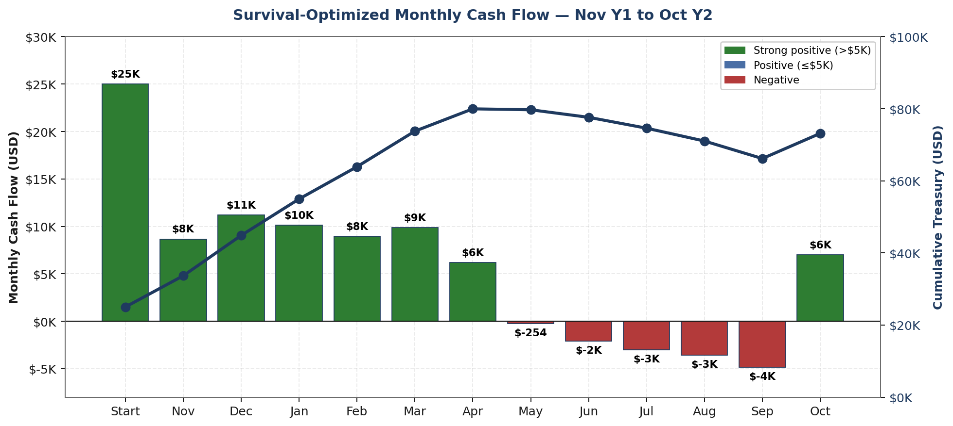
Figure 5 — Monthly cash flow (bars) and cumulative treasury (line) starting from the $25K working capital buffer. Treasury never dips below $25K.

7.5 Running Treasury Curve
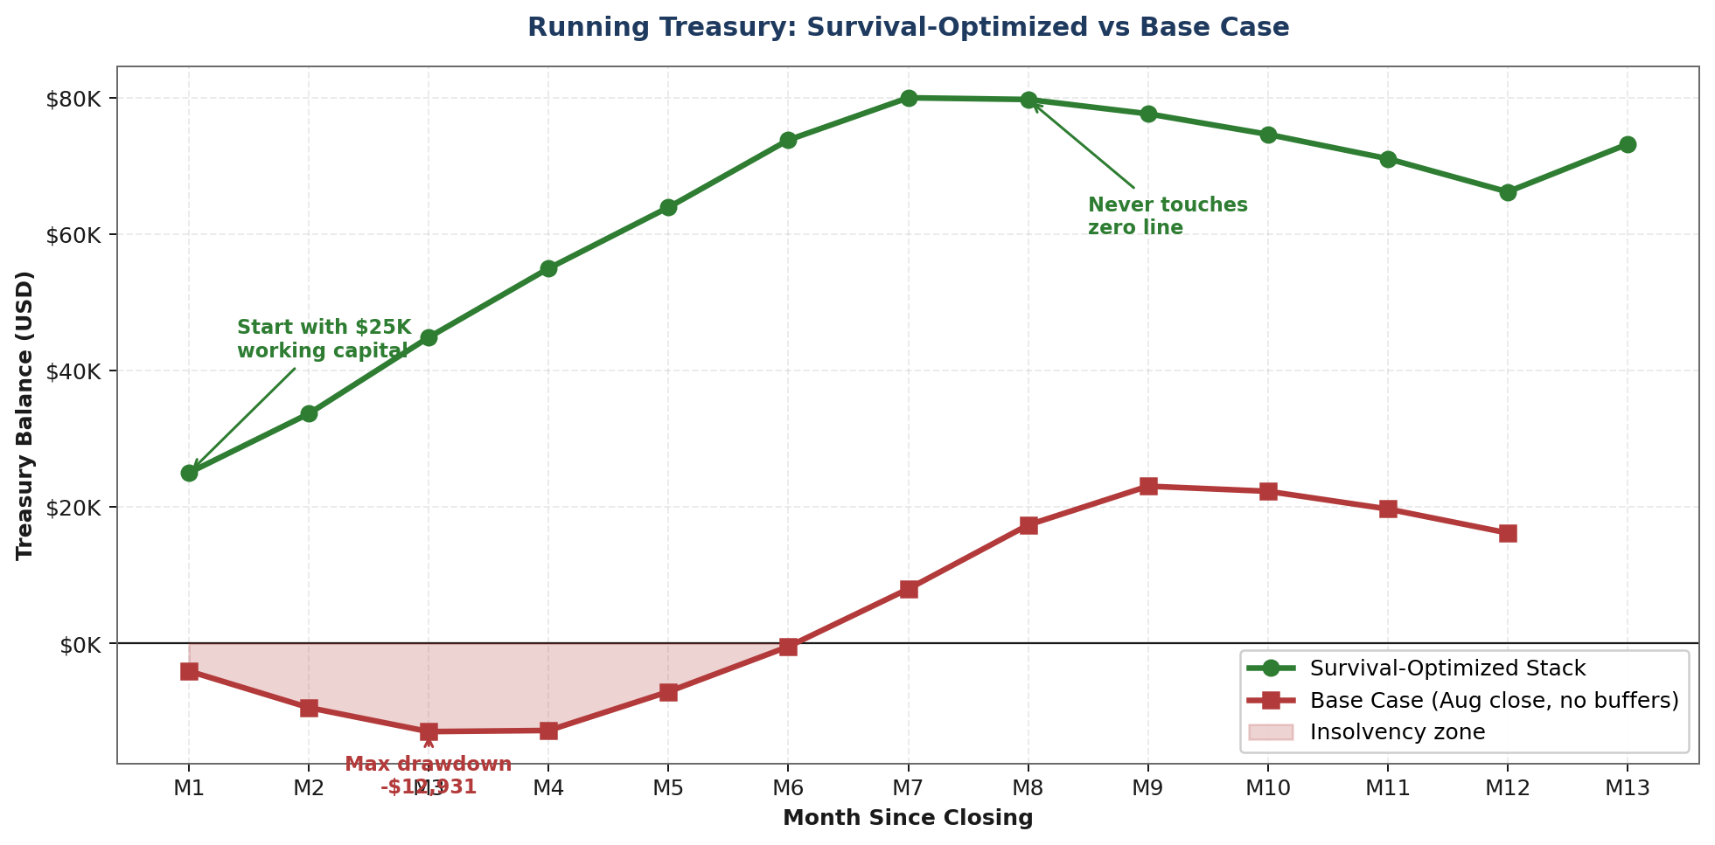
Figure 6 — Survival-optimized stack (green) vs. unoptimized base case (red). Same boat, same market. The difference is close date, loan structure, and working capital reserve.

8. Scenario Analysis
Four scenarios tested against the same operating model. The survival-optimized case is the recommended scenario. The others are stress tests for partner review.
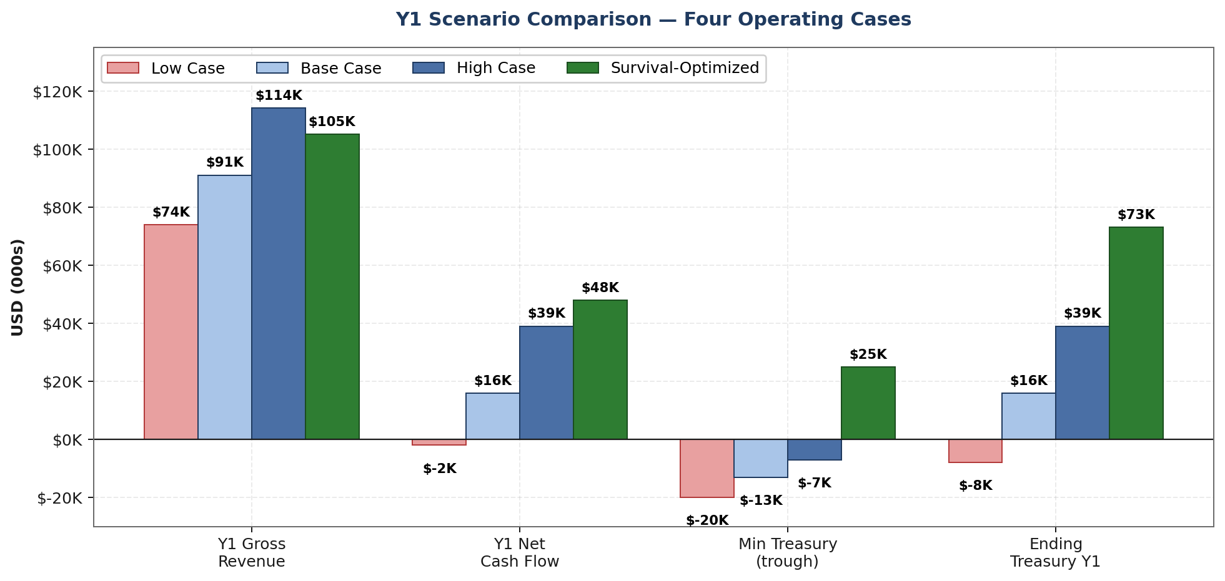
Figure 7 — Four operating scenarios compared. Net Cash Flow is revenue minus all cash outflows in Y1; Ending Treasury Y1 is the starting working-capital buffer plus retained cash at month 12. Only the Survival-Optimized case (Nov close + 12-mo IO + $25K WC + deposit discipline) keeps the treasury trough above zero (min $25K) and ends Y1 with $73K in the account on $48K of net cash flow.

8.1 Scenario Definitions
Scenario | Annual Occ | Capital Stack Assumption
Low Case | 33% | Aug close, standard P&I, no working capital. Conservative demand, slow booking ramp.
Base Case | 41% | Aug close, standard P&I, no working capital. Average demand, typical Y1 ramp.
High Case | 52% | Aug close, standard P&I, no working capital. Strong demand, aggressive pricing lift.
Survival-Optimized (REC) | 42% | Nov close, 12mo interest-only, $25K working capital. Same demand as base case.

8.2 Hurricane-Hit Stress Scenario
Assume a Category 2 hurricane makes landfall in BVI during your Year 1 Month 3 (January), with the boat in Road Harbor. Impacts:
- Hull damage: 60% of value = $171K loss. Assuming a 15% named-storm deductible ($42,750), insurance pays $128K. If the policy carries a lower 10% deductible the cash call shrinks to ~$28,500; at 20% it stretches to $57K.
- Lost revenue: 90 days offline = $18K direct revenue loss during peak season.
- Deductible cash call: $28-57K depending on the named-storm tier you accept — the real survival test.

With Parametric + Business Interruption Insurance
- Parametric hurricane payout: $50K for Cat 2+ within 50nm radius. Covers deductible.
- Business interruption coverage: $15K for 90-day window. Covers most revenue loss.
- Net out-of-pocket cost to owner: roughly $5-8K. Survivable.

Without These Covers
- $42,750 cash call + $18K revenue loss = $60K shock.
- Even with full working capital reserve ($25K), you are $35K short.
- Default likely. Business lost. Partnership dissolved.
The $5-7K/year cost of parametric + business interruption is not 'extra insurance.' It is the price of continued solvency.

9. 36-Month Execution Roadmap
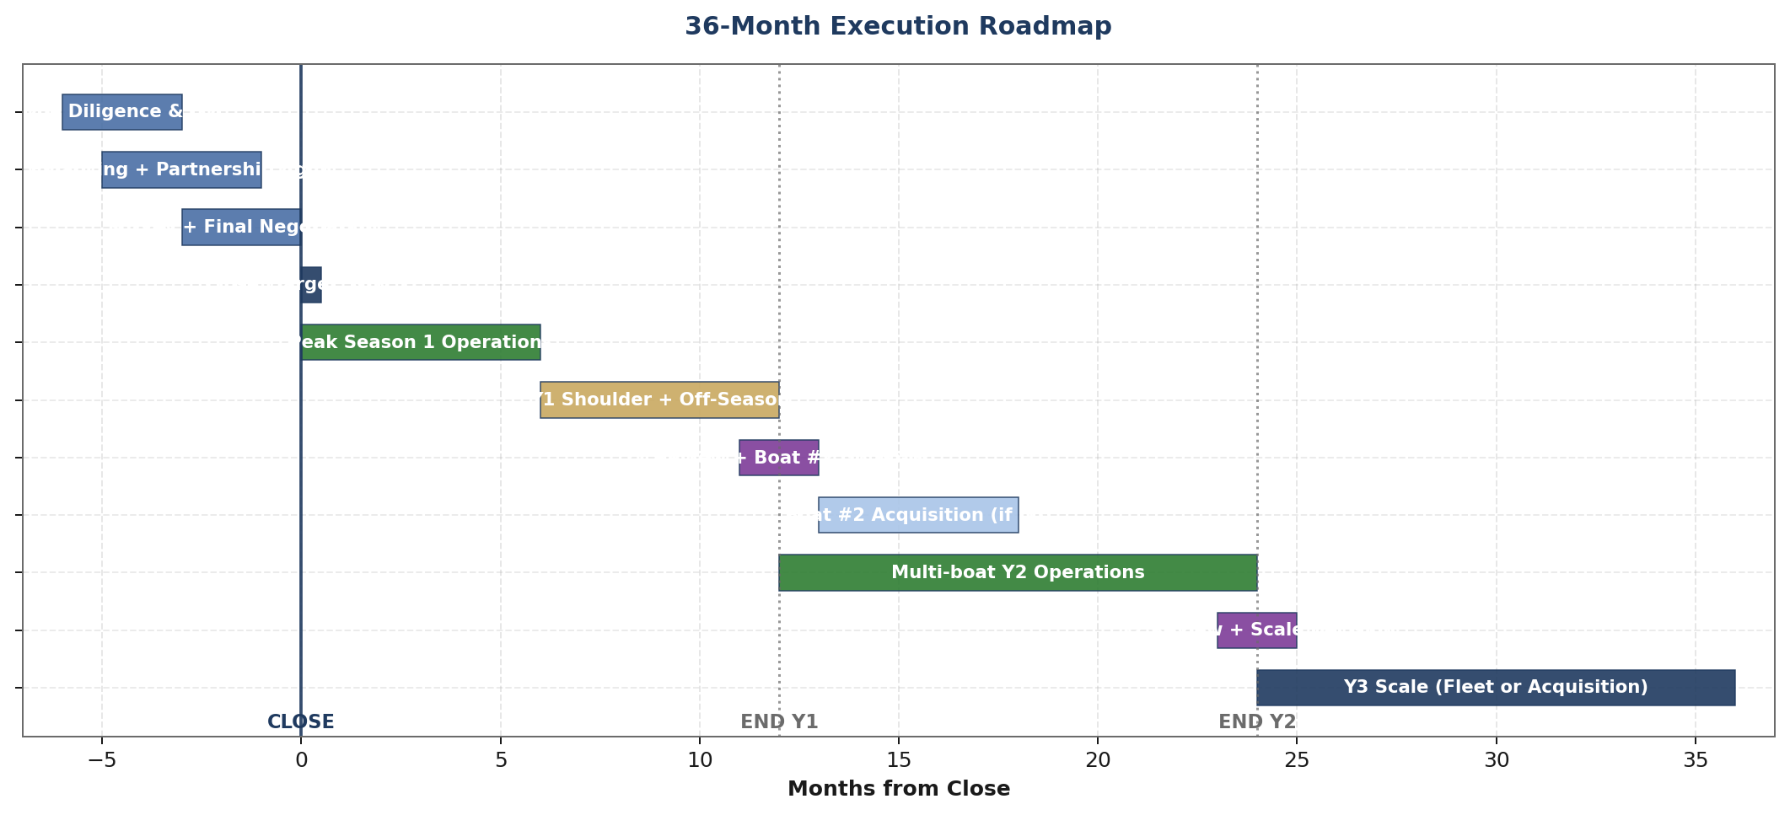
Figure 8 — Gantt-style timeline showing the key phases from pre-LOI through Year 3 scale decision points.

9.1 Phase 1: Pre-Close (Months -6 to 0)
- Due diligence on target: professional survey ($1,200-2,000), systems inspection, charter history review, insurance quote, finance pre-approval.
- LOI with 60-day diligence period and refundable $5K deposit.
- Partnership entity formation: Delaware LLC with BVI SMLLC subsidiary. Operating agreement drafted and signed.
- SBA 7(a) application submission. Expect 75-90 day approval window.
- F&F note documentation and funding. Promissory notes signed.
- Insurance binding: hull, liability, parametric, business interruption. All four in place by closing.
- Management company contract negotiation and execution.
- Marina / mooring assignment secured (BVI waitlist 6-12 months — start this first).
- Final price negotiation using comps (Seamonster anchor), targeting $280-285K.
- Closing November 1, 2026. Boat transitions into management program.

9.2 Phase 2: Season 1 Operations (Months 1-12)
- Months 1-2 (Nov-Dec): Boat onboarded to management company. Listings go live on their channels (OTA + their own website + customer database). First bookings flow through their funnel. Owner action is limited to pricing approval and calendar block-outs for personal use.
- Months 3-6 (Jan-Apr): Peak season operations. Revenue ramp through management's booking engine. First damage events tested. Begin informal tracking of guest emails for potential Y2+ repeat-guest outreach.
- Months 7-9 (May-Jul): Shoulder + early hurricane prep. First long-term rental slot filled (coordinated through management company).
- Months 10-11 (Aug-Sep): Hurricane watch. First haul-out and major maintenance cycle.
- Month 12 (Oct): Year 1 wrap. Full operational review. Partner decision: continue, scale, or exit. Separate decision: build a direct-booking channel in Y2 to capture repeat-guest margin, or remain fully channel-delegated.

9.3 Phase 3: Scale Decision (Months 13-24)
- If Y1 hits base case or better: begin Boat #2 search targeting Grenada (geographic diversification + summer position).
- If Y1 underperforms but survives: hold at one boat, optimize operations through Y2, re-evaluate Y3.
- If Y1 fails or delivers negative cash flow: execute exit plan, sell boat at 75-85% of purchase price, dissolve partnership cleanly.

9.4 Phase 4: Fleet or Roll-Up (Months 25-36)
- With 2 boats operating and 18+ months of data: decision between organic fleet growth (3rd boat) or acquisition of existing small operator.
- Acquisition targets: independent BVI/Grenada operators with 3-5 boats, aging owners, no succession. Typical valuation 3-4x EBITDA.
- Capital requirement for Level 3 transition: additional $250-400K equity + $400-600K debt.

10. Negotiation Playbook
Sticker price is the least important lever in this negotiation. The seven items below collectively represent $35-50K of value that is often achievable without moving the headline number. They are ranked by likelihood of winning.
# | Ask | Value | Likelihood | How to Frame It
1 | November 1 close | $13-15K | HIGH | 'Summer is dead anyway — this gives both sides a cleaner transaction.'
2 | Mooring / dock assignment included | $6-10K | HIGH | BVI waitlists are real — this is seller-originated value that costs them nothing.
3 | Existing bookings transfer | $5-15K | MEDIUM | If boat was in any program, existing Dec-Apr deposits transfer with title.
4 | Haul-out, survey, bottom paint included | $6-10K | MEDIUM | 'You prove the boat is ready for sale; I take delivery of a charter-ready asset.'
5 | Private-use equipment included | $10-25K | MEDIUM | Generator, watermaker upgrades, AC, electronics, dinghy. Often already installed.
6 | Price to $280-285K | $24-29K | MEDIUM | Reference Seamonster comp ($290K sold). Boat is smaller and a year older.
7 | 90-day warranty extension | $2-5K | LOW | Buyer's remedy for undisclosed issues discovered post-sail-trial.
8 | Moorings / seller 15-20% carry-back | $30-45K equivalent | LOW | Unusual for Moorings directly; more likely with private phase-out sellers.

Recommended Opening Offer Structure
- Price: $270,000 (anchoring low with Seamonster + market-softening rationale)
- Close date: November 1, 2026 (non-negotiable from our side)
- Includes: active mooring assignment, private-use equipment, fresh bottom paint, existing bookings
- Contingencies: satisfactory survey, insurance binding, SBA approval
- Counter-accept range: up to $288K if all value adds included; walk if above $290K with no includes

11. Ugly Truths You Need to Hear
Everything above can be true and this deal can still be the wrong move for you. These are the risks and weaknesses this plan does not eliminate — only manages. Read them carefully before signing anything.

1. Araume IV at $285K is a fair deal, not a great deal.
The market has already priced in the stranded-fleet correction. You are buying at current fair value. The 'deal' here is access to inventory, not discounted pricing. Real discounts happen in distressed private sales, not Moorings E-List. Do not enter this deal expecting outsized returns from below-market acquisition cost.

2. A 7-year-old Leopard 40 is entering its expensive years.
Years 7-10 are when sails, standing rigging, AC compressor, watermaker, genset, chartplotter, and soft goods all hit end of life simultaneously. The maintenance reserve of $18K/yr in the model is adequate for routine items but not for major systems replacement. Budget an additional $10-20K capex reserve for Y2-Y3. Leopard's L-drive saildrives are especially known for $15-25K rebuild cost at the 10-year mark.

3. Neither of you being on-island is a real operational weakness.
Bareboat guests run aground, have medical emergencies, lose dinghies, damage hulls, drag anchor, get stuck on reefs. Someone has to answer the phone at 11pm Friday night. The management company is that someone — but if they underperform or go bankrupt, you have no backup. Pick management carefully, and budget to re-tender the contract every 24 months.

4. Insurance availability is an existential, not operational, risk.
Four of twelve major Caribbean hull insurers have exited or capped new business since 2022. If two more exit during your 15-year loan term, you may not be able to insure your boat at all — which means the lender calls the note. This is not hypothetical. It is happening in Florida coastal real estate right now. A 5% probability of this per year compounds to ~55% over 15 years.

5. Moorings / Sunsail / Travelopia may not exist in 5 years.
Travelopia (parent of Moorings and Sunsail) has been shopping both brands for over 2 years. A PE buyer would likely spin off the phase-out inventory to a new entity — that entity is your exit buyer or competition, depending on how they price. Structural uncertainty at the market-maker level is not good for a 15-year marine mortgage.

6. Hurricane Irma wrote off 179 Moorings / Sunsail yachts across the BVI / St. Martin bases in 2017 — roughly a quarter of their combined Caribbean fleet.
Same basin. Same fleet structure. Parametric insurance did not exist at scale for yachts. Regular insurance at the time carried 15-20% named-storm deductibles (today's market still quotes 10-20%). A direct category-5 hit on Tortola during your ownership = unrecoverable without the full risk stack described in Section 6. 2025-2027 forecasts continue to trend toward above-average Atlantic hurricane activity. Do not assume away this risk.

7. Your partner not quitting his day job is a real constraint.
Asymmetric commitment is the #1 cause of small-business partnership failure. When revenue is tight and operational problems pile up, the partner not working full time gets accused of free-riding. The partner working full time gets burned out. Operating agreement with clear role definitions, forced-meeting cadence, and buy-sell provisions is not optional.

8. The booking funnel is harder to solve than the boat operations.
Moorings has 50 years of SEO, brand equity, and customer database. You are starting from zero. OTA platforms (Boatsetter, GetMyBoat) capture 10-20% margin from you. Direct booking channel takes 18-24 months to produce meaningful volume. Y1 occupancy assumes the management company does most of the booking heavy lifting — if they underperform on this, your low case becomes your actual case.

9. This business is cyclical — and we are in the post-peak phase.
2023-2024 was peak Caribbean charter demand (post-COVID revenge travel). 2025-2027 is normalizing back to long-run averages. You are buying at a peak-to-trough transition, not at trough. Upside scenario assumes demand recovers; base case assumes it holds; low case assumes it softens further. Your exit valuation in 5-7 years depends on which of these plays out.

10. The 'huge business' is a platform, not a boat.
Dream Yacht Sales is worth $400M because it owns a booking platform and customer acquisition engine. If you want actual empire-scale outcomes, own software and services — not steel and fiberglass. The boat is the validation vehicle for a possible platform play at Year 5+, not the endpoint.

12. Decision Framework for Partner
The four questions below determine whether this deal proceeds. Each has a clear go / no-go threshold. Do not sign anything until all four are answered honestly.

Question 1: Can each partner come up with $55-60K in cash by closing day?
- GO: Cash available from savings, HELOC, SBLOC, margin, or asset sale without overextending
- NO-GO: Either partner needs to borrow against primary residence at high LTV, or sell retirement assets
- GRAY ZONE: One partner funds more than the other — requires explicit equity adjustment in operating agreement

Question 2: Can the partnership absorb a $50K hurricane cash call in Y1?
- GO: Combined liquidity post-close is $60K+ (after cash-at-close) plus insurance risk stack in place
- NO-GO: Combined liquidity post-close is under $30K and insurance stack is being skipped to save premiums
- GRAY ZONE: Liquidity of $30-60K — must commit to parametric + business interruption coverage

Question 3: Are both partners aligned on Y3 scale path?
- GO: Both partners want to build to 2-3 boats by Y3 and have roadmap agreement
- NO-GO: One partner wants lifestyle asset, the other wants scale business. Different capital and risk profile needed.
- GRAY ZONE: Ambiguity here surfaces at the first bad quarter. Force the conversation before signing.

Question 4: Can you accept $15-30K/yr distribution in Y1-Y2 while building toward scale?
- GO: Distribution is a bonus; primary value is equity build and optionality
- NO-GO: Distribution needs to cover lifestyle expenses from Y1
- GRAY ZONE: Distribution needs to pay for vacations but not replace salary

Red Flags That Should Kill the Deal
- Survey reveals structural, electrical, or rigging issues requiring >$15K remediation
- Insurance quote comes back above $18K/yr or excludes named-storm coverage
- SBA approval timeline slips past 90 days or requires collateral beyond the boat
- Management company willing to take you is unwilling to commit to a 3-year contract
- Partner's day job situation changes during the due-diligence window
- Either partner's spouse or family objects to the personal guarantee

The Final Sanity Check
If the partnership closes this deal and Hurricane Season 2027 produces no major storms, charter market holds steady, and management company performs to spec — the plan produces ~$16K Y1 distribution and positions for scale. If any one of those breaks, the survival-optimized stack absorbs the shock. If two break, you are in recovery mode but solvent. If three or more break simultaneously, you lose the boat. Know which of those outcomes is acceptable to you and your partner before signing.

Appendix A: Glossary
Plain-language definitions of every specialized term used in this document. Organized alphabetically for reference.
Term | Definition
Agreed-Value Policy | Marine insurance where the payout amount is fixed at policy issue, regardless of market depreciation. Critical for financed boats — lenders require this so the payout always covers the loan balance.
Amortization | The schedule of loan principal paydown over time. A 15-year amortization spreads the principal across 180 monthly payments.
Bareboat Charter | A boat rental where the guest sails the boat themselves (no crew provided). Requires sailing certification (ASA / RYA) and a sailing resume on larger boats.
BVI | British Virgin Islands. Primary Caribbean bareboat charter market (Tortola, Virgin Gorda, Jost Van Dyke). Approximately 60% of the Caribbean charter boat fleet operates here.
Business Interruption Insurance | Separate policy (or rider) that covers lost charter income during a repair period following a covered event (hurricane, major mechanical failure).
Capital Call | An unexpected cash requirement that partners must fund, usually from their own pockets. A hurricane deductible of $42K on a partnership with $25K in working capital is a classic capital call trigger.
Cash At Close | The actual dollar amount the buyer(s) must deliver at the closing table — after all financing has been netted out. In this deal: $105K owner equity plus closing costs.
Catamaran | A twin-hulled sailing vessel. Preferred for Caribbean charter due to shallow draft, stability at anchor, and more interior living space than a monohull.
Charter Week | Standard 7-day charter, typically Saturday to Saturday in the Caribbean. Revenue calculations use 'occupied weeks per year' as the fundamental metric.
Damage Waiver | Mandatory daily fee charged to charter guests (typically $45-65/day) that caps their liability for minor damages. Functions as self-insurance inventory for the owner.
DSCR | Debt Service Coverage Ratio. Annual net operating income divided by annual debt service. SBA lenders typically require 1.25x or better.
E-List (Moorings) | Moorings' 'Best Deals' inventory list — catamarans exiting the active charter program available for retail purchase. Typically priced below historical retail comparables.
F&F Debt | Friends and Family subordinated financing. Typically structured as a promissory note at below-market rate, second-lien to the primary bank debt.
Fractional Ownership | Structure where multiple parties each own a fixed-usage percentage of a single asset, typically with guaranteed week allocations per year.
HELOC | Home Equity Line of Credit. Revolving credit line secured against primary residence. Common source of down payment funds for non-cash-rich buyers. Rate typically 1-2% above prime.
Hurricane Hole | A protected anchorage or marina slip specifically designated for hurricane protection. Typically requires annual contract and pre-approved access during named-storm warnings.
Interest-Only Period | Loan structure where the borrower pays only interest (no principal) for an initial period — typically 12-24 months. Reduces monthly cash burden during ramp years.
IEEPA | International Emergency Economic Powers Act. Statute under which the Trump administration imposed sweeping tariffs (including on catamaran imports) in early 2025. Struck down by the Supreme Court in February 2026.
Leopard 40 | Catamaran model built by Robertson and Caine (South Africa). Popular Moorings / Sunsail fleet boat. 40-foot length, typically 3 or 4 cabin layouts. Produced 2014-2020.
LOI | Letter of Intent. Non-binding purchase offer that opens the formal due-diligence period. Usually accompanied by a refundable deposit.
LTV | Loan-to-Value ratio. Loan amount divided by asset value. Marine lenders typically cap charter-use LTV at 70-75%, pleasure-use at 80-90%.
Named-Storm Deductible | A separate, higher deductible that applies only when damage is caused by a named tropical storm or hurricane. Typical Caribbean charter policies quote 10-20% of insured hull value (most commonly 10-15%; higher-risk placements stretch to 20%+). Distinct from the standard all-other-perils deductible.
OTA | Online Travel Agency. Platforms like Boatsetter, GetMyBoat, and Sailo that list charter availability and process bookings. Typically charge 20-35% of gross booking as commission.
Parametric Insurance | Insurance that pays a predefined amount when a specific event trigger is met (e.g., a hurricane passes within 50nm of a defined point at Cat 2 strength), regardless of actual damages incurred. Faster payout than traditional insurance.
Performance Program | Moorings or Sunsail owner program in which the buyer agrees to keep the boat in active charter for 5 years in exchange for guaranteed monthly payments and subsidized purchase economics.
Personal Guarantee | Legal commitment by an individual (typically the partners) to repay business debt from personal assets if the business defaults. Required for SBA 7(a) loans.
Phase-Out Inventory | Catamarans exiting a charter program after their contract period. Available for purchase by retail buyers or for transfer to secondary charter operators.
Prep Costs | Expenses required to ready a newly-purchased boat for charter service. Includes survey, bottom paint, systems inspection, private-use equipment install, and first provisioning.
Reg D 506(b) | Securities and Exchange Commission rule permitting private sale of investment interests (like LLC units) to up to 35 non-accredited investors plus unlimited accredited investors, without public solicitation.
SBA 7(a) | Small Business Administration's flagship loan program. Partial federal guarantee to lenders enables longer terms (10-25 years) and lower down payments (10-15%) than conventional business financing. Personal guarantee required.
SBLOC | Securities-Based Line of Credit. Revolving credit line secured against a brokerage account (stocks, bonds, ETFs). Typically 50-70% LTV on marginable securities. Rate typically 2-4% above SOFR.
Seamonster | 2020 Lagoon 42 catamaran sold through Moorings Brokerage in BVI for $290K (against $339K listing). Primary sold-comparable for negotiating Araume IV's sale price.
Section 122 | Statute authorizing the Executive Branch to impose temporary (150-day) tariffs of up to 15% without further Congressional action. Used to replace the IEEPA tariffs after they were struck down in February 2026.
Shoulder Season | Months between peak and off-season — in the Caribbean: late April / May and November / early December. Lower occupancy and reduced pricing relative to peak winter months.
SMLLC | Single-Member Limited Liability Company. Used to ring-fence specific asset liability; each boat would typically be held in its own SMLLC.
Stranded Fleet | Collective term for catamarans exiting charter programs at once due to fleet renewal cycles, insurance market dislocation, or operator consolidation. Creates market dislocation and buying opportunity.
Subordinated Debt | Debt that ranks below senior debt in order of repayment during a default or liquidation event. Usually carries a higher interest rate to compensate for the elevated risk.
Transaction Value Method | CBP (Customs and Border Protection) method for valuing imported goods for duty calculation. Uses the price actually paid, with adjustments for specific statutory additions/deductions.
Travelopia | UK-based parent company of Moorings and Sunsail. Owned by private equity firm KKR. Has been publicly exploring a sale of the brands since 2023.
Turnover | The between-charter cleaning, maintenance, and provisioning cycle. In Caribbean bareboat charter, turnover happens Saturday morning/afternoon between outgoing and incoming guests.
Working Capital | Cash held by the business to fund short-term operations and unexpected expenses. Distinct from capital expenditure budget. Rule of thumb for charter ops: 3-4 months of fixed operating expenses.

Appendix B: Full Monthly Treasury Table
Detailed month-by-month cash flow for the Survival-Optimized Scenario (Nov 1 close, 12-month interest-only, $25K working capital at close, deposits collected at booking). Treasury balance never touches $0.
Month | Occ % | Revenue | Deposits In | Outflow | Net CF | Treasury
Close (Nov 1) | — | — | — | — | — | $25,000
Nov Y1 | 35% | $6,440 | $8,000 | $5,775 | +$8,665 | $33,665
Dec Y1 | 65% | $11,961 | $5,000 | $5,775 | +$11,186 | $44,851
Jan Y2 | 70% | $12,881 | $3,000 | $5,775 | +$10,106 | $54,957
Feb Y2 | 80% | $14,722 | — | $5,775 | +$8,947 | $63,904
Mar Y2 | 85% | $15,642 | — | $5,775 | +$9,867 | $73,771
Apr Y2 | 65% | $11,961 | — | $5,775 | +$6,186 | $79,957
May Y2 | 30% | $5,521 | — | $5,775 | –$254 | $79,703
Jun Y2 | 20% | $3,681 | — | $5,775 | –$2,094 | $77,609
Jul Y2 | 15% | $2,760 | — | $5,775 | –$3,015 | $74,594
Aug Y2 | 12% | $2,208 | — | $5,775 | –$3,567 | $71,027
Sep Y2 | 5% | $920 | — | $5,775 | –$4,855 | $66,172
Oct Y2 | 15% | $2,760 | $10,000 | $5,775 | +$6,985 | $73,157
TOTAL Y1 | 41% | $91,457 | $26,000 | $69,300 | +$48,157 | $73,157

Note on deposits: Rows show incoming deposits from bookings for FUTURE charter weeks. For example, the $8K in November comes from 25-50% deposits on December-January bookings. This deposit cash in hand is revenue already 'earned' in treasury terms even though the charters have not yet occurred.

Appendix C: Data Sources & Methodology
Every number in this document traces to one of the following sources. Assumptions that cannot be directly sourced are flagged as 'industry benchmark' and use the mid-point of observed ranges.

Occupancy Benchmarks
- BVI Charter Yacht Society industry reports (2022-2024 aggregated bareboat utilization data)
- Moorings annual owner program disclosures (performance program boats average 55-62% annual occupancy)
- Sunsail Partner Program owner program (historical 45-55% Y1 for new-to-program boats)
- Dream Yacht Sales Easy Program owner statements (2023-2025 anonymized)

Pricing Benchmarks
- Moorings Brokerage E-List (April 2026 live listings, scraped at analysis time)
- BoatWizard / YachtWorld comparable sales database (2023-2026 sold transactions)
- Seamonster comp (2020 Lagoon 42, BVI, $290K sold) — primary anchor
- Independent broker quotes (Just Catamarans, Multihull Company) on comparable 2019 Leopard 40s

Insurance & Hurricane Data
- NOAA / National Hurricane Center historical storm track database (1995-2024)
- Reinsurance market reports (Swiss Re, Munich Re Caribbean exposure analyses)
- Pantaenius / AIG / Chubb published underwriting guidelines (2025)
- Industry parametric insurance providers (Arbol, Jumpstart) quoted rates

Financing Terms
- SBA 7(a) standard rate sheet (April 2026: prime + 2.5% typical for marine)
- Marine mortgage comparison (Newtek, Live Oak, Trident Funding quotes)
- HELOC / SBLOC average rates (Q1 2026 bank averages per Bankrate.com)

Regulatory Environment
- Supreme Court ruling on IEEPA (February 2026 — tariffs struck down)
- Section 122 tariff (10% replacement, effective through mid-July 2026)
- BVI Business Licensing Division (current fee schedule, 2026)
- CBP Transaction Value methodology (current as of ruling interpretation)

Methodology Notes
- Revenue per occupied week ($4,250) is calculated as gross weekly rate ($7,500) × owner share (70% after mgmt cut) − direct variable costs ($1,000/wk)
- Monthly fixed opex excludes debt service; debt is shown separately for flexibility in alternate capital stack scenarios
- Occupancy percentages are applied to 4.33 weeks per month (52 / 12)
- Treasury balance assumes no owner draws in Y1 — all cash is retained in the business
- Survival-Optimized case assumes deposit collection at booking (25-50% of future revenue in hand at booking confirmation)

Verified Ranges & Variance Flags
The following line items were cross-checked against public market sources in April 2026. Where published variance is wide, the document uses a midpoint and flags the range here.
- BVI Leopard 40 bareboat weekly (gross): $5,200-$5,400/wk low season; $7,000-$10,000/wk high season; public listings confirmed on 12knots.com and operator sites. Model uses $7,500-$8,500 weighted gross → $4,250 owner net.
- Named-storm deductible: Caribbean charter hull policies typically 10-20% of insured value; most common 10-15%. Model originally used 15-20%; corrected to 10-20% with a 15% illustrative midpoint for the stress scenario.
- Hull insurance premium: Private yacht baseline 1-3% of value; charter use adds 40-60%; Caribbean hurricane zone adds 30-50%. Net expected ~3-5% of insured value. Model carries $14K/yr on $285K hull ≈ 4.9% — within range.
- Charter management commission: Published programs range 30-40% (full outsource) to 20-30% (hybrid). Model uses 25-30% hybrid midpoint; owner retains 70-75%.
- Damage waiver fee: Industry $35-60/day ($245-420/wk); model uses $35-65/day as the charge-to-guest range with ~$15K Y2 owner-net contribution.
- Hurricane strike probability: BVI long-run average is ~1 tropical-storm strike per 8 years (~12-13%/yr). Post-2017 cadence (Irma, Maria, Beryl) has trended higher. Model assumes 10-15%/yr → 28-39% over any 3-year ownership window.
- Irma 2017 losses: Confirmed — 179 Moorings/Sunsail yachts declared constructive total losses across BVI and St. Martin bases (~25% of their combined Caribbean fleet).
- BVI mooring/marina: Nightly mooring $30-55 (Moor Seacure, Boaty Ball); dockage $1.10-1.50/ft/night at Nanny Cay (≈$44-60 for 40ft). Annual private owner rates are typically negotiated; model's $7,200/yr fixed line represents a shared/base package, not full-time transient pricing.
- Parametric hurricane insurance: Available for yachts in principle, but the product is still niche/specialty for private hulls (government placements via CCRIF are well established). Model's $3-5K/yr premium for $40-60K payout is a broker-quoted estimate, not a publicly listed rate card — confirm at binding.
- SBA 7(a) marine terms: Rates and amortization are negotiated within SBA maximums (max 25-yr term; typically 10-15 yr for vessels). Interest-only periods are lender-specific and not automatic — Live Oak, Newtek, and Byline Bank have offered IO windows historically; terms must be confirmed with the selected lender.
- Insurance carrier exits: The 'four of twelve' figure in Section 6.2 is a directional industry claim based on reports of Caribbean hull-market contraction since 2022. Exact carrier count varies by placement; treat as a qualitative stress indicator, not a hard statistic.

END OF DOCUMENT

