Big O Notation

What is Big O Notation - > How code slows as data grows
Big O Notation is used to measure the running and space requirements of a particular code as the input size increases or decreases.
Measuring time of a program might depend upon the factor that how fast your computer is so we have to use a mathematical representation of the same.
This mathematical representation is know as the Big O

Rules for deriving the Big O
Let's take an example using python
square = []
numbers = [2,3,4,5]
for each_number in numbers:
square.append(each_number*each_number)
print(square)
In this program we are running n iterations (I have mentioned 4 input so the for loop did 4 iterations but it can be a long list of n integers hence it will do n iterations)
we will use the general representation as - time = a*n + b
- we can neglect b since a*n is fastest growing term and adding of b wont affect it on a large scale.
- we will not consider the constants , which is a.
- hence time = O(n)

Let's see some quick examples
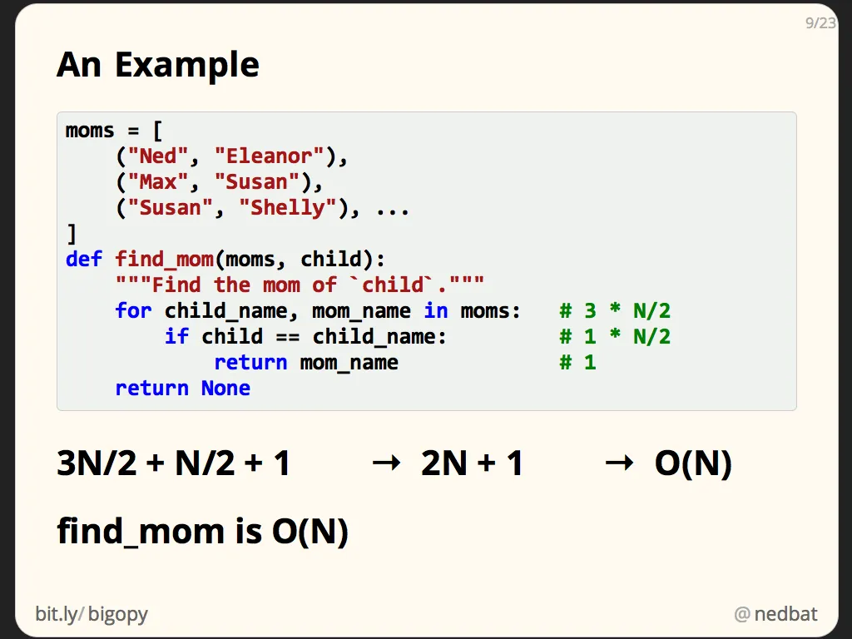
The find_mom function searches a list of tuples looking for a match on the first element of the tuple. In this case, N is the length of the list of tuples.
Since we don’t know where any given value is in the list, we don’t know whether we’ll find it at the beginning of the list, or near the end. So we guess that over many runs of the function, we’ll have to look at (on average) half the entries in the list.
In our average run, looping over the moms will happen N/2 times. Each time around, there’s one step to get the next element, and one step each to assign the tuple to child_name and mom_name. So the for-loop line gives us 3*N/2 steps.
The comparison is just one step, but since we loop N/2 times, it contributes another N/2 steps. The return statement happens only once, for 1 more step.
The grand total is 3N/2 + N/2 + 1, or 2N+1.
Since we are only interested in the large-scale growth trends as N gets very large, we drop the +1, and the 2 coefficient, to get O(N).

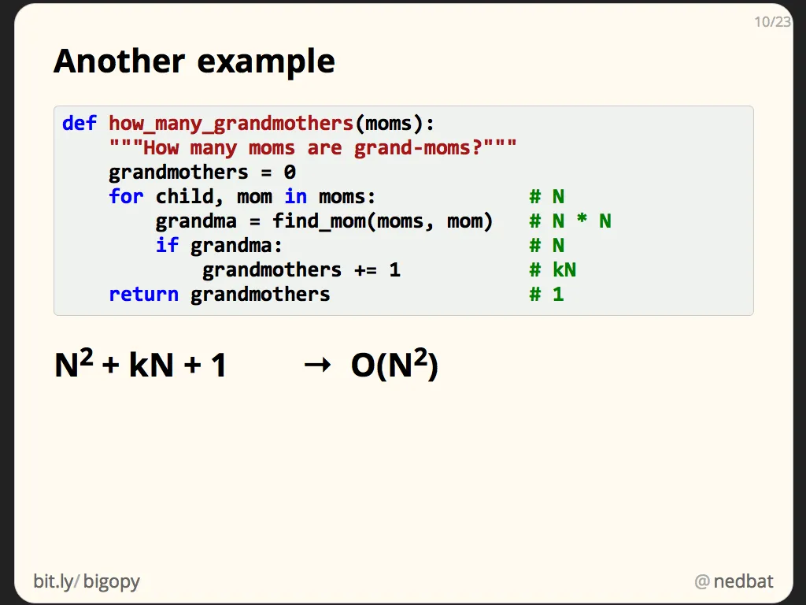
let’s consider this function to count how many of the entries in our list are grandmothers: the mom in the pair also appears as a child in another pair:
We know that we are only going to keep the most significant component, and we don’t care about the coefficients, so we won’t bother to track them. Instead we’ll just note the exponent for each part of the code.
Here we’re going to loop over the entire moms list so our loop will execute N times. The for statement itself will contribute N steps.
The next line is the interesting one though: we call find_mom. We just did the analysis of find_mom, so we know it’s O(N). This line contributes N steps each time it’s executed, but it’s executed N times, once for each execution of the loop. So this line contributes N2 steps.
We can continue with the rest of the analysis, but note that we already have an N2 component, so N components or constant components will eventually be discarded, so we can skip collecting them.
Because the largest component is N2, the result is O(N2).

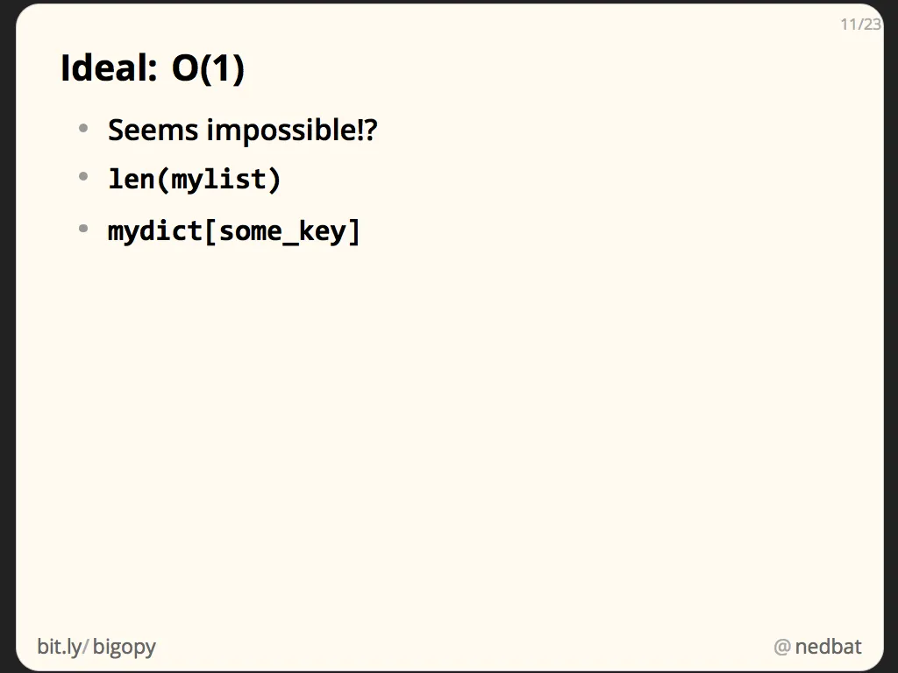
The best possible complexity is constant-time: no matter how much data, it always takes the same amount of time.
We saw one example with the labelled jars of jelly beans. Python lists work the same way: getting the length of a Python list is an O(1) operation because the list stores its length outside of the actual data of the list, just as the bean jar has a count on the outside.
A more interesting example is looking up a key in a dict. In the typical case, looking up a key in a dict takes the same amount of time no matter how large the dict is. This is why dictionaries underpin every name lookup in Python: they are fast.

- O(1) - In the below code what ever you give the input as (small or large) the time will remain constant .
def division(n,m):
div = n/m
print(div)
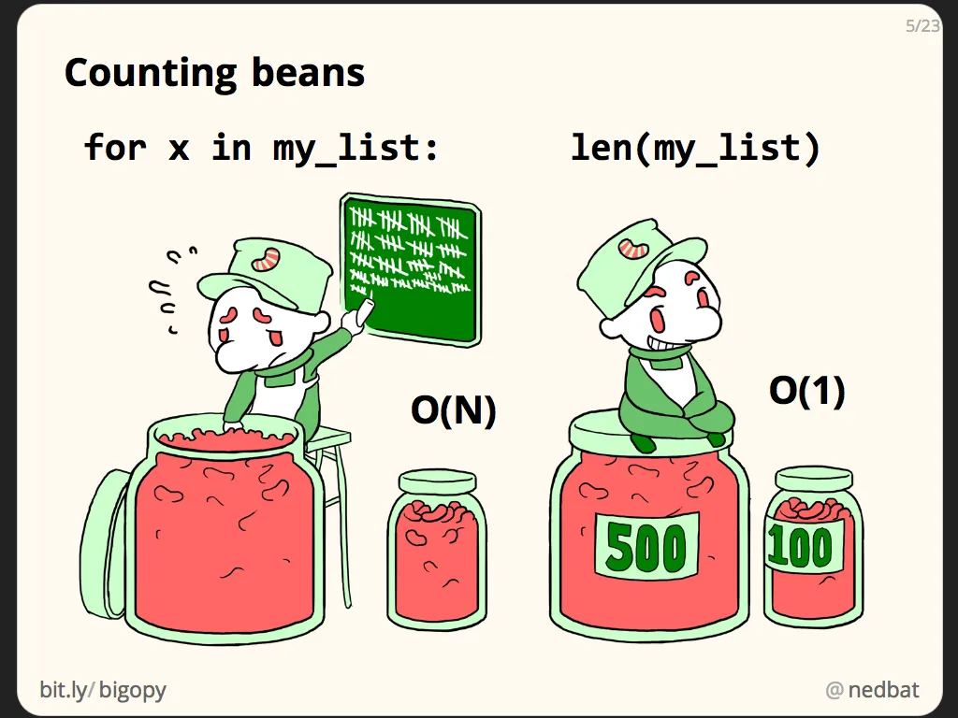
Let’s consider a real-world example. Suppose you have jars of jelly beans. You want to know how many are in each jar. The first way to do it is to count each bean, as this guy on the left is doing.
It’s pretty clear that the time it will take to count the beans is proportional to the number of beans. If one jar has five times as many beans as another, it will take five times longer to count.
The time it takes to complete the work is proportional to the number of beans (or amount of data), so we say it is O(N). The time grows in the same way that N does. It’s on the order of N.
Now suppose we arrange our data (beans) differently. We put a label on each jar, indicating how many beans are in the jar. Now the time to complete the task changes enormously, since our worker just has to read the label! Now no matter how many beans are in the jar, it takes the same amount of time to determine how many beans there are (assuming we trust the labels).
This is now a constant-time task: no matter how large the jar, it will take the same amount of time to determine the number. We just read it off the label. This is known as O(1), which is a funny way to write, “the run time doesn’t depend on N at all.”

- Binary Search O(log n)
- Consider a list of sorted n number - my_list = [1,2,3,4,5,6,7,8]
- Now in-order to search index of 6 in the my_list we have many ways and the first way you might think of is using a for loop and going through each number one by one and comparing to 6. The time complexity will be (n) , but what if we have billion numbers in the list , we can't do billion iterations.
- Second method is Binary search , you divide my_list from the middle element . We select the middle element and compare with the required element. So 4 < 6 , Hence we will discard the left including the middle element.
- [1,2,3,4] discarded and the left is [5,6,7,8] = n/2 iterations
- we apply the same and the iterations will ne (n/2)/2 until we reach the element which is n/2*2 .... and n /2^k
- so basically in each iterations we are dividing it by half.
- so for k Iterations = n/2^k
- keeping k iterations as 1 we have 1 = n/2^k
n = 2^k
log₂ n = log₂ 2^k
log₂ n = k * log₂ 2
log₂ n = k * 1 ( because log₂ 2 value is 1)
O(log n)
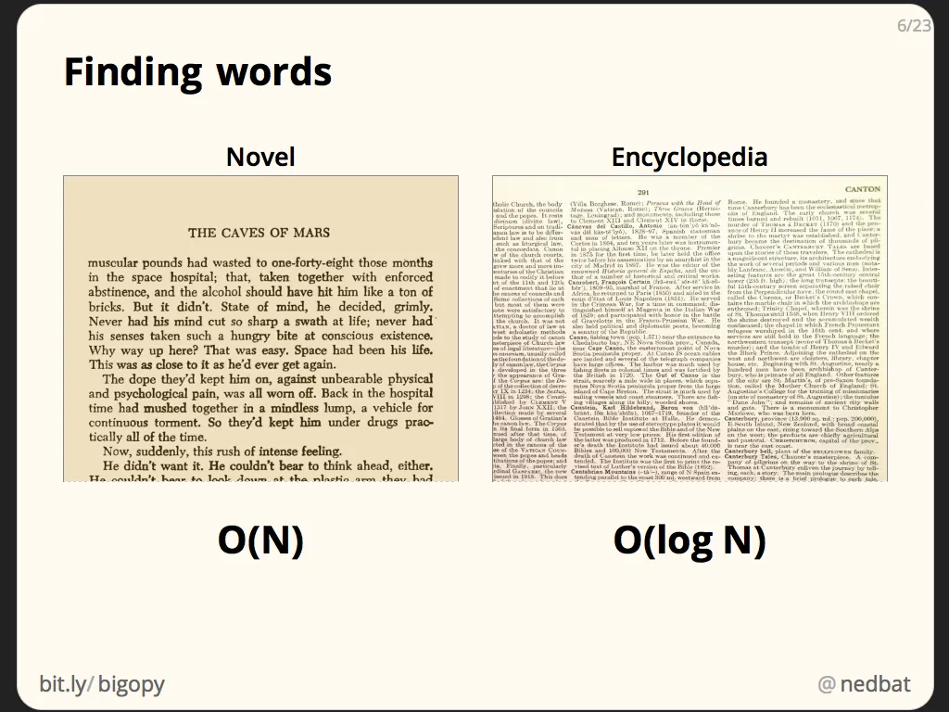
Real World Example

Let’s consider another real-world example: finding words in a book. If I hand you a novel, and ask you to find the word “horse” in it, you would start at the beginning and read until you found it. This is another O(N) task. If you double the length of the novel, it could take you twice as long to find it.
Now I hand you another book: an encyclopedia. Finding the word “horse” is easier now. You open to the middle of the book, and see whether the desired word is before or after the word on the page. If it’s before, then you open to the middle of the left-hand side, and continue your divide-and-conquer strategy until you find the word.
In this case, doubling the size of the encyclopedia doesn’t double the time it takes. It just adds one more divide-in-half step to the work.

- O(n²) - In the below program the outer loop executes N times. Every time the outer loop executes, the inner loop executes M times. Therefore , the statements in the inner loop execute a total of N*M times. Thus, the complexity is O(N*M) but We always consider the worst case scenario which means that the inner loop will go on till N iterations hence the total complexity for the two loops is O(N2).

n=5
for x in range (n):
for y in range(x+1):
print("*",end='')
print("\n")

- O(n²) - So in the code below - we can see there are 3 loops . We have already seen that the first two loops have a complexity of n² and the single outer loop will have a complexity of n. taking the equation - time = an² + bn + c after applying the rules we will get the Big O as O(n² + n ) but still the actual answer will be O(n²).
- Reason for this is - we always consider the worst case scenario , assuming the value of n is 10000 , now in that case n² is be very very large that n itself . So discarding n won't impact the Big O.

n=5
for x in range (n):
for y in range(x+1):
print("*",end='')
print("\n")
for x in range(n):
print('*')

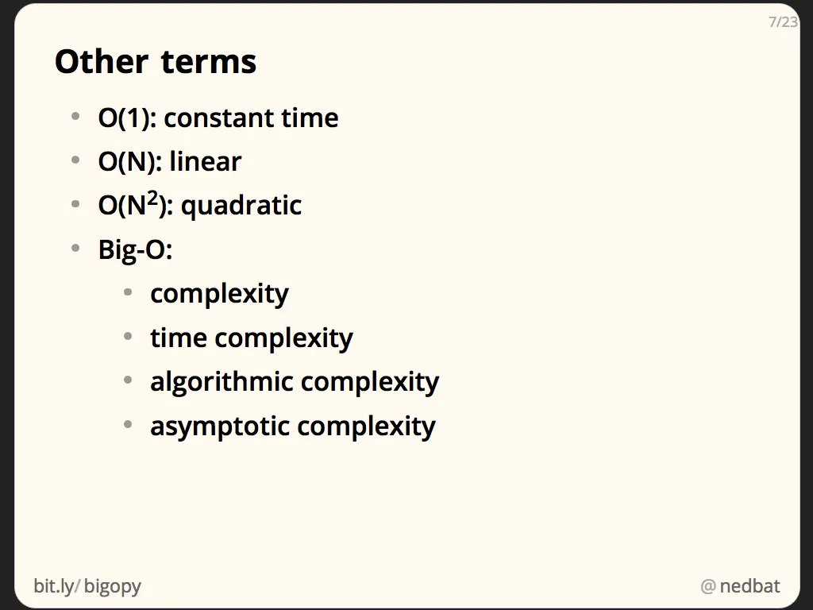
A little more terminology to get out of the way. Some of the more common big-O characterizations have short-hand names. O(1) is sometimes called “constant time” or just “constant” because it doesn’t change as the data size changes. O(N) is often called “linear” because the time is a linear expression of the data size. And O(N2) is called “quadratic” because the time is a quadratic expression of the data size.
The whole idea of big-O is also known as “algorithmic complexity” or “algorithmic analysis.” Those sound complicated and fancy, but it’s all the same stuff. Sometimes the big-O characterization is called the “complexity” of an algorithm, or the “time complexity.”

No discussion of big-O notation would be complete without showing a graph of how various complexities grow. Here the x-axis is the growth of data, and the y-axis is running time. There are no units here, because as with all the rest of this discussion, we are only looking for a rough characterization of how the running time relates to the data size.
You can see here that N2 can get really bad really fast. If there’s one thing to take away from this entire talk, it’s “avoid N2“.

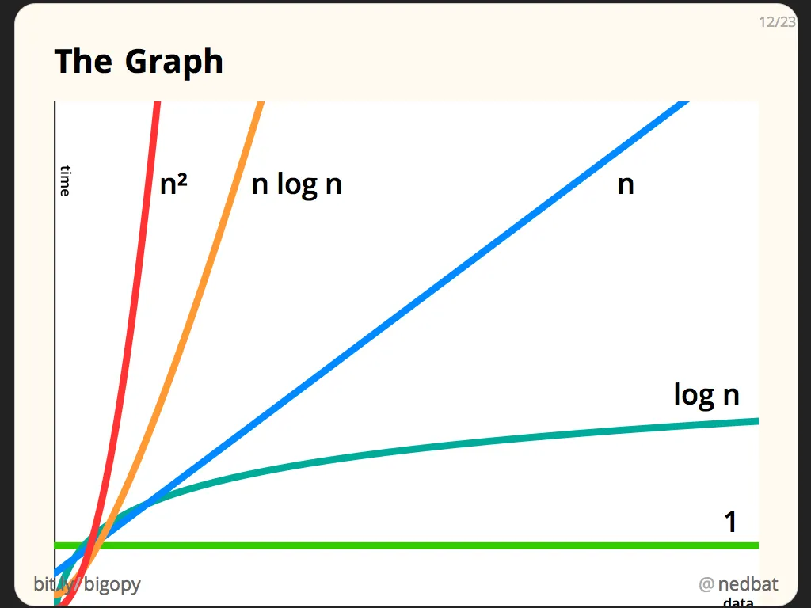
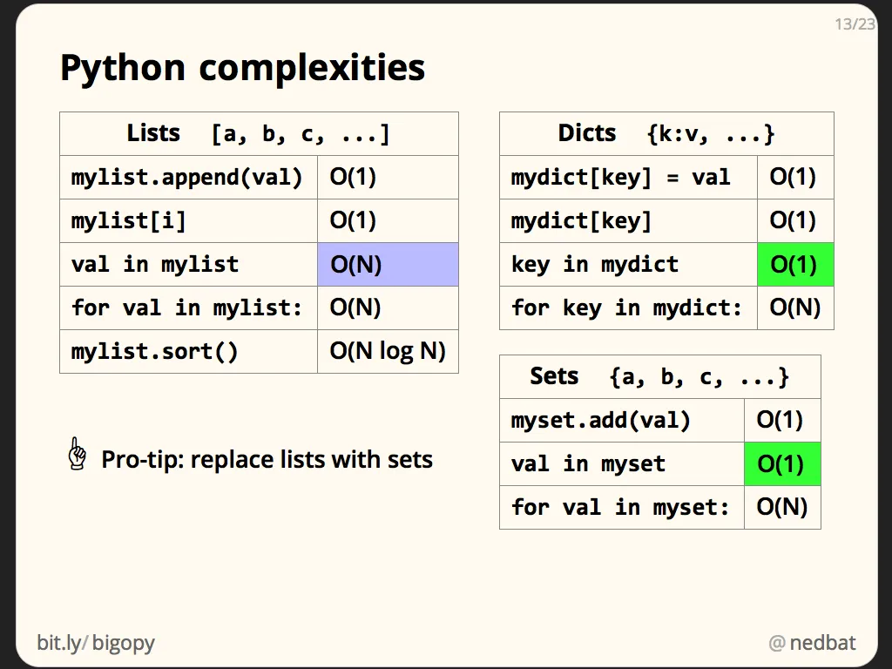
Python Complexities
To analyze your code, you have to understand the complexities of the Python primitives you’ll be using. These tables show the typical time complexity of common Python operations.
Many of the similar operations on list, dict, and set have the same complexities. A big difference is finding an element in each. In particular, finding an element in a list is O(N), while finding an element in a dict or set is O(1). This can make a huge difference in your program’s speed. If you can replace a list lookup with a set lookup, do it.

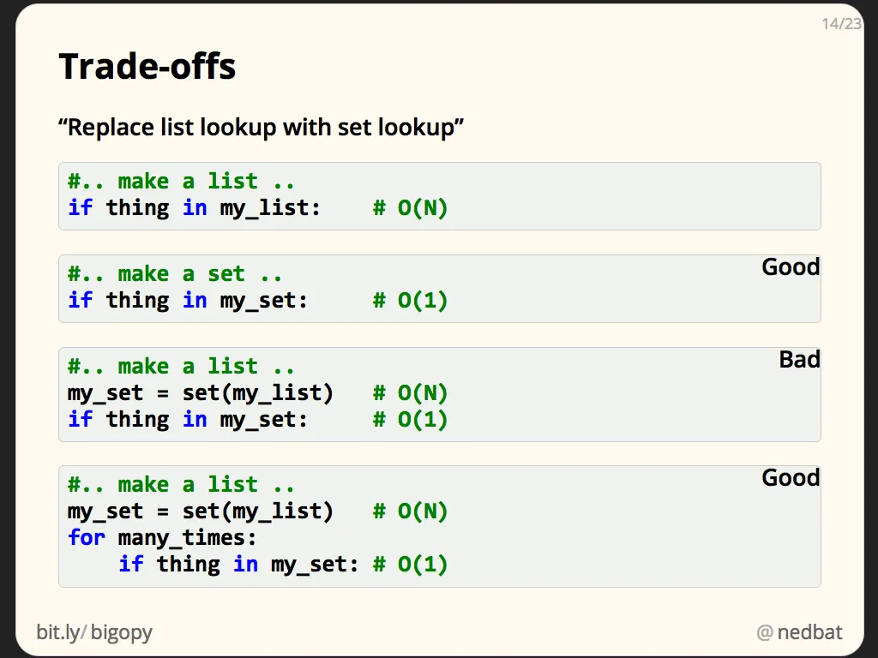
Replacing a list lookup with a set lookup is good, but you have to be careful.
The best way is to not create a list in the first place. Instead, create a set from the start.
The worst way to go is to have a list in hand, and then make a set from it, then do the lookup in the set. The set lookup is a fast constant-time lookup, but what did it cost to create the set? Creating a set from an iterable is an O(N) operation because every element of the iterable has to be considered.
Making a set just to perform one lookup is a waste of time. But it can be a good trade-off if you can make the set once and then use it for many lookups.

