Stack

What Is a Stack?
A stack is a data structure that stores items in an Last-In/First-Out manner. This is frequently referred to as LIFO.

Example 1 – Stack of plates


Example 2 – Undo feature in Editor

Let’s imagine you’re editing a Python file so we can look at some of the operations you perform. First, you add a new function. This adds a new item to the undo stack:

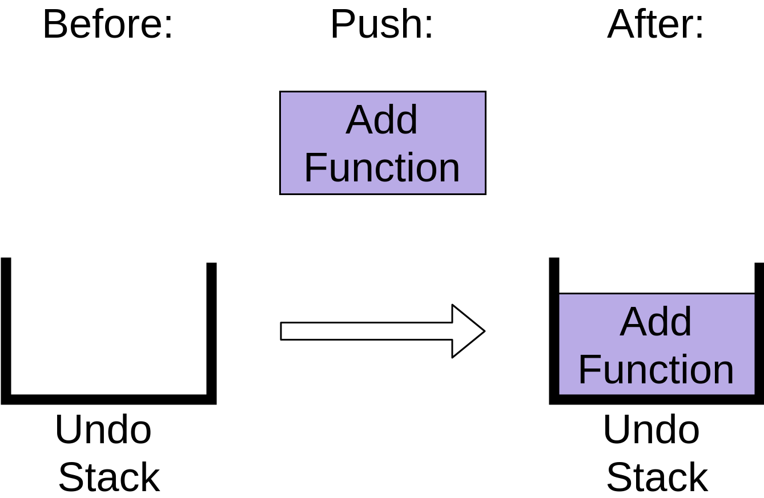

You can see that the stack now has an Add Function operation on it.
After adding the function, you delete a word from a comment. This also gets added to the undo stack:

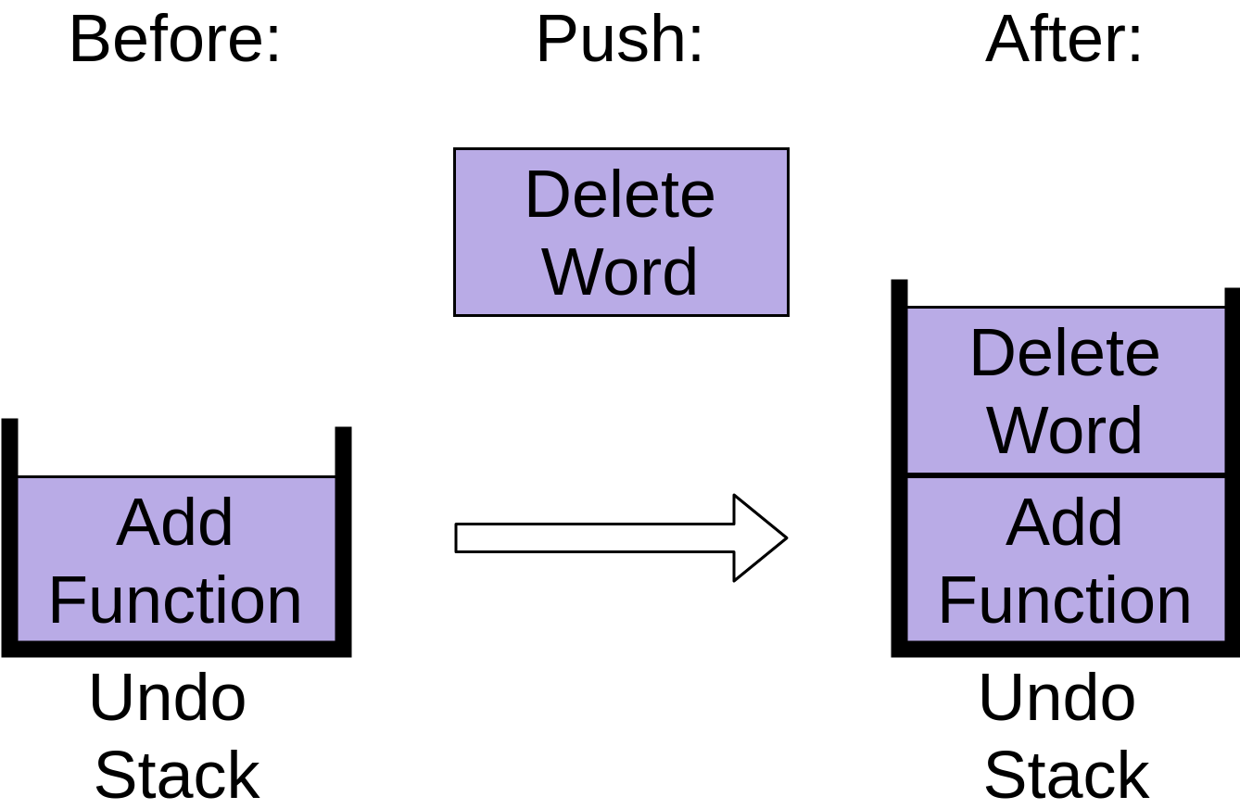
Notice how the Delete Word item is placed on top of the stack. Finally you indent a comment so that it’s lined up properly:
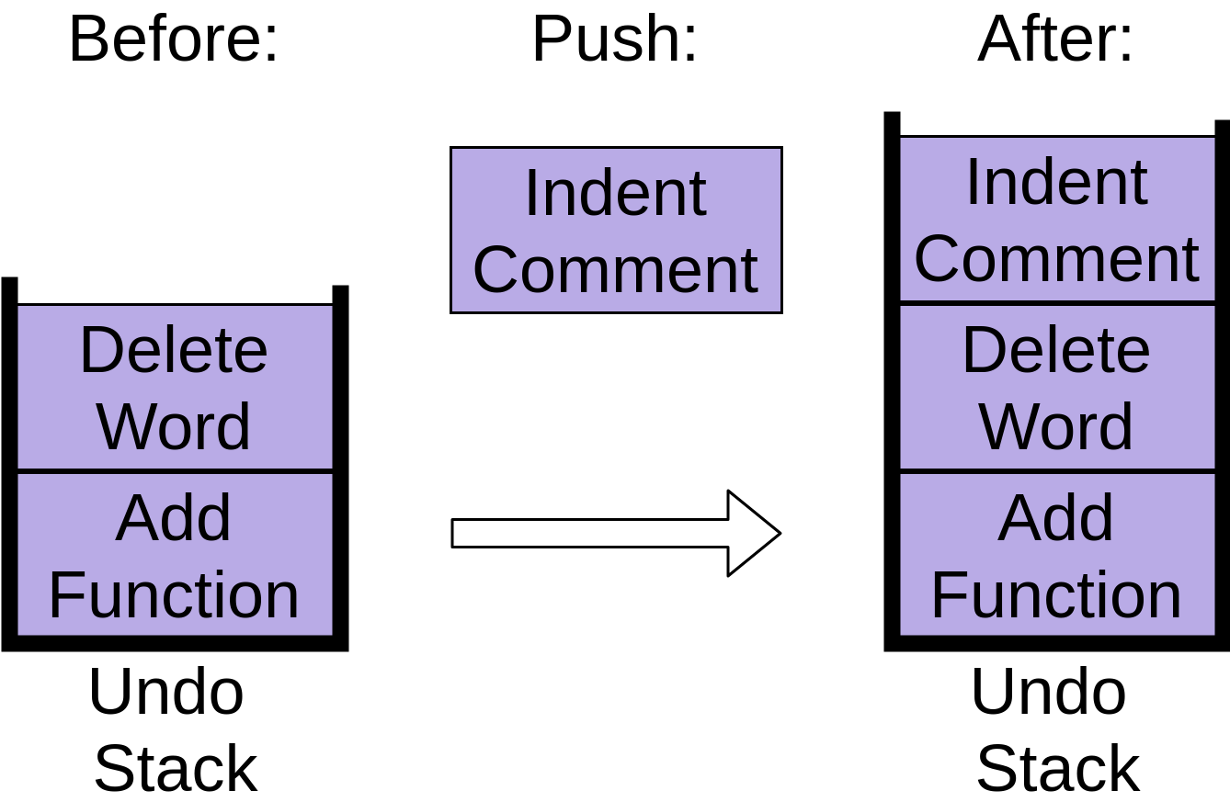

You can see that each of these commands are stored in an undo stack, with each new command being put at the top. When you’re working with stacks, adding new items like this is called push.

Now you’ve decided to undo all three of those changes, so you hit the undo command. It takes the item at the top of the stack, which was indenting the comment, and removes that from the stack:
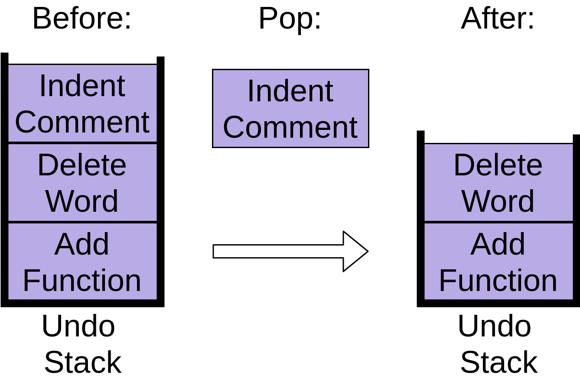
Your editor undoes the indent, and the undo stack now contains two items. This operation is the opposite of push and is commonly called pop.

When you hit undo again, the next item is popped off the stack:
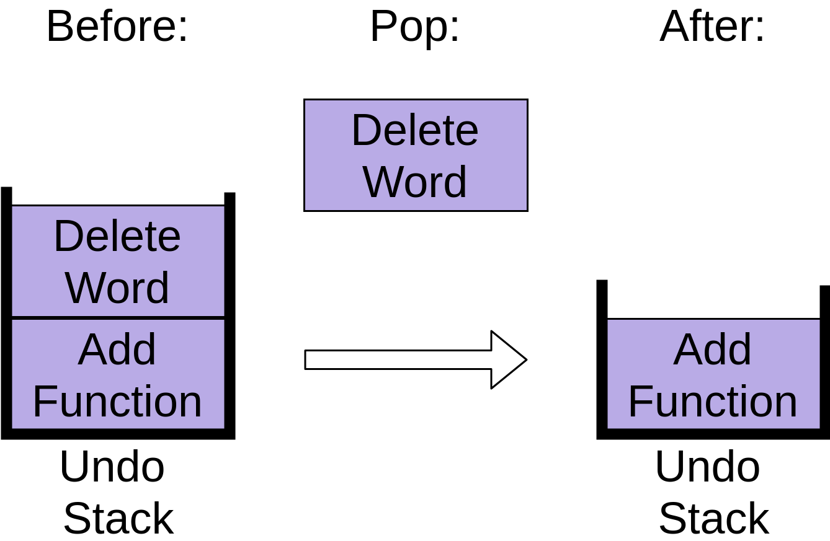
This removes the Delete Word item, leaving only one operation on the stack.
Finally, if you hit Undo a third time, then the last item will be popped off the stack:
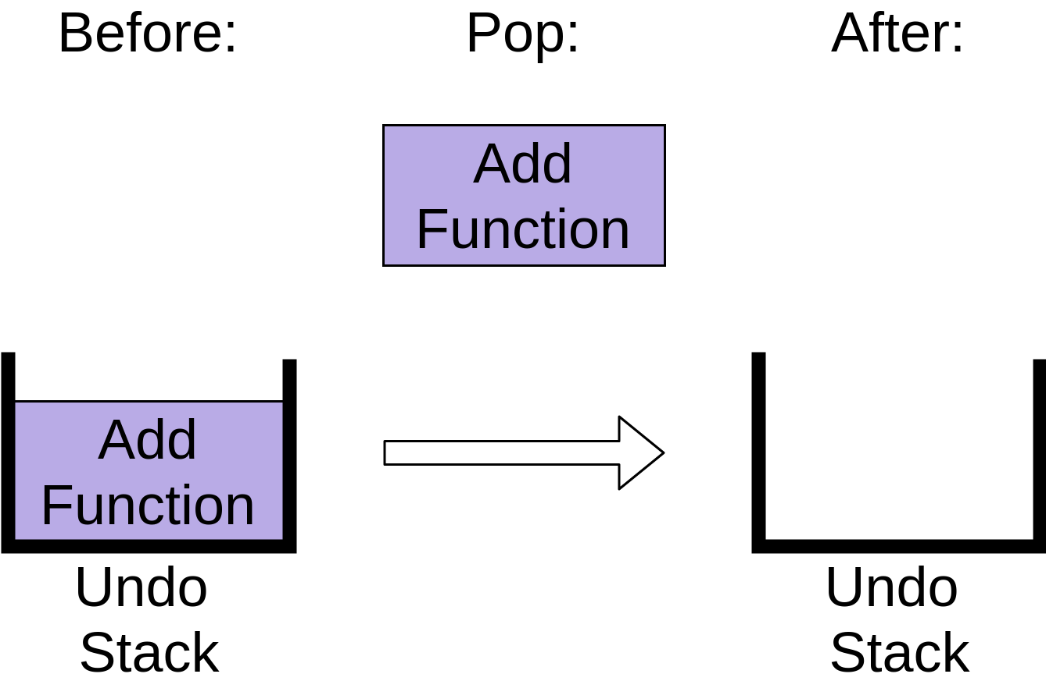
The undo stack is now empty. Hitting Undo again after this will have no effect because your undo stack is empty, at least in most editors.

Example 3
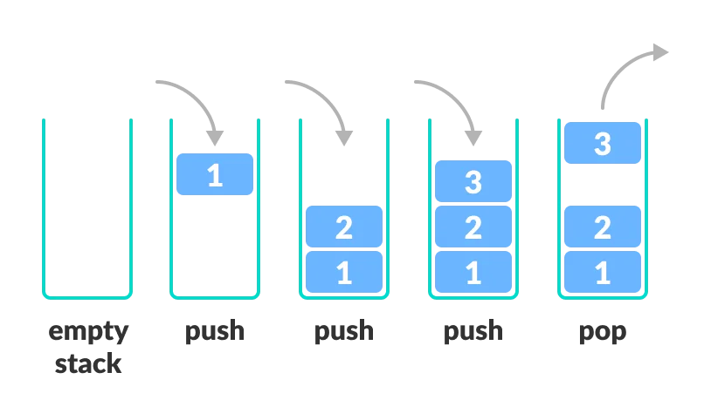

Basic Operations of Stack
There are some basic operations that allow us to perform different actions on a stack.
- Push: Add an element to the top of a stack
- Pop: Remove an element from the top of a stack
- IsEmpty: Check if the stack is empty
- Size: Check if the size of the stack
- Top: Get the value of the top element without removing it

Implementing a Python Stack
There are a couple of options when you’re implementing a Python stack.
You’ll look at the following Python stack implementations:
- list
- collections.deque
- queue.LifoQueue

Check the Implementations on the Stack folder in the Exercises project

Implementing using List
Unfortunately, list has a few shortcomings compared to other data structures you’ll look at.
The biggest issue is that it can run into speed issues as it grows. The items in a list are stored with the goal of providing fast access to random elements in the list. At a high level, this means that the items are stored next to each other in memory.
If your stack grows bigger than the block of memory that currently holds it, then Python needs to do some memory allocations. This can lead to some .append() calls taking much longer than other ones.

Implementing using deque() vs List
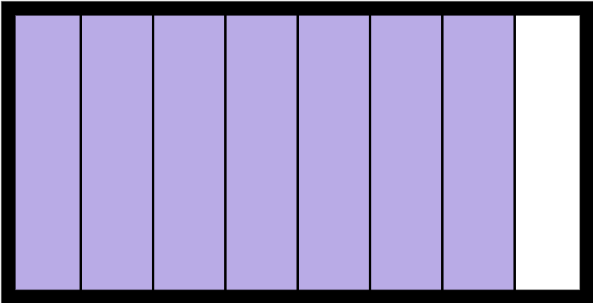
As you saw in the discussion about list above, it was built upon blocks of contiguous memory, meaning that the items in the list are stored right next to each other
This works great for several operations, like indexing into the list. Getting myList[3] is fast, as Python knows exactly where to look in memory to find it. This memory layout also allows slices to work well on lists.
The contiguous memory layout is the reason that list might need to take more time to .append() some objects than others. If the block of contiguous memory is full, then it will need to get another block, which can take much longer than a normal .append():
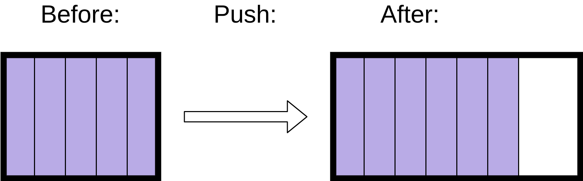
deque, on the other hand, is built upon a doubly linked list.
In a linked list structure, each entry is stored in its own memory block and has a reference to the next entry in the list. A doubly linked list is just the same, except that each entry has references to both the previous and the next entry in the list.
This allows you to easily add nodes to either end of the list.
Adding a new entry into a linked list structure only requires setting the new entry’s reference to point to the current top of the stack and then pointing the top of the stack to the new entry:
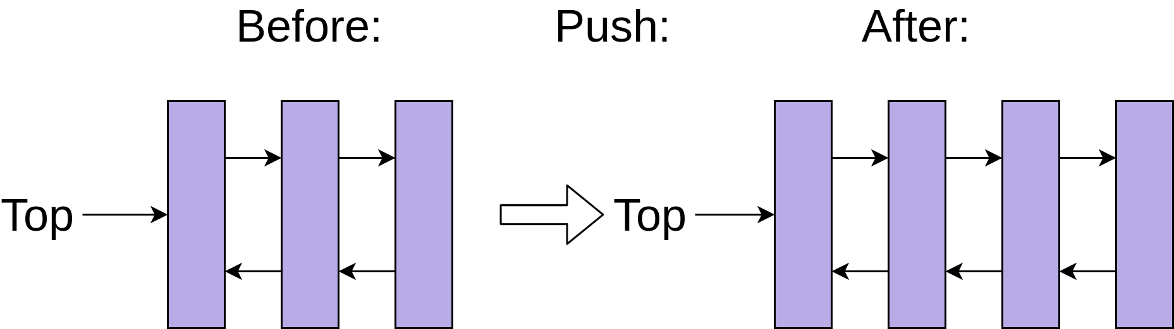
This constant-time addition and removal of entries onto a stack comes with a trade-off, however. Getting myDeque[3] is slower than it was for a list, because Python needs to walk through each node of the list to get to the third element.
Fortunately, you rarely want to do random indexing or slicing on a stack. Most operations on a stack are either push or pop.
The constant time .append() an .pop() operations make deque an excellent choice for implementing a Python stack.

Exercises
1) Reverse a string using Stack. For this function is preferred to use an functional approach
- Create a stack based on a string chars.
- Create the reverse string based on the Stack created.
Solution → reverse_string.py

2) Write code simulating a Stack of books. The BooksStack class should have also a category and name property. The class should allow you to add and remove books from the Stack, browse titles in Stack and show the last position on the Stack. Use magic methods to allow for:
- adding Stacks together
- comparing Stack sizes
- Stack string representation
- stating Stack length
The methods that the class should implement
from typing import List
class BooksStack:
def add_new_book(self, title: str): pass
def get_book(self): pass
def all_books(self) -> List[str]: pass
TIP: The class should implement the following magic methods to meet the requirements:
def __init__(self): pass
def __add__(self, second_stack): pass

# comparision
def __gt__(self, second_stack): pass
def __lt__(self, second_stack): pass
def __ge__(self, second_stack): pass
def __le__(self, second_stack): pass
# representation
def __str__(self): pass
def __repr__(self): pass
def __len__(self): pass

Solution → books_stack.py

3) Find the maximum in stack without using additional stack.
Tip: Instead of pushing a single element to the stack, push a pair instead. The pair consists of the (value, localMax) where localMax is the maximum value up to that element.
Solution → find_max.py

