Q1:
By plotting the Euclidean error between the ground-truth angles and the KNN-predicted joint angles for K from 1 to 20, we can see how prediction accuracy changes with K (Figure 1). At K = 1, the error is sharpest at 2.1283. K = 2 brings it down to 1.0641, and K = 3 hits the lowest tested value at 0.9586. K = 4 sits at 1.0578, and the error then slowly rises as K grows, reaching 1.3193 at K = 20. K = 3 is the best trade-off for this query.
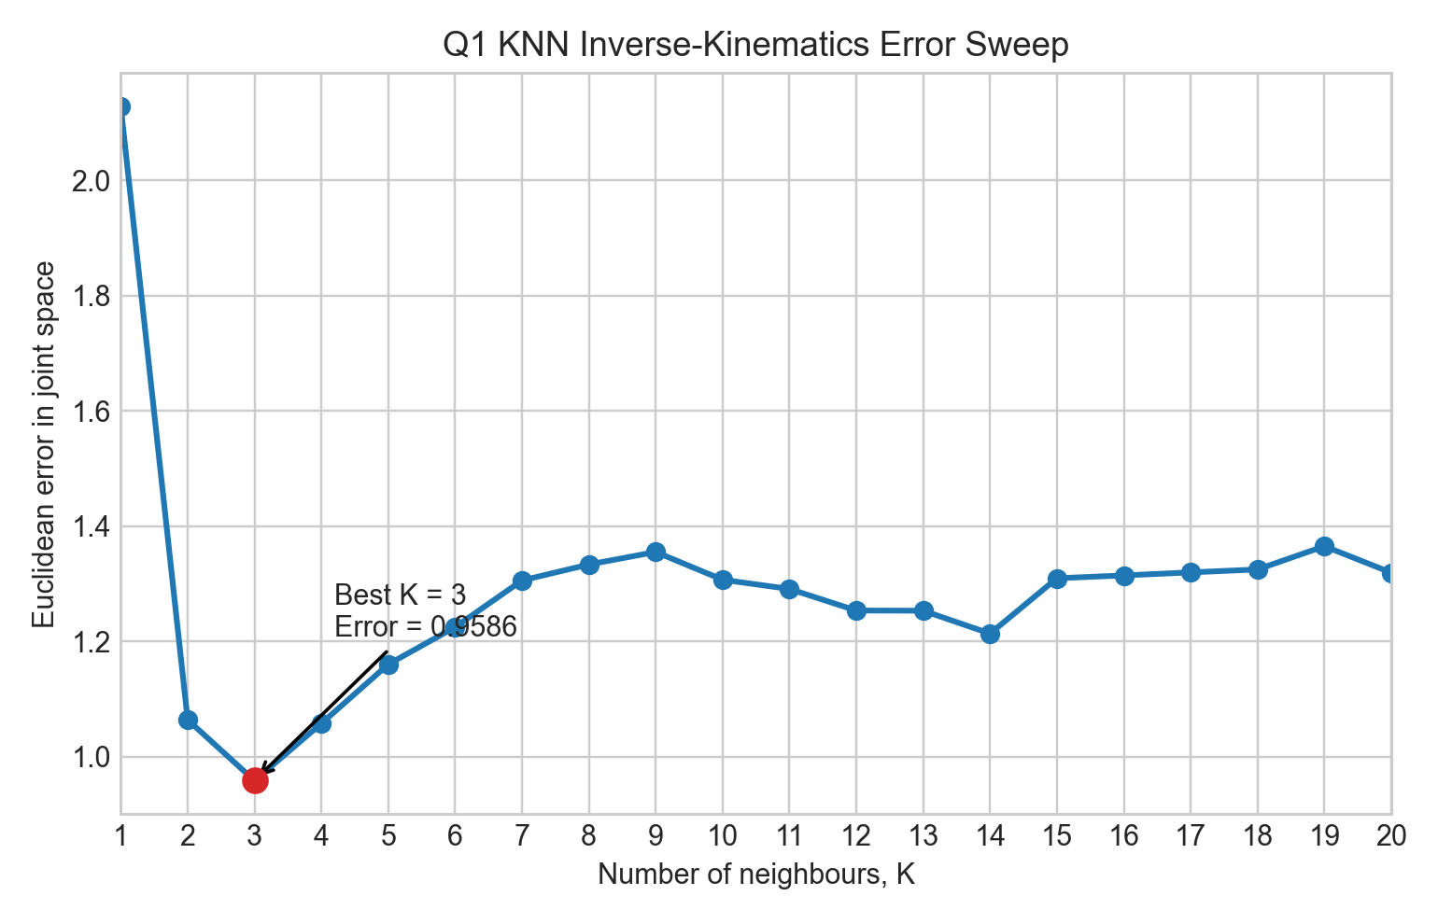
Figure 1. Euclidean joint-space prediction error versus K for the KNN inverse-kinematics estimate. The minimum tested error occurs at K = 3.
Very small K values rely on only one or two samples, so the prediction is highly sensitive and noisy, which explains the large error at K = 1. Very large K averages over neighbours that are less similar to the query in Cartesian space, so the prediction becomes more stable but more biased. A K that's too small has high variance, and a K that's too large underfits.
There's a robotics-specific reason this matters too. The task approximates inverse kinematics for a 7-DOF arm, where the mapping from end-effector position to joint configuration is not one-to-one. Similar end-effector positions can correspond to very different arm postures, so averaging too many joint vectors blends valid solutions together and gives a configuration that isn't really representative of any of them. KNN benefits from local information, but only when the neighbourhood stays tight enough to preserve posture similarity.
Prediction accuracy is best at an intermediate K, where the model balances local fidelity and robustness. For this query and dataset, that point is K = 3. A fuller evaluation would repeat the analysis across many query positions to confirm this generalises.

Q3:
k_att controls how strongly the robot is pulled toward the goal. When k_att is too small, the attractive pull is weak and the planner cannot converge (seen at k_att = 0.1, which stalls 6.0140 from the goal after 10000 iterations). When k_att is too large, the pull becomes aggressive, causing overshooting and oscillation around the goal while even cutting through obstacles (seen at k_att = 2.0, which only reaches the goal after 4444 iterations with negative clearance). Strong attraction fails because the goal term dominates obstacle avoidance, and the fixed step size in gradient descent turns this into overshoot. The best in the sweep is k_att = 1.0, which reaches the goal in 96 iterations (Figure 2).
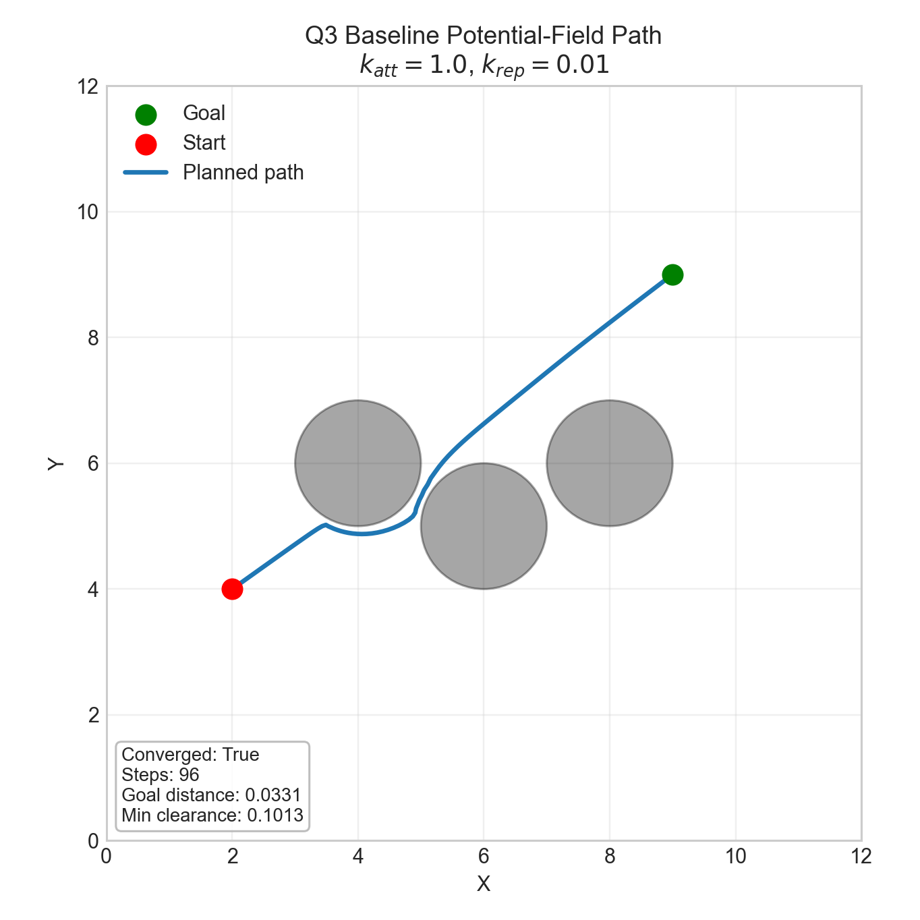
Figure 2. Baseline potential-field path for k_att = 1.0 and k_rep = 0.01. The planner reaches the goal region while keeping positive obstacle clearance.
k_rep controls how strongly the robot is pushed away from obstacles. When k_rep is too small, repulsion is insufficient, allowing the robot to pass dangerously close to obstacles for a more direct but unsafe path (seen at k_rep = 0.001, which gives a clearance of only 0.0137). When k_rep is too large, the repulsive gradients from neighbouring obstacles dominate the attractive pull of the goal, trapping the robot in local minima or oscillatory regions (seen at k_rep = 0.05 and 0.1, both of which fail to converge). The best in the sweep is k_rep = 0.01, which reaches the goal in 96 iterations with clearance 0.1013 (Figure 3).
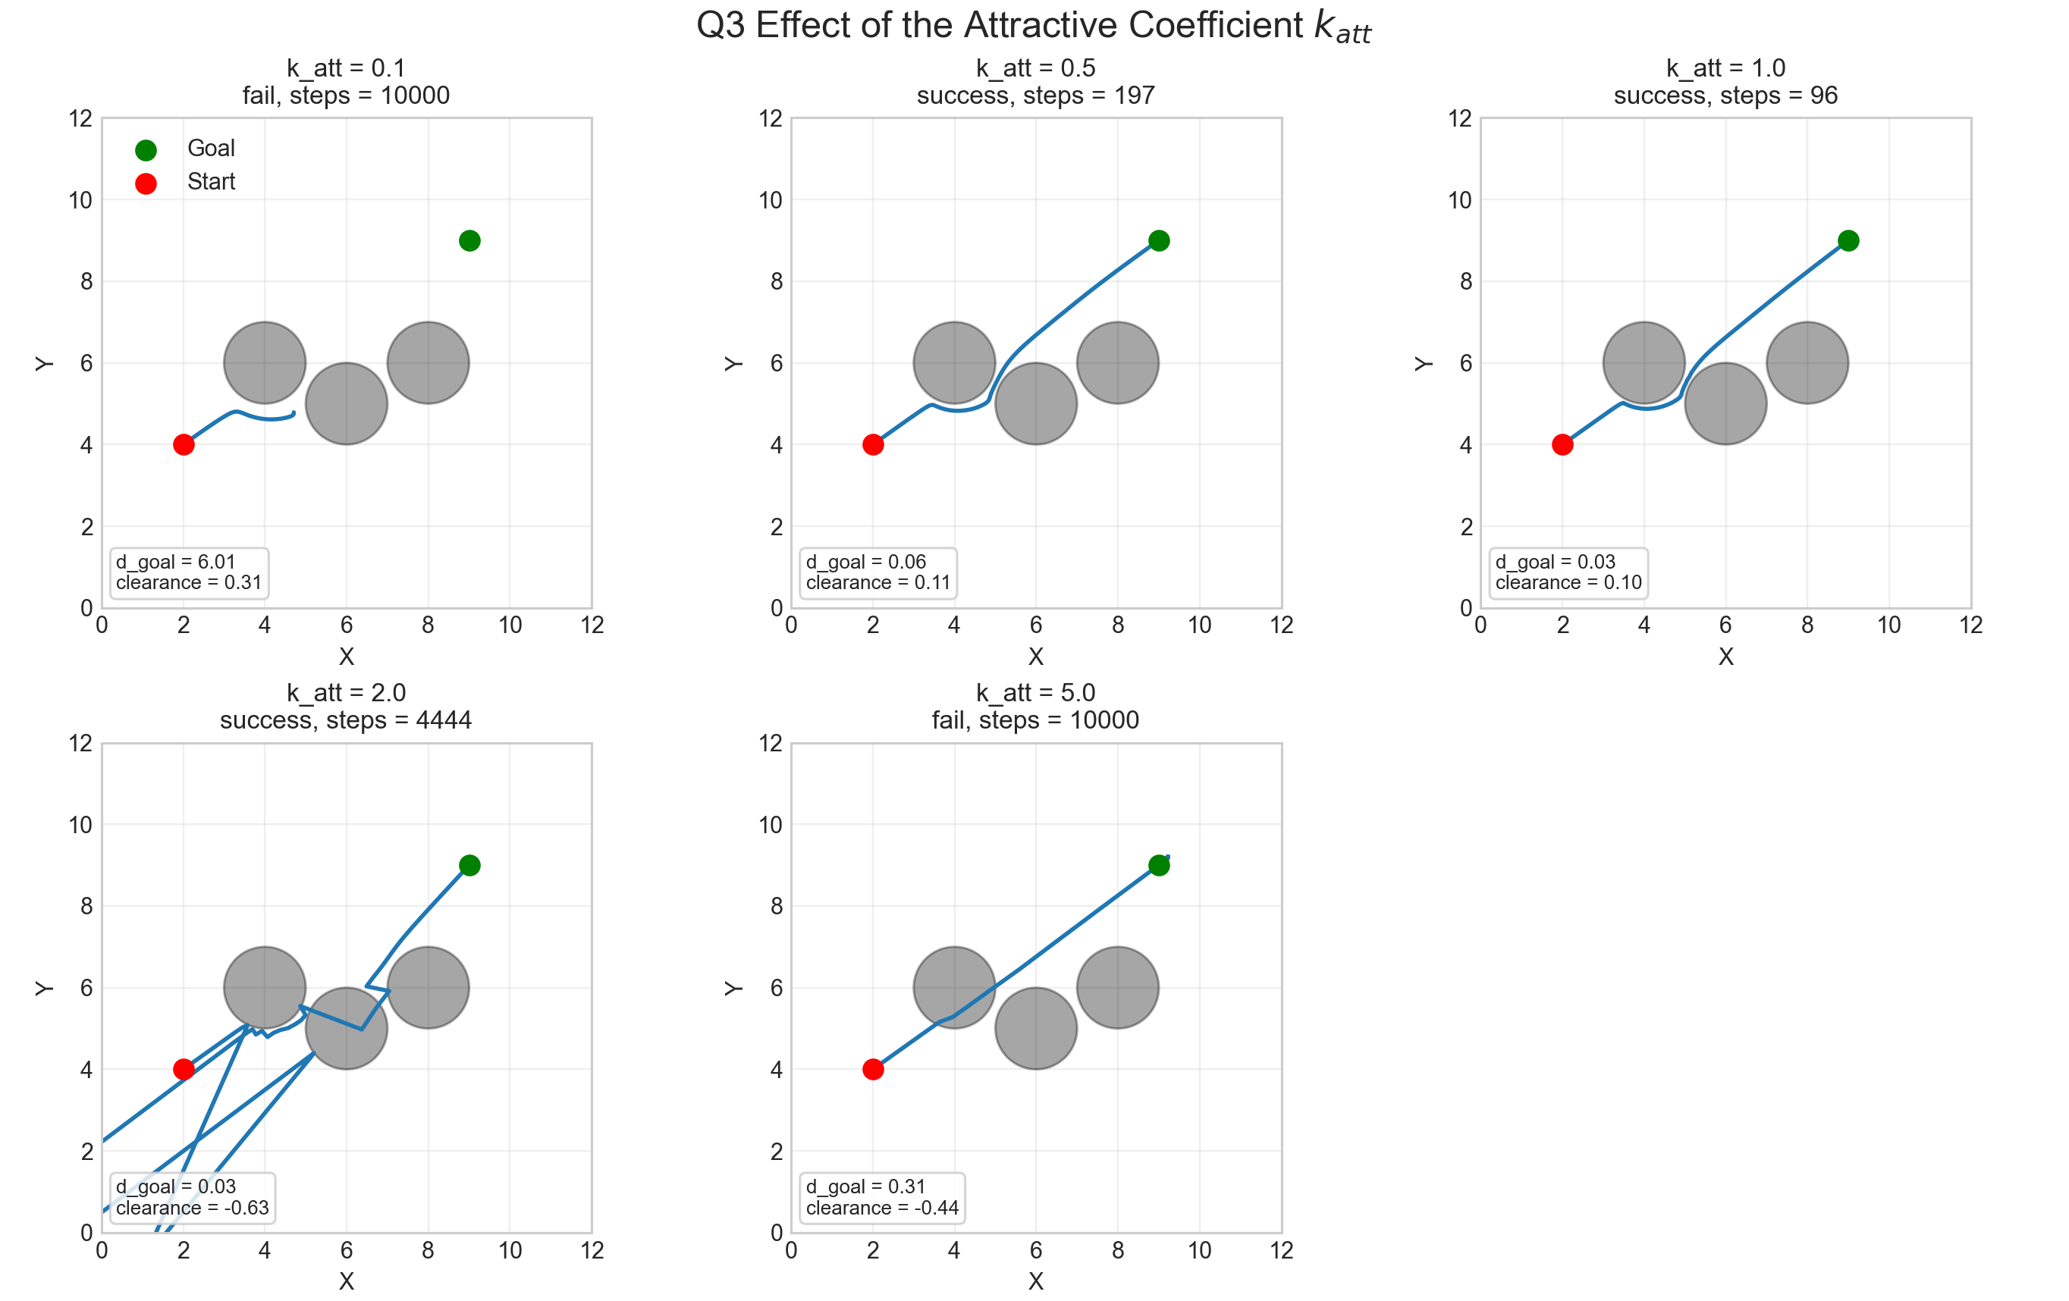
Figure 3. Effect of varying k_att with k_rep fixed at 0.01. Moderate attraction improves convergence, while excessive attraction causes unstable and unsafe trajectories.
Larger goal attraction does not automatically produce a better path. Moderate attraction creates a strong enough descent direction to overcome shallow local structure in the field. Weak attraction stalls the robot before it reaches the target. Strong attraction lets the goal term dominate obstacle avoidance, and combined with the fixed gradient-descent step size, this produces overshoot and oscillation. k_att = 1.0 is the most effective compromise for this environment.
Figure 4 shows the effect of k_rep with k_att fixed at 1.0. At k_rep = 0.001 the planner converges in 94 iterations, but minimum clearance is only 0.0137, so the path passes extremely close to an obstacle. k_rep = 0.005 and k_rep = 0.01 keep convergence while improving the safety margin. k_rep = 0.01 reaches the goal in 96 iterations with clearance of 0.1013, which is the most reasonable trade-off in the sweep. Increasing further to k_rep = 0.05 or 0.1 causes complete failure, with the planner remaining 5.7424 and 6.0140 units from the goal after 10000 iterations.
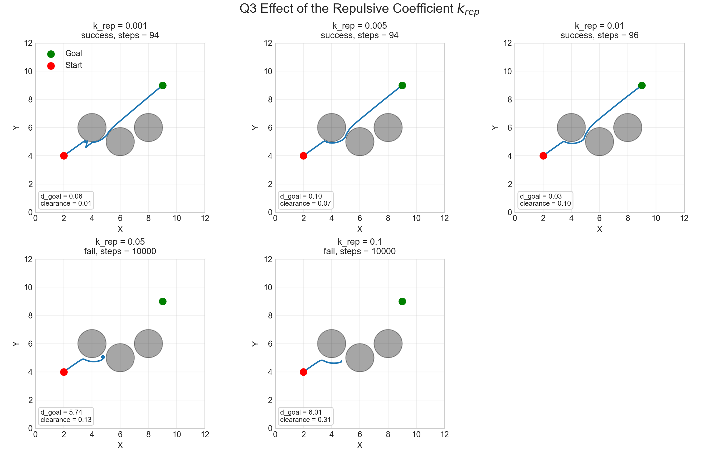
Figure 4. Effect of varying k_rep with k_att fixed at 1.0. Low repulsion gives efficient but unsafe paths, while excessive repulsion traps the planner in local minima.
The choice of k_att and k_rep depends on the environment structure. In tight spaces with narrow passages, aggressive tuning fails. High k_rep causes oscillation-induced local minima, and low k_att fails to provide sufficient pull through the constraints. In wide, open environments, both coefficients can be increased for faster convergence and wider safety margins.
The potential-field method is computationally light and easy to differentiate with PyTorch, but the results show its main weakness. Performance is highly sensitive to parameter tuning and environment geometry, and the method doesn't guarantee global optimality or escape from local minima. The chosen coefficients are good for this environment and shouldn't be reused elsewhere without re-tuning.

