Tracing a Non-Compliant Deployment Through Azure Policy

Scenario
An intern with temporary Contributor access spun up a test environment intended for a leadership presentation, but the resource group didn't follow the tenant's naming standards. My task was to determine what had been deployed, how it got deployed, and why Azure Policy governance in the tenant failed to catch a non-compliant deployment before it landed.
The investigation was carried out in a live, multi-user Azure training tenant (Mad Hat Labs) with Reader-only access, so every step below was read-only — no resources were modified in the process.

Environment
- Platform: Microsoft Azure — “Mad Hat Labs” tenant
- Services used: Azure Resource Manager (Resource Groups, Deployments), Azure Policy (Assignments, Compliance)
- Access level: Reader access only, in a live multi-user Azure training tenant — no resources were created, modified, or deleted
- Tools: Azure Portal (no CLI/PowerShell used — investigation was portal-native)

Investigation
1. Identify the naming anomaly
I started in Resource Manager → Resource Groups and scanned for anything that broke the tenant's naming convention, which normally follows {resource-type}-{workload}-{environment}-{region}-{instance}. That pattern encodes a resource group's workload, environment, region, and purpose at a glance, so a group that doesn't fit it stands out immediately. One resource group broke the pattern. Based on the name alone I didn't suspect anything malicious — it just didn't fit the standard, which made it worth a closer look.
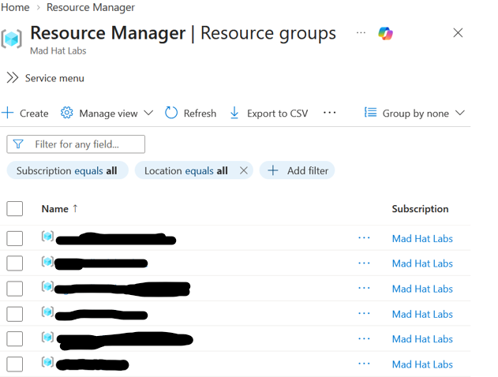
Resource Groups view — one group's name breaks the {resource-type}-{workload}-{environment}-{region}-{instance} convention used everywhere else in the tenant.
2. Check the resource's tags and metadata
Next I opened the resource group's Tags blade to see whether it carried any of the metadata upper management requires for documenting test resources. Even though the group's name didn't follow convention, the intern had still added the expected tag string — so the deployment wasn't undocumented, just misnamed.
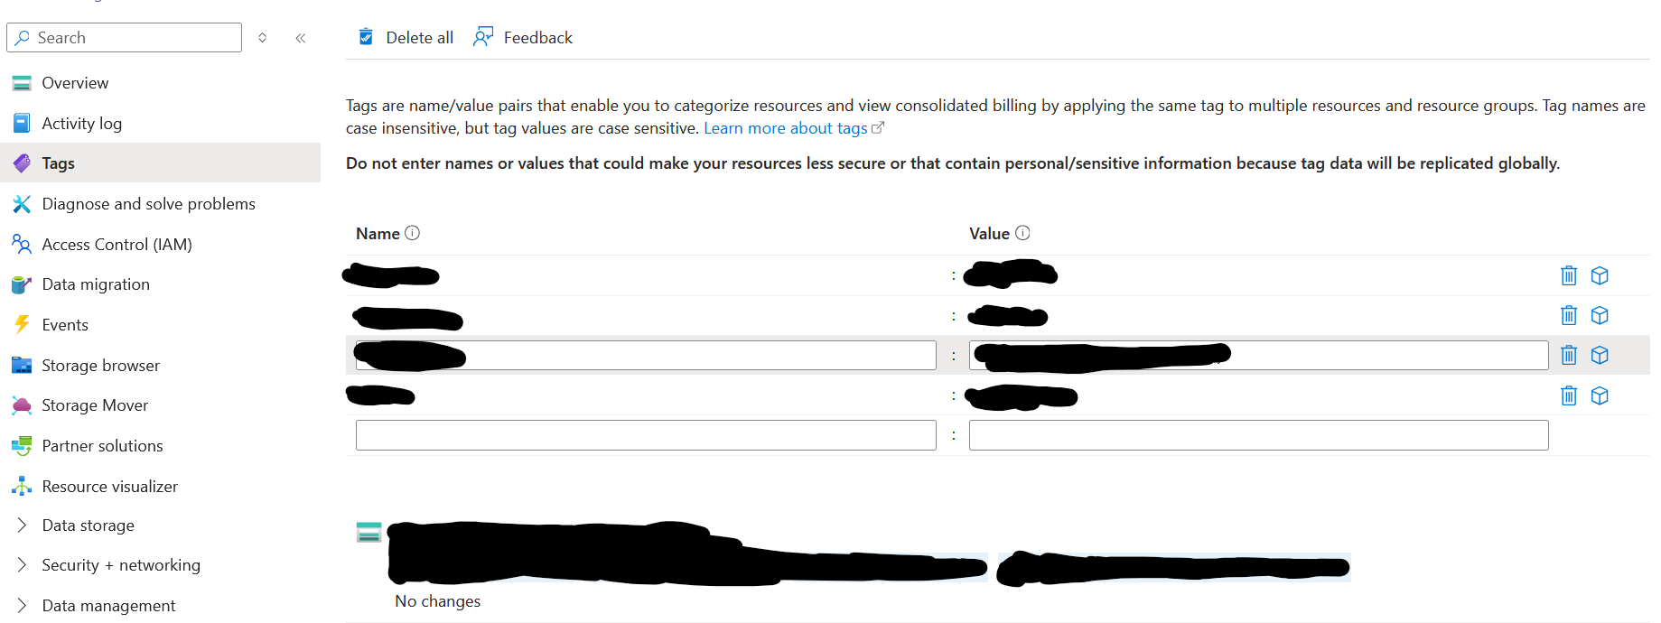
Tags blade — the required test-resource documentation tag is present despite the naming convention violation.
3. Trace the deployment
The resource group didn't create itself, so I moved to the group's Overview → Deployments to see what had actually been deployed and by what mechanism. There was a single deployment with a simple, intern-assigned name, which made it easy to identify as the one in question. Opening it surfaced the deployment status, its config inputs, and the timestamp it was created.
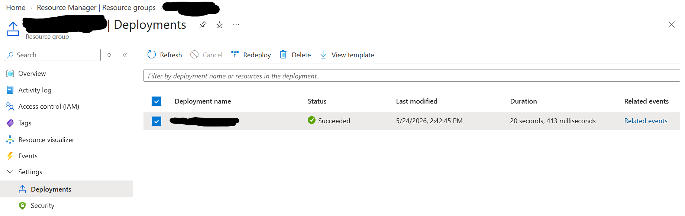
Deployments list — a single successful deployment, 20 seconds in duration, is the only entry in the resource group.
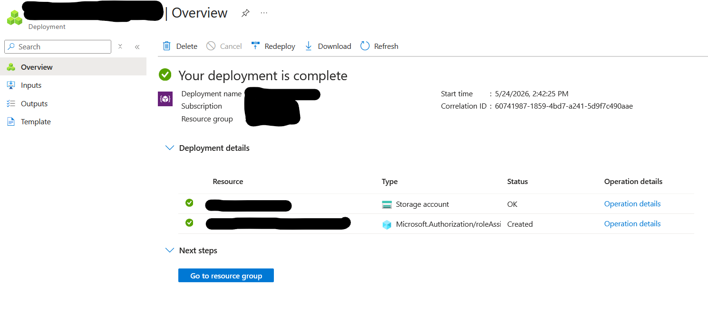
Deployment detail — the deployment created a storage account and a role assignment (Microsoft.Authorization/roleAssignments), both completed successfully.
4. Check why Azure Policy didn't flag it
To understand why governance didn't catch this, I opened the resource group's Policies blade to look at its compliance score. The naming convention policy was showing as non-compliant against this resource group, which confirmed the violation was visible to Azure Policy — the question was why it hadn't stopped anything.
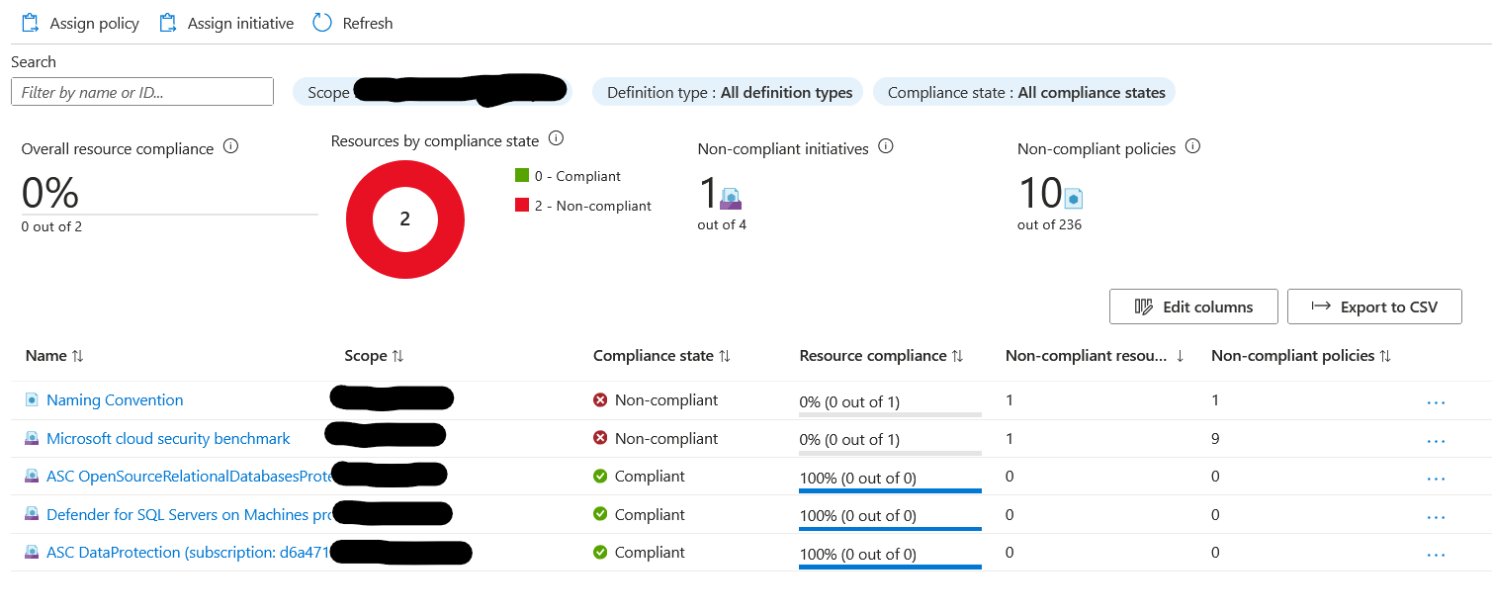
Policy compliance view — the Naming Convention assignment and the Microsoft Cloud Security Benchmark initiative both show 0% compliance for this resource group, alongside several compliant initiatives.
5. Find the governance control failure
Finally, I went to Policy → Assignments at the tenant scope and opened the Naming Convention assignment to see how it was configured. Its effect parameter was set to Audit rather than Deny. An Audit effect logs and scores the violation but never blocks the request — a Deny effect would have rejected the deployment outright before it was created. That single parameter was the actual root cause: the policy existed, was correctly scoped to the tenant, and correctly detected the violation — it just wasn't configured to enforce it.
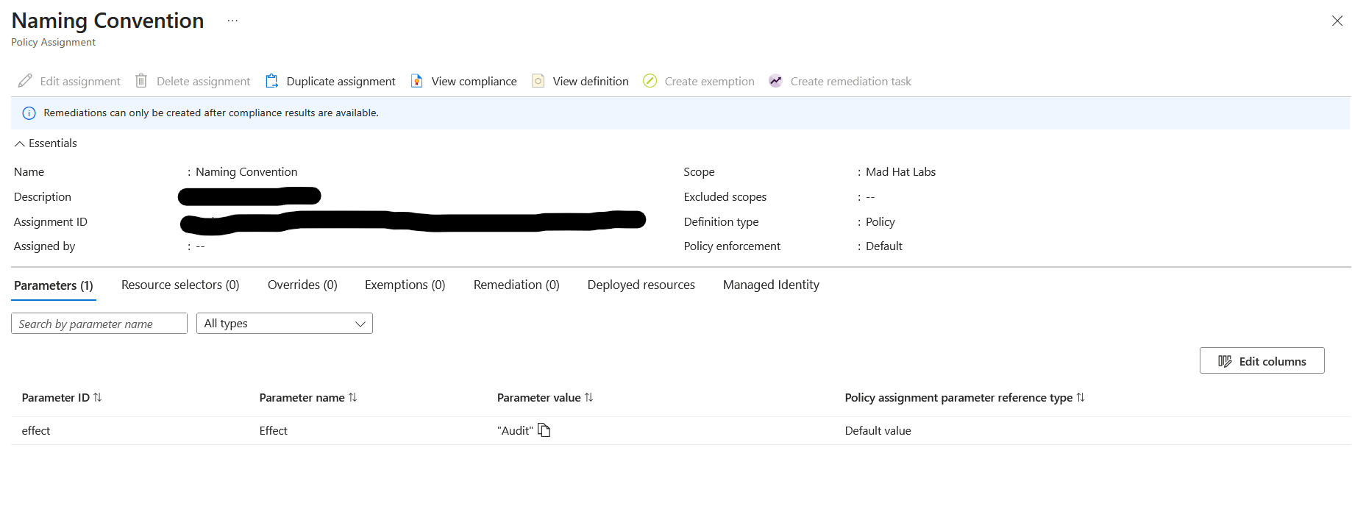
Naming Convention policy assignment — Effect parameter is set to “Audit,” scoped to Mad Hat Labs.
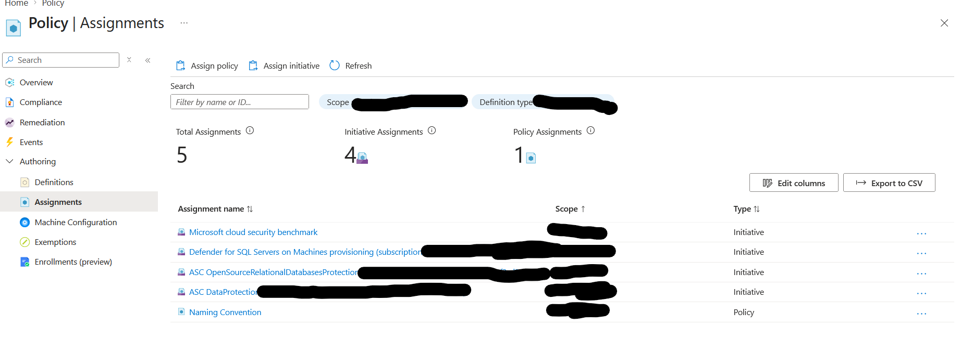
Policy → Assignments — five total assignments in the tenant; Naming Convention is the only one scoped as a standalone Policy rather than an Initiative.

What broke / what surprised me
My first assumption when I spotted the odd name was that this could be an unsanctioned or even malicious deployment — the naming break was the kind of thing that, in a real production tenant, gets treated as a red flag first and investigated second. Finding the correct documentation tag already in place on step 2 reframed the whole investigation: this wasn't a rogue deployment instead it was a sanctioned one that simply skipped one convention. That distinction mattered, because it meant the fix wasn't “find and remove an unauthorized resource” — it was “figure out why a control that should have caught this didn't.”
The other thing that wasn't obvious going in: I expected the root cause to be that no naming policy existed at all, or that it wasn't assigned to the right scope. Instead, the policy was correctly assigned to the whole tenant and was correctly evaluating the resource as non-compliant — it showed up right there in the compliance score. The actual gap was a single configuration choice (Audit vs. Deny) buried in the assignment's parameters, which took working backward from the compliance dashboard into the assignment itself to find.

Findings and recommendations
The intern's deployment (a storage account plus an associated role assignment) was legitimate, authorized, and tagged correctly for tracking — it simply didn't follow the tenant's resource-group naming standard. Azure Policy correctly detected this: the Naming Convention assignment showed the resource group at 0% compliance. However, that assignment's effect was set to Audit, not Deny, so the non-compliant name was logged rather than blocked, allowing the deployment through unchanged.
If I were reporting this to the resource owner, I'd recommend:
- Change the Naming Convention policy's effect parameter from Audit to Deny.
- Review the tenant's other policy assignments for the same Audit-only pattern — the Microsoft Cloud Security Benchmark initiative was also showing non-compliant, and it's worth confirming that isn't set to audit-only as well before assuming it would catch a real issue.
- Add a lightweight pre-deployment check (or a short naming-convention reference doc) for temporary/intern Contributor access, so the convention is caught at request time rather than relying on policy enforcement alone as the only safety net.

What I learned
- Azure Policy effects matter as much as the policy definition itself. A correctly scoped, correctly evaluating policy set to Audit will detect a violation and still let it through. Deny is what blocks.
- Deployment history (Resource Group → Deployments) is a fast, low privilege way to trace who/what created a resource and when, without needing to write access or search through log queries.
- Tags and naming conventions are separate controls that can pass or fail independently. A resource can be fully documented and still violate structural naming standards, so I couldn't assume one implied the other.
- What I'd do differently: I'd check the policy assignment's effect parameter earlier in the process instead of last. I would also spend time confirming the deployment itself was legitimate before I got to the actual root cause, when the compliance dashboard had already pointed at the failing policy from step 4 onward.

