User Manual:

# Overview:

The game revolves around our main character who is tasked with collecting apples for the three villages so that he can then move onto the boss monster to fight. Helping the villages is an optional task however does allow the player a better chance of success.

# How to run the executable

To run the executable:

* Firstly locate the folder the executable it located in.
* Then double lcik the executable
* Select the setting you want and click run
* You will now be at the main menu.
* Select start
* Now you can play the game!

# How to run the installer

To install the program:

* Double click the installer
* Follow the prompts to successfully install the program
* Open it up and select the settings you want
* You will now be at the main menu
* Select Start
* Now you can play the game!

# Controls:

|  |  |  |  |
| --- | --- | --- | --- |
| **Movement** | **Keyboard** | **Mouse** | **Gamepad** |
| **Forward** | W / UP arrow | N/A | Up on Stick |
| **Back** | S / Down arrow | N/A | Down on stick |
| **Left** | A / Left arrow | N/A | Left on stick |
| **Right** | D / Right arrow | N/A | Right on stick |
| **Exit to main menu** | Escape | N/A | N/A |
| **Camera movement** |  | X + Y movement on the mouse | Camera follows behind you |

# HUD:

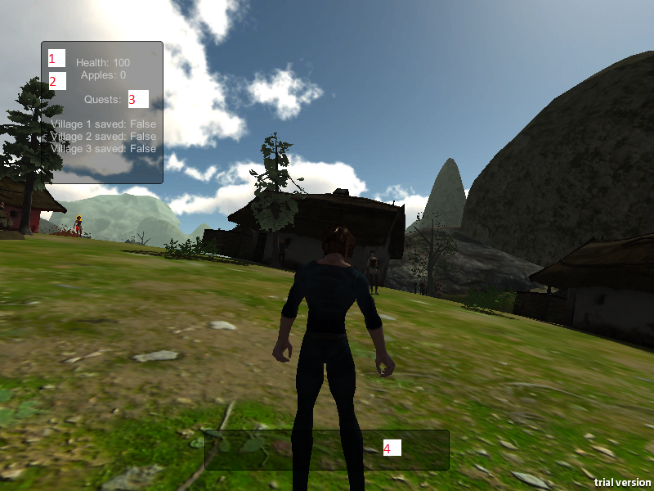

|  |  |  |
| --- | --- | --- |
| Number | Name | Description |
| 1 | Player Health | This number represents the players health points when this number is zero you will faint and find yourself back at town |
| 2 | Apples | This tells you how many apples you currently have in your inventory |
| 3 | Quests | This shows a list of quests which have been completed and which have not. |
| 4 | Chat bar | This is where all the chat will be located when you interact with the people around town |

# Main objective:

Your first step is to locate the quest giver She looks like this and is located at the edge of the village. From there you need to complete her quest and the ones in the other towns as well. Once this is done you can go face the boss located in the cave (picture below).

# Quest Giver

# 

Once you get close to the quest givers you will automatically start a conversation with them, they will give you the details of your quest and then once that quest is complete you can go back to the quest giver to hand it and she will send you on your way.

# Cave

# Checkpoints

Another good location to keep an eye out for is the checkpoint locations. These Places will save your progress so when you die you won't loose it all. You can save walking through the building show below. There is one in each town.

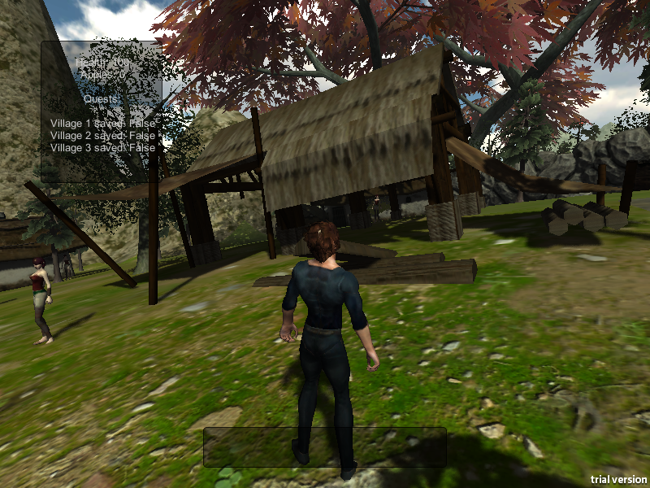

# Wolf

The wolf is a common enemy that the player should avoid, once they detect you they will start to chase you. If you are close enough to their mouths they will bite and you will lose health. Try to avoid them, if you get caught just run you should be safe.

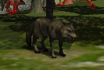

# Apples

This is an apple. It is the main quest item in the game and you will need to collect a number of these. So keep an eye out for them. They mostly grow in the forest but so do the wolfs.



# Giant Apple

The giant apple is the main goal of the game, the game does not have a normal boss monster because it didn't really suit the game style to have one so the second level is just a boss level where all the wolves are harder and you have to run from them while still looking for the giant apple, it is quiet easy to spot.