**REQUIREMENTS AND ANALYSIS DOCUMENT**

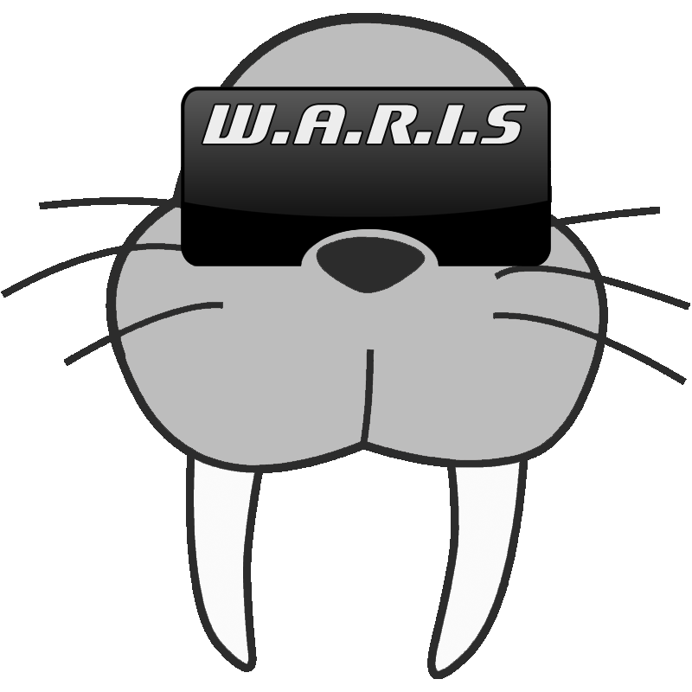

|  |  |
| --- | --- |
| Project Name: | W.A.R.I.S. |
| Client: | Mr Shri Rai |
| Supervisor: | Dr Fairuz Shiratuddin |
|  |  |
| Team Name: | W.A.R.I.S |
| Members: | Raymond Forster |
|  | Brandon Ashworth |
|  | Mitch Askew |
|  | Ross Johnson |
|  | Tim Matisons |
|  | Welsley Lui |
|  |  |
| Document Date: | 28/10/2014 |
| Document Version: | 2.2 |

**Contents:**

Executive summary ......................................................................................................................... 3

Introduction ..................................................................................................................................... 3

Solution outline ............................................................................................................................... 3

Functional requirements .................................................................................................................. 4

Non-functional requirements ........................................................................................................... 5

Diagrammatic representation of the requirements ........................................................................... 7

Conclusion ....................................................................................................................................... 7

Appendix A ...................................................................................................................................... 8

1. **Executive summary**

The purpose of this document is to record, break down and outline the project requirements. It will be used to provide a clear and thorough list of both the functional and non-functional project requirements, which have been extracted from the client over numerous client meetings. We will be providing a comprehensive diagrammatic overview of the structure of the project.

Included in this document is an introduction outlining the purpose of the project, an outline of the scope and constraints involved in the completion of the project and the functional and non-functional requirements to be taken into consideration.

1. **Introduction**

The purpose of this project is to plan and create a wearable augmented reality product which is similar to the Google Glasses. The goal of the project is to have at least a working prototype which can demonstrate the capability of a wearable augmented reality device, including recognising tags, displaying information and storing data.

The client for our project is Mr Shri Rai who is a professor at Murdoch University and is the Academic chair for the Games Software Design and Production major, and coordinates various units within the IT field.

There is no current system to work from for this project, so we shall be beginning from a fresh idea. The system we are creating will be able to be carried around by an individual and when worn, will give detailed information of their surroundings with the ability to follow campus maps, display information regarding offices in buildings and give information for lecture times from lecture theatres. We are aiming to run this system using a gestural interface through the user’s fingers, but we will implement another way of control for either a game pad or touch screen in case the gestural interface malfunctions.

The problem that we are trying to solve is for an easier way for people to interact with the environment around them, and for quicker, more relevant access to information that might be of need to a person who is looking for something specific, without the need to hunt through pages and pages of information.

The primary goal for this project is to create a system which is use able and informative, which helps augment daily life for an individual and hopefully provides a more efficient way of sending relevant information regarding the individuals surroundings. It is also hoped that this project can then become a proof of concept for future projects.

The methodology we have chosen to follow for our project is the Agile model, we chose this methodology because it offers a flexible platform for us to be able to rapidly develop our system, while still allowing for design changes should they arise.

1. **Outline of the solution proposed to solve the problem(s)**

In consultation with our client, we have established a scope that is both flexible and still able to meet all the necessary client requirements. The project has been designed in a way that allows us to add and remove content without affecting the underlying functionality of the system.

The system is being designed as a platform for people to be able to access information on various things they come across in a fast and helpful way. The user should be able to take the information provided and translate it into help for their daily lives.

The interface that the user will access the functions of the system is hoped to be gestural, which will be the movement of their fingers in front of the camera which is on the device, in the case that this does not work, there will be support for a game pad or touch screen input. The interface that the user will see is just overlayed over their current view, and so when they look at a tag on a building, they will see the relevant information appear in their vision.

The constraints imposed on this project are as follows: Time, Cost, Technical and Content.

Time: Project development time is restricted by the set deadline.

Cost: Project cost is restricted by our complete lack of funds.

Technical: The technical constraint is limited by each of our individual skill sets and by the tools we have available to us.

Content: The content constraint is the limit we have from the client requirements.

Hardware and Software requirements are as follows:

Windows PC’s.

Android Smart Phone and/or Tablet.

Unity

Vuforia.

Github.

Skype.

Facebook.

Google Drive.

1. **Functional requirements**

These are all the requirements, both crucial and non crucial presented to the group by the client. They have been ranked in order of importance to the client and the project on the following scale:

Criticality key ratings – through 5;

1. Not at all Critical
2. Slightly Critical
3. Moderately Critical
4. Very Critical
5. Absolutely Critical

Interface Design between Software and External Non-Human Entities

The software will interface with the Murdoch University website by parsing web pages related to

specific buildings and Murdoch University staff working in those buildings. This will be done either

through a web page parser or through an XML parser of which the selection will be implemented in

Unity.

Information such as building number and name will be extracted from the building information and

information such as staff number and qualification will be extracted from the staff pages.

Interface Design between Software and Human Users

A human user will interact with the software via a Graphical User Interface (GUI) and by using a

gamepad controller attached to the device running the WARIS. The GUI will have a few simple

elements such as windows, buttons and scroll windows, all of which will be semi-transparent so that

the camera video feed will still be somewhat visible behind them.

A custom cursor will be displayed with the GUI which the user has control of using the left control

stick on the gamepad. The user can click the cursor using either the ‘A’ button or the right bumper,

whichever they prefer. Buttons can be interacted with by moving the cursor over them and clicking

on them while the scroll windows can be scrolled by hovering over them and using the right control

stick.

While the user is looking at a building with information stored, a window will appear with basic

information on that building and some interactive buttons that will allow the user to go into more

depth with the information that they can see. This window will remain on the screen until it is closed

by the user so that they can continue searching for information on the building while looking away

from it.

This simple interface design will be capable of displaying all the information necessary for the WARIS in an easy-to-use format.

Interface Specifications:

• MicroUSB male to USB female adapter for Android

• Phone specific male to USB female adapter for iPhone/iOS

• Xbox controller or equivalent (preferably wireless but compatible with both wired and wireless)

1. **Non-functional requirements**

These are the requirements inherent to the project creation, but that aren’t to do with the content of the project itself.

**Documentation**

**Required Documentation**

* Design Documents
* Requirements and Analysis (This)
* Project Management Plan
* Project/Team charter
* Deliverable Task Breakdown Statement
* Meeting Agenda and Minutes
* Weekly Status Reports
* User Manual

**Audiences**

Except for the User Manual, all of these documents are for project staff, supervisors and the client.

The User Manual is for the end user.

**Hardware Considerations**

**Hardware**

* Windows PC
* Android Smart Phone/Tablet

**System Requirements**

* Windows XP or later
* 2GB Ram
* CPU at least 2.0Ghz
* 1GB of hard disk space

**Performance Characteristics**

* The system should be responsive to the user actions
* The system must have a loading time of under 1 minute
* The system should operate on as wider range of devices as possible
* The system should always present the user with a smooth, enjoyable experience.

**Error Handling and Extreme Conditions**

**Input Errors**

* In the case of an input error, the system should prompt the user for a valid action
* The system will not accept input errors as valid inputs

**Extreme Conditions**

* In the case of an extreme condition, the system is to attempt to save its data and then terminate

**System Interfacing and Compatibility**

* The system will need to be able to be able to accept inputs from multiple interface types.

**Hardware**

**Reliability**

* The system should not crash unexpectedly at any point
* The system should be able to handle various inputs (Finger gestures, mouse/keyboard, game pad, touch screen.)

**Portability**

* The system is being build primarily for Android, but if possible should also be able to run on IOS.

**System Modifications**

* The ability to add or remove content, including, the potential for voice commands.
* Multiple Inputs/Outputs
* Addition to the interface

**Physical Environment**

**Location**

* Campus, Home or Work environment.
* There is a certain space required for the gestural interface.
* The user needs to be able to see the target for the device to recognise the tag.

**Security Issues**

**Privacy**

* If the project is to go ahead with facial recognition, there is a potential privacy breach there.

**System Security**

* Security is not an issue for this project because we are not concerned whether or not the end user wants to make their own modifications to the program

**Resource Issues**

* The end user is responsible for installation.
* Nobody is responsible for maintenance after release.

**Diagrammatic representation of the requirements**

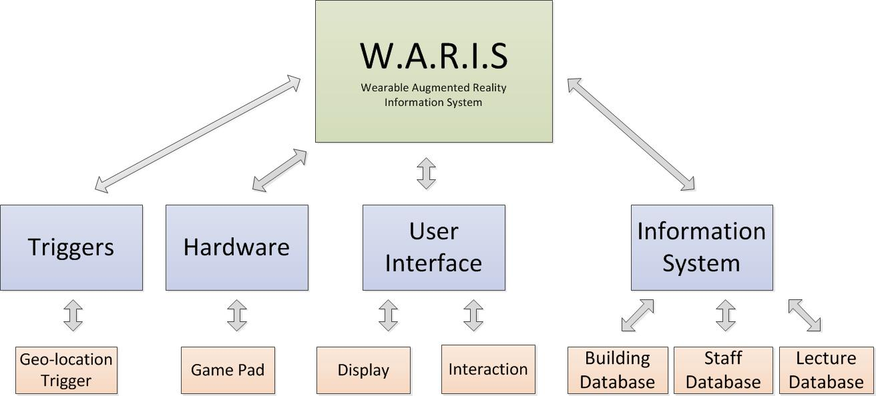

**Conclusion**

In this document we have outlined the scope of the project, including the system functionality and the constraints imposed. We have also ranked and documented the functional requirements and given a description of all applicable non-functional requirements. We have included diagrammatic representation of the requirements and a diagrammatic representation of the processes in the system.

Appendix A - Deliverable

**Deliverable Task Breakdown Statement**

**Deliverable Name:** Requirements and Analysis Document

|  |  |
| --- | --- |
| **Project Team Name** | **Team Number** |
| WARIS | Team 12 |
| **Team Member Names** | **Deliverable Percentage Completed** | **Date** | **Signature** |
| Ross Johnson | 16.6667 | 29/08/14 | *Ross Johnson* |
| Mitchell Askew | 16.6667 | 29/08/14 | *Mitchell Askew* |
| Tim Matisons | 16.6667 | 29/08/14 | *Tim Matisons* |
| Welsley Lui | 16.6667 | 29/08/14 | *Welsley Lui* |
| Raymond Forster | 16.6667 | 29/08/14 | *Raymond Forster* |
| Brandon Ashworth | 16.6667 | 29/08/14 | *Brandon Ashworth* |

Appendix B - Copies of client documents on which you based the analysis.

Appendix C - Glossary