JAVA – It’s a High Level, Object Oriented, General Purpose, platform Independent, Multi -threaded, Portable Programming Language

Multi-Threaded means – Perform multiple operations/tasks at the same time.

JAVA is a Platform Independent programming Lang

WORA – Write Once and Run Anywhere(In Windows, In Linux, In Mac, In Solaris)

JAVA – Is a case sensitive computer programming language.

JDK – Java Development Kit (Collection of various tools and files which consist of java compiler)

java source compiler java byte code (Intermediate code)

java byte code (.class) will be executed by the JVM.

Compilation ?? Converting the source code to byte code. [.java --🡪 .class] (Entire code at the same time)

Interpretation ??? Line by line conversion of source code to byte code (Object code)

JAVA is both compiled as well as interpreted language (.java --🡪 .class == compilation process --- javac – will do the compilation process)

When we execute the Java .class file, JVM will interpret the byte code.

Byte code will run in JVM (Java Virtual Machine ) only.

English ---🡪 French (Translation)

JDK is a super set. JRE is a subset.

JDK – Will help you to compile and execute your java project/application . Here converting the source code into byte code can be done using javac.exe

JRE – With JRE we can able to run the java application but can’t convert the source code to byte code. Javac.exe will not be available in JRE.

To write & Run a Java program, we need a text editor (notepad, wordpad, vi, vim, terminal )

Normal Text editor will not give you auto code suggestion, auto code completion, syntax checking.

Developer Tool – IDE – Integrated Development Environment – Eclipse (Open Source IDE) for Java

Javac.exe – java compiler

IDE – Integrated Development Environment

Eclipse is an IDE.

Understanding Classes & Object

Class – It’s a blue print for Objects.

Task : Draw a circle in paper using pen/pencil.

Tools used to draw a circle

1. Coin (select)
2. Compass
3. Any objects which is circular in size.

Coin – is a class

Circles – Is an Object.

In Java, class will be created using the below code

public class <Class_name> {

}

public class Employee {

}

IDE – Integrated Development Environment ( Create files, projects, folders, java project, dynamic web project, jpa project etc.,)

Eclipse Workspace is nothing but a space in the File/Operating System.

Src – folder – It the folder where we store all the Java source code in the form of a file. (.java)

While creating a new .java file (source code) in src folder – IDE will automatically create .class file (byte code) in the bin folder

Public class Car {

}

**Byte code** that is generated by the JAVA Compiler is also called as **Intermediate** code.

Source code (.java) -- Compiler (javac) --🡪 Byte code (.class)

Javac – java compiler

//access_modifier non-access_modifier return_datatype method_name (arguments ) {

}

**public** **static** **void** main(String[] args) {

// **TODO** Auto-generated method stub

}

; - Is a line terminator in java.

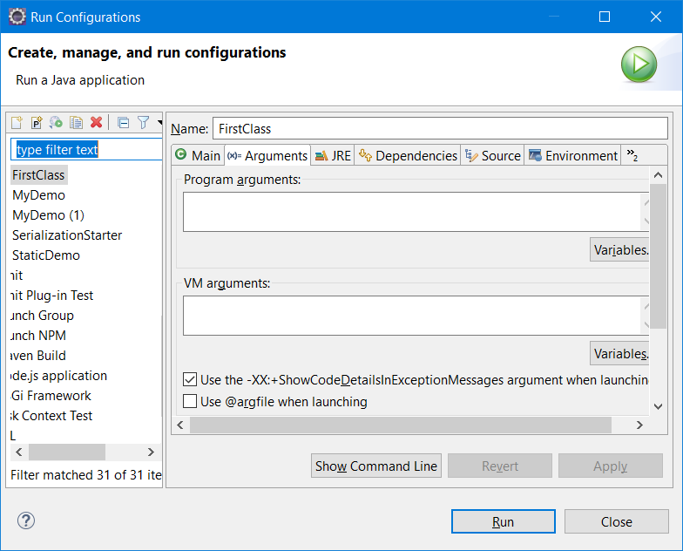

Passing a data to args[] from command prompt is called as Command-Line Arguments.

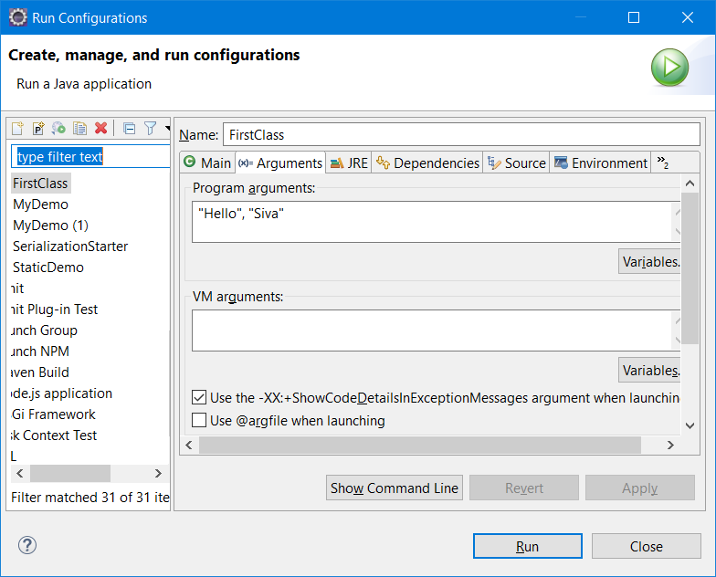

Methods – In Java, the functions defined inside a class is called as method

Create a class with the name “Car” and add these properties

1. YearofMfg - int yearOfMfg
2. NoOfGears – int noOfGears
3. engineType - String engineType
4. speed – int speed

Class – will consist of

1. member variables / instance variable /state
2. Member methods / behavior

Constructors will help you to initialize all the member properties of an object.

Default constructors will assign the default value to the object.

Primitive property = 0;

Object = null;

Boolean = false;

Two Types of Constructor

1. Default or No-Arg constructor. – It will not return anything.
2. Parameterized constructor. This will help to initialize all the member variables