Week1 Revisit

1. Types of Computer/Memory
2. Operating System (DOS, UNIX, WINDOWS, LINUX, MAC)
3. Unix Commands (Cygwin & Git-Bash)
4. Ls, mkdir, cd, pwd, date, time, cp, touch, man,
5. AWS – Private Cloud & Public Cloud, EC2, AMI, ECS, S3
6. IaaS, PaaS, SaaS. Free-tier account in AWS.
7. Core JAVA, Lang Fundamentals
8. Data Types, Operators, Statements, Control Statements,
9. JDK, JRE, JVM
10. Naming convention in JAVA
11. Packages, Classes & Objects
12. Git – Commands & Github
13. Creating a repository in github & git.
14. Creating Local repo & push it github
15. Cloning & Forking a repo

Agenda

Packages & imports, Constructors & it’s types, Arrays, var-args, control flow statements

Access & Non-Access Modifiers.

Generally the first line of java source code will be the package declaration statement.

To Create a Java project, Open Eclipse IDE (Integrated Development Environment)

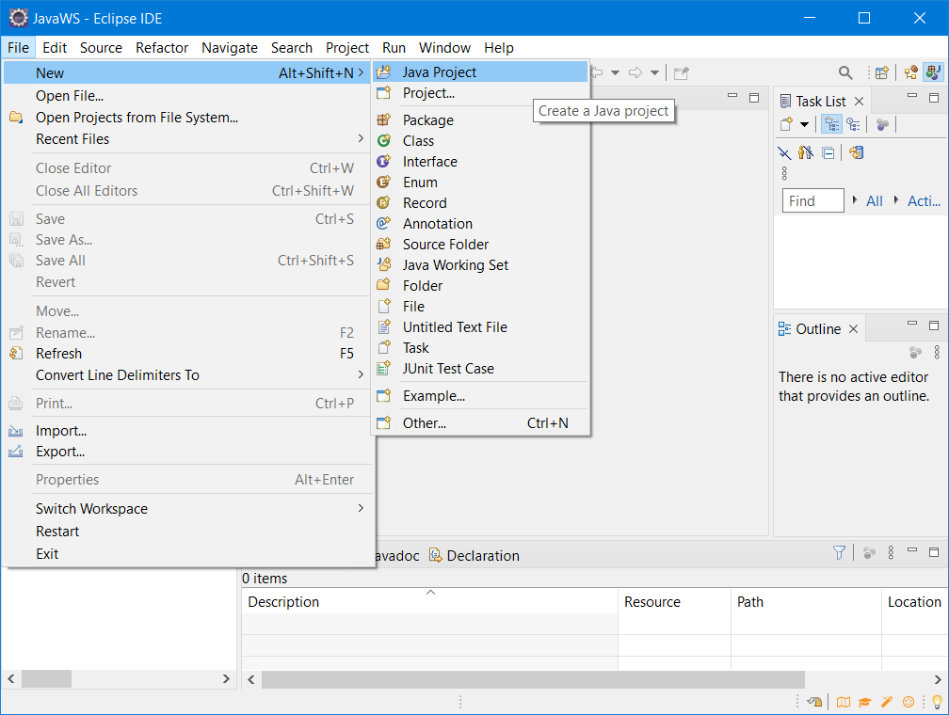

Enter the project name in the given text box as shown below and make sure to select the proper jdk/jre for the project.

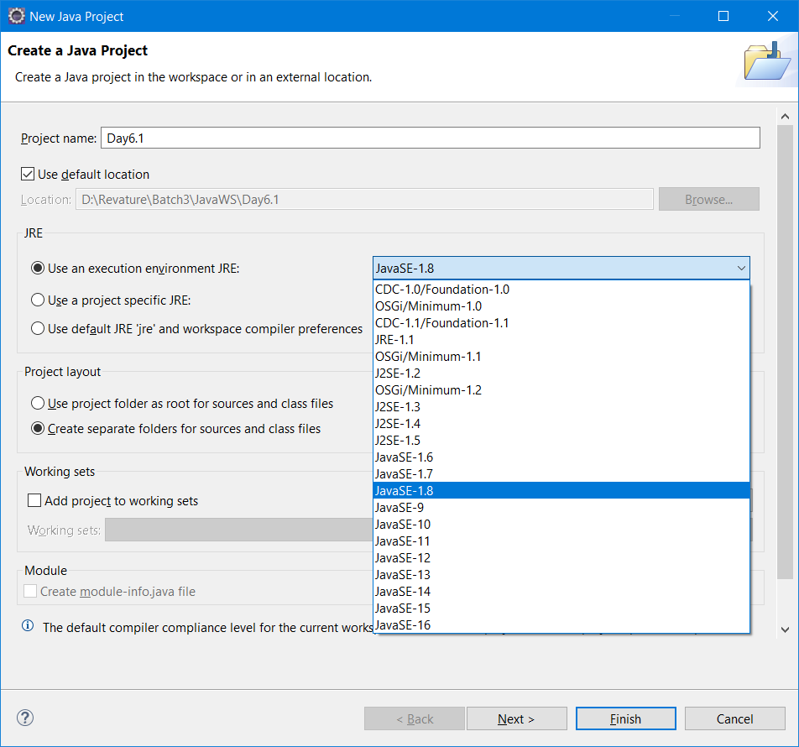

And click on “Finish” button.

Right click the project/src folder and select New -> package

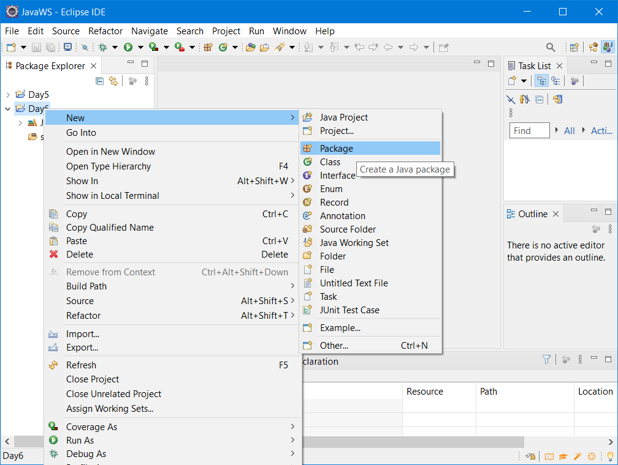

Then type the name of the package in all small case (reverse of the company url)

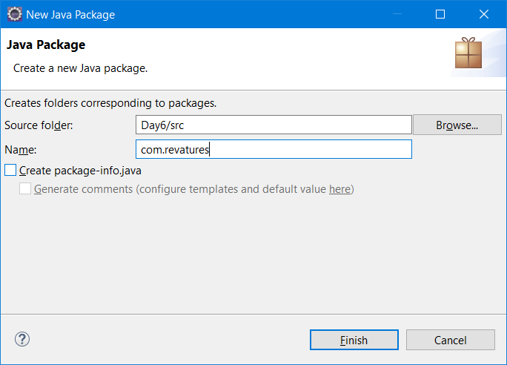

This step will create an empty package inside src folder.

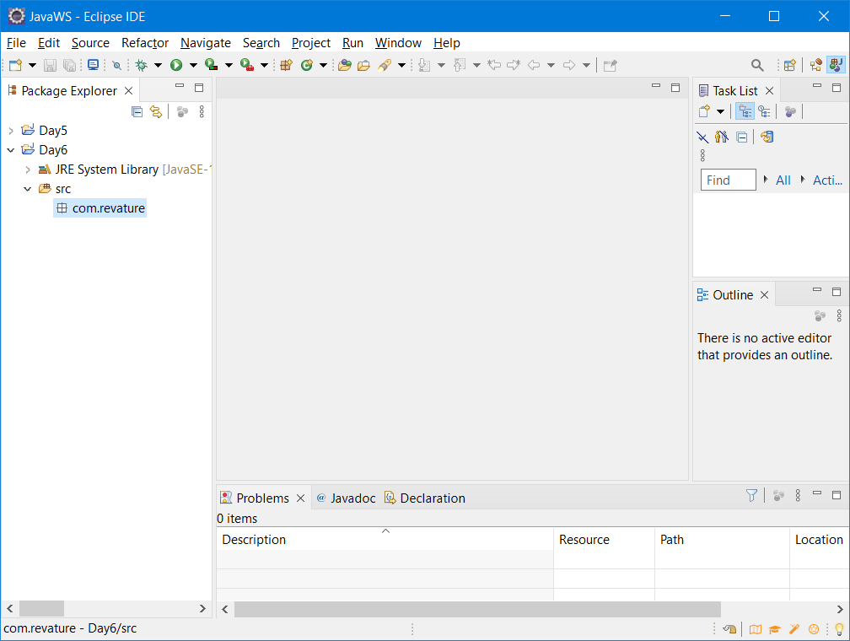

Add a new class by right clicking the project, New -> Class

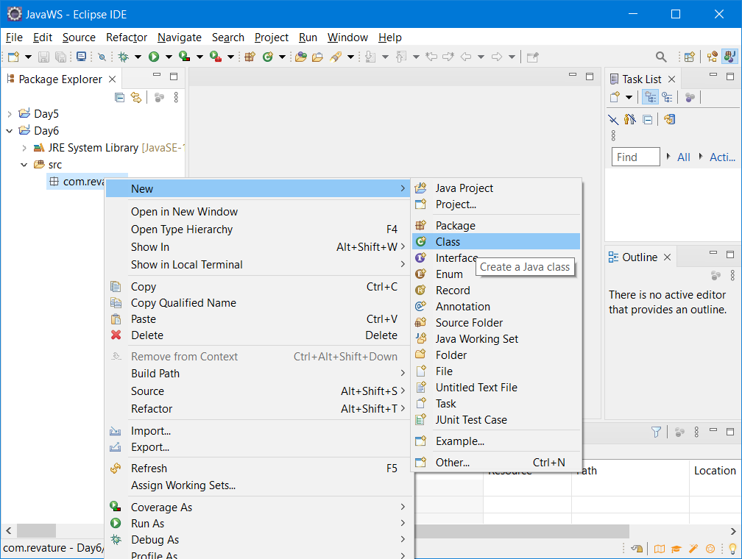

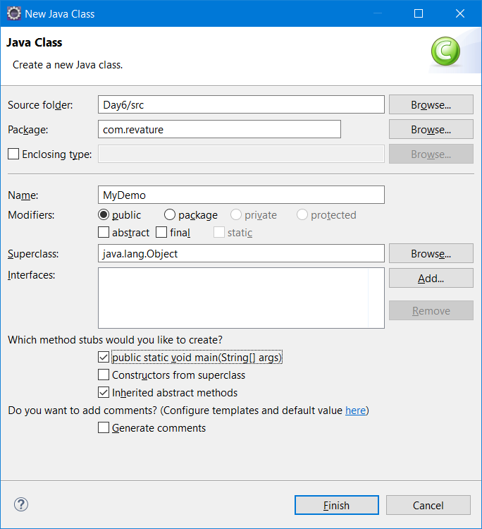

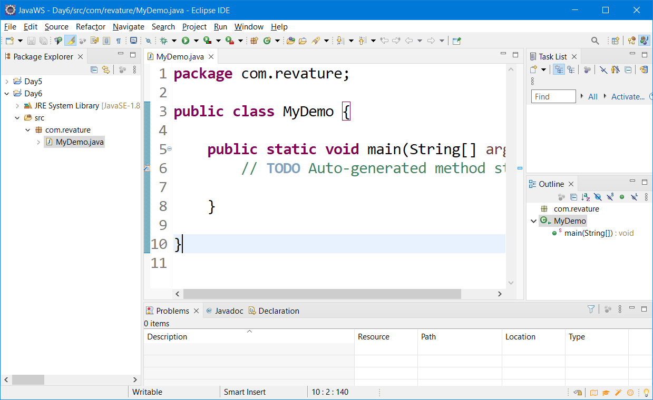

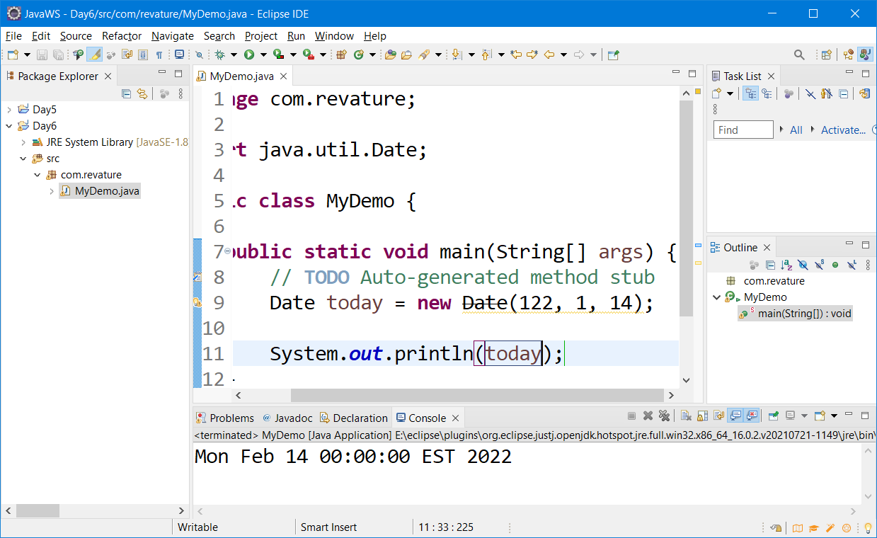

Packages are used for storing similar type of Java Source code file.

It also helps you to avoid naming conflicts. ( If two or more classes have same name then Java compiler will use, fully packaged/qualified name of a class

Access – Non-Access Modifiers

|  |  |  |
| --- | --- | --- |
| **Sl No** | **Access Modifier** | **Usage** |
| 1 | Private | Only used with in the class (Least accessible element) |
| 2 | Package /default | Available in the same package |
| 3 | Protected | Available in the same package as well as the package name which is defined in other package |
| 4 | public | Anywhere and anyone can access it (Most accessible item) |
| **Sl No** | **Non-Access Modifier** | **Usage (Behavioral Modifiers)** |
| 1 | Static | Class level Variable – Once per class not once per instances |
| 2 | Final | It can be used before class, methods & variables (you can’t extend final constants) |
| 3 | abstract | Hiding implementation (Use abstract keyword before the class name/method name) – abstract methods are nothing but empty methods. No body, no signature etc., |

Visitors count for website. Static int visitorCount = 0;

To call a method without creating object of the class, that time we can use static methods

Abstract keyword can be used with methods & classes only.

We can’t abstract keyword before the variable name.

Abstract means incomplete. Abstract class means incomplete class.

Abstract method means it’s a incomplete method.

When a class is abstract, it can have zero or more abstract methods.

When a method declaration only available, not the definition, it is called abstract method.

Class can have private variables & public methods (private state & public behaviors)

Method signature includes access_modifier return_data_type name_of_method (name & type of args) --- Method declaration line

You can’t create object of abstract class directly. Using anonymous (nameless) inner class you can create abstract class object.

You can extend abstract class and provide implementation to abstract methods

Final is a keyword, it can be used with variables, methods & class

Final variables are constants;

Final methods can’t be overridden (Redefining in child class is not possible)

Final class can’t be extended (No child class can be created for final class) – String is a final class

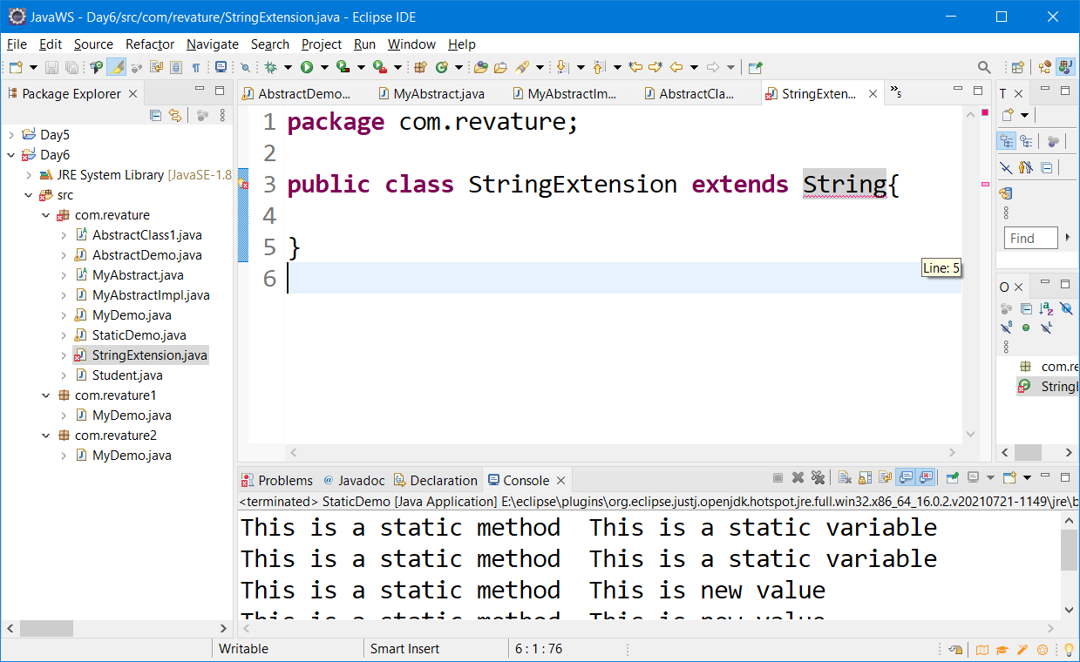

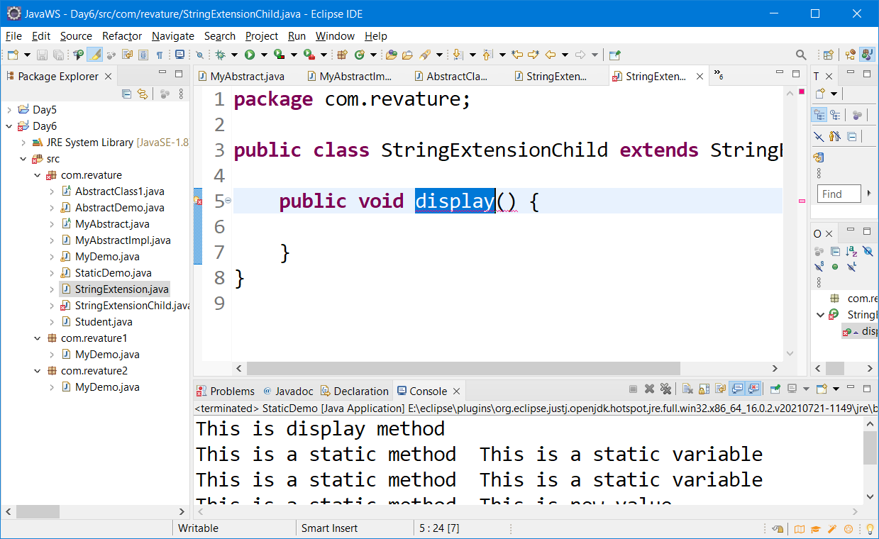

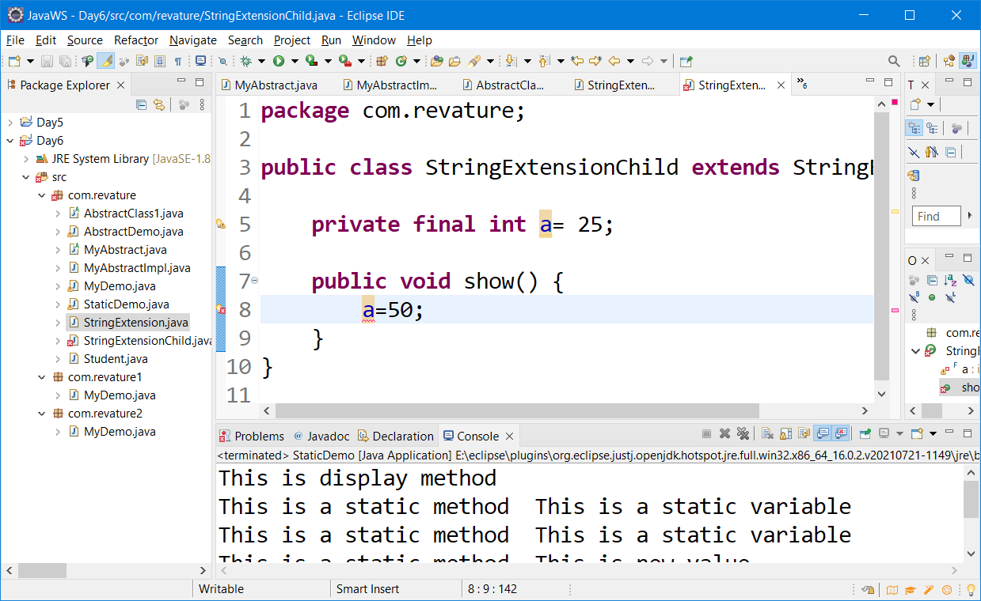

Final variables are constant that can’t be modified after creation

Final methods can’t be overridden. Redefining the final methods in child class is not possible.

Final class can’t be extended. We can’t able to have child class for a final class.

Control flow statements

1. Statements in java will be executed line by line. (Normal flow – default behavior)
2. Conditional Control statement (if, else, nested if, switch)
3. Repetitive/Looping control Statement (Same task/statement will be executed n number of times)

Two types of Looping control statements (1) Entry control (2) Exit control loop

1. Entry control loop [for, while ] enhanced for loop [The code will be executed zero or more time. Condition check will happen before entering the loop
2. Exit control loop [do.. while] [the code will get executed one or more time] condition check will happen after entering the loop.

Arrays are used to store similar data types in a continuous memory.

If you need to store 20 students marks obtained in a class test, easy way to do it is arrays;

Arrays are derived data type in java. It can created using new keyword or by assigning the values using curly braces;

In JAVA, arrays are fixed in size;

Ctrl + / = to comment a single line (selected lines) = toggle shortcut (uncomment & comment)

Ctrl + Space = Auto Code completion, Auto code suggest,

Ctrl +Shift + F = To Format /To align the code properly.