Introduction to Software-Defined Radio

ECE 531

Brandon Lipjanic

February 4, 2019

Contents

Table of Figures 1

Introduction 2

Sampling Rates 2

Complex Sampling 4

Frequency Observations: Complex-sampled Flowgraph 8

Frequency Observations: Real-sampled Flowgraph 10

I/Q Imbalance 10

Adding Noise 11

Interpolation and Decimation 14

Questions 15

Conclusion 15

# Table of Figures

Figure 1: Sampling Rates Setup 2

Figure 2: Time and Frequency Sink Output 3

Figure 3: Time and Frequency Sink Output 40kHz 4

Figure 4: Complex Sampling Setup 5

Figure 5: Complex Time and Frequency Sink Output 5

Figure 6: Time Sink 15.4kHz Sampling Frequency 6

Figure 7: Complex Sampling 40kHz Sampling Rate 7

Figure 8: Complex Sampling 2kHz Sampling Rate 7

Figure 9: Frequency Observations Complex-sampled Flowgraph 8

Figure 10: Split Peak Frequency 9

Figure 11: Complex-sampled Flowgraph Shifting Frequency 9

Figure 12: Dual Frequency Peak 10

Figure 13: I/Q Imbalance Setup 11

Figure 14: I/Q Plot Spurs 11

Figure 15: Adding Noise Setup 12

Figure 16: Raised Noise Floor 12

Figure 17: Distorted I/Q Plot 13

Figure 18: Gaussian Noise 13

Figure 19: Impulse Noise 13

Figure 20: Laplacian Noise 13

Figure 21: Uniform Noise 13

Figure 22: Interpolation and Decimation Setup 14

Figure 23: Interpolated and Decimated Signals 15

# Introduction

This laboratory experiment explores some of the fundaments of signals and signal processing using the GNU Radio Companion software. The goal of the lab experiments is to understand how signals are sampled in the GNU Radio software, and how changing various parameters of the signal and sampling can affect the output. These variations in parameters include changing the sampling rate, signal frequency, and adding distortion to the signal. In addition, interpolation and decimation will be explored. After all the experiments are performed, a better understanding of the GNU Radio software, and basic signal and sampling concepts should be understood.

# Sampling Rates

The first experiment focuses on sampling a simple sine wave signal and observing the time and frequency outputs of the sampled signal. The signal is produced using real float values. The setup used to run this lab experiment is displayed in Figure 1.

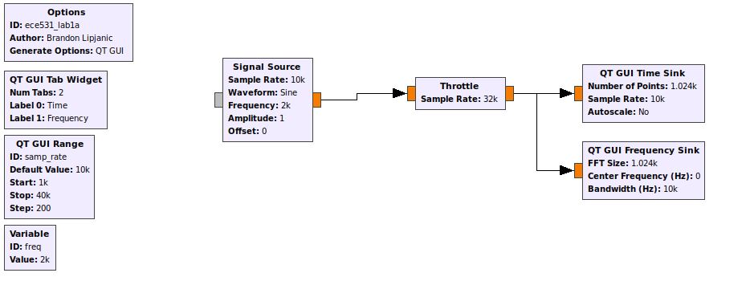

Figure 1: Sampling Rates Setup

Using the default sampling rate of 10kHz and frequency of 2kHz Figure 2 shows the output of the time and frequency sinks.

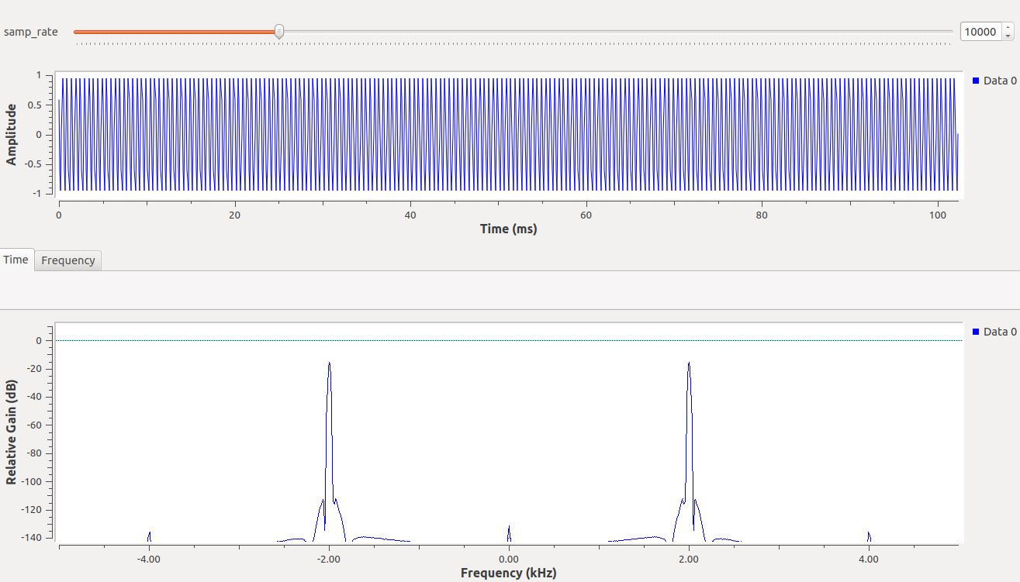

Figure 2: Time and Frequency Sink Output

Observing Figure 2 the peak frequency can be found at +- 2kHz with a power level of -14.43dB. As the sampling rate (samp_rate) variable increases from 10kHz to 40kHz the peak frequency of the signal stays constant at +-2kHz. The frequency of the time sample has increased significantly because the sampling rate has increased. At the maximum sampling rate of 40kHz the amplitude of the time signal is also constant. Figure 3 shows the frequency and time sinks using a sampling rate of 40kHz.

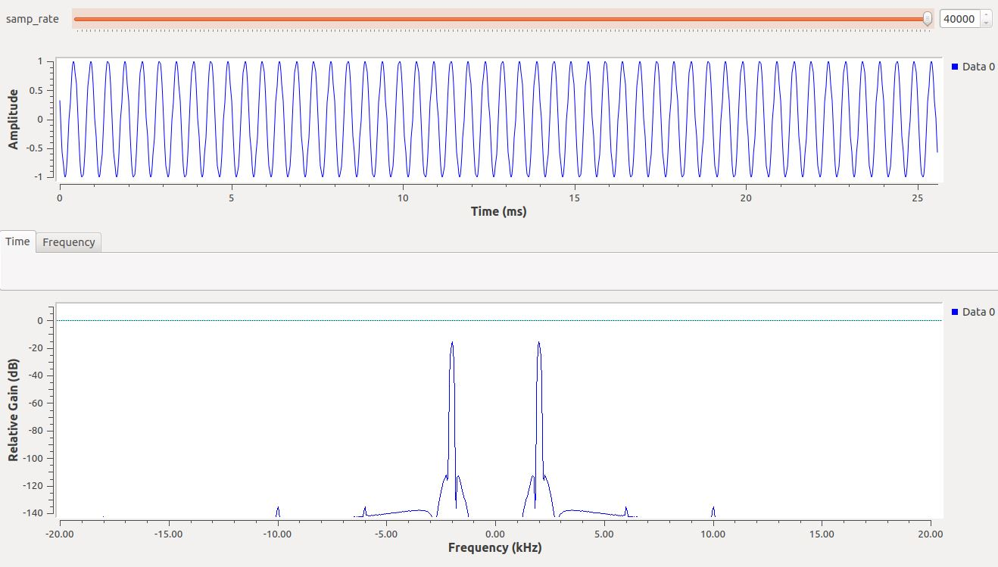

Figure 3: Time and Frequency Sink Output 40kHz

When the sampling rate is changed to 3500, the peak frequency now exists at +-1.5kHz. The frequency changed by -2.5kHz. At 4kHz sampling rate the peak frequency changes to +-2kHz and as the sampling frequency decreases the peak center frequency approaches zero at a sampling rate of 2kHz This is because the frequency of the signal source is also exactly 2kHz.

# Complex Sampling

The next experiment, similarly to the first experiment, focuses on sampling a simple sine wave signal and observing the time and frequency outputs of the sampled signal. However, the data is now complex float values, compared to the real floats used previously. The setup used to run this lab experiment is displayed in Figure 4.

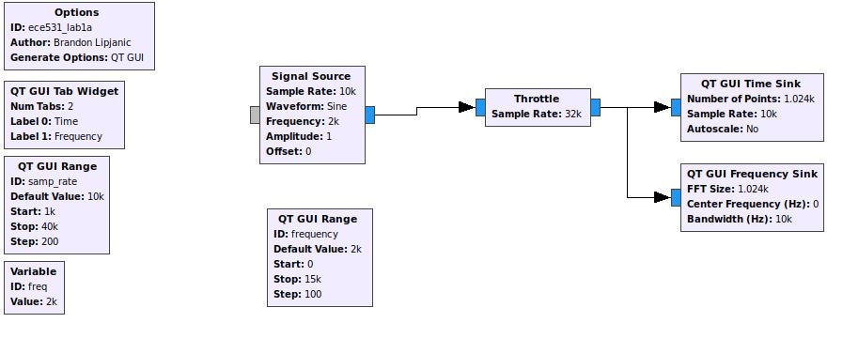

Figure 4: Complex Sampling Setup

As shown in Figure 5 when comparing the output of the complex sampled signal to the real sampled signal, the main difference is the absence of the frequency peak at -2kHz. In addition, there are now two different signals that appear on the time plot. One is the in-phase signal and the other is the quadrature signal, they differ by 90 degrees.

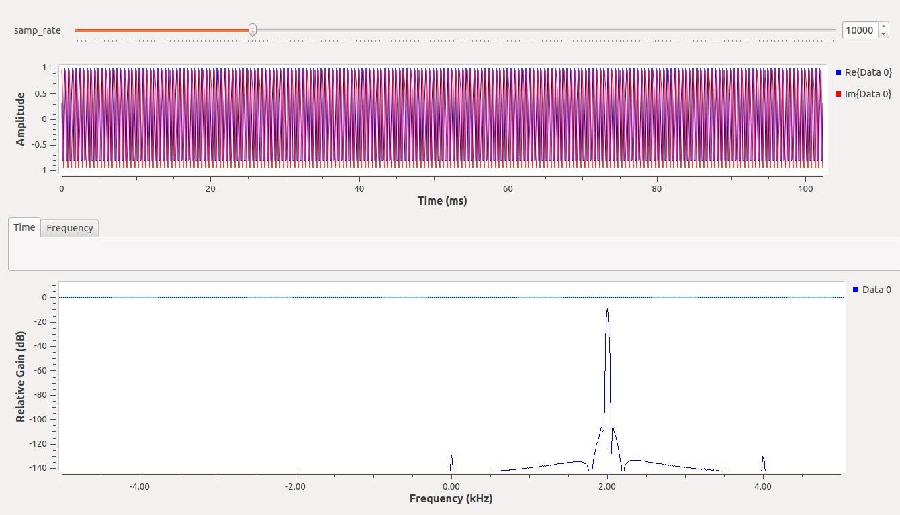

Figure 5: Complex Time and Frequency Sink Output

Next the sampling rate is again varied from 10kHz to 40kHz. During this transition the signal amplitude stays relatively close to 1 for the time signal but has variation when the sampling rate is not a multiple of the frequency. Figure 6 demonstrates an example of the variation in amplitude of the time signal at 15.4kHz.

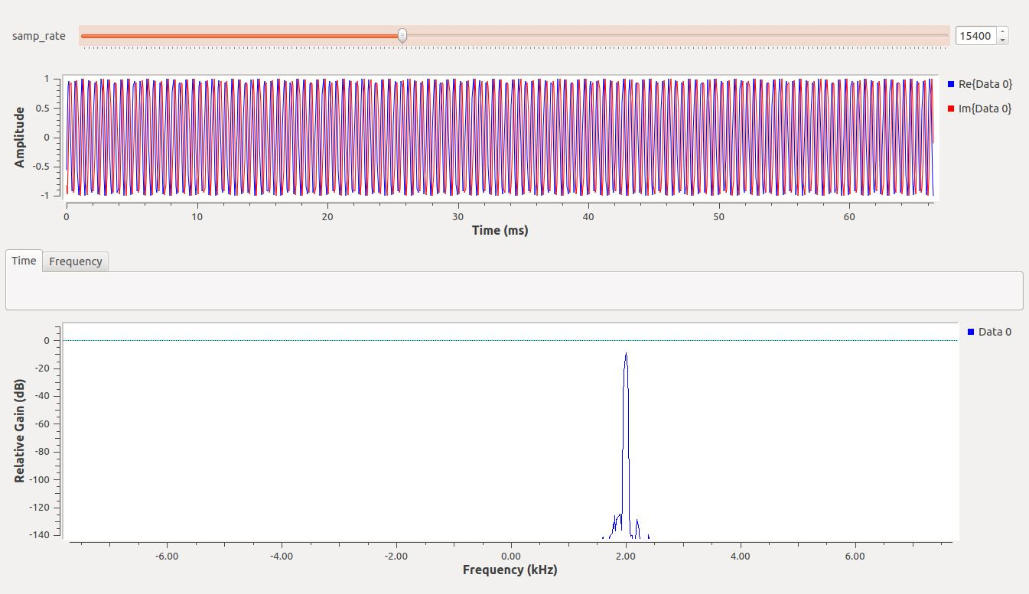

Figure 6: Time Sink 15.4kHz Sampling Frequency

As demonstrated in Figure 7, when observing the frequency plot at a sampling rate of 40kHz, the peak frequency is -10.8dB at 2kHz center frequency.

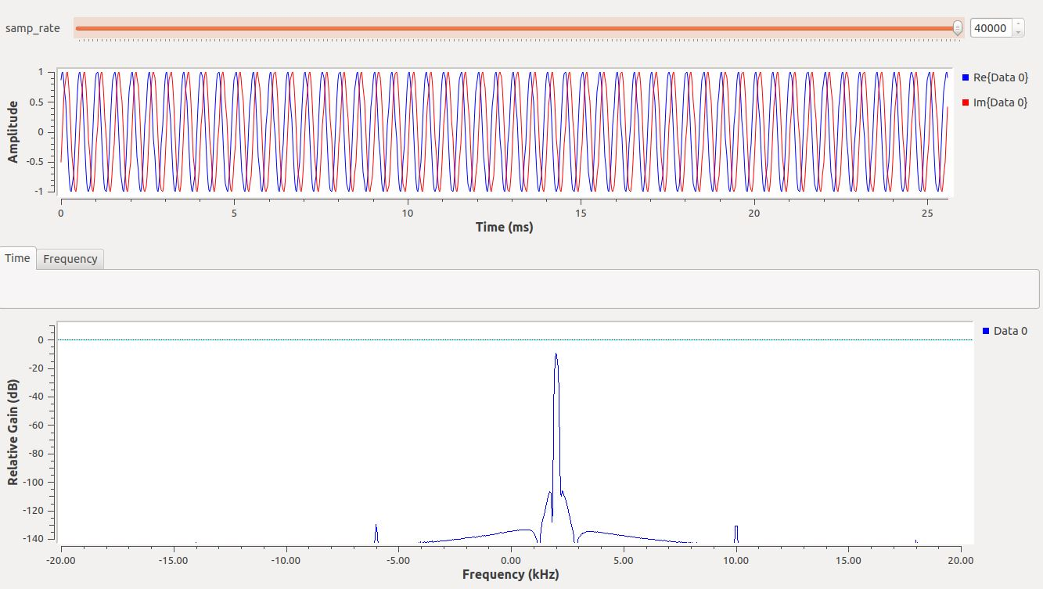

Figure 7: Complex Sampling 40kHz Sampling Rate

Next the sampling rate is decreased. Up until a 4kHz sampling rate, the peak frequency is constant. At 4kHz sampling rate the frequency changes to -2kHz, as shown in Figure 8. As the sampling frequency decreases further the peak center frequency approaches zero at a sampling frequency of 2k because the frequency of the signal source is 2k.

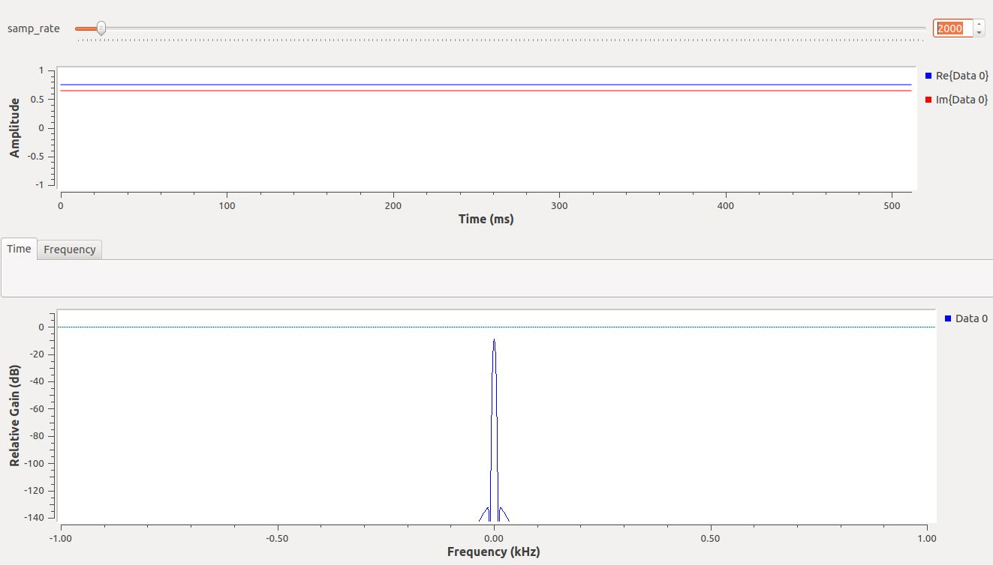

Figure 8: Complex Sampling 2kHz Sampling Rate

# Frequency Observations: Complex-sampled Flowgraph

In this experiment another variable, the frequency, is adjusted and the frequency and time sinks are observed. Figure 9 shows the setup for the experiment. The frequency starts at 2kHz and is slowly increased to 15kHz. During this the frequency peak “splits” at a frequency of 5kHz with half the power being at -5kHz and the other half at 5kHz. As the frequency increases toward 10kHz, the peak frequency gets closer to 0, until it reaches 0 at 10kHz. This happens because the 5kHz frequency is a multiple of (1/2) the sampling rate (which is why this occurs again at 15kHz). The peak frequency is at 0Hz when the frequency is 10kHz because the sampling rate is equal to the frequency in that scenario. An example of these results are showcased in Figures 10 and 11.

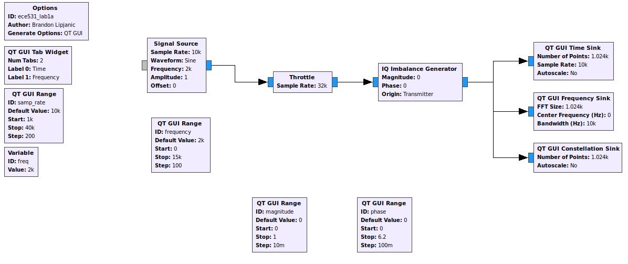

Figure 9: Frequency Observations Complex-sampled Flowgraph

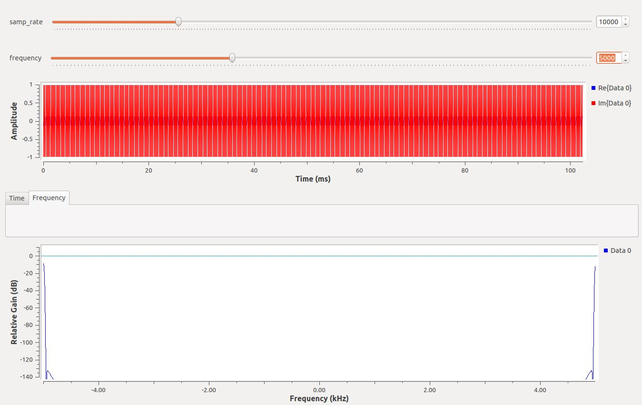

Figure 10: Split Peak Frequency

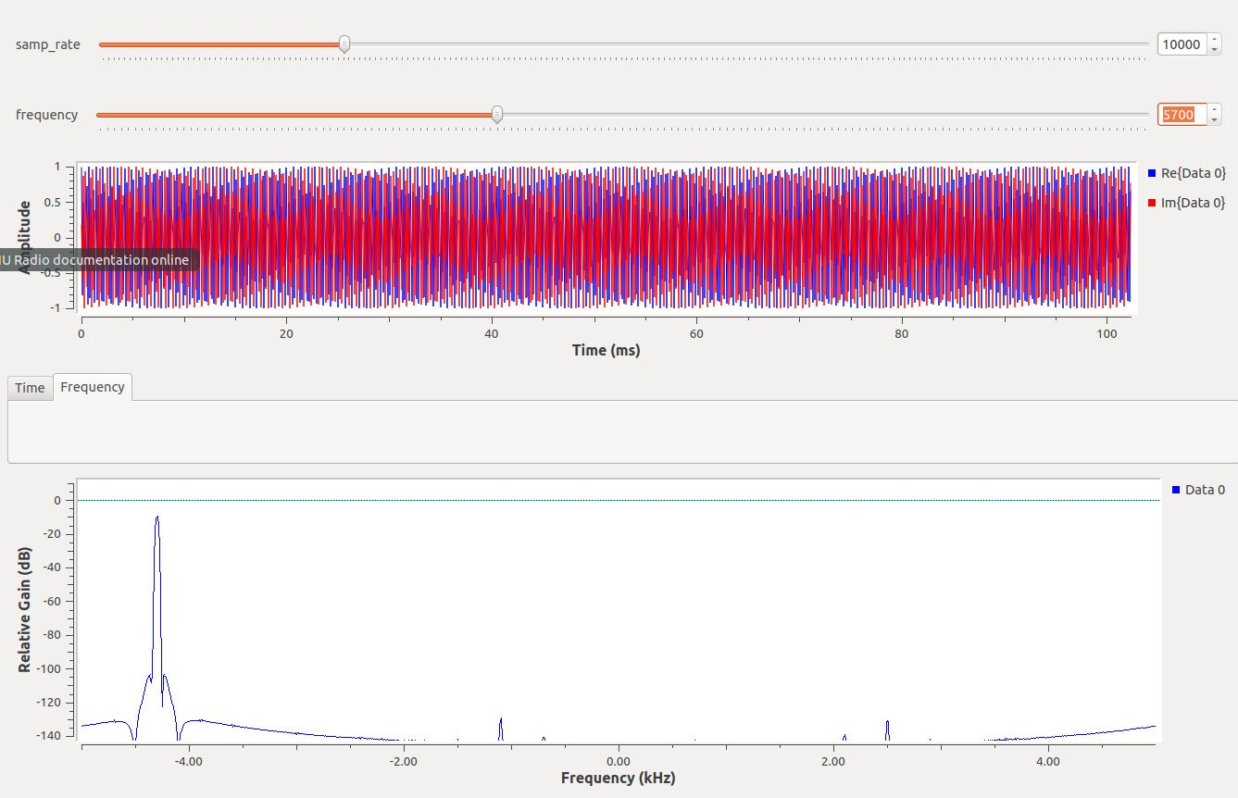

Figure 11: Complex-sampled Flowgraph Shifting Frequency

# Frequency Observations: Real-sampled Flowgraph

Similarly to the first two experiments, this experiment is a replica of the previous experiment, with the only difference being a real signal is used rather than a complex. The result is similar to what was seen in the previous experiment, the main difference is the appearance of the identical peak frequency at the same relative negative frequency. In addition, when at a frequency rate of 10k, the peak amplitude will be higher since the two frequency peaks are overlapping at 0kHz (measured ~4dB higher). Figure 12 demonstrates the dual frequency peak.

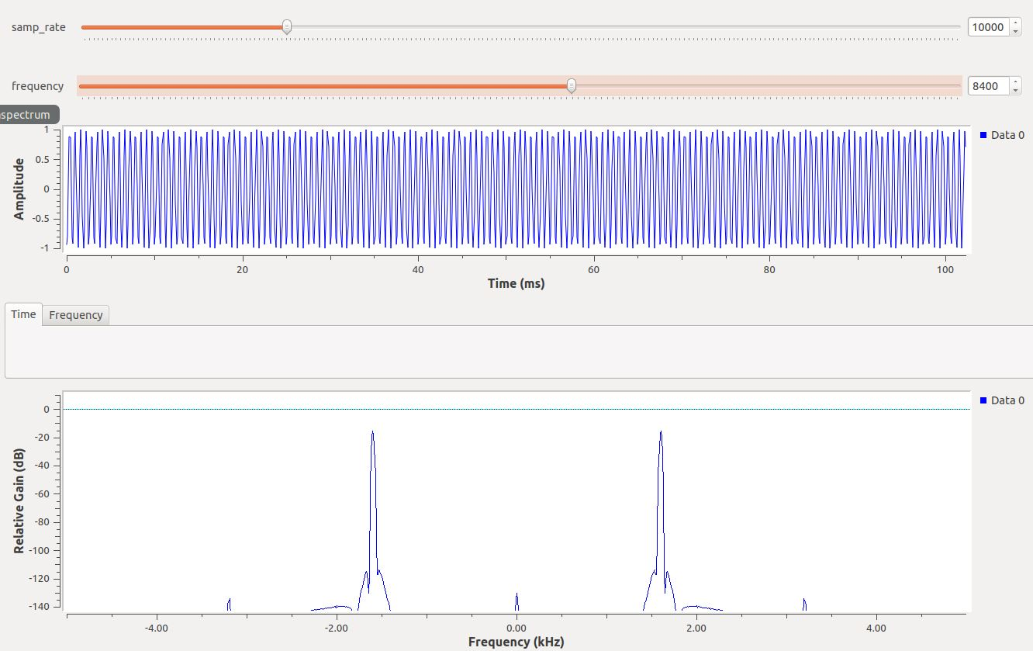

Figure 12: Dual Frequency Peak

# I/Q Imbalance

In this experiment another component is introduced in the signal path called an IQ Imbalance Generator. This component introduces magnitude and phase error to the signal which creates distortion on the I/Q plot and makes the data harder to recover. Figure 13 demonstrates the setup for this experiment.

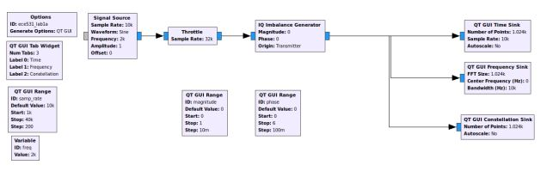

Figure 13: I/Q Imbalance Setup

First the phase imbalance is increased, during this a spur appears at -2kHz and rises in peak frequency (dBc) as the phase imbalance increases. This is because the EVM of the signal is increasing with the increase in phase imbalance. The same result occurs when the magnitude of the IQ imbalance is changed, a spur appears and grows in power as the magnitude imbalance increases. This is because the EVM of the signal is increasing with the increase in magnitude imbalance. The spurs are visible in Figure 14, but very low in power as magnitude and phase error have not been increased yet. As magnitude increases, the points on the IQ plot move outward, away from their original position (as expected with increasing magnitude error).

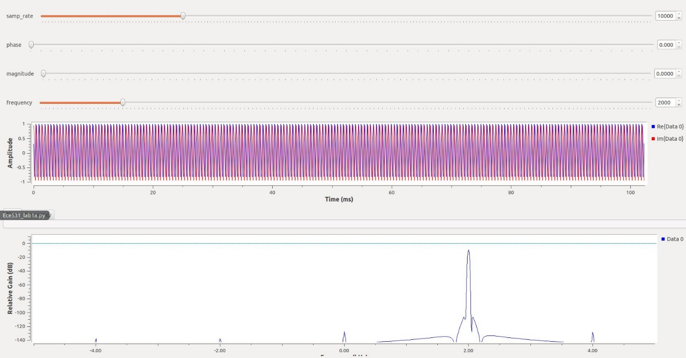

Figure 14: I/Q Plot Spurs

# Adding Noise

The next step is to introduce Gaussian Noise into the signal. Figure 15 demonstrates the setup used for adding noise.

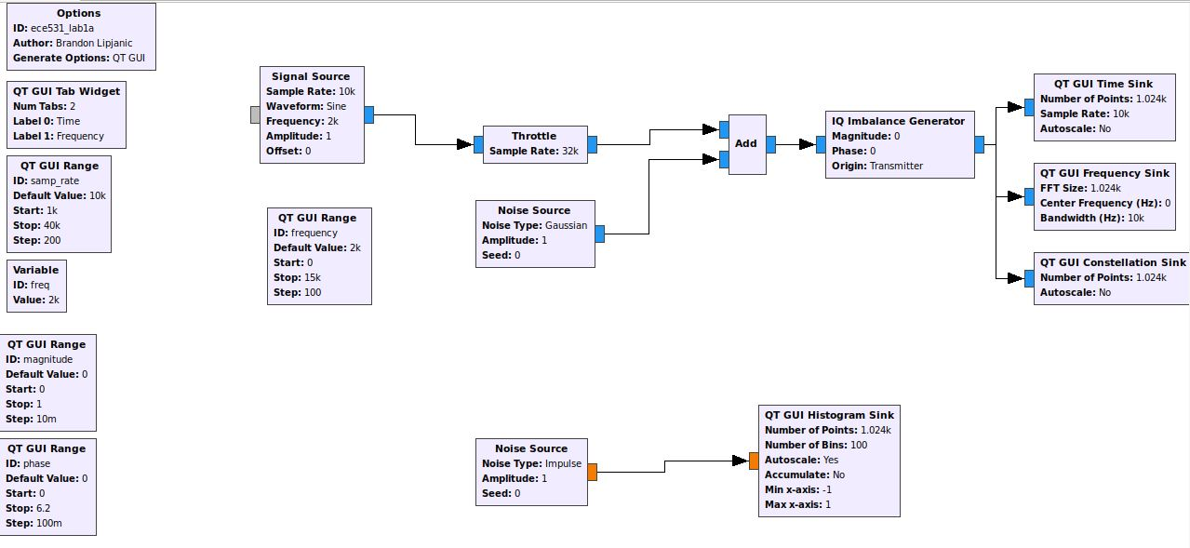

Figure 15: Adding Noise Setup

The Time plot now has a wide swing of amplitudes displayed with what appears to be relatively the same frequency as before. The frequency plot now has the noise floor much higher than before (it is not around -37dB), and the peak signal is harder to detect, although still visible at -9.78dB. The IQ plot has a scatter of indistinguishable points and the signal cannot be made out as seen in Figure 17.

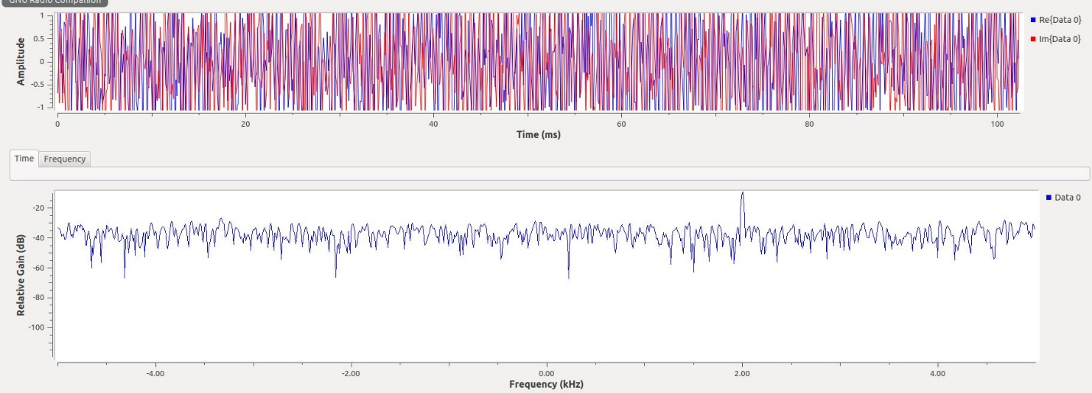

Figure 16: Raised Noise Floor

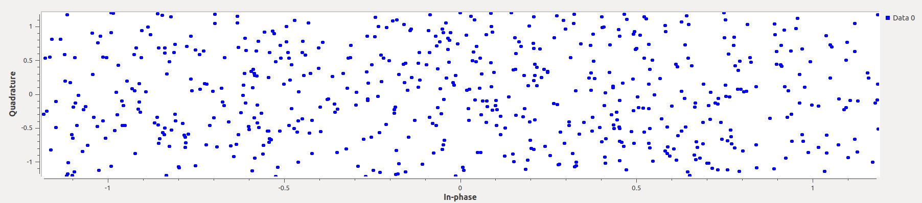

Figure 17: Distorted I/Q Plot

In addition, several different noise sources are observed to visualize the type of noise generated. These are shown in Figured 18-21.

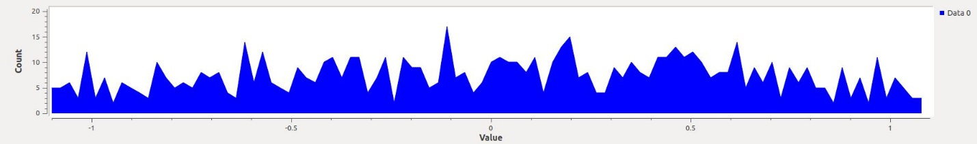

Figure 18: Gaussian Noise

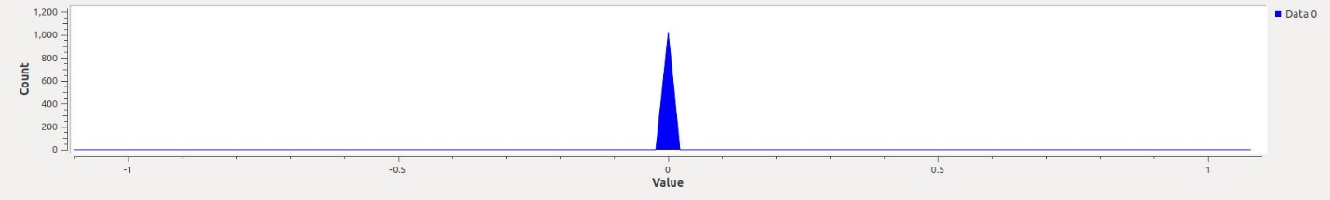

Figure 19: Impulse Noise

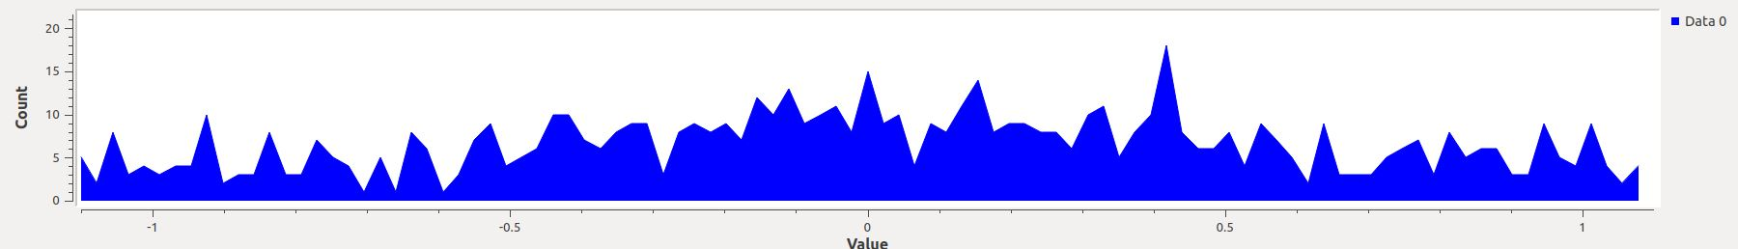

Figure 20: Laplacian Noise

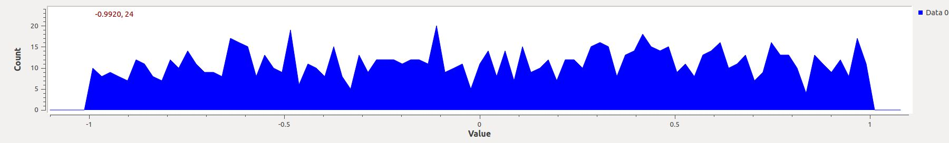

Figure 21: Uniform Noise

# Interpolation and Decimation

The last experiment introduces the idea of interpolation and decimation and the affect these have on the sampled signal. Figure 22 demonstrates the setup used in this experiment

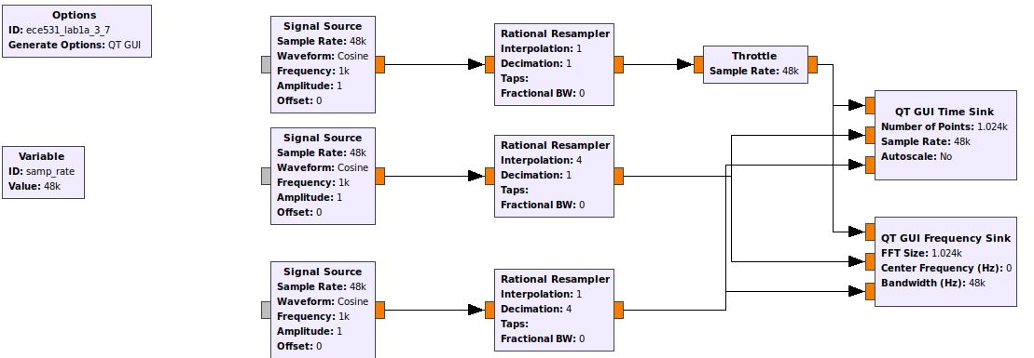

Figure 22: Interpolation and Decimation Setup

The signals show various frequencies in the time domain, and different peak frequencies in the frequency domain. The standard signal looks as expected, with frequency peaks at +-1kHz. The Interpolated signal has frequency peaks at +-250Hz because it has been up sampled by 4x. On the other side, the Decimated signal has frequency peaks at +-4kHz because it has been down sampled. The up sampling introduces zeros between samples, and the down sampling subsamples. The effect can also be seen in the time domain graph, where the frequency of the signal is much greater for the decimated signal, and much lower for the interpolated signal. In Figure 23, Data 0 represents the original signal, Data 1 represents the Interpolated signal, Data 2 represents the Decimated Signal.

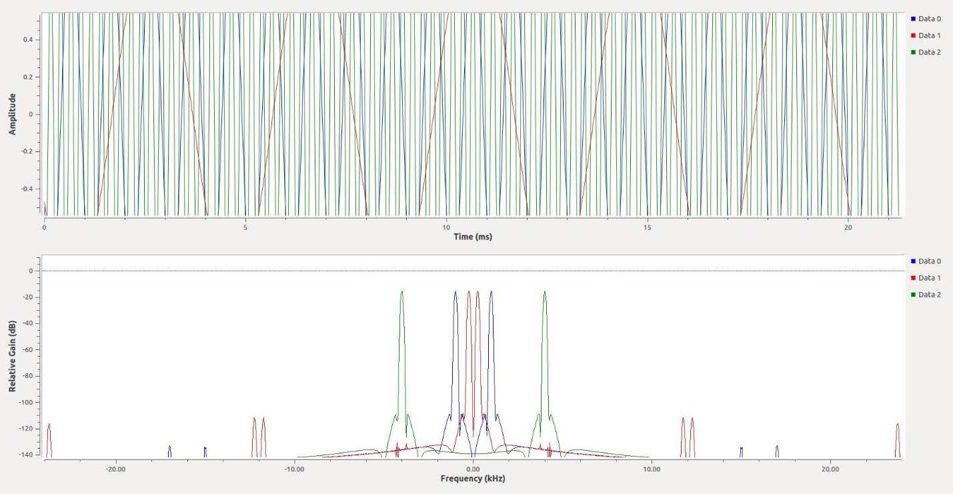

Figure 23: Interpolated and Decimated Signals

# Questions

The following questions are designed to more deeply explore and challenge some of the concepts demonstrated throughout the lab experiments.

1. In GNU Radio What is the Throttle block for? When should it be used? What happens if you use more than one throttle block? When is a throttle block unnecessary?
   1. The throttle block limits the data throughput to the specified sampling rate. Anytime sampling is being done, the throttle block should be used. Without it the CPU resource utilization of GNURadio will be extremely high. If you use multiple throttle blocks only the first one implemented is used by GNURadio (you only ever need one). The throttle block is unnecessary if the flowgraph is being regulated by external hardware.
2. What are Nyquist zones? How are they useful with software-defined radio?
   1. A Nyquist zone is where a band-limited signal will alias down into a lower frequency zone. For example, a 2MHz band between 10-12MHz could be sampled at 2MHz in order to characterize it making it easier for software-defined radios to sample data.
3. Why is dither noise used on Digital-to-Analog converter (DAC) circuits?
   1. Dither noise is used on DAC circuits to add a slight amount of noise amplitude to remove spurs from the signal.

# Conclusion

The objective of this lab was to understand various tools within GNU Radio and GNU Radio Companion, and utilize those tools to simulate sampling a signal. The sampled signal was observed in the frequency and time domain, as well as on an IQ plot. For this lab, both real and complex signals were observed. The experiments performed were aimed at varying parameters of the signal and the sampling of the signal, to observe how the output reacted to such changes. The main difference in the observed time plot between the real and complex domain is the addition of the Quadrature signal, a 90 degree offset signal. In the frequency domain a peak frequency appeared on both the positive and negative frequencies of the plot. Distortion was also added to the signal in multiple forms: using an I/Q Imbalance device to introduce phase and magnitude error, and adding Gaussian noise to the signal. These distortions introduce things such as spurs and a higher noise floor in the frequency domain. Lastly, interpolation and decimation were introduced to demonstrate the idea of up sampling and down sampling.