User Manual

Table of Contents

Creating/Deleting New Sheets 2

Exporting Encrypted Sheet(s) 2

Importing Encrypted Sheet(s) 3

Updating Chart 4

Exporting Report 4

## Creating/Deleting New Sheets

Creating and deleting new sheet are done the same way you always have. You can then edit your sheets freely.

## Exporting Encrypted Sheet(s)

To export the sheet(s), head to the main sheet and click the button labelled **Import/Export**.

**Import/Export**

After clicking the **Import/Export**, a user form will open. Choose the **Export Tab** located near the top left. Now you can select which sheet(s) you would like to export. You can select multiple sheets by holding down “Ctrl”. Then you must choose a folder path that can be done by click on the **Folder Picker**. Once you have chosen a path it will appear in the **Folder Path**. Then once you have the folder path and sheets you would like to export, click **Export**. Choosing **Cancel** will close the user form, and **Refresh Sheet List** will refresh the list of sheet names just in case some are missing.

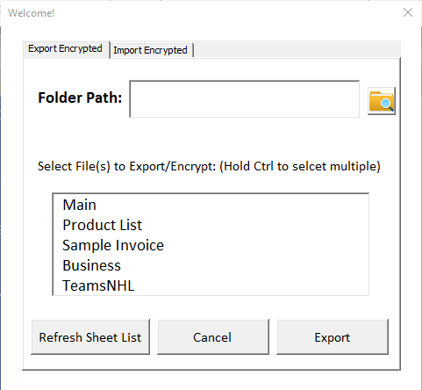

**Export Tab**

**Folder Picker**

## Importing Encrypted Sheet(s)

To import the sheet(s), head to the main sheet and click the button labelled **Import/Export**.

**Import/Export**

After clicking the **Import/Export**, a user form will open. Choose the **Import Tab** located near the top left. You can select multiple sheets from the same location using the **File Picker**. After using the **File Picker**, a list of all the sheet(s) you choose to import will appear in the **File List.** Once you have chosen the file(s) you would like to import, click **Import**. Once clicking import a new worksheet will be created for each file you choose to import. Choosing **Cancel** will close the user form, and **Clear** will clear the **File List** and the **File(s) Path**.

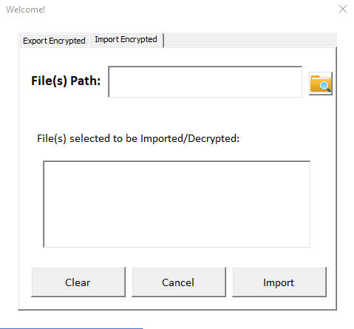

**Import Tab**

**File Picker**

**File List**

## Updating Chart

To update the chart located on the Chart sheet with the most recent data from Access first click on the **Update/Report** button located on the Main sheet.

**Update/Report**

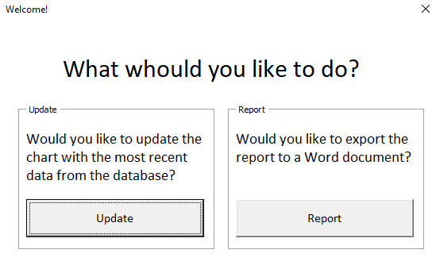After clicking **Update/Report**, a user form will open. You will have two options, click **Update.**

## Exporting Report

To export a report based on the current Chart located on the Char sheet **Update/Report** button located on the Main sheet.

**Update/Report**

After clicking **Update/Report**, a user form will open. You will have two options, click **Report**. The generated report will be in the same location as this application. The Filename will be "Encryption _Report.docx".

