Date Warehouse Development of Car Repair Shop System

Group 3

Irina Becknell, Joe Chan, Thomas Jensen, Brandon Russell

University of Maryland University College

Author Note

This project was prepared for DBST665, taught by Professor Kuchibhotla

Data Warehouse Development of Car Repair Shop System

Abstract

In this project a data warehouse is developed for a car repair shop. The project begins with development of a project plan and a business case for the data warehouse. This will be followed by a design of a data warehouse schema, which consists of one FACT table and four DIMENSION tables. Farther, the requirements are gathered and analyzed. Then, the database is designed and built. The research concludes with summary of findings and lessons learned. This research is meant to investigate the data warehouse technology.

**Project Plan**

Table 1 presents the work breakdown structure (WBS) of the project.

|  |  |  |  |  |
| --- | --- | --- | --- | --- |
| **Phase** | **Steps** | **Week** | **Task** | **Group member** |
| 1 | 1 | 1 | Group formed | All |
| 2 | 1 | Select the topic | All |
| 3 | 1 | Roles assignment | All |
| 4 | 2 | Develop project plan (WBS) for the data warehouse project | Irina Becknell |
| 5 | 2 | Inform professor of the project topic and submit group work schedule to professor | Irina Becknell |
| 6 | 3 to 12 | Inform professor of the project progress and clarify any questions with professor | Irina Becknell |
| 7 | 4 | Writing of the Abstract of the project report | Irina Becknell |
| 8 | 4 | Writing of the Introduction of the project report | Irina Becknell |
| 2 | 9 | 4 | Data Model/DDL design (DB schema consisting of one FACT table and four DIMENSION tables). Record and include DDL script design for Appendix | Brandon Russell |
| 10 | 4 | Requirements analysis (develop description of the data sources, analyze the requirements documented in the introduction.) | Irina Becknell |
| 11 | 4 | ETLs/DMLs (identification of the data sources, data map, and the methodology used to load the data. Identify, describe and record the DML or SQL*Loader scripts for Appendix ) | Chan, Joe |
| 12 | 6 | Data Model/DDL development and implementation. Record steps for the body of the report | Brandon Russell |
| 13 | 7 | Writing SQL queries. Record the scripts for the Appendix | Brandon Russell |
| 14 | 8 | Report analysis (development of all the report scenarios (at least 4) that demonstrate how the requirements identified in the introduction were met. Identify and record the SQL scripts in the Appendix). | Thomas Jensen |
| 3 | 15 | 10 | Writing of Lesson learned section (record any problems and issues) | Irina Becknell |
| 16 | 10 | Writing of Conclusion of the project report (one page discussion of the project, explain how has this report solved the business needs identified in the Introduction.) | Irina Becknell |
| 17 | 11 | Review of the project report, make necessary changes. Submission of the project | All |

Table 1. Project plan (WBS)

The following roles were assigned to the team members (Table 2):

|  |  |
| --- | --- |
| **Team Member** | **Role** |
| Becknell, Irina | Project Lead |
| Chan, Joe | Business Analyst |
| Jensen, Thomas | Database Administrator (DBA) |
| Russell, Brandon | Database Developer |

Table 2. Team members and roles

**Introduction**

**Requirements Analysis**

Requirements analysis is the first stage in the systems engineering process and software development process: it encompasses those tasks that go into determining the needs or conditions to meet for a new or altered product, taking account of the possibly conflicting requirements of the various stakeholders, such as beneficiaries or users. Requirements analysis is critical to the success of a development project (Software Development Process – activities and steps, 2010).

**Introduction**

* **Purpose of the system** The purpose of the developed data warehouse system is to provide tools for reporting and data analysis of a hypothetical car repair shop. The car repair shop data warehouse system that is to be developed in this project is considered a core component of business intelligence.

The database will enable a user to enter customer’s personal data (first and last names, address, phone number), vehicle’s data (make, model, year, color, body type, number of axles, fuel type, number of cylinders, weight), parts (name, decription, category, brand, weight, unit of issue), maintenance actions (name, description, category, number of hours spent, team size), time (time name, day, month, year, quarter. The reporting data will be used to track business metrics, such as cost, time spent on repairs, quarterly sales, etc.

* **Scope of the system**

The project scope is determined as follows:

* Data Model/DDL design – database schema consisting of five dimension tables (CUSTOMERS, MAINTENACE_ACTIONS, TIME_TABLE, VEHICLES, PARTS) and one fact table (WORK_FACT). Data base schema is to be developed and DDL files will be created to build the database
* ETL/DML development

Data source

The source of the data for the CUSTOMERS table is the data that was directly taken from the customers at the time of the car repair estimate. The data source of the PARTS table is the data that comes from the manufacturer of the automobile parts. The data source of the VEHICLES table comes from the car manufacturers and the customer if the car is not already recorded in the database. The data source of the MAINTENANCE_ACTIONS is supplied by the employees and occasionally company president. The TIME table data source is provided by the database administrator who must create data entries representing moments in time. The WORK_FACT table data is received from the store employee before and after the car repair is completed. For this project, a sample of random data is created for each table and it is stored the data in CSV files (Customers.csv, Maintenance_Actions.csv, Parts.csv, Time_Table.csv, Vehicels.csv, Work.csv).

The dimension tables are as follows:

1. Customer

The data comes from a relational database system. This dimension is intended to represent individuals that have previously paid for services or parts from the auto repair shop or their partners. For instance, if the customer has purchases parts or services from an associated shop, the auto shop will have access to these records.

The identifying customer information instance includes:

* Customer Id
* Customer First Name
* Customer Last Name
* Customer Address
* Customer City
* Customer Country
* Customer State
* Customer Zip Code
* Customer Phone Number

1. Maintenance Actions

The data comes from a relational database system. This dimension represents the maintenance actions that the auto repair shop offers based on parts and expertise. Mechanics log the type of maintenance and number of hours to complete the job into the system using an API, along with a description of the work done and any notes.

Each maintenance action type instance includes:

* Maintenance Action ID
* Maintenance Name
* Maintenance Action Description (Oil Change, battery replacement, wheel alignment, coolant flush)
* Maintenance Action Category (Engine, brakes, transmission, electrical)
* Maintenance number of hours required
* Maintenance Team Size Required

1. Parts

The data comes from a relational database system. This dimension keeps track the parts available in the warehouse along the supplier (brand) that the part is manufactured by. The availability of parts needs to be known for mechanics to be able to perform certain maintenance actions.

Each Parts instance includes:

* Part ID
* Part Name
* Part Description
* Part Category
* Part Brand
* Part Weight
* Parts Union of Issue available in the warehouse

1. Vehicles

The data comes from a relational database system. This dimension represents the attributes of all vehicles currently in circulation. Vehicle dates range from 1983 to current day. The system needs to be updated regularly to include the attributes of newly released vehicles in order to order corresponding parts and further training for mechanics.

Each Vehicle instance includes:

* Vehicle ID
* Vehicle Make
* Vehicle Model
* Vehicle Year
* Vehicle Body Type
* Number of Axles
* Fuel Type
* Number of Cylinders
* Vehicle Weight

1. Time

The data comes from a relational database system. This dimension represents the attributes of time of repairs that were performed by the car repair shop.

* Time ID
* Time Day
* Time Month Year
* Time Month
* Time Month Number
* Time Year
* Time Day of Week
* Time Quarter
* Time Julian (i.e. Julian time metric)

Fact Table

The fact table is Work Fact. It consists of the foreign keys (FK) that correspond to the primary keys (PK) in the corresponding dimension table.

* FK Cust_ID (correspond to PK Cust_ID in CUSTOMERS)
* FK Parts_ID (correspond to PK Parts_ID in PARTS)
* FK MainAct_ID (correspond to PK MainAct_ID in MAINTENANCE_ACTIONS)
* FK Veh_ID (correspond to PK Veh_ID in VEHICLES)
* FK Time_ID (correspond to PK Time_ID in TIME)
* Work odometer reading
* Work Cost
* Work Number of Action Hours
* SQL Queries creation – SQL queries is to be created for the reporting purposes
* **Current system**

There is no current system that the hypothetical car repair shop uses.

* **Technical specifications**

**Diagram Tool**

ER Assistant will be used to design ERD of the database. ERD will communicate all entities of the database, its attributes and keys; it will also identify the relationships between entities in the database.

**Database**

Object-relational database management systemOracle 11g (via web service Amazon Work Space (AWS)) will be used to develop and implement the database. Oracle 11g will be also used to create the tables, SQL queries and other required database objects for the project via SQL DDL statements.

**Hardware and Software**

Environment that will be used to implement the project is UMUC’s AWS Intel(R) Xeon(R) with operating system Microsoft Windows Server 2012R2.

**DDL and DML**

SQL will be used for the DDL and DML. SQL will be used to translate the information captured in the ER diagram (created in ER Assistant) into the database table creation scripts via DDL scripts. SQL Loader scripts will be used to pre-populate and load the tables of the database. Python script will be used to generate data for the Work_Fact table.

Schedule/Milestones

* Stage 1 - Project planning phase – 01/29/2018-02/23/2018
* Stage 2 - Design phase (development, building, implementation, testing and reporting) – 02/26/2018-03/23/2018
* Stage 3 – Project closure phase – 03/26/2018-04/15/2018

**Data Model/DDL Development**

The database schema consists of five dimension tables (CUSTOMERS, MAINTENACE_ACTIONS, TIME_TABLE, VEHICLES, PARTS) and one fact table (WORK_FACT).

The relationships between tables are as follows: the fact table has a one to many (1:M) relationship with each dimension table, i.e. there are 5 relationships defined.

Each dimension table has a primary key (PK) which uniquely identifies each row in the correposnding table. For example, each customer is uniquely identified in the CUSTOMER table by Cust_ID.

WORK_FACT table consists of all the PKs from the dimension tables (Cust_ID, Parts_ID, MaintACT_ID, Veh_ID, Time_ID) and some additional metrics (cost, etc.) These PKs in the WORK_FACT table are foreign keys (FK) that each correspond to the PK of its table. For example, Cust_ID in the WORK_FACT table is a FK corresponding to PK Cust_ID in the CUSTOMERS table.

The database schema is presented in Figure 1. The DDL script that is used to build the database is attached in the Appendix A and attached to the project (DBST665_Group_Project_DDLs.sql).

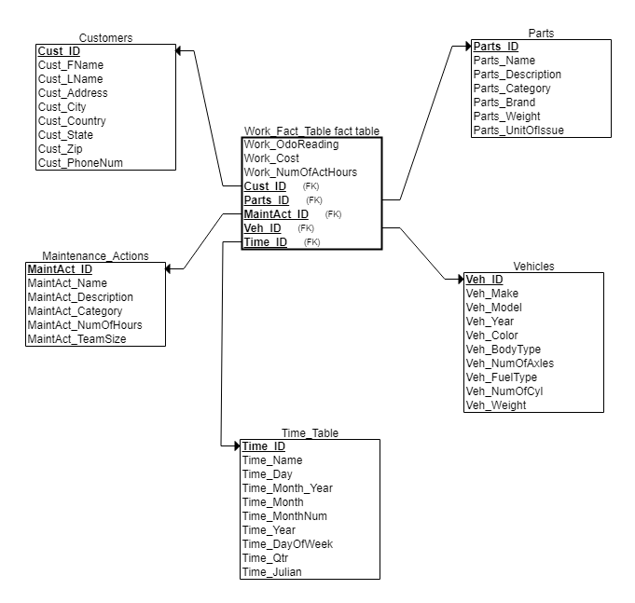

Figure 1. Database Schema

**ETL/DML development**

SQL Loader scripts are used to pre-populate and load the database. There are six SQL loader scripts used to load each dimension table and the fact table. The sqlldr command is used in SQL*Plus to upload the data from a csv file using commands instructed by a control file. A bad file was created to capture errors in the data upload.

Loading the Customer dimension table is presented in Figure 2.

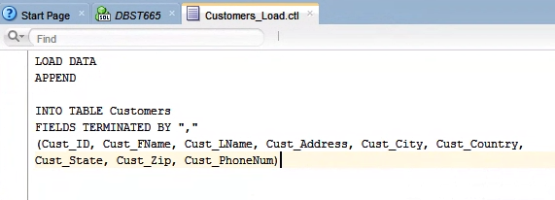

Figure 2. CUSTOMER table population - Step 1

The Customers_Load.ctl file loaded the data into the Customers dimension table using the APPEND function. The data was loaded from the Customers.csv file into columns of the Customers table labeled Cust_ID, Cust_FName, Cust_LName, Cust_Address, Cust_City, Cust_Country, Cust_State, Cust_Zip, and Cust_PhoneNum.

The SQLLDR command identified the userid and password at the database, the control file, the csv data file, and the bad file for the customers load procedure (Figure 3).



Figure 3. CUSTOMER table population - Step 2

Loading the Vehicles dimension table is shown in Figure 4.

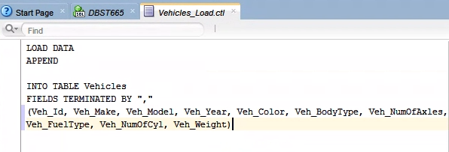

Figure 4. VEHICLES table population - Step 1

The Vehicles_Load.ctl file loaded the data into the Vehicles dimension table using the APPEND function. The data was loaded from the Vehicles.csv file into columns of the Vehicles table labeled Veh_Id, Veh_Make, Veh_Model, Veh_Year, Veh_Color, Veh_BodyType, Veh_NumOfAxles, Veh_FuelType, Veh_NumOfCyl, Veh_Weight.

The SQLLDR command identified the userid and password at the database, the control file, the csv data file, and the bad file for the vehicles load procedure (Figure 5).

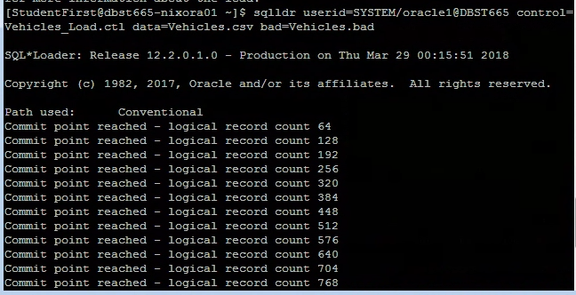

Figure 5. VEHICLES table population - Step 2

Loading the Parts dimension table is presented in Figure 6.

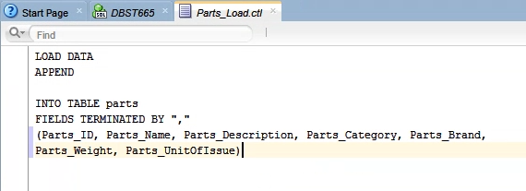

Figure 6. PARTS table population - Step 1

The Parts_Load.ctl file loaded the data into the parts dimension table using the APPEND function. The data was loaded from the Parts.csv file into columns of the parts table labeled Parts_ID, Parts_Name, Parts_Description, Parts_Category, Parts_Brand, Parts_Weight, and Parts_UnitOfIssue.

The SQLLDR command identified the userid and password at the database, the control file, the csv data file, and the bad file for the parts load procedure (Figure 7).



Figure 7. PARTS table population - Step 2

Next, The Maintenance Actions dimension table is loaded (Figure 8)

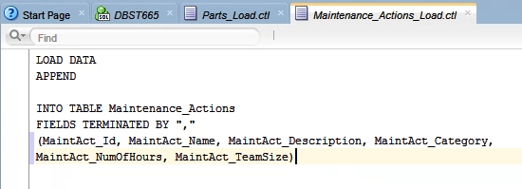

Figure 8. MAINTENANCE ACTIONS table population - Step 1

The Maintenance_Actions_Load.ctl file loaded the data into the Maintenance_Actions dimension table using the APPEND function. The data was loaded from the Maintenance_Actions.csv file into columns of the Maintenance_Action table labeled MaintAct_Id, MainAct_Name, MaintAct_Description, MaintAct_Category, MaintAct_NumOfHours, and MaintAct_TeamSize.

The SQLLDR command identified the userid and password at the database, the control file, the csv data file, and the bad file for the Maintenance Actions load procedure (Figure 9).



Figure 9. MAINTENANCE ACTIONS table population - Step 2

Loading the Time Table dimension table is presented in Figure 10.

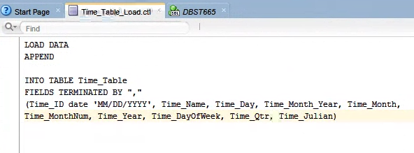

Figure 10. TIME table population - Step 1

The Time_Table_Load.ctl file loaded the data into the Time_Table dimension table using the APPEND function. The data was loaded from the Time_Table.csv file into columns of the Time_Table table labeled Time_ID, Time_Name, Time_Day, Time_Month_Year, Time_Month, Time_MonthNum, Time_Year, Time_DayOfWeek, Time_Qtr, and Time_Julian.

The SQLLDR command identified the userid and password at the database, the control file, the csv data file, and the bad file for the time table load procedure (Figure 11).



Figure 11. TIME table population - Step 2

Finally, we load the Work Fact table (Figure 12)

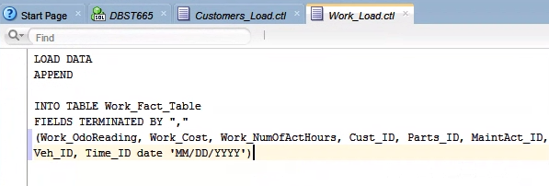

Figure 12. WORK FACT table population - Step 1

The Work_Load.ctl file loaded the data into the Work_Fact_Table fact table using the APPEND function. The data was loaded from the Work.csv file into columns of the Work_Fact_Table table labeled Work_OdoReading, Work_Cost, Work_NumOfActHours, Cust_ID, Parts_ID, MaintAct_ID, Veh_ID, and Time_ID.

The SQLLDR command identified the userid and password at the database, the control file, the csv data file, and the bad file for the work fact table load procedure (Figure 13).



Figure 13. WORK FACT table population - Step 2.

**SQL Queries**

Now the database is ready for the reporting. The following SQL queries are developed for the reporting purposes (the scripts for all SQL queries presented below are attached in Appendix B and attached to the project DBST665_SQLQueries.sql):

1. Suppose we want to check to see how many parts with a weight of more than 20 are not being used. We run the command below to find that amount (Figure 14).

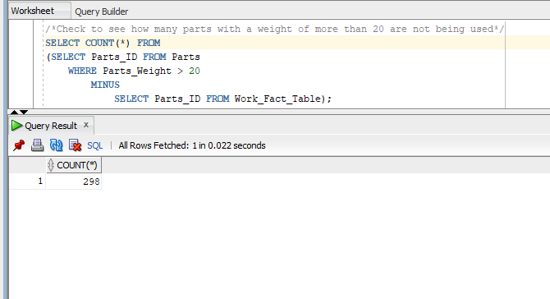

Figure 14. Amount of unused parts with a weight of more than 20

1. Let’s assume the car repair shop wants to send out promotional coupons. Hence we would like to get the list of repeated customers, so we can send them the coupon as they most likely will use it. The result of the query is presented in Figure 15.

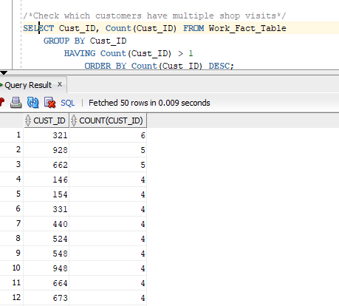

Figure 15. List of repeated customers

1. In order to perform reconciliation check, we run the command below (Figure 16).

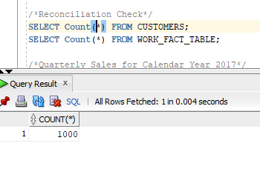

Figure 16. reconciliation check

1. One other common requested report is the Quarterly Sales. Let’s review the Quarterly Sales for Calendar Year 2017 (Figure 17).

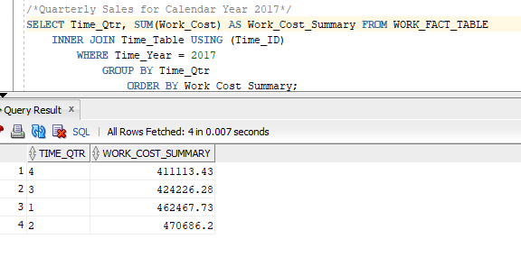

Figure 17. Quarterly Sales for 2017

1. Management is also always interested what brings most business and produces most profit for the company. In our case, we can find that out by identifying which vehicles are bringing in the most profit by using ROLLUP function (Figure 18)

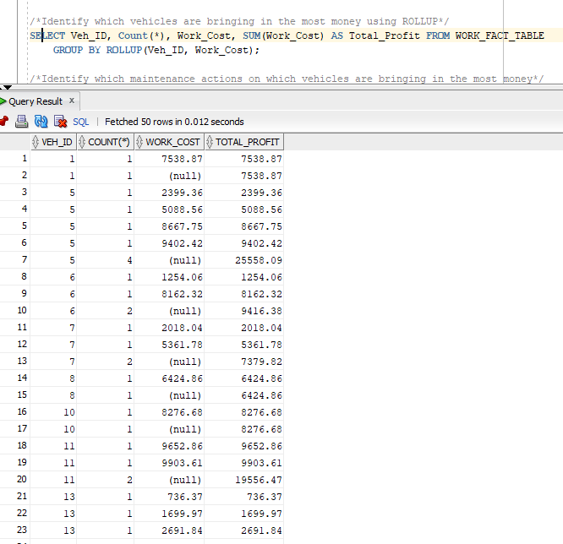Figure 18. vehicles are bringing in the most profit

1. We also could check which tasks and on which vehicles generate the most profit for the car repair shop (Figure 19).

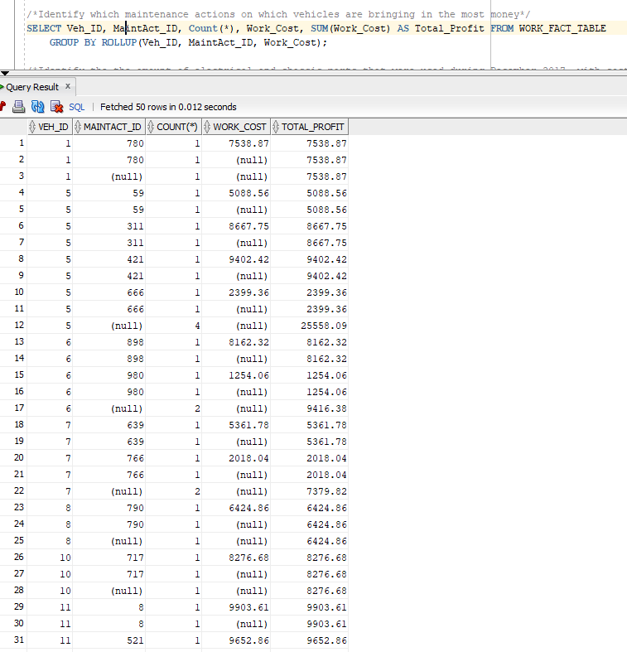

Figure 19. Tasks and vehicles generating the most profit for the car repair shop

1. The query below shows the amount and cost of electrical and chassis parts that were during December 2017 (Figure 20)

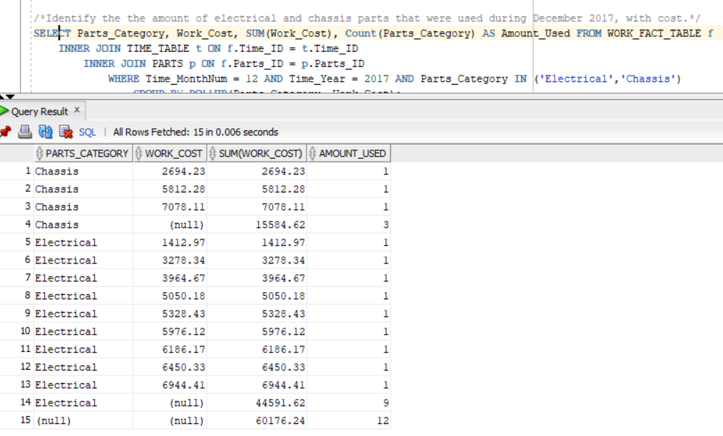

Figure 20. The amount and cost of electrical and chassis parts that were during December 2017

1. The query below returns the amount of maintenance actions taken along with the number of individual hours worked and a sum of all hours for each maintenance actions and overall (Figure 21).

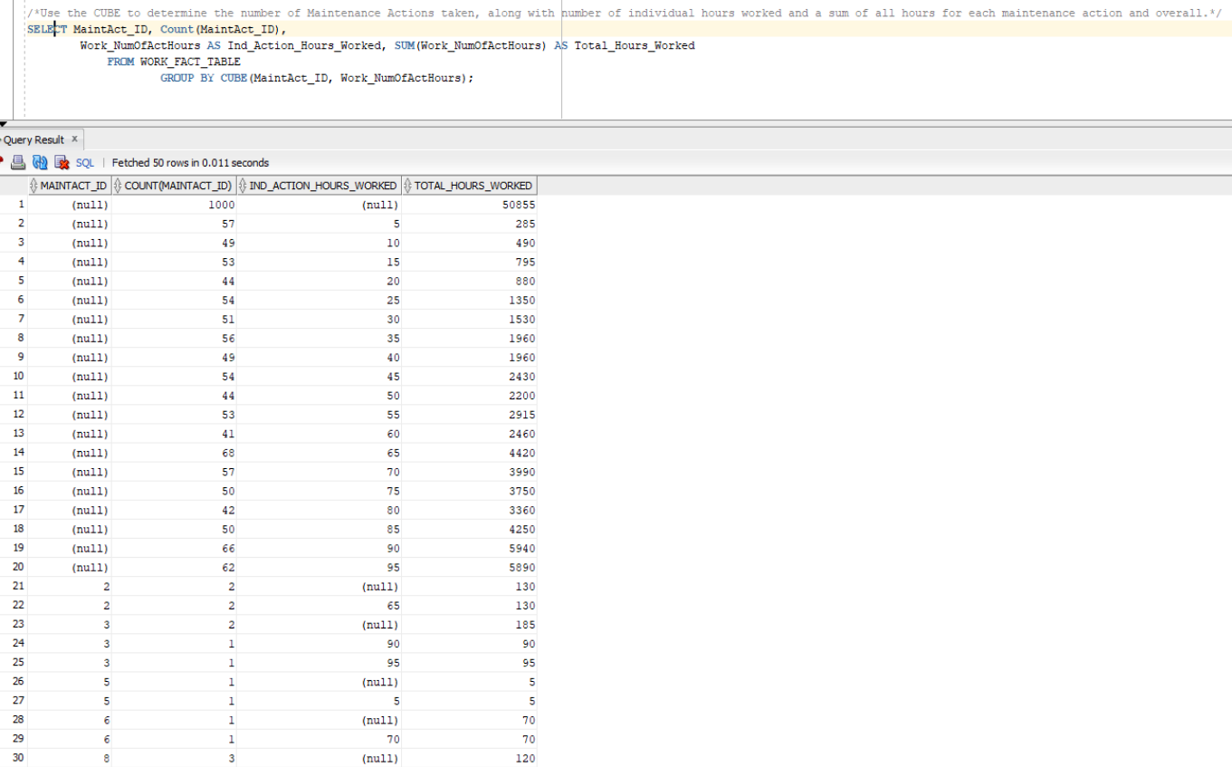

Figure 21. Amount of maintenance actions taken along with the number of individual hours worked and a sum of all hours for each maintenance actions and overall

Report Analysis

For our reports we determined we would needed nine separate queries, as demonstrated in the previous section. The first query demonstrated our ability to query our system for parts that are not being used. This is a useful metric for determining what parts we do or do not need to keep on hand for cost purposes. The second query showcases our ability to see which customers frequented our shops, providing us the ability to provide focus marketing, such as coupons, towards these customers. The third and fourth queries simply provided reconciliation checks. The fifth query showed quarterly sales data for the calendar year 2017. This is a useful metric in determining which quarters held better sales. The sixth query highlights which vehicles frequented the shop, and which provided the shop the most profit. This could be used in analysis to determine which vehicles make the most money. The seventh query determined which maintenance actions on different vehicles provided the most profit, providing similar metrics as the sixth query. The eighth query shows amounts used for specific category of parts and profits made. This is useful data for maintaining stocks, in general, and keeping stock of profitable items. The final query used the CUBE function to provide an analysis of how many times different maintenance actions were worked, along with how many hours were worked on each one and overall. This is a useful metric if we need to determine what training our employees need the most.

**Lessons Learned**

During the creation of the data model we decided to model a car repair shop maintenance tracking system. While there are several statistically viable attributes, we decided the best ones to track in the fact table were the odometer reading of the vehicle at the time of entry into the system, how much the overall work cost, and finally the number of actual hours it took to complete the job. These were determined to be best placed in the fact table. The odometer reading would not work well in the vehicles table, since this would require an update to the reading on every new job, thus not allowing for an historical record of the mileage of the vehicle between jobs. Though individual cost could be entered into the dimension tables, this would again force us to update these tables, versus tracking trends in the historical fact table data. The number of actual hours in the fact table contrasts with the estimated hours for a job listed in the maintenance actions table. This is a viable metric for tracking shop efficiency. While creating the DDLs, we determined the need for indexes on the foreign key constraints within the fact table to increase query speeds. In our business, we previously tracked all these records in comma-delimited files. Therefore, we decided the best method for loading our data into the database would be using the SQL loader and control files. While creating the queries we learned we needed to utilize the SQL ROLLUP and CUBE functions for effective statistical analysis of many of our shop metrics.

**Conclusion**

Data warehouses are centralized data storage systems that allow the organization to integrate data from multiple applications and sources into one location, which provides an environment that is designed for decision support, analytics reporting, and data mining. When the data is isolated and optimized, it can be managed without impacting primary business processes.

# The benefits of data warehousing are obvious: warehousing solves the ongoing problem of analyzing separate data and converting it into actionable information that can be used. Warehousing also allows for processing of large amounts of complex data in an efficient way. With a successful implementation of a data warehouse system, it is possible to access the benefits such as increased efficiency, profitability and overall success through ETL and data warehousing. In addition to that, warehouse system offers improved and timely access to information **with enhanced quality and consistency**, i**ncreased query and system performance, which leads to higher return on the investments, as the** use of data warehousing also enables the business to generate a higher amount of revenue due to cost savings. (The Benefits of Data Warehousing and ETL, 2016).

It is clear that when data warehousing is implemented and designed properly it can provide a variety of advantages to the business.

The presented data warehouse design would be extremely beneficial for the car repair company as it would bring numerous advantages such as improved data management, reduced speeds in critical decision making and therefore improved business operation.

**Appendixes**

1. **DDL Script to build the database(creating tables)**

DROP TABLE Work_Fact_Table;

DROP TABLE Parts;

DROP TABLE Customers;

DROP TABLE Maintenance_Actions;

DROP TABLE Time_Table;

DROP TABLE Vehicles;

CREATE TABLE Parts (

Parts_ID NUMBER NOT NULL,

Parts_Name VARCHAR(50) NOT NULL,

Parts_Description VARCHAR(100) NOT NULL,

Parts_Category VARCHAR(50) NOT NULL,

Parts_Brand VARCHAR(50) NOT NULL,

Parts_Weight NUMBER NOT NULL,

Parts_UnitOfIssue NUMBER NOT NULL,

CONSTRAINT pk_parts PRIMARY KEY (Parts_ID)

);

CREATE TABLE Customers (

Cust_ID NUMBER NOT NULL,

Cust_FName VARCHAR(50) NOT NULL,

Cust_LName VARCHAR(50) NOT NULL,

Cust_Address VARCHAR(100) NOT NULL,

Cust_City VARCHAR(50) NOT NULL,

Cust_Country VARCHAR(50) NOT NULL,

Cust_State VARCHAR(50) NOT NULL,

Cust_Zip VARCHAR(50) NOT NULL,

Cust_PhoneNum VARCHAR(50) NOT NULL,

CONSTRAINT pk_customers PRIMARY KEY (Cust_ID)

);

CREATE TABLE Maintenance_Actions (

MaintAct_ID NUMBER NOT NULL,

MaintAct_Name VARCHAR(50) NOT NULL,

MaintAct_Description VARCHAR(100) NOT NULL,

MaintAct_Category VARCHAR(100) NOT NULL,

MaintAct_NumOfHours NUMBER NOT NULL,

MaintAct_TeamSize NUMBER NOT NULL,

CONSTRAINT pk_maintenance_actions PRIMARY KEY (MaintAct_ID)

);

CREATE TABLE Time_Table (

Time_ID DATE NOT NULL,

Time_Name VARCHAR(50)NOT NULL,

Time_Day NUMBER NOT NULL,

Time_Month_Year VARCHAR(50)NOT NULL,

Time_Month VARCHAR(50) NOT NULL,

Time_MonthNum NUMBER NOT NULL,

Time_Year NUMBER(4,0) NOT NULL,

Time_DayOfWeek VARCHAR(50) NOT NULL,

Time_Qtr VARCHAR(50) NOT NULL,

Time_Julian NUMBER NOT NULL,

CONSTRAINT pk_time PRIMARY KEY (Time_ID)

);

CREATE TABLE Vehicles (

Veh_ID NUMBER NOT NULL,

Veh_Make VARCHAR(50) NOT NULL,

Veh_Model VARCHAR(50) NOT NULL,

Veh_Year NUMBER(4,0) NOT NULL,

Veh_Color VARCHAR(50) NOT NULL,

Veh_BodyType VARCHAR(50) NOT NULL,

Veh_NumOfAxles NUMBER NOT NULL,

Veh_FuelType VARCHAR(50) NOT NULL,

Veh_NumOfCyl NUMBER NOT NULL,

Veh_Weight NUMBER NOT NULL,

CONSTRAINT pk_vehicles PRIMARY KEY (Veh_ID)

);

CREATE TABLE Work_Fact_Table (

Work_OdoReading NUMBER NOT NULL,

Work_Cost NUMBER(*, 2) NOT NULL,

Work_NumOfActHours NUMBER NOT NULL,

Cust_ID NUMBER NOT NULL,

Parts_ID NUMBER NOT NULL,

MaintAct_ID NUMBER NOT NULL,

Veh_ID NUMBER NOT NULL,

Time_ID DATE NOT NULL,

CONSTRAINT pk_work_fact_table PRIMARY KEY (Cust_ID,Parts_ID,MaintAct_ID,Veh_ID,Time_ID),

CONSTRAINT fk_customers FOREIGN KEY (Cust_ID)

REFERENCES Customers ON DELETE CASCADE,

CONSTRAINT fk_maintenance_actions FOREIGN KEY (MaintAct_ID)

REFERENCES Maintenance_Actions ON DELETE CASCADE,

CONSTRAINT fk_time_table FOREIGN KEY (Time_ID)

REFERENCES Time_Table ON DELETE CASCADE,

CONSTRAINT fk_vehicles FOREIGN KEY (Veh_ID)

REFERENCES Vehicles ON DELETE CASCADE,

CONSTRAINT fk_parts FOREIGN KEY (Parts_ID)

REFERENCES Parts ON DELETE CASCADE

);

CREATE INDEX fk_customers on Work_Fact_Table(Cust_ID);

CREATE INDEX fk_maintenance_actions on Work_Fact_Table(MaintAct_ID);

CREATE INDEX fk_time_table on Work_Fact_Table(Time_ID);

CREATE INDEX fk_vehicles on Work_Fact_Table(Veh_ID);

CREATE INDEX fk_parts on Work_Fact_Table(Parts_ID);

1. **SQL Queries**

/*Check to see how many parts with a weight of more than 20 are not being used*/

SELECT COUNT(*) FROM

(SELECT Parts_ID FROM Parts

WHERE Parts_Weight > 20

MINUS

SELECT Parts_ID FROM Work_Fact_Table);

/*Check which customers have multiple shop visits*/

SELECT Cust_ID, Count(Cust_ID) FROM Work_Fact_Table

GROUP BY Cust_ID

HAVING Count(Cust_ID) > 1

ORDER BY Count(Cust_ID) DESC;

/*Reconciliation Check*/

SELECT Count(*) FROM CUSTOMERS;

SELECT Count(*) FROM WORK_FACT_TABLE;

/*Quarterly Sales for Calendar Year 2017*/

SELECT Time_Qtr, SUM(Work_Cost) AS Work_Cost_Summary FROM WORK_FACT_TABLE

INNER JOIN Time_Table USING (Time_ID)

WHERE Time_Year = 2017

GROUP BY Time_Qtr

ORDER BY Work_Cost_Summary;

/*Identify which vehicles are bringing in the most money using ROLLUP*/

SELECT Veh_ID, Count(*), Work_Cost, SUM(Work_Cost) AS Total_Profit FROM WORK_FACT_TABLE

GROUP BY ROLLUP(Veh_ID, Work_Cost);

/*Identify which maintenance actions on which vehicles are bringing in the most money*/

SELECT Veh_ID, MaintAct_ID, Count(*), Work_Cost, SUM(Work_Cost) AS Total_Profit FROM WORK_FACT_TABLE

GROUP BY ROLLUP(Veh_ID, MaintAct_ID, Work_Cost);

/*Identify the the amount of electrical and chassis parts that were used during December 2017, with cost.*/

SELECT Parts_Category, Work_Cost, SUM(Work_Cost), Count(Parts_Category) AS Amount_Used FROM WORK_FACT_TABLE f

INNER JOIN TIME_TABLE t ON f.Time_ID = t.Time_ID

INNER JOIN PARTS p ON f.Parts_ID = p.Parts_ID

WHERE Time_MonthNum = 12 AND Time_Year = 2017 AND Parts_Category IN ('Electrical','Chassis')

GROUP BY ROLLUP(Parts_Category, Work_Cost);

/*Use the CUBE to determine the number of Maintenance Actions taken, along with number of individual hours worked and a sum of all hours for each maintenance action and overall.*/

SELECT MaintAct_ID, Count(MaintAct_ID),

Work_NumOfActHours AS Ind_Action_Hours_Worked, SUM(Work_NumOfActHours) AS Total_Hours_Worked

FROM WORK_FACT_TABLE

GROUP BY CUBE(MaintAct_ID, Work_NumOfActHours);

References

Software Development Process – activities and steps. (2010). Retrieved from http://www.uacg.bg/filebank/acadstaff/userfiles/publ_bg_397_SDP_activities_and_steps. pdf

# The Benefits of Data Warehousing and ETL(April 5, 2016). Retrieved from https://www.glowtouch.com/blog/analytics/the-benefits-of-data-warehousing-and-etl/