Converting an ERD to DDL

# Key Points

* Each entity on ERD becomes a table.
* Each attribute becomes a table column.
* An entity on one side of relationship is a parent.
* An entity on many side of the relationship is a child.
* Put all statements to drop tables at the top of the script.
* Drop child table before the parent table.
* Create parent table before the child table.
* We can have only one table with the same name in the same schema
* We can have only one constraint with the same name in the same schema.
* Reserved words cannot be used for the table names, column names, and constraint names. Oracle SQL developer shows reserved words in blue.
* The child table needs a foreign key referencing the parent table.
* Primary key attributes should be numeric.
* The data type of the foreign key needs to match the data type of the corresponding primary key.

# Example

An entity relationship diagram on **Figure 1** has Customer entity, Order entity, and one-to-many relationship between the entities.

Customer entity is a **parent** – on one side of the relationship.

Order entity is a **child** – on the many side of the relationship.

Order is a reserved word in Oracle. Hence, we rename the table as Orders.

We drop orders table (child) before customer table (parent). – Lines 1 and 2 on Figure 2

We create customer table (parent) before orders table (child).



Figure 1: Entity Relationship Diagram

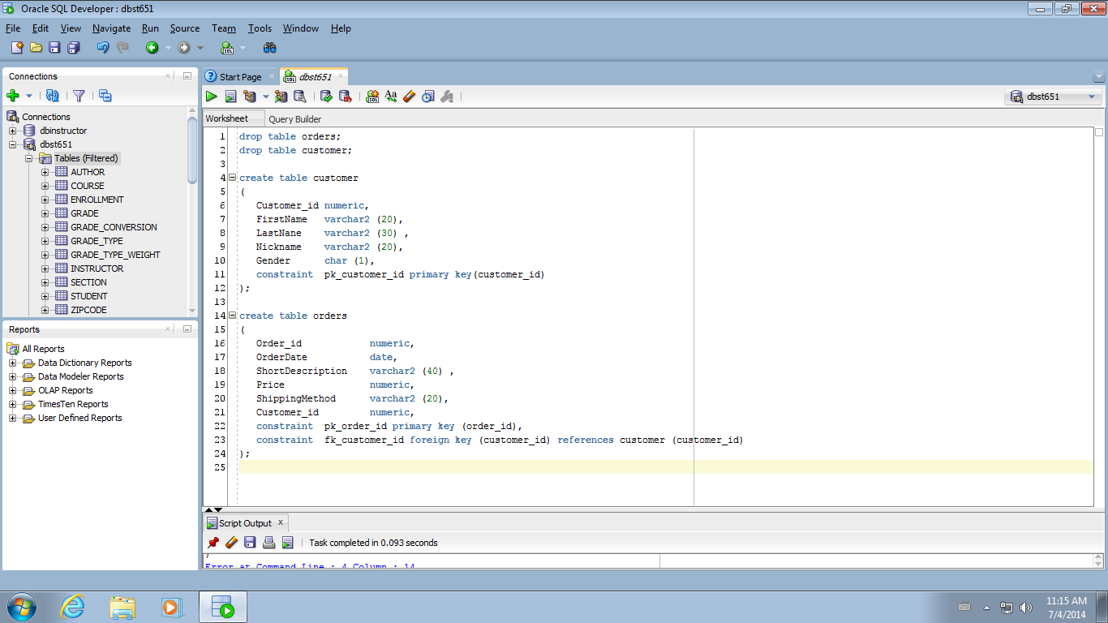Lines 4-11 on Figure 2 are the code to create customer table. Lines 14-24 are the code to create orders table.





Figure 2: Script

Child table orders has a foreign key referencing customer table – Line 23. Line 11 is the definition of the customer primary key. Line 22 is the definition of orders primary key.