Oracle Data Dictionary

Data dictionary consists of the read-only tables that store the information on the objects on your schema. The objects you create in DBST 651 class include tables, sequences, views, indexes, and triggers.

# Data Dictionary Queries Examples

**USER_CATALOG** – list tables, sequences, and views that you created.

select * from USER_CATALOG;

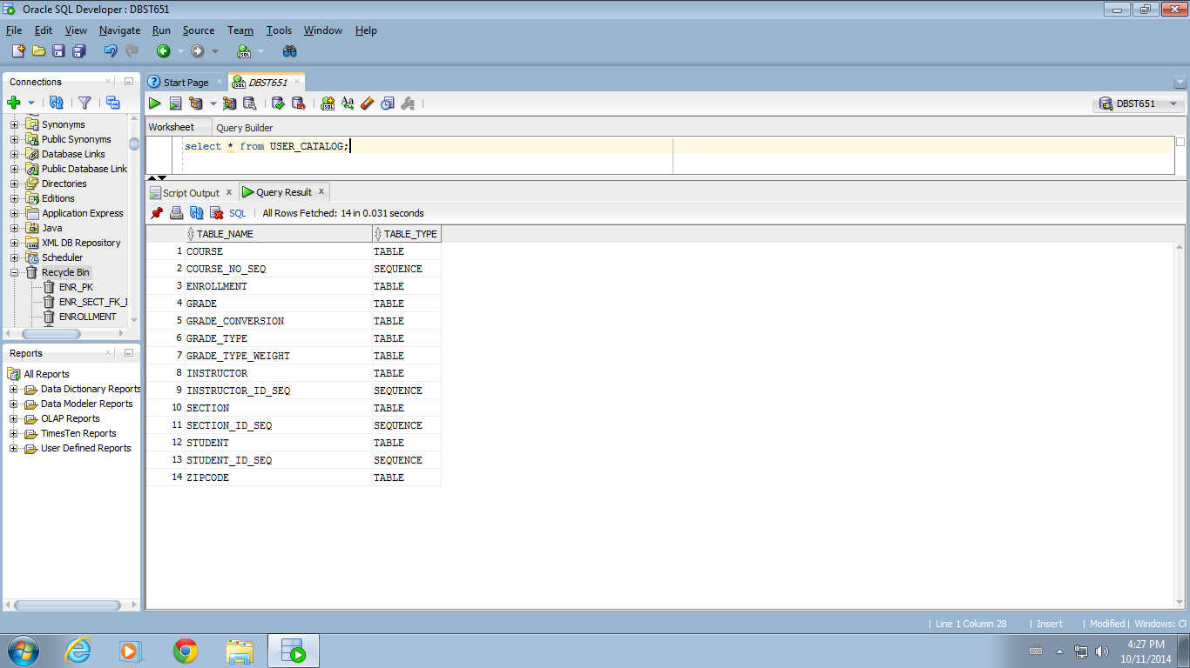

**USER_OBJECTS** – Detailed information on tables, views, sequences, constraints, triggers, etc. on your account.

Select * from user_objects;

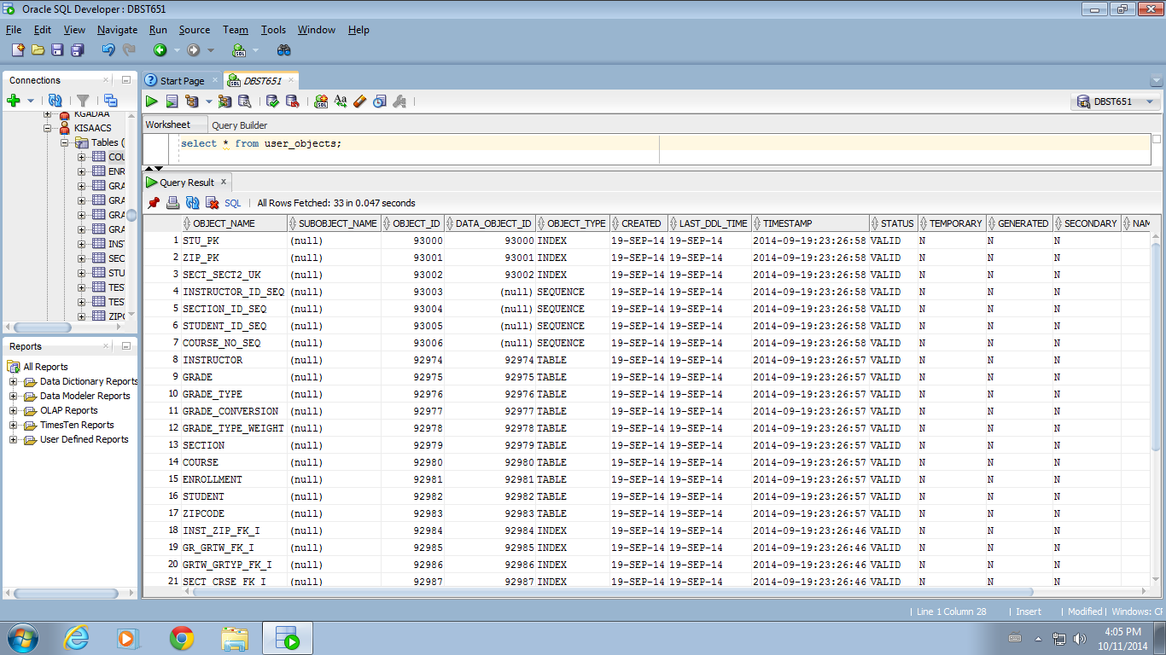

**TAB** - Tables and views in your schema

select * from TAB;

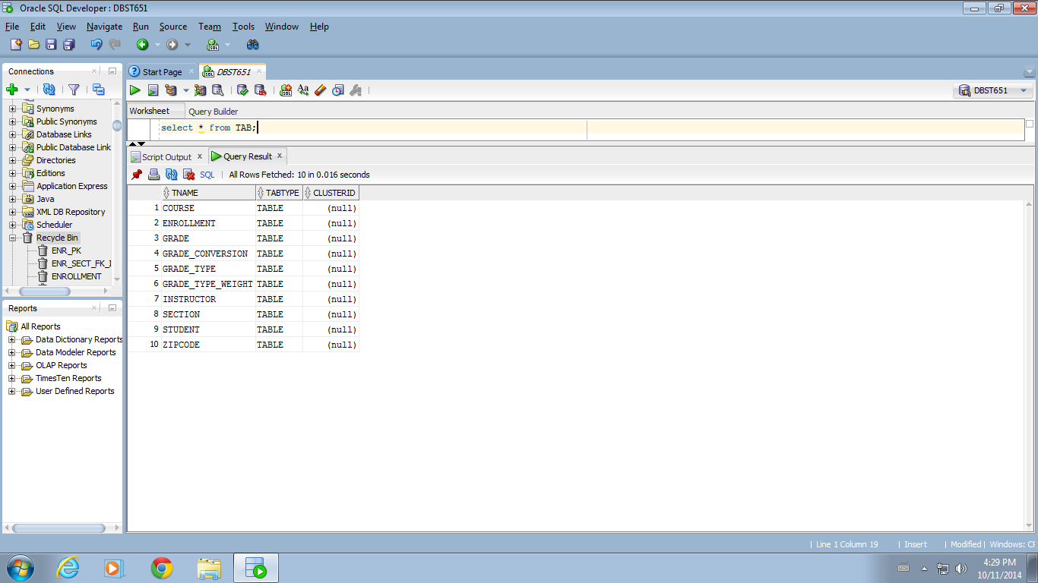

**USER_TABLES** – detailed information on tables in your schema.

select * from user_tables;

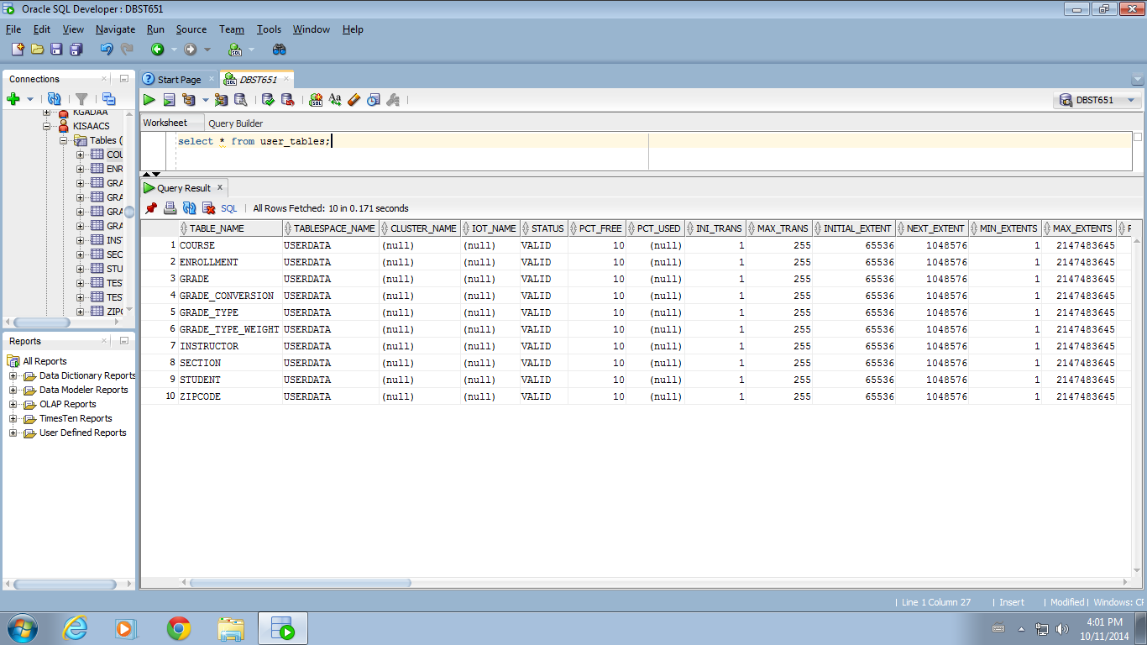

**USER_TAB_COL** – Details about columns in each table, including table name, column name, data type, length, etc.

select * from user_tab_cols;

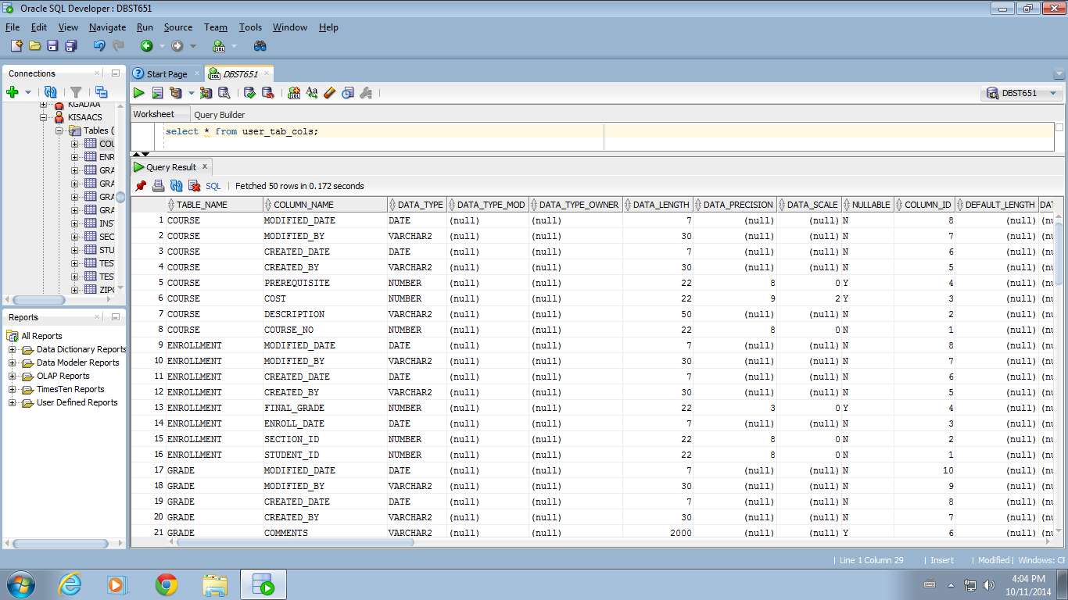

**USER_CONSTRAINTS** – details on constraints, including primary keys and foreign keys.

select * from user_constraints;

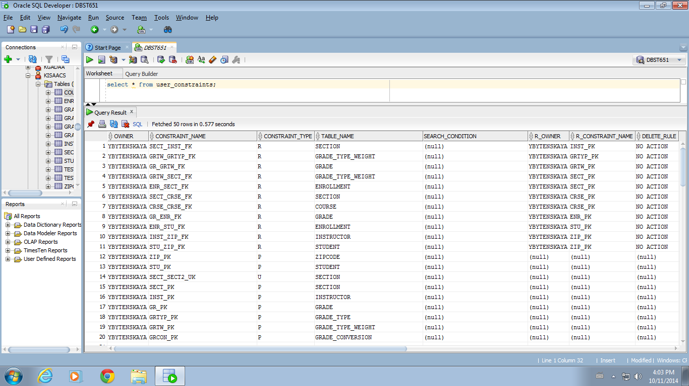

**USER_INDEXES** – Information on indexes, including index name, index type, table name, and uniqueness.

select * from user_indexes;

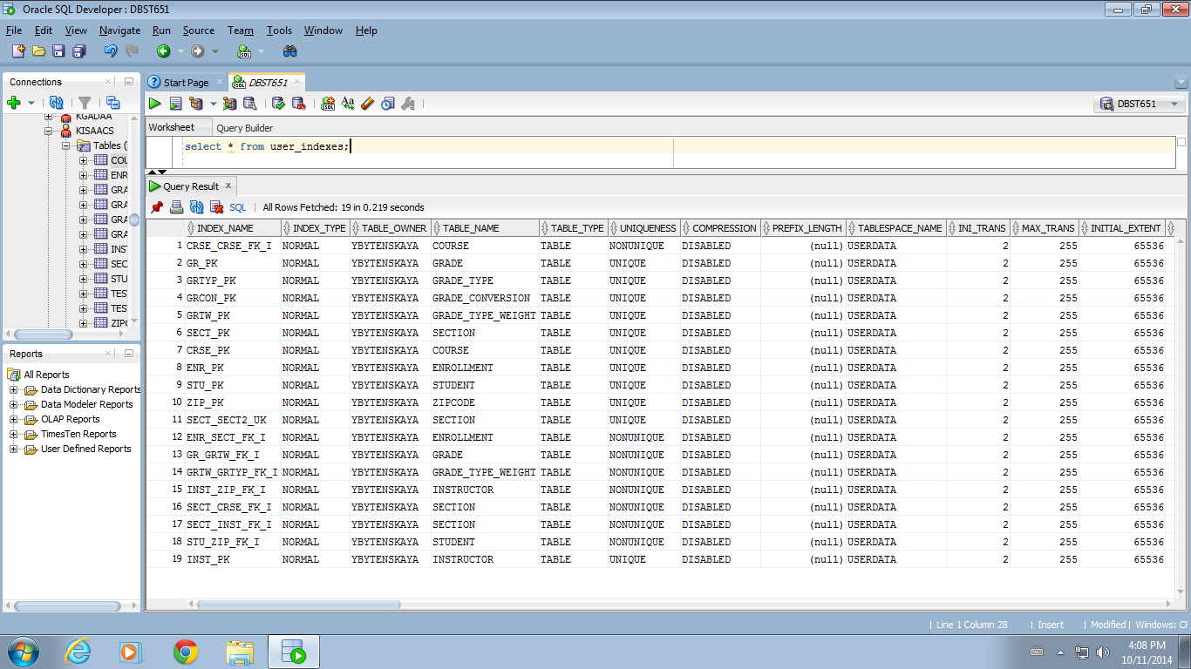

**USER_SEQUENCES** – details about the sequences, including sequence name, minimum value, etc.

select * from user_sequences;

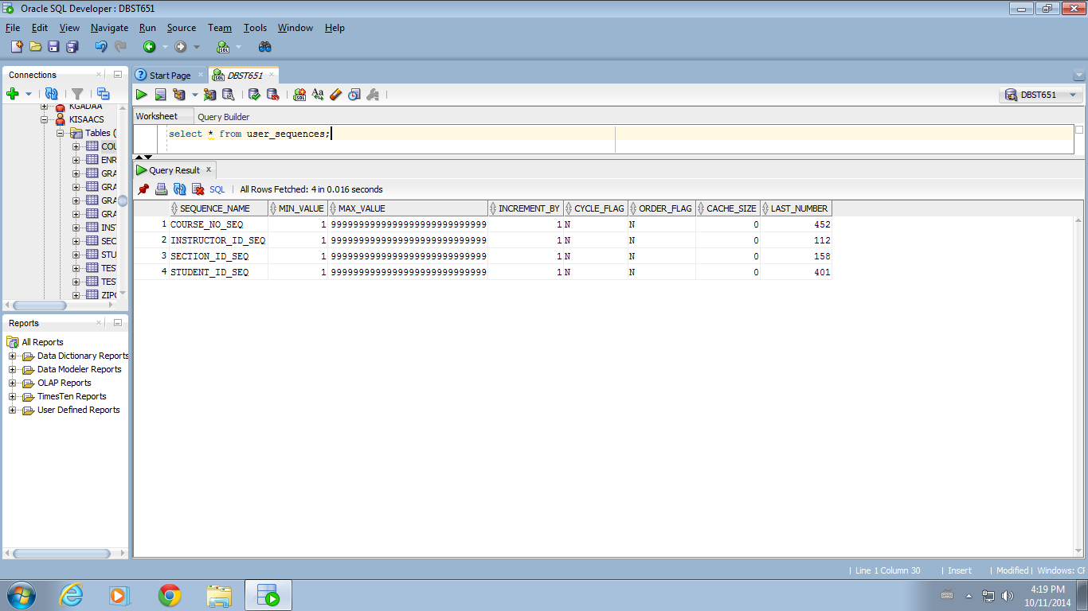

**USER_USERS** – information about your user name, including user name and date when your account was created.

select * from user_users;

