Instructor Teaching Tracker: Security Project

Brandon R. Russell

University of Maryland University College

Abstract

This paper provides an

Keywords: Database, Instructor, Teaching, Tracker, Security

Contents

Abstract 2

Instructor Teaching Tracker: Security Project 6

Statement of Work 6

Database Name 6

Database Objective 6

The Problem 7

Security Plan 7

Technical Details 8

Timeline 8

Data Model 9

Conceptual 9

User Roles. 9

Assumptions. 9

Business Rules. 9

Logical 10

Implementation 11

DDL 11

DML 18

Security 34

Policies 34

Password Policy. 35

Connection Policy. 35

Role Assignment Policy. 35

Account Modify Policy. 35

Course Management Policy. 35

Section Management Policy. 35

Class Schedule Modify Policy. 35

Admin Support Policy. 35

Instructor View Policy. 35

Instructor Modify Policy. 36

Student View Policy. 36

Student Modify Policy. 36

Procedures 36

Password Procedure. 36

Connection Procedure. 36

Role Assignment Procedure. 36

Account Modify Procedure. 36

Course Management Procedure. 36

Section Management Procedure. 36

Class Schedule Modify Procedure. 37

Admin Support Procedure. 37

Instructor View Procedure. 37

Instructor Modify Procedure. 37

Student View Procedure. 37

Student Modify Procedure. 37

Conclusion 37

Lesson Learned 37

Final Thoughts 37

References 38

Instructor Teaching Tracker: Security Project

This

# Statement of Work

## **Database Name**

Instructor Teaching Tracker

Database Objective

The purpose of this project is to implement security measures into the existing instructor teaching tracker database. This database supports the Instructor Teaching Tracker application for Training Detachment 6. It keeps track of instructor, course, admin, student, and section data; additionally, it tracks classes taught, the schedule, and students signed up for classes. The overall purpose is assisting instructors, administrators, and students with creating, scheduling, maintaining, and monitoring personal, course, and class data in an efficient manner. The instructor, administrator, and student tables hold all pertinent personal information, such as: name, address, and phone number. The course list table is a comprehensive listing of all courses taught across the different sections of the school, and it contains the name, author, description, hours, and section number for each course. The section table provides basic information on the sections which instructors and courses belong to, and it holds the following information: section number, name, address, and field of study. The class schedule table holds the different schedules classes can follow and gives the day and time a class is taught, a down day schedule, and notes. The Instructor Classes table is at the core of the database, providing a complete schedule of all courses taught by all instructors, with schedules, and also the room number of the class and any instructor notes. The Student Class Signup table provides students the ability to sign up for available classes in the Instructor Classes table.

## The Problem

Training Detachment 6 is a military field training facility, employing eleven instructors and eleven support admin staff at any given time, and host a variable number of students annually. The teaching tracker application and associated database became a necessity due to the complexities of tracking a large number of instructors, courses, and students. The database was created in house, and as a result no security was implemented within the initial design. In an effort to maintain the confidentiality of certain data, such as instructor’s phone numbers and addresses, and to ensure the integrity of the data, i.e. prevent students from changing course data, we need to hire a security consultant to redesign the database with security permissions added.

# Security Plan

One of the most important steps in this project is to create a sound security plan. This document will be an overarching guide on set requirements to be enforced through security policies to establish sound security within the database (Theriault & Heney, 1998). For our database, the Instructor Teaching Tracker, we will achieve the necessary security by separating user accounts into specific groups, i.e. students, instructors, and support administrators. We will then enact policies to assign roles to these groups with specific actions they are allowed to use, and this will be augmented with Views and Oracle Label Security. There will also be established policies on standard password requirements, and the enforcement of autogenerated identification numbers to reduce the storing of sensitive data. All security policies will have an accompanying procedure for implementation, and this will be thoroughly tested and documented before operationalized. Any user in violation of this plan or subsequent policies are subject to account disablement.

# Technical Details

The database was built with Oracle 11g on a Windows platform. We used Oracle SQL Developer Data Modeler to design the Entity Relationship Diagram (ERD). All Data Definition Language (DDL), Data Manipulation Language (DML), and Data Control Language (DCL) implementation scripts were rendered in Oracle SQL Developer or SQL Plus.

# Timeline

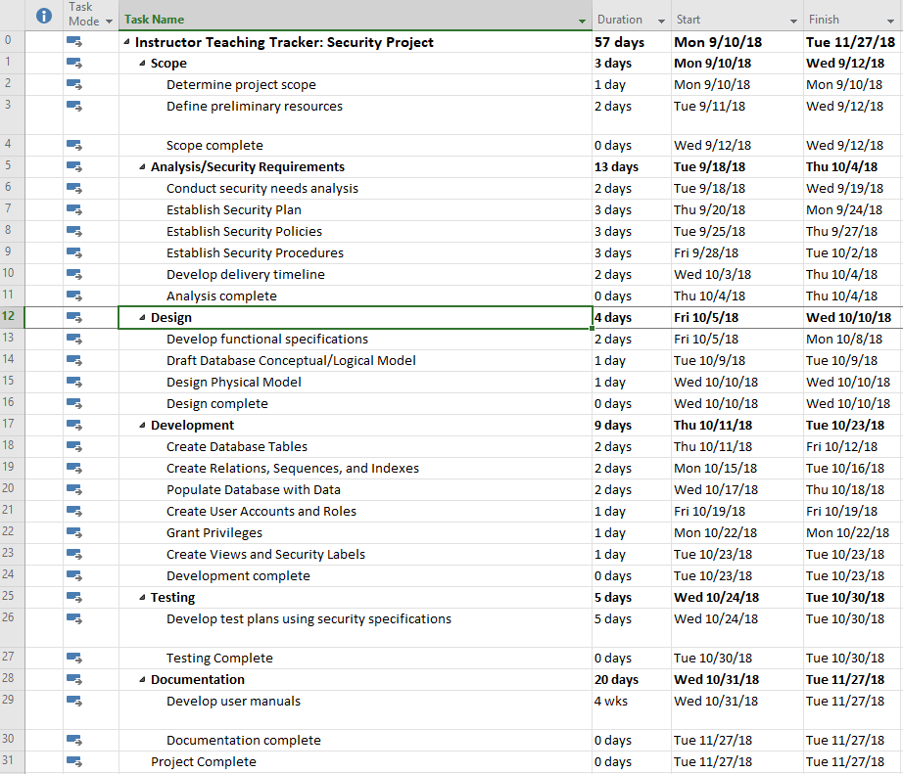

Figure 1. Project timeline created with Microsoft Project.

# Data Model

## Conceptual

User Roles. There will be three different primary user roles: student, instructor, and support admin. Specific policies will be defined in the security policy section for how each user role can and cannot interact with the database.

Assumptions. This application tracks classes taught by instructors and includes a class schedule. It is assumed classes will always meet a specific schedule criteria, i.e. Monday-Wednesday-Friday, Tuesday-Thursday, or Saturday. Down days are tracked for individual classes since this will vary based upon the specific class. For the usernames, we are using the user’s first character of their first name concatenated with the full last name with their sequence id added to the end. There is still a chance of duplicate user names since instructor, student, and admin information is stored in different tables, but for the purpose of this project we are assuming this will not occur due to the low number of users.

Business Rules. The business rules to follow for this database are as follows:

1. A section may hire zero or more instructors, but an instructor must belong to only one section.
2. A section may own zero or more courses, but a course must be owned by only one section.
3. A section may hire zero or more administrators, but an administrator must belong to only one section.
4. An administrator can own multiple courses, a course can only be owned by one administrator.
5. A course may generate zero or more classes, but a class can only be generated from one course.
6. An instructor may teach zero or more classes, but a class can only be taught by one instructor.
7. A schedule may be generated for zero or more classes, but a class must only have one schedule.
8. A class may have zero or more students.
9. A student can sign up for zero or more classes, so long as there is no schedule conflict.

## Logical

Figure 2 provides a logical rendering of the database design, while figure 3 provides a more detailed ERD of the database design.

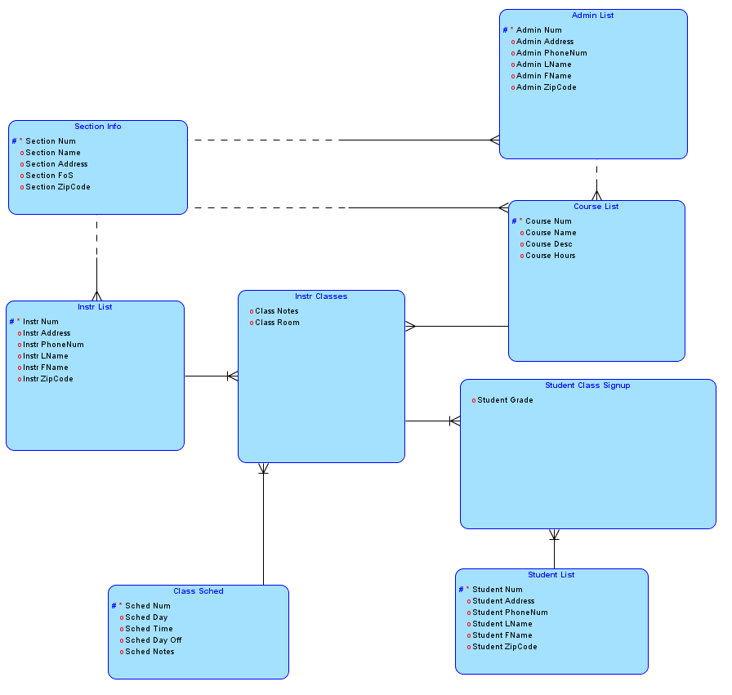

Figure 2. Logical model created with Oracle SQL Developer Data Modeler.

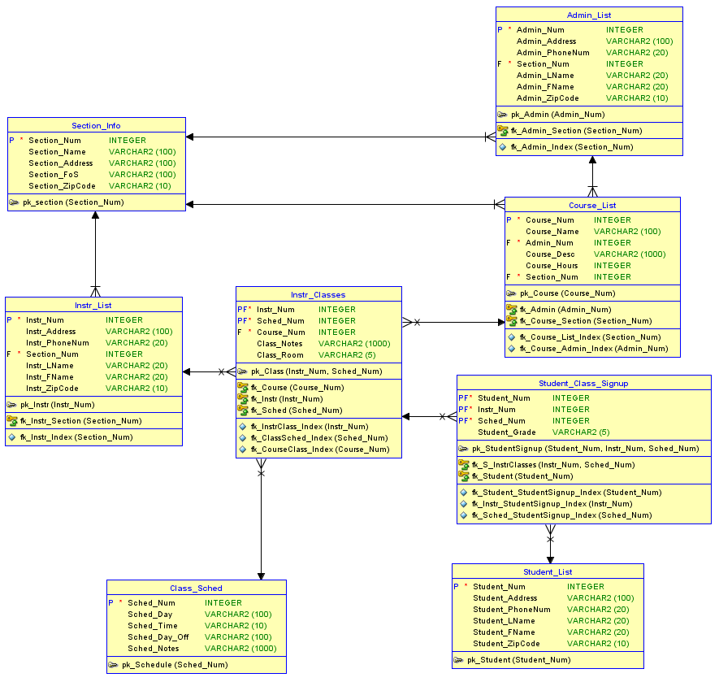

Figure 3. ERD created with Oracle SQL Developer Data Modeler.

# Implementation

This section consists of the physical implementation of the database, i.e. DDLs, used to create the database and the DMLs used to insert data into it.

## DDL

SQL> SET echo on;

SQL> SET serveroutput on;

SQL> /* Drop tables, sequence, and other objects you create*/

SQL>

SQL> DROP TABLE Student_Class_Signup;

Table STUDENT_CLASS_SIGNUP dropped.

SQL> DROP TABLE Instr_Classes;

Table INSTR_CLASSES dropped.

SQL> DROP TABLE Student_List;

Table STUDENT_LIST dropped.

SQL> DROP TABLE Instr_List;

Table INSTR_LIST dropped.

SQL> DROP TABLE Course_List;

Table COURSE_LIST dropped.

SQL> DROP TABLE Admin_List;

Table ADMIN_LIST dropped.

SQL> DROP TABLE Section_Info;

Table SECTION_INFO dropped.

SQL> DROP TABLE Class_Sched;

Table CLASS_SCHED dropped.

SQL> DROP SEQUENCE SectionNum_Seq;

Sequence SECTIONNUM_SEQ dropped.

SQL> DROP SEQUENCE InstrNum_Seq;

Sequence INSTRNUM_SEQ dropped.

SQL> DROP SEQUENCE CourseNum_Seq;

Sequence COURSENUM_SEQ dropped.

SQL> DROP SEQUENCE AdminNum_Seq;

Sequence ADMINNUM_SEQ dropped.

SQL> DROP SEQUENCE SchedNum_Seq;

Sequence SCHEDNUM_SEQ dropped.

SQL> DROP SEQUENCE StudentNum_Seq;

Sequence STUDENTNUM_SEQ dropped.

SQL>

SQL> /* Create tables */

SQL>

SQL> CREATE TABLE Section_Info

2 (

3 Section_Num INTEGER NOT NULL,

4 Section_Name VARCHAR (100),

5 Section_Address VARCHAR (100),

6 Section_FoS VARCHAR (100),

7 Section_ZipCode VARCHAR(10),

8 CONSTRAINT pk_section PRIMARY KEY (Section_Num)

9 );

Table SECTION_INFO created.

SQL>

SQL> DESCRIBE Section_Info;

Name Null? Type

--------------- -------- -------------

SECTION_NUM NOT NULL NUMBER(38)

SECTION_NAME VARCHAR2(100)

SECTION_ADDRESS VARCHAR2(100)

SECTION_FOS VARCHAR2(100)

SECTION_ZIPCODE VARCHAR2(10)

SQL>

SQL> CREATE TABLE Admin_List

2 (

3 Admin_Num INTEGER NOT NULL,

4 Admin_Address VARCHAR (100),

5 Admin_PhoneNum VARCHAR (20),

6 Section_Num INTEGER NOT NULL,

7 Admin_LName VARCHAR (20),

8 Admin_FName VARCHAR (20),

9 Admin_ZipCode VARCHAR (10),

10 CONSTRAINT pk_Admin PRIMARY KEY (Admin_Num),

11 CONSTRAINT fk_Admin_Section FOREIGN KEY (Section_Num)

12 REFERENCES Section_Info

13 );

Table ADMIN_LIST created.

SQL>

SQL> DESCRIBE Admin_List;

Name Null? Type

-------------- -------- -------------

ADMIN_NUM NOT NULL NUMBER(38)

ADMIN_ADDRESS VARCHAR2(100)

ADMIN_PHONENUM VARCHAR2(20)

SECTION_NUM NOT NULL NUMBER(38)

ADMIN_LNAME VARCHAR2(20)

ADMIN_FNAME VARCHAR2(20)

ADMIN_ZIPCODE VARCHAR2(10)

SQL>

SQL>

SQL> CREATE TABLE Student_List

2 (

3 Student_Num INTEGER NOT NULL,

4 Student_Address VARCHAR (100),

5 Student_PhoneNum VARCHAR (20),

6 Student_LName VARCHAR (20),

7 Student_FName VARCHAR (20),

8 Student_ZipCode VARCHAR (10),

9 CONSTRAINT pk_Student PRIMARY KEY (Student_Num)

10 );

Table STUDENT_LIST created.

SQL>

SQL> DESCRIBE Student_List;

Name Null? Type

---------------- -------- -------------

STUDENT_NUM NOT NULL NUMBER(38)

STUDENT_ADDRESS VARCHAR2(100)

STUDENT_PHONENUM VARCHAR2(20)

STUDENT_LNAME VARCHAR2(20)

STUDENT_FNAME VARCHAR2(20)

STUDENT_ZIPCODE VARCHAR2(10)

SQL>

SQL>

SQL> CREATE TABLE Instr_List

2 (

3 Instr_Num INTEGER NOT NULL,

4 Instr_Address VARCHAR (100),

5 Instr_PhoneNum VARCHAR (20),

6 Section_Num INTEGER NOT NULL,

7 Instr_LName VARCHAR (20),

8 Instr_FName VARCHAR (20),

9 Instr_ZipCode VARCHAR (10),

10 CONSTRAINT pk_Instr PRIMARY KEY (Instr_Num),

11 CONSTRAINT fk_Instr_Section FOREIGN KEY (Section_Num)

12 REFERENCES Section_Info

13 );

Table INSTR_LIST created.

SQL>

SQL> DESCRIBE Instr_List;

Name Null? Type

-------------- -------- -------------

INSTR_NUM NOT NULL NUMBER(38)

INSTR_ADDRESS VARCHAR2(100)

INSTR_PHONENUM VARCHAR2(20)

SECTION_NUM NOT NULL NUMBER(38)

INSTR_LNAME VARCHAR2(20)

INSTR_FNAME VARCHAR2(20)

INSTR_ZIPCODE VARCHAR2(10)

SQL>

SQL>

SQL> CREATE TABLE Course_List

2 (

3 Course_Num INTEGER NOT NULL,

4 Course_Name VARCHAR (100),

5 Admin_Num INTEGER NOT NULL,

6 Course_Desc VARCHAR (1000),

7 Course_Hours INTEGER,

8 Section_Num INTEGER NOT NULL,

9 CONSTRAINT pk_Course PRIMARY KEY (Course_Num),

10 CONSTRAINT fk_Course_Section FOREIGN KEY (Section_Num)

11 REFERENCES Section_Info,

12 CONSTRAINT fk_Admin FOREIGN KEY (Admin_Num)

13 REFERENCES Admin_List

14

15 );

Table COURSE_LIST created.

SQL>

SQL> DESCRIBE Course_List;

Name Null? Type

------------ -------- --------------

COURSE_NUM NOT NULL NUMBER(38)

COURSE_NAME VARCHAR2(100)

ADMIN_NUM NOT NULL NUMBER(38)

COURSE_DESC VARCHAR2(1000)

COURSE_HOURS NUMBER(38)

SECTION_NUM NOT NULL NUMBER(38)

SQL>

SQL>

SQL> CREATE TABLE Class_Sched

2 (

3 Sched_Num INTEGER NOT NULL,

4 Sched_Day VARCHAR (100),

5 Sched_Time VARCHAR (10),

6 Sched_Day_Off VARCHAR (100),

7 Sched_Notes VARCHAR (1000),

8 CONSTRAINT pk_Schedule PRIMARY KEY (Sched_Num)

9 );

Table CLASS_SCHED created.

SQL>

SQL> DESCRIBE Class_Sched;

Name Null? Type

------------- -------- --------------

SCHED_NUM NOT NULL NUMBER(38)

SCHED_DAY VARCHAR2(100)

SCHED_TIME VARCHAR2(10)

SCHED_DAY_OFF VARCHAR2(100)

SCHED_NOTES VARCHAR2(1000)

SQL>

SQL> CREATE TABLE Instr_Classes

2 (

3

4 Instr_Num INTEGER NOT NULL,

5 Sched_Num INTEGER NOT NULL,

6 Course_Num INTEGER NOT NULL,

7 Class_Notes VARCHAR (1000),

8 Class_Room VARCHAR (5),

9 CONSTRAINT pk_Class PRIMARY KEY (Instr_Num, Sched_Num),

10 CONSTRAINT fk_Instr FOREIGN KEY (Instr_Num)

11 REFERENCES Instr_List

12 ON DELETE CASCADE,

13 CONSTRAINT fk_Sched FOREIGN KEY (Sched_Num)

14 REFERENCES Class_Sched

15 ON DELETE CASCADE,

16 CONSTRAINT fk_Course FOREIGN KEY (Course_Num)

17 REFERENCES Course_List

18 ON DELETE CASCADE

19 );

Table INSTR_CLASSES created.

SQL>

SQL> DESCRIBE Instr_Classes;

Name Null? Type

----------- -------- --------------

INSTR_NUM NOT NULL NUMBER(38)

SCHED_NUM NOT NULL NUMBER(38)

COURSE_NUM NOT NULL NUMBER(38)

CLASS_NOTES VARCHAR2(1000)

CLASS_ROOM VARCHAR2(5)

SQL>

SQL>

SQL> CREATE TABLE Student_Class_Signup

2 (

3 Student_Num INTEGER NOT NULL,

4 Instr_Num INTEGER NOT NULL,

5 Sched_Num INTEGER NOT NULL,

6 Student_Grade VARCHAR (5),

7 CONSTRAINT pk_StudentSignup PRIMARY KEY (Student_Num, Instr_Num, Sched_Num),

8 CONSTRAINT fk_Student FOREIGN KEY (Student_Num)

9 REFERENCES Student_List

10 ON DELETE CASCADE,

11 CONSTRAINT fk_S_InstrClasses FOREIGN KEY (Instr_Num, Sched_Num)

12 REFERENCES Instr_Classes(Instr_Num, Sched_Num)

13 ON DELETE CASCADE

14 );

Table STUDENT_CLASS_SIGNUP created.

SQL> /* Create indexes on foreign keys*/

SQL>

SQL> CREATE INDEX fk_Course_List_Index on Course_List(Section_Num);

Index FK_COURSE_LIST_INDEX created.

SQL> CREATE INDEX fk_Course_Admin_Index on Course_List(Admin_Num);

Index FK_COURSE_ADMIN_INDEX created.

SQL> CREATE INDEX fk_Instr_Index on Instr_List(Section_Num);

Index FK_INSTR_INDEX created.

SQL> CREATE INDEX fk_Admin_Index on Admin_List(Section_Num);

Index FK_ADMIN_INDEX created.

SQL> CREATE INDEX fk_InstrClass_Index on Instr_Classes(Instr_Num);

Index FK_INSTRCLASS_INDEX created.

SQL> CREATE INDEX fk_ClassSched_Index on Instr_Classes(Sched_Num);

Index FK_CLASSSCHED_INDEX created.

SQL> CREATE INDEX fk_CourseClass_Index on Instr_Classes(Course_Num);

Index FK_COURSECLASS_INDEX created.

SQL> CREATE INDEX fk_Student_StudentSignup_Index on Student_Class_Signup(Student_Num);

Index FK_STUDENT_STUDENTSIGNUP_INDEX created.

SQL> CREATE INDEX fk_Instr_StudentSignup_Index on Student_Class_Signup(Instr_Num);

Index FK_INSTR_STUDENTSIGNUP_INDEX created.

SQL> CREATE INDEX fk_Sched_StudentSignup_Index on Student_Class_Signup(Sched_Num);

Index FK_SCHED_STUDENTSIGNUP_INDEX created.

SQL>

SQL> /* Create trigger */

SQL> /*This trigger will display a message when a row is added to Instr_Classes*/

SQL> CREATE OR REPLACE TRIGGER SchedClass_Trigger AFTER INSERT ON Instr_Classes

2 FOR EACH ROW

3 BEGIN

4 dbms_output.put_line ('A class has been added!!');

5 END;

6 /

Trigger SCHEDCLASS_TRIGGER compiled

SQL> /* Create sequence*/

SQL>

SQL> CREATE SEQUENCE SectionNum_Seq

2 START WITH 1

3 INCREMENT BY 1;

Sequence SECTIONNUM_SEQ created.

SQL>

SQL> CREATE SEQUENCE AdminNum_Seq

2 START WITH 1

3 INCREMENT BY 1;

Sequence ADMINNUM_SEQ created.

SQL>

SQL> CREATE SEQUENCE InstrNum_Seq

2 START WITH 1

3 INCREMENT BY 1;

Sequence INSTRNUM_SEQ created.

SQL>

SQL> CREATE SEQUENCE CourseNum_Seq

2 START WITH 1

3 INCREMENT BY 1;

Sequence COURSENUM_SEQ created.

SQL>

SQL> CREATE SEQUENCE SchedNum_Seq

2 START WITH 1

3 INCREMENT BY 1;

Sequence SCHEDNUM_SEQ created.

SQL>

SQL> CREATE SEQUENCE StudentNum_Seq

2 START WITH 1

3 INCREMENT BY 1;

Sequence STUDENTNUM_SEQ created.

## DML

SQL>

SQL> /* Insert 10 or more rows into each table */

SQL>

SQL>

SQL> INSERT INTO Section_Info (Section_Num, Section_Name, Section_Address, Section_FoS, Section_ZipCode)

2 VALUES (SectionNum_Seq.NEXTVAL, 'Computer Science Section', '110 Finegand Place','Computer Science','31088');

1 row inserted.

SQL> INSERT INTO Section_Info (Section_Num, Section_Name, Section_Address, Section_FoS,Section_ZipCode)

2 VALUES (SectionNum_Seq.NEXTVAL, 'Art Section', '111 Finegand Place','Art','31088');

1 row inserted.

SQL> INSERT INTO Section_Info (Section_Num, Section_Name, Section_Address, Section_FoS,Section_ZipCode)

2 VALUES (SectionNum_Seq.NEXTVAL, 'Aircraft Section', '112 Finegand Place','Aircraft','31088');

1 row inserted.

SQL> INSERT INTO Section_Info (Section_Num, Section_Name, Section_Address, Section_FoS,Section_ZipCode)

2 VALUES (SectionNum_Seq.NEXTVAL, 'Robotic Section', '113 Finegand Place','Robotics','31088');

1 row inserted.

SQL> INSERT INTO Section_Info (Section_Num, Section_Name, Section_Address, Section_FoS, Section_ZipCode)

2 VALUES (SectionNum_Seq.NEXTVAL, 'Database Section', '114 Finegand Place','Database Technology','31088');

1 row inserted.

SQL> INSERT INTO Section_Info (Section_Num, Section_Name, Section_Address, Section_FoS, Section_ZipCode)

2 VALUES (SectionNum_Seq.NEXTVAL, 'English Section', '115 Finegand Place','English language','31088');

1 row inserted.

SQL> INSERT INTO Section_Info (Section_Num, Section_Name, Section_Address, Section_FoS, Section_ZipCode)

2 VALUES (SectionNum_Seq.NEXTVAL, 'Physics Section', '116 Finegand Place','Physics','31088');

1 row inserted.

SQL> INSERT INTO Section_Info (Section_Num, Section_Name, Section_Address, Section_FoS,Section_ZipCode)

2 VALUES (SectionNum_Seq.NEXTVAL, 'Chemistry Section', '117 Finegand Place','Chemistry','31088');

1 row inserted.

SQL> INSERT INTO Section_Info (Section_Num, Section_Name, Section_Address, Section_FoS, Section_ZipCode)

2 VALUES (SectionNum_Seq.NEXTVAL, 'Spanish Section', '118 Finegand Place','Spanish language','31088');

1 row inserted.

SQL> INSERT INTO Section_Info (Section_Num, Section_Name, Section_Address, Section_FoS, Section_ZipCode)

2 VALUES (SectionNum_Seq.NEXTVAL, 'Automotive Section', '119 Finegand Place','Automotive Mechanics','31088');

1 row inserted.

SQL> INSERT INTO Section_Info (Section_Num, Section_Name, Section_Address, Section_FoS, Section_ZipCode)

2 VALUES (SectionNum_Seq.NEXTVAL, 'Space Travel Section', '120 Finegand Place','Space Travel','31088');

1 row inserted.

SQL>

SQL> INSERT INTO Admin_List (Admin_Num, Admin_Address, Admin_PhoneNum, Section_Num, Admin_LName, Admin_FName, Admin_ZipCode)

2 VALUES (AdminNum_Seq.NEXTVAL,'501 Orange Park','111-333-3434', '1', 'Evans', 'Bob', '31004');

1 row inserted.

SQL> INSERT INTO Admin_List (Admin_Num, Admin_Address, Admin_PhoneNum, Section_Num, Admin_LName, Admin_FName, Admin_ZipCode)

2 VALUES (AdminNum_Seq.NEXTVAL,'502 Orange Park','111-333-3435', '2', 'Johnson', 'Mike', '31004');

1 row inserted.

SQL> INSERT INTO Admin_List (Admin_Num, Admin_Address, Admin_PhoneNum, Section_Num, Admin_LName, Admin_FName, Admin_ZipCode)

2 VALUES (AdminNum_Seq.NEXTVAL,'503 Orange Park','111-333-3436', '3', 'Jenkins', 'Mary', '31004');

1 row inserted.

SQL> INSERT INTO Admin_List (Admin_Num, Admin_Address, Admin_PhoneNum, Section_Num, Admin_LName, Admin_FName, Admin_ZipCode)

2 VALUES (AdminNum_Seq.NEXTVAL,'504 Orange Park','111-333-3437', '4', 'Russell', 'Jim', '31004');

1 row inserted.

SQL> INSERT INTO Admin_List (Admin_Num, Admin_Address, Admin_PhoneNum, Section_Num, Admin_LName, Admin_FName, Admin_ZipCode)

2 VALUES (AdminNum_Seq.NEXTVAL,'505 Orange Park','111-333-3438', '5', 'Bargueno', 'Patricia', '31004');

1 row inserted.

SQL> INSERT INTO Admin_List (Admin_Num, Admin_Address, Admin_PhoneNum, Section_Num, Admin_LName, Admin_FName, Admin_ZipCode)

2 VALUES (AdminNum_Seq.NEXTVAL,'506 Orange Park','111-333-3439', '6', 'Hopkins', 'John', '31004');

1 row inserted.

SQL> INSERT INTO Admin_List (Admin_Num, Admin_Address, Admin_PhoneNum, Section_Num, Admin_LName, Admin_FName, Admin_ZipCode)

2 VALUES (AdminNum_Seq.NEXTVAL,'507 Orange Park','111-333-3440', '7', 'Smith', 'Will', '31004');

1 row inserted.

SQL> INSERT INTO Admin_List (Admin_Num, Admin_Address, Admin_PhoneNum, Section_Num, Admin_LName, Admin_FName, Admin_ZipCode)

2 VALUES (AdminNum_Seq.NEXTVAL,'508 Orange Park','111-333-3441', '8', 'Brown', 'Adam', '31004');

1 row inserted.

SQL> INSERT INTO Admin_List (Admin_Num, Admin_Address, Admin_PhoneNum, Section_Num, Admin_LName, Admin_FName, Admin_ZipCode)

2 VALUES (AdminNum_Seq.NEXTVAL,'509 Orange Park','111-333-3442', '9', 'Williams', 'Shane', '31004');

1 row inserted.

SQL> INSERT INTO Admin_List (Admin_Num, Admin_Address, Admin_PhoneNum, Section_Num, Admin_LName, Admin_FName, Admin_ZipCode)

2 VALUES (AdminNum_Seq.NEXTVAL,'510 Orange Park','111-333-3443', '10', 'Robins', 'Amber', '31004');

1 row inserted.

SQL> INSERT INTO Admin_List (Admin_Num, Admin_Address, Admin_PhoneNum, Section_Num, Admin_LName, Admin_FName, Admin_ZipCode)

2 VALUES (AdminNum_Seq.NEXTVAL,'511 Orange Park','111-333-3444', '4', 'Hawkins', 'Tim', '31004');

1 row inserted.

SQL>

SQL> INSERT INTO Student_List (Student_Num, Student_Address, Student_PhoneNum, Student_LName, Student_FName, Student_ZipCode)

2 VALUES (StudentNum_Seq.NEXTVAL,'Dorm 1','222-333-3434', 'Gilbert', 'Sarah', '31005');

1 row inserted.

SQL> INSERT INTO Student_List (Student_Num, Student_Address, Student_PhoneNum, Student_LName, Student_FName, Student_ZipCode)

2 VALUES (StudentNum_Seq.NEXTVAL,'Dorm 2','222-333-3435', 'Myers', 'James', '31005');

1 row inserted.

SQL> INSERT INTO Student_List (Student_Num, Student_Address, Student_PhoneNum, Student_LName, Student_FName, Student_ZipCode)

2 VALUES (StudentNum_Seq.NEXTVAL,'Dorm 3','222-333-3436', 'Howard', 'Rico', '31005');

1 row inserted.

SQL> INSERT INTO Student_List (Student_Num, Student_Address, Student_PhoneNum, Student_LName, Student_FName, Student_ZipCode)

2 VALUES (StudentNum_Seq.NEXTVAL,'Dorm 4','222-333-3437', 'Bush', 'Donald', '31005');

1 row inserted.

SQL> INSERT INTO Student_List (Student_Num, Student_Address, Student_PhoneNum, Student_LName, Student_FName, Student_ZipCode)

2 VALUES (StudentNum_Seq.NEXTVAL,'Dorm 5','222-333-3438', 'Simmons', 'Bill', '31005');

1 row inserted.

SQL> INSERT INTO Student_List (Student_Num, Student_Address, Student_PhoneNum, Student_LName, Student_FName, Student_ZipCode)

2 VALUES (StudentNum_Seq.NEXTVAL,'Dorm 6','222-333-3439', 'Aultman', 'Richard', '31005');

1 row inserted.

SQL> INSERT INTO Student_List (Student_Num, Student_Address, Student_PhoneNum, Student_LName, Student_FName, Student_ZipCode)

2 VALUES (StudentNum_Seq.NEXTVAL,'Dorm 7','222-333-3440', 'Ruger', 'Victoria', '31005');

1 row inserted.

SQL> INSERT INTO Student_List (Student_Num, Student_Address, Student_PhoneNum, Student_LName, Student_FName, Student_ZipCode)

2 VALUES (StudentNum_Seq.NEXTVAL,'Dorm 8','222-333-3441', 'Thomas', 'Melissa', '31005');

1 row inserted.

SQL> INSERT INTO Student_List (Student_Num, Student_Address, Student_PhoneNum, Student_LName, Student_FName, Student_ZipCode)

2 VALUES (StudentNum_Seq.NEXTVAL,'Dorm 9','222-333-3442', 'Synder', 'Jennifer', '31005');

1 row inserted.

SQL> INSERT INTO Student_List (Student_Num, Student_Address, Student_PhoneNum, Student_LName, Student_FName, Student_ZipCode)

2 VALUES (StudentNum_Seq.NEXTVAL,'Dorm 10','222-333-3443', 'Baker', 'Elizabeth', '31005');

1 row inserted.

SQL> INSERT INTO Student_List (Student_Num, Student_Address, Student_PhoneNum, Student_LName, Student_FName, Student_ZipCode)

2 VALUES (StudentNum_Seq.NEXTVAL,'Dorm 11','222-333-3444', 'Pines', 'Matt', '31005');

1 row inserted.

SQL>

SQL>

SQL>

SQL> INSERT INTO Instr_List (Instr_Num, Instr_Address, Instr_PhoneNum, Section_Num, Instr_LName, Instr_FName, Instr_ZipCode)

2 VALUES (InstrNum_Seq.NEXTVAL,'101 Apple Street','111-222-3434', '1', 'Roberts', 'John', '31003');

1 row inserted.

SQL> INSERT INTO Instr_List (Instr_Num, Instr_Address, Instr_PhoneNum, Section_Num, Instr_LName, Instr_FName, Instr_ZipCode)

2 VALUES (InstrNum_Seq.NEXTVAL,'102 Apple Street','111-222-3435', '2', 'Russell', 'Brandon', '31003');

1 row inserted.

SQL> INSERT INTO Instr_List (Instr_Num, Instr_Address, Instr_PhoneNum, Section_Num, Instr_LName, Instr_FName, Instr_ZipCode)

2 VALUES (InstrNum_Seq.NEXTVAL,'103 Apple Street','111-222-3436', '3', 'Lopez', 'Mike', '31003');

1 row inserted.

SQL> INSERT INTO Instr_List (Instr_Num, Instr_Address, Instr_PhoneNum, Section_Num, Instr_LName, Instr_FName, Instr_ZipCode)

2 VALUES (InstrNum_Seq.NEXTVAL,'104 Apple Street','111-222-3437', '4', 'Monteor', 'Jim', '31003');

1 row inserted.

SQL> INSERT INTO Instr_List (Instr_Num, Instr_Address, Instr_PhoneNum, Section_Num, Instr_LName, Instr_FName, Instr_ZipCode)

2 VALUES (InstrNum_Seq.NEXTVAL,'105 Apple Street','111-222-3438', '5', 'Hamm', 'Patricia', '31003');

1 row inserted.

SQL> INSERT INTO Instr_List (Instr_Num, Instr_Address, Instr_PhoneNum, Section_Num, Instr_LName, Instr_FName, Instr_ZipCode)

2 VALUES (InstrNum_Seq.NEXTVAL,'106 Apple Street','111-222-3439', '6', 'Ingle', 'Tammy', '31003');

1 row inserted.

SQL> INSERT INTO Instr_List (Instr_Num, Instr_Address, Instr_PhoneNum, Section_Num, Instr_LName, Instr_FName, Instr_ZipCode)

2 VALUES (InstrNum_Seq.NEXTVAL,'107 Apple Street','111-222-3440', '7', 'Jordan', 'Keith', '31003');

1 row inserted.

SQL> INSERT INTO Instr_List (Instr_Num, Instr_Address, Instr_PhoneNum, Section_Num, Instr_LName, Instr_FName, Instr_ZipCode)

2 VALUES (InstrNum_Seq.NEXTVAL,'108 Apple Street','111-222-3441', '8', 'Cooper', 'Adam', '31003');

1 row inserted.

SQL> INSERT INTO Instr_List (Instr_Num, Instr_Address, Instr_PhoneNum, Section_Num, Instr_LName, Instr_FName, Instr_ZipCode)

2 VALUES (InstrNum_Seq.NEXTVAL,'109 Apple Street','111-222-3442', '9', 'McCoy', 'Amber', '31003');

1 row inserted.

SQL> INSERT INTO Instr_List (Instr_Num, Instr_Address, Instr_PhoneNum, Section_Num, Instr_LName, Instr_FName, Instr_ZipCode)

2 VALUES (InstrNum_Seq.NEXTVAL,'110 Apple Street','111-222-3443', '10', 'Fuller', 'Jana', '31003');

1 row inserted.

SQL> INSERT INTO Instr_List (Instr_Num, Instr_Address, Instr_PhoneNum, Section_Num, Instr_LName, Instr_FName, Instr_ZipCode)

2 VALUES (InstrNum_Seq.NEXTVAL,'111 Apple Street','111-222-3444', '10', 'Xavier', 'Mark', '31003');

1 row inserted.

SQL>

SQL> INSERT INTO Course_List (Course_Num, Course_Name, Admin_Num , Course_Desc, Course_Hours, Section_Num)

2 VALUES (CourseNum_Seq.NEXTVAL, 'Intro to Computer Science',1, 'Intro to Computer Science','3', '1');

1 row inserted.

SQL> INSERT INTO Course_List (Course_Num, Course_Name, Admin_Num , Course_Desc, Course_Hours, Section_Num)

2 VALUES (CourseNum_Seq.NEXTVAL, 'Intro to Art',2, 'Intro to Art','3', '2');

1 row inserted.

SQL> INSERT INTO Course_List (Course_Num, Course_Name, Admin_Num , Course_Desc, Course_Hours, Section_Num)

2 VALUES (CourseNum_Seq.NEXTVAL, 'Intro to Aircraft mechanics',3, 'Intro to Aircraft mechanics','3', '3');

1 row inserted.

SQL> INSERT INTO Course_List (Course_Num, Course_Name, Admin_Num , Course_Desc, Course_Hours, Section_Num)

2 VALUES (CourseNum_Seq.NEXTVAL, 'Intro to Robotics',4, 'Intro to Robotics','3', '4');

1 row inserted.

SQL> INSERT INTO Course_List (Course_Num, Course_Name, Admin_Num , Course_Desc, Course_Hours, Section_Num)

2 VALUES (CourseNum_Seq.NEXTVAL, 'Intro to Databases',5, 'Intro to Databases','3', '5');

1 row inserted.

SQL> INSERT INTO Course_List (Course_Num, Course_Name, Admin_Num , Course_Desc, Course_Hours, Section_Num)

2 VALUES (CourseNum_Seq.NEXTVAL, 'Advanced English',6, 'Advanced English','3', '6');

1 row inserted.

SQL> INSERT INTO Course_List (Course_Num, Course_Name, Admin_Num , Course_Desc, Course_Hours, Section_Num)

2 VALUES (CourseNum_Seq.NEXTVAL, 'Intro to Physics',7, 'Intro to Physics','3', '7');

1 row inserted.

SQL> INSERT INTO Course_List (Course_Num, Course_Name, Admin_Num , Course_Desc, Course_Hours, Section_Num)

2 VALUES (CourseNum_Seq.NEXTVAL, 'Intro to Chemistry',8, 'Intro to Chemistry','3', '8');

1 row inserted.

SQL> INSERT INTO Course_List (Course_Num, Course_Name, Admin_Num , Course_Desc, Course_Hours, Section_Num)

2 VALUES (CourseNum_Seq.NEXTVAL, 'Intro to Spanish',9, 'Intro to Spanish','3', '9');

1 row inserted.

SQL> INSERT INTO Course_List (Course_Num, Course_Name, Admin_Num , Course_Desc, Course_Hours, Section_Num)

2 VALUES (CourseNum_Seq.NEXTVAL, 'Automotive mechanics Intro',10, 'Automotive mechanics Intro','3', '10');

1 row inserted.

SQL> INSERT INTO Course_List (Course_Num, Course_Name, Admin_Num , Course_Desc, Course_Hours, Section_Num)

2 VALUES (CourseNum_Seq.NEXTVAL, 'Advanced Robotics',11, 'Advanced Robotics','6', '4');

1 row inserted.

SQL>

SQL> INSERT INTO Class_Sched (Sched_Num, Sched_Day, Sched_Time, Sched_Day_Off, Sched_Notes)

2 VALUES (SchedNum_Seq.NEXTVAL,'Mon-Tues-Wed','0900-1100','Oct. 13th', 'This is the one of the main schedules');

1 row inserted.

SQL> INSERT INTO Class_Sched (Sched_Num, Sched_Day, Sched_Time, Sched_Day_Off, Sched_Notes)

2 VALUES (SchedNum_Seq.NEXTVAL,'Mon-Tues-Thur','0900-1100','Oct. 13th', 'This is the one of the main schedules');

1 row inserted.

SQL> INSERT INTO Class_Sched (Sched_Num, Sched_Day, Sched_Time, Sched_Day_Off, Sched_Notes)

2 VALUES (SchedNum_Seq.NEXTVAL,'Mon-Wed','1000-1200','Oct. 14th', 'This is the one of the main schedules');

1 row inserted.

SQL> INSERT INTO Class_Sched (Sched_Num, Sched_Day, Sched_Time, Sched_Day_Off, Sched_Notes)

2 VALUES (SchedNum_Seq.NEXTVAL,'Mon-Wed-Fri','1000-1200','Oct. 15th', 'This a alternative schedules');

1 row inserted.

SQL> INSERT INTO Class_Sched (Sched_Num, Sched_Day, Sched_Time, Sched_Day_Off, Sched_Notes)

2 VALUES (SchedNum_Seq.NEXTVAL,'Mon-Tues','0800-0900','Oct. 16th', 'This a alternative schedules');

1 row inserted.

SQL> INSERT INTO Class_Sched (Sched_Num, Sched_Day, Sched_Time, Sched_Day_Off, Sched_Notes)

2 VALUES (SchedNum_Seq.NEXTVAL,'Tues-Wed','1300-1500','Oct. 17th', 'This a alternative schedules');

1 row inserted.

SQL> INSERT INTO Class_Sched (Sched_Num, Sched_Day, Sched_Time, Sched_Day_Off, Sched_Notes)

2 VALUES (SchedNum_Seq.NEXTVAL,'Thur-Fri','1300-1500','Oct. 18th', 'This a alternative schedules');

1 row inserted.

SQL> INSERT INTO Class_Sched (Sched_Num, Sched_Day, Sched_Time, Sched_Day_Off, Sched_Notes)

2 VALUES (SchedNum_Seq.NEXTVAL,'Wed-Fri','1600-1800','Oct. 19th', 'This a alternative schedules');

1 row inserted.

SQL> INSERT INTO Class_Sched (Sched_Num, Sched_Day, Sched_Time, Sched_Day_Off, Sched_Notes)

2 VALUES (SchedNum_Seq.NEXTVAL,'Sat', '0900-1100','Oct. 20th', 'Weekend Schedule');

1 row inserted.

SQL> INSERT INTO Class_Sched (Sched_Num, Sched_Day, Sched_Time, Sched_Day_Off, Sched_Notes)

2 VALUES (SchedNum_Seq.NEXTVAL,'Sun', '0900-1100','Oct. 21st', 'Weekend Schedule');

1 row inserted.

SQL>

SQL> INSERT INTO Instr_Classes (Instr_Num, Sched_Num, Course_Num, Class_Notes, Class_Room)

2 VALUES ('1', '1', '1', 'Computer one broke','A');

1 row inserted.

SQL> INSERT INTO Instr_Classes (Instr_Num, Sched_Num, Course_Num, Class_Notes, Class_Room)

2 VALUES ('2', '2', '2', 'Room Ready','B');

1 row inserted.

SQL> INSERT INTO Instr_Classes (Instr_Num, Sched_Num, Course_Num, Class_Notes, Class_Room)

2 VALUES ('3', '3', '3', 'Instructor Chair broke','C');

1 row inserted.

SQL> INSERT INTO Instr_Classes (Instr_Num, Sched_Num, Course_Num, Class_Notes, Class_Room)

2 VALUES ('4', '4', '4', 'A/C not working','D');

1 row inserted.

SQL> INSERT INTO Instr_Classes (Instr_Num, Sched_Num, Course_Num, Class_Notes, Class_Room)

2 VALUES ('5', '5', '5', 'Computer two broke','E');

1 row inserted.

SQL> INSERT INTO Instr_Classes (Instr_Num, Sched_Num, Course_Num, Class_Notes, Class_Room)

2 VALUES ('6', '6', '6', 'No whiteboard','F');

1 row inserted.

SQL> INSERT INTO Instr_Classes (Instr_Num, Sched_Num, Course_Num, Class_Notes, Class_Room)

2 VALUES ('7', '7', '7', 'station 3 missing keyboard','G');

1 row inserted.

SQL> INSERT INTO Instr_Classes (Instr_Num, Sched_Num, Course_Num, Class_Notes, Class_Room)

2 VALUES ('8', '8', '8', 'Room Ready','H');

1 row inserted.

SQL> INSERT INTO Instr_Classes (Instr_Num, Sched_Num, Course_Num, Class_Notes, Class_Room)

2 VALUES ('9', '9', '9', 'Room Ready','I');

1 row inserted.

SQL> INSERT INTO Instr_Classes (Instr_Num, Sched_Num, Course_Num, Class_Notes, Class_Room)

2 VALUES ('10', '10', '10', 'Room Ready','J');

1 row inserted.

SQL> INSERT INTO Instr_Classes (Instr_Num, Sched_Num, Course_Num, Class_Notes, Class_Room)

2 VALUES ('10', '9', '10', 'Room Ready','J');

1 row inserted.

SQL> INSERT INTO Instr_Classes (Instr_Num, Sched_Num, Course_Num, Class_Notes, Class_Room)

2 VALUES ('9', '8', '10', 'Room Ready','X');

1 row inserted.

SQL> INSERT INTO Instr_Classes (Instr_Num, Sched_Num, Course_Num, Class_Notes, Class_Room)

2 VALUES ('1', '2', '9', 'Room Ready','Z');

1 row inserted.

SQL>

SQL>

SQL> INSERT INTO Student_Class_Signup (Student_Num, Instr_Num, Sched_Num, Student_Grade)

2 VALUES (1, 1, 1, 'A');

1 row inserted.

SQL> INSERT INTO Student_Class_Signup (Student_Num, Instr_Num, Sched_Num, Student_Grade)

2 VALUES (1, 2, 2, 'B');

1 row inserted.

SQL> INSERT INTO Student_Class_Signup (Student_Num, Instr_Num, Sched_Num, Student_Grade)

2 VALUES (2, 3, 3, 'A');

1 row inserted.

SQL> INSERT INTO Student_Class_Signup (Student_Num, Instr_Num, Sched_Num, Student_Grade)

2 VALUES (3, 3, 3, 'C');

1 row inserted.

SQL> INSERT INTO Student_Class_Signup (Student_Num, Instr_Num, Sched_Num,Student_Grade)

2 VALUES (4, 4, 4, 'C');

1 row inserted.

SQL> INSERT INTO Student_Class_Signup (Student_Num, Instr_Num, Sched_Num, Student_Grade)

2 VALUES (5, 5, 5, 'B');

1 row inserted.

SQL> INSERT INTO Student_Class_Signup (Student_Num, Instr_Num, Sched_Num, Student_Grade)

2 VALUES (6, 6, 6, 'D');

1 row inserted.

SQL> INSERT INTO Student_Class_Signup (Student_Num, Instr_Num, Sched_Num, Student_Grade)

2 VALUES (7, 7, 7, 'F');

1 row inserted.

SQL> INSERT INTO Student_Class_Signup (Student_Num, Instr_Num, Sched_Num, Student_Grade)

2 VALUES (8, 8, 8, '');

1 row inserted.

SQL> INSERT INTO Student_Class_Signup (Student_Num, Instr_Num, Sched_Num, Student_Grade)

2 VALUES (9, 9, 9, 'A');

1 row inserted.

SQL> INSERT INTO Student_Class_Signup (Student_Num, Instr_Num, Sched_Num, Student_Grade)

2 VALUES (10, 10, 10, 'A');

1 row inserted.

SQL>

SQL> commit;

Commit complete.

A class has been added!!

A class has been added!!

A class has been added!!

A class has been added!!

A class has been added!!

A class has been added!!

A class has been added!!

A class has been added!!

A class has been added!!

A class has been added!!

A class has been added!!

A class has been added!!

A class has been added!!

SQL>

SQL> /* Verify that each table has 10 or more rows of data */

SQL>

SQL> SELECT /*fixed*/ * FROM Section_Info;

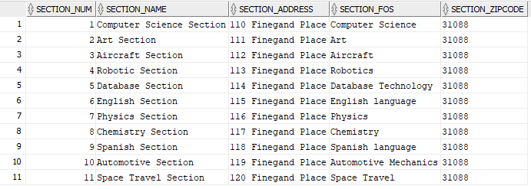

Figure 4. Graphical representation of Section Info SELECT.

11 rows selected.

SQL> SELECT /*fixed*/ * FROM Instr_List;

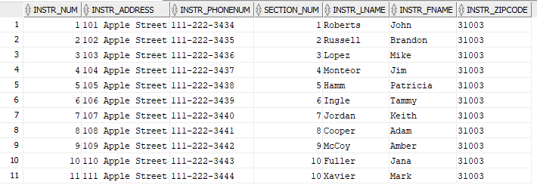

Figure 5. Graphical representation of Instructor List SELECT.

11 rows selected.

SQL> SELECT /*fixed*/ * FROM Admin_List;

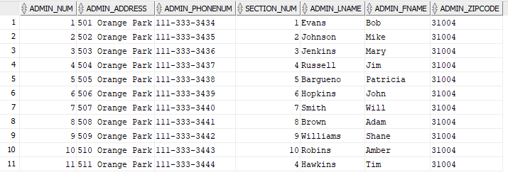

Figure 6. Graphical representation of Admin List SELECT.

11 rows selected.

SQL> SELECT /*fixed*/ * FROM Student_List;

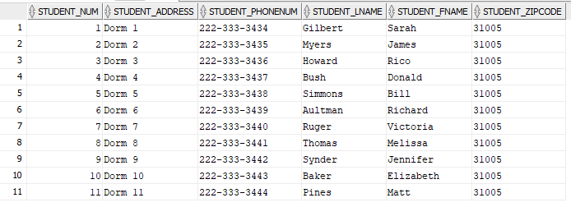

Figure 7. Graphical representation of Student List SELECT.

11 rows selected.

SQL> SELECT /*fixed*/ * FROM Course_List;

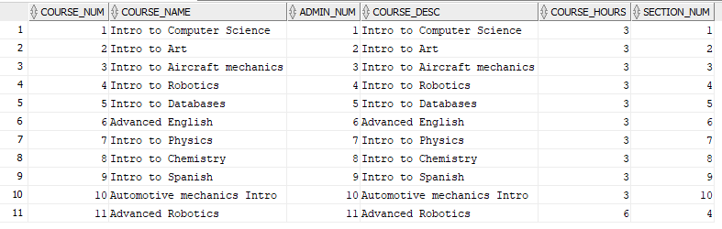

Figure 8. Graphical representation of Course List SELECT.

11 rows selected.

SQL> SELECT /*fixed*/ * FROM Class_Sched;

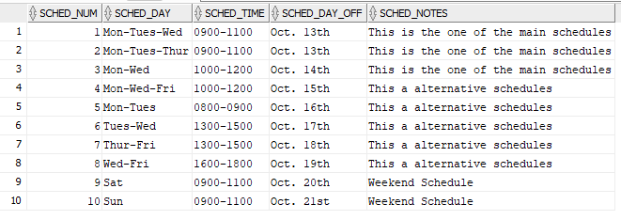

Figure 9. Graphical representation of Class Schedule SELECT.

10 rows selected.

SQL> SELECT /*fixed*/ * FROM Instr_Classes;

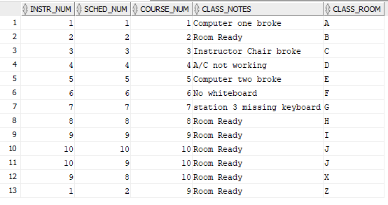

Figure 10. Graphical representation of Instructor Classes SELECT.

13 rows selected.

SQL> SELECT /*fixed*/ * FROM Student_Class_Signup;

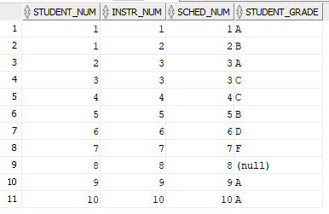

Figure 11. Graphical representation of Student Class Signup SELECT.

11 rows selected.

# Security

## Policies

Security policies are a subset of the security plan, defined in a previous section, and provide more detailed specification of what requirements will be enforced to promote database security hardening (Theriault & Heney, 1998). The following policies will be implemented in the Instructor Teaching Tracker database:

Username Policy. Effective immediately, all database users will be assigned a username. The username will consist of the first letter of the first name, followed by the full last name with no space, followed by the row identification number with no space.

Password Policy. Per the recommendation of (Grassi, et al., 2017), user passwords will be at least 8 characters in length, using a combination of all available Unicode characters, and should avoid common words or repetitive characters.

Connection Policy. All users are allowed to create a session to the database.

Role Assignment Policy. The admin_role will be assigned to all administrative support staff. The instructor_role will be assigned to all instructors. The student_role will be assigned to all students.

Account Modify Policy. Administrators are the only authorized users to add or remove users from the instructor and student tables. Administrators can view and update their personal information in the admin table.

Course Management Policy. Administrators are in charge of adding, removing, and updating course table data.

Section Management Policy. Administrators are in charge of adding, removing, and updating section table data.

Class Schedule Modify Policy. Administrators are the only authorized user to add, remove, and update the class schedule table data. However, instructors can update the notes section.

Admin Support Policy. Administrators are authorized to insert, update, and delete all database tables, in the event other users need assistance. For example, instructors rely on administrators to add and remove classes from their schedule, and students would need an administrator to disenroll from a class.

Admin Account Restriction Policy. Administrators can view the admin table and update their personal information. The system administrators are the only ones able to add or remove from the admin table.

Instructor View Policy. Instructors are authorized to view only their personal info in the instructor list table. They may also view their section info, their class schedule, course information on all courses, and a complete list of available schedules to assign their classes to. They may also the name view basic information on students enrolled in their classes.

Instructor Modify Policy. Instructors are only authorized to update their personal information, their class notes, student grades of students enrolled in their classes, and may also remove students from their classes.

Student View Policy. Students are only authorized to view their personal information, the instructor class schedule, classes they are enrolled in, and their grade for classes they are enrolled in.

Student Modify Policy. Students are only authorized to update their personal information, and they may also enroll themselves in classes.

Class Tentative Schedule Policy. Only the Instructor DBA and school administrators may view and/or create tentative class schedules, i.e. alpha and beta test schedules. Tentative schedules will be regarded as highly sensitive data, while approved schedules will be regarded as sensitive data. Instructors and students may view approved class schedules.

## Procedures

Username Procedure. The following shows the SQL implementation procedure of the corresponding policy:

Password Procedure. The following shows the SQL implementation procedure of the corresponding policy:

Connection Procedure. The following shows the SQL implementation procedure of the corresponding policy:

Role Assignment Procedure. The following shows the SQL implementation procedure of the corresponding policy:

Account Modify Procedure. The following shows the SQL implementation procedure of the corresponding policy:

Course Management Procedure. The following shows the SQL implementation procedure of the corresponding policy:

Section Management Procedure. The following shows the SQL implementation procedure of the corresponding policy:

Class Schedule Modify Procedure. The following shows the SQL implementation procedure of the corresponding policy:

Admin Support Procedure. The following shows the SQL implementation procedure of the corresponding policy:

Admin Account Restriction Procedure. The following shows the SQL implementation procedure of the corresponding policy:

Instructor View Procedure. The following shows the SQL implementation procedure of the corresponding policy:

Instructor Modify Procedure. The following shows the SQL implementation procedure of the corresponding policy:

Student View Procedure. The following shows the SQL implementation procedure of the corresponding policy:

Student Modify Procedure. The following shows the SQL implementation procedure of the corresponding policy:

Class Tentative Schedule Policy. The following shows the SQL implementation procedure of the corresponding policy:

# Conclusion

conducted

## Lesson Learned

This

## Final Thoughts

The

References

Grassi, P. A., Fenton, J. L., Newton, E. M., Perlner, R. A., Regenscheid, A. R., Burr, W. E., . . . Theofanos, M. F. (2017). *NIST Special Publication 800-63B.* Gaithersburg: National Institute of Standards and Technology. doi:https://doi.org/10.6028/NIST.SP.800-63b

Theriault, M., & Heney, W. (1998). *Oracle Security.* O'Reilly Media, Inc.