# **Lab Part 2 – Checklist Items 13-19**

## **Monitor Health of Database – Items 13-15**

SQL>

SQL> SET SERVEROUTPUT ON;

SQL>

SQL> /*---------------------------------------------------*/

SQL> /* Part 2 Checklist Items 13-19 */

SQL> /*---------------------------------------------------*/

SQL>

SQL> SHOW USER;

USER is "DBAUSER"

SQL>

SQL> CONNECT DBAUser/abc123;

Connected.

SQL>

SQL> SHOW USER;

USER is "DBAUSER"

SQL>

SQL> /*Item 13-15 - Monitor Database status*/

SQL>

SQL> /*Check if database status is open and active*/

SQL> SELECT instance_name, status, database_status FROM V$INSTANCE;

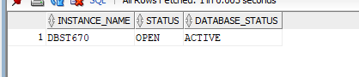

SQL>

SQL> /*Check if status allows you to read and write to database*/

SQL> SELECT name, open_mode FROM V$DATABASE;

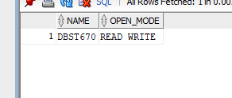

SQL>

SQL>

SQL> /*Get Database reserved, used, and free space size*/

SQL> SELECT "Reserved_Space(MB)", "Reserved_Space(MB)" - "Free_Space(MB)" "Used_Space(MB)","Free_Space(MB)"

2 FROM ( SELECT

3 (SELECT round(SUM(bytes/(1024*1024)),2) FROM dba_data_files) "Reserved_Space(MB)",

4 (SELECT round(SUM(bytes/(1024*1024)),2) FROM dba_free_space) "Free_Space(MB)"

5 FROM dual);

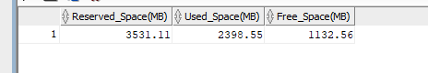

SQL>

SQL> /*Show tablespace file location. Also, allocated and free space per tablespace*/

SQL> SELECT

2 a.tablespace_name,

3 a.file_name,

4 round(a.bytes/(1024*1024), 2) allocated_MB,

5 round(b.free_bytes/(1024*1024),2) free_MB

6 FROM

7 (SELECT tablespace_name, file_name, bytes

8 FROM dba_data_files UNION SELECT tablespace_name, file_name, bytes FROM dba_temp_files )a,

9 (SELECT tablespace_name, SUM(bytes) free_bytes

10 FROM dba_free_space b GROUP BY tablespace_name) b

11 WHERE a.tablespace_name=b.tablespace_name(+) ORDER BY a.tablespace_name;

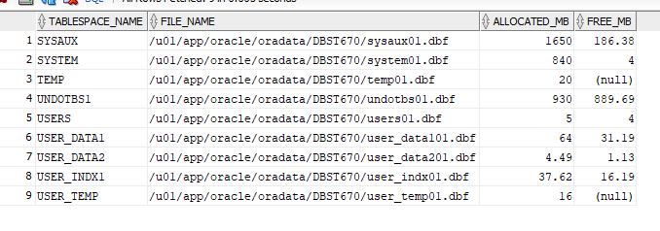

SQL>

SQL>

SQL> /*Return all objects*/

SQL> SELECT substr(object_name,1,20), object_type,status FROM all_objects;

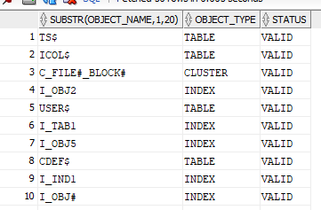

SQL>

SQL> /*Return all invalid objects*/

SQL> SELECT owner, substr(object_name,1,20), object_type, status FROM all_objects WHERE status = 'INVALID';

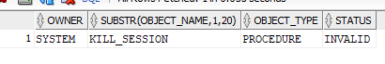

## **Create Users – Item 16**

SQL>

SQL> /*Item 16 - Create end users and give privileges*/

SQL>

SQL> /*Drop Users*/

SQL>

SQL> DROP USER jkamando CASCADE;

User JKAMANDO dropped.

SQL>

SQL> DROP USER tokusanya CASCADE;

User TOKUSANYA dropped.

SQL>

SQL> DROP USER joluwadamilare CASCADE;

User JOLUWADAMILARE dropped.

SQL>

SQL> DROP USER brussell CASCADE;

User BRUSSELL dropped.

SQL>

SQL> DROP USER rseyoum CASCADE;

User RSEYOUM dropped.

SQL>

SQL> /*---------------------------------------------------*/

SQL> /* CREATE USERS */

SQL> /*---------------------------------------------------*/

SQL>

SQL> CREATE USER jkamando IDENTIFIED BY abc123

2 DEFAULT TABLESPACE users

3 TEMPORARY TABLESPACE temp;

User JKAMANDO created.

SQL>

SQL> CREATE USER tokusanya IDENTIFIED BY abc123

2 DEFAULT TABLESPACE users

3 TEMPORARY TABLESPACE temp;

User TOKUSANYA created.

SQL>

SQL> CREATE USER joluwadamilare IDENTIFIED BY abc123

2 DEFAULT TABLESPACE users

3 TEMPORARY TABLESPACE temp;

User JOLUWADAMILARE created.

SQL>

SQL> CREATE USER brussell IDENTIFIED BY abc123

2 DEFAULT TABLESPACE users

3 TEMPORARY TABLESPACE temp;

User BRUSSELL created.

SQL>

SQL> CREATE USER rseyoum IDENTIFIED BY abc123

2 DEFAULT TABLESPACE users

3 TEMPORARY TABLESPACE temp;

User RSEYOUM created.

SQL>

SQL>

SQL> /*Grant necessary permissions*/

SQL>

SQL> GRANT connect,resource TO jkamando;

Grant succeeded.

SQL>

SQL> GRANT connect,resource TO tokusanya;

Grant succeeded.

SQL>

SQL> GRANT connect,resource TO joluwadamilare;

Grant succeeded.

SQL>

SQL> GRANT connect,resource TO brussell;

Grant succeeded.

SQL>

SQL> GRANT connect,resource TO rseyoum;

Grant succeeded.

SQL>

SQL>

SQL> /*Alter unprivileged user tablespace*/

SQL> ALTER USER JKamando DEFAULT TABLESPACE user_data1 TEMPORARY TABLESPACE user_temp;

User JKAMANDO altered.

SQL> ALTER USER TOkusanya DEFAULT TABLESPACE user_data1 TEMPORARY TABLESPACE user_temp;

User TOKUSANYA altered.

SQL> ALTER USER JOluwadamilare DEFAULT TABLESPACE user_data1 TEMPORARY TABLESPACE user_temp;

User JOLUWADAMILARE altered.

SQL> ALTER USER BRussell DEFAULT TABLESPACE user_data1 TEMPORARY TABLESPACE user_temp;

User BRUSSELL altered.

SQL> ALTER USER RSeyoum DEFAULT TABLESPACE user_data1 TEMPORARY TABLESPACE user_temp;

User RSEYOUM altered.

## **Create Synonyms – Item 17**

SQL>

SQL> /*Item 17 - Create synonyms*/

SQL>

SQL> /*Create synonym for each table from DBAUser*/

SQL> CREATE OR REPLACE PUBLIC SYNONYM MYCUSTOMERS

2 FOR DATADESIGNLEADUSER.CUSTOMER;

SYNONYM MYCUSTOMERS created.

SQL> CREATE OR REPLACE PUBLIC SYNONYM MYEMPLOYEE

2 FOR DATADESIGNLEADUSER.EMPLOYEE;

SYNONYM MYEMPLOYEE created.

SQL> CREATE OR REPLACE PUBLIC SYNONYM MYORDER_ITEM

2 FOR DATADESIGNLEADUSER.ORDER_ITEM;

SYNONYM MYORDER_ITEM created.

SQL> CREATE OR REPLACE PUBLIC SYNONYM MYORDERS

2 FOR DATADESIGNLEADUSER.ORDERS;

SYNONYM MYORDERS created.

SQL> CREATE OR REPLACE PUBLIC SYNONYM MYPAYMENT

2 FOR DATADESIGNLEADUSER.PAYMENT;

SYNONYM MYPAYMENT created.

SQL> CREATE OR REPLACE PUBLIC SYNONYM MYPRODUCT

2 FOR DATADESIGNLEADUSER.PRODUCT;

SYNONYM MYPRODUCT created.

SQL> CREATE OR REPLACE PUBLIC SYNONYM MYPRODUCT_CAT

2 FOR DATADESIGNLEADUSER.PRODUCT_CAT;

SYNONYM MYPRODUCT_CAT created.

SQL> CREATE OR REPLACE PUBLIC SYNONYM MYREGION

2 FOR DATADESIGNLEADUSER.REGION;

SYNONYM MYREGION created.

SQL> CREATE OR REPLACE PUBLIC SYNONYM MYSTORES

2 FOR DATADESIGNLEADUSER.STORES;

SYNONYM MYSTORES created.

SQL> CREATE OR REPLACE PUBLIC SYNONYM MYZIP

2 FOR DATADESIGNLEADUSER.ZIP;

SYNONYM MYZIP created.

SQL>

SQL> /*Verify synonym works*/

SQL> SELECT * FROM MYCUSTOMERS;

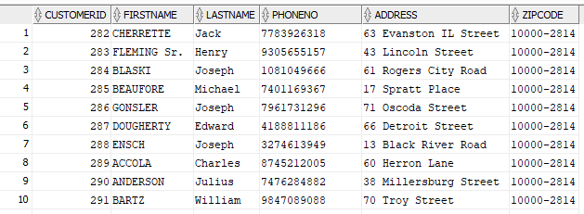

SQL> SELECT * FROM MYEMPLOYEE;

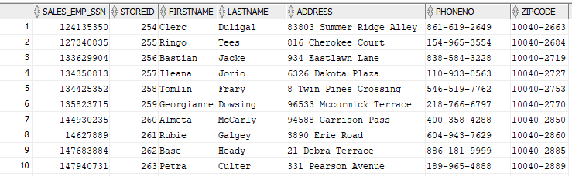

SQL> SELECT * FROM MYORDER_ITEM;

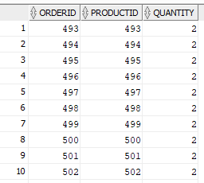

SQL> SELECT * FROM MYORDERS;

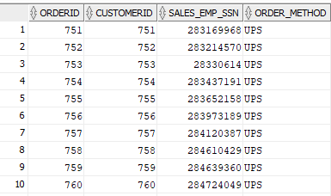

SQL> SELECT * FROM MYPAYMENT;

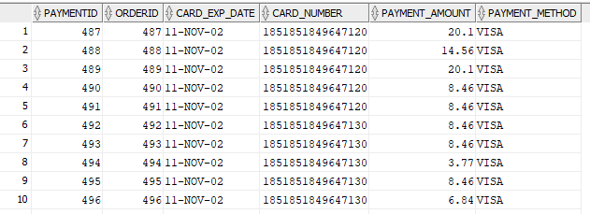

SQL> SELECT * FROM MYPRODUCT;

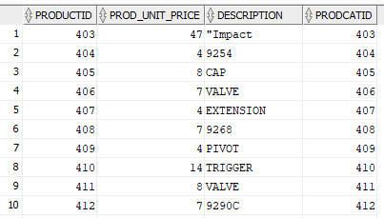

SQL> SELECT * FROM MYPRODUCT_CAT;

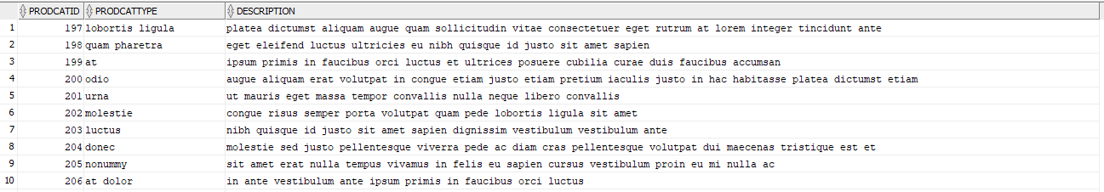

SQL> SELECT * FROM MYREGION;

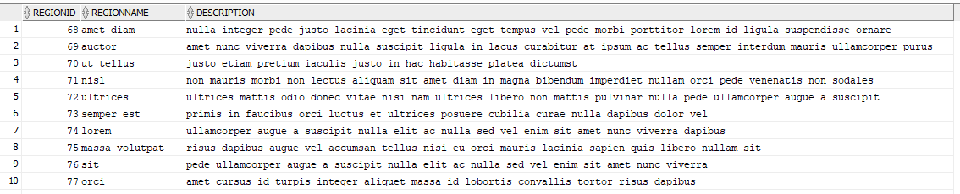

SQL> SELECT * FROM MYSTORES;

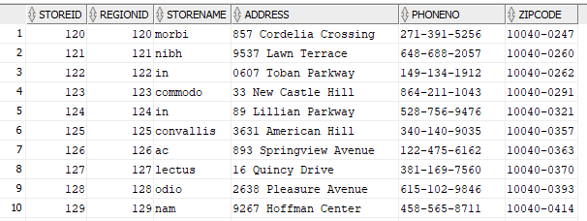

SQL> SELECT * FROM MYZIP;

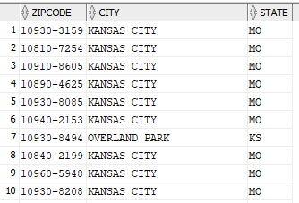

## **Create reverse engineer on all_objects views – Item 18**

SQL>

SQL> SET HEADING ON;

SQL> SET PAGES 999;

SQL> SET LONG 90000;

SQL>

SQL> /*Generate DDLs for tables and indexes in DataDesignLeadUser schema*/

SQL> SELECT

2 dbms_metadata.GET_DDL(object_type,object_name,'DATADESIGNLEADUSER')

3 FROM all_objects

4 WHERE owner = 'DATADESIGNLEADUSER' AND (object_type = 'TABLE' OR object_type = 'INDEX');

DBMS_METADATA.GET_DDL(OBJECT_TYPE,OBJECT_NAME,'DATADESIGNLEADUSER')

--------------------------------------------------------------------------------

CREATE TABLE "DATADESIGNLEADUSER"."ZIP"

( "ZIPCODE" CHAR(10) NOT NULL ENABLE,

"CITY" CHAR(25),

"STATE" CHAR(2),

CONSTRAINT "PK_ZIP" PRIMARY KEY ("ZIPCODE")

USING INDEX PCTFREE 10 INITRANS 2 MAXTRANS 255 COMPUTE STATISTICS

STORAGE(INITIAL 1024000 NEXT 122880 MINEXTENTS 1 MAXEXTENTS 2147483645

PCTINCREASE 0 FREELISTS 1 FREELIST GROUPS 1

BUFFER_POOL DEFAULT FLASH_CACHE DEFAULT CELL_FLASH_CACHE DEFAULT)

TABLESPACE "USER_INDX1" ENABLE

) PCTFREE 10 PCTUSED 40 INITRANS 1 MAXTRANS 255

STORAGE(

BUFFER_POOL DEFAULT FLASH_CACHE DEFAULT CELL_FLASH_CACHE DEFAULT)

TABLESPACE "USER_DATA1"

PARTITION BY RANGE ("STATE")

(PARTITION "ZIP_PART1" VALUES LESS THAN ('N') SEGMENT CREATION IMMEDIATE

PCTFREE 5 PCTUSED 90 INITRANS 1 MAXTRANS 255

NOCOMPRESS LOGGING

STORAGE(INITIAL 1122304 NEXT 204800 MINEXTENTS 1 MAXEXTENTS 2147483645

PCTINCREASE 0 FREELISTS 1 FREELIST GROUPS 1

BUFFER_POOL DEFAULT FLASH_CACHE DEFAULT CELL_FLASH_CACHE DEFAULT)

TABLESPACE "USER_DATA1" ,

PARTITION "ZIP_PART2" VALUES LESS THAN (MAXVALUE) SEGMENT CREATION IMMEDIATE

PCTFREE 5 PCTUSED 90 INITRANS 1 MAXTRANS 255

NOCOMPRESS LOGGING

STORAGE(INITIAL 1122304 NEXT 204800 MINEXTENTS 1 MAXEXTENTS 2147483645

PCTINCREASE 0 FREELISTS 1 FREELIST GROUPS 1

BUFFER_POOL DEFAULT FLASH_CACHE DEFAULT CELL_FLASH_CACHE DEFAULT)

TABLESPACE "USER_DATA2" )

CREATE UNIQUE INDEX "DATADESIGNLEADUSER"."PK_ZIP" ON "DATADESIGNLEADUSER"."ZIP

" ("ZIPCODE")

PCTFREE 10 INITRANS 2 MAXTRANS 255 COMPUTE STATISTICS

STORAGE(INITIAL 1024000 NEXT 122880 MINEXTENTS 1 MAXEXTENTS 2147483645

PCTINCREASE 0 FREELISTS 1 FREELIST GROUPS 1

BUFFER_POOL DEFAULT FLASH_CACHE DEFAULT CELL_FLASH_CACHE DEFAULT)

TABLESPACE "USER_INDX1"

CREATE TABLE "DATADESIGNLEADUSER"."CUSTOMER"

( "CUSTOMERID" NUMBER(10,0) NOT NULL ENABLE,

"FIRSTNAME" VARCHAR2(15),

"LASTNAME" VARCHAR2(15),

"PHONENO" CHAR(15),

"ADDRESS" VARCHAR2(35),

"ZIPCODE" CHAR(10),

CONSTRAINT "PK_CUSTOMER_ID" PRIMARY KEY ("CUSTOMERID")

USING INDEX PCTFREE 10 INITRANS 2 MAXTRANS 255 COMPUTE STATISTICS

STORAGE(INITIAL 57344 NEXT 16384 MINEXTENTS 1 MAXEXTENTS 2147483645

PCTINCREASE 0 FREELISTS 1 FREELIST GROUPS 1

BUFFER_POOL DEFAULT FLASH_CACHE DEFAULT CELL_FLASH_CACHE DEFAULT)

TABLESPACE "USER_INDX1" ENABLE,

CONSTRAINT "FK_ZIP" FOREIGN KEY ("ZIPCODE")

REFERENCES "DATADESIGNLEADUSER"."ZIP" ("ZIPCODE") ENABLE

) SEGMENT CREATION IMMEDIATE

PCTFREE 20 PCTUSED 40 INITRANS 1 MAXTRANS 255

NOCOMPRESS LOGGING

STORAGE(INITIAL 122880 NEXT 16384 MINEXTENTS 1 MAXEXTENTS 2147483645

PCTINCREASE 0 FREELISTS 1 FREELIST GROUPS 1

BUFFER_POOL DEFAULT FLASH_CACHE DEFAULT CELL_FLASH_CACHE DEFAULT)

TABLESPACE "USER_DATA1"

CREATE UNIQUE INDEX "DATADESIGNLEADUSER"."PK_CUSTOMER_ID" ON "DATADESIGNLEADUS

ER"."CUSTOMER" ("CUSTOMERID")

PCTFREE 10 INITRANS 2 MAXTRANS 255 COMPUTE STATISTICS

STORAGE(INITIAL 57344 NEXT 16384 MINEXTENTS 1 MAXEXTENTS 2147483645

PCTINCREASE 0 FREELISTS 1 FREELIST GROUPS 1

BUFFER_POOL DEFAULT FLASH_CACHE DEFAULT CELL_FLASH_CACHE DEFAULT)

TABLESPACE "USER_INDX1"

CREATE TABLE "DATADESIGNLEADUSER"."PRODUCT"

( "PRODUCTID" NUMBER(10,0) NOT NULL ENABLE,

"PROD_UNIT_PRICE" NUMBER(10,0),

"DESCRIPTION" VARCHAR2(150),

"PRODCATID" NUMBER(10,0),

CONSTRAINT "PK_PRODUCTID" PRIMARY KEY ("PRODUCTID")

USING INDEX PCTFREE 10 INITRANS 2 MAXTRANS 255 COMPUTE STATISTICS

STORAGE(INITIAL 57344 NEXT 16384 MINEXTENTS 1 MAXEXTENTS 2147483645

PCTINCREASE 0 FREELISTS 1 FREELIST GROUPS 1

BUFFER_POOL DEFAULT FLASH_CACHE DEFAULT CELL_FLASH_CACHE DEFAULT)

TABLESPACE "USER_INDX1" ENABLE,

CONSTRAINT "FK_PRODCATID" FOREIGN KEY ("PRODCATID")

REFERENCES "DATADESIGNLEADUSER"."PRODUCT_CAT" ("PRODCATID") ENABLE

) SEGMENT CREATION IMMEDIATE

PCTFREE 5 PCTUSED 90 INITRANS 1 MAXTRANS 255

NOCOMPRESS LOGGING

STORAGE(INITIAL 172032 NEXT 24576 MINEXTENTS 1 MAXEXTENTS 2147483645

PCTINCREASE 0 FREELISTS 1 FREELIST GROUPS 1

BUFFER_POOL DEFAULT FLASH_CACHE DEFAULT CELL_FLASH_CACHE DEFAULT)

TABLESPACE "USER_DATA2"

CREATE UNIQUE INDEX "DATADESIGNLEADUSER"."PK_PRODUCTID" ON "DATADESIGNLEADUSER

"."PRODUCT" ("PRODUCTID")

PCTFREE 10 INITRANS 2 MAXTRANS 255 COMPUTE STATISTICS

STORAGE(INITIAL 57344 NEXT 16384 MINEXTENTS 1 MAXEXTENTS 2147483645

PCTINCREASE 0 FREELISTS 1 FREELIST GROUPS 1

BUFFER_POOL DEFAULT FLASH_CACHE DEFAULT CELL_FLASH_CACHE DEFAULT)

TABLESPACE "USER_INDX1"

CREATE TABLE "DATADESIGNLEADUSER"."REGION"

( "REGIONID" NUMBER(10,0) NOT NULL ENABLE,

"REGIONNAME" VARCHAR2(25),

"DESCRIPTION" VARCHAR2(150),

CONSTRAINT "PK_REGION" PRIMARY KEY ("REGIONID")

USING INDEX PCTFREE 10 INITRANS 2 MAXTRANS 255 COMPUTE STATISTICS

STORAGE(INITIAL 57344 NEXT 16384 MINEXTENTS 1 MAXEXTENTS 2147483645

PCTINCREASE 0 FREELISTS 1 FREELIST GROUPS 1

BUFFER_POOL DEFAULT FLASH_CACHE DEFAULT CELL_FLASH_CACHE DEFAULT)

TABLESPACE "USER_INDX1" ENABLE

) SEGMENT CREATION IMMEDIATE

PCTFREE 5 PCTUSED 90 INITRANS 1 MAXTRANS 255

NOCOMPRESS LOGGING

STORAGE(INITIAL 196608 NEXT 24576 MINEXTENTS 1 MAXEXTENTS 2147483645

PCTINCREASE 0 FREELISTS 1 FREELIST GROUPS 1

BUFFER_POOL DEFAULT FLASH_CACHE DEFAULT CELL_FLASH_CACHE DEFAULT)

TABLESPACE "USER_DATA1"

CREATE UNIQUE INDEX "DATADESIGNLEADUSER"."PK_REGION" ON "DATADESIGNLEADUSER"."

REGION" ("REGIONID")

PCTFREE 10 INITRANS 2 MAXTRANS 255 COMPUTE STATISTICS

STORAGE(INITIAL 57344 NEXT 16384 MINEXTENTS 1 MAXEXTENTS 2147483645

PCTINCREASE 0 FREELISTS 1 FREELIST GROUPS 1

BUFFER_POOL DEFAULT FLASH_CACHE DEFAULT CELL_FLASH_CACHE DEFAULT)

TABLESPACE "USER_INDX1"

CREATE TABLE "DATADESIGNLEADUSER"."STORES"

( "STOREID" NUMBER(10,0) NOT NULL ENABLE,

"REGIONID" NUMBER(10,0),

"STORENAME" VARCHAR2(15),

"ADDRESS" VARCHAR2(35),

"PHONENO" CHAR(15),

"ZIPCODE" CHAR(10),

CONSTRAINT "PK_STORES" PRIMARY KEY ("STOREID")

USING INDEX PCTFREE 10 INITRANS 2 MAXTRANS 255 COMPUTE STATISTICS

STORAGE(INITIAL 57344 NEXT 16384 MINEXTENTS 1 MAXEXTENTS 2147483645

PCTINCREASE 0 FREELISTS 1 FREELIST GROUPS 1

BUFFER_POOL DEFAULT FLASH_CACHE DEFAULT CELL_FLASH_CACHE DEFAULT)

TABLESPACE "USER_INDX1" ENABLE,

CONSTRAINT "FK_STORE_REGION" FOREIGN KEY ("REGIONID")

REFERENCES "DATADESIGNLEADUSER"."REGION" ("REGIONID") ENABLE,

CONSTRAINT "FK_STORE_ZIP" FOREIGN KEY ("ZIPCODE")

REFERENCES "DATADESIGNLEADUSER"."ZIP" ("ZIPCODE") ENABLE

) SEGMENT CREATION IMMEDIATE

PCTFREE 5 PCTUSED 90 INITRANS 1 MAXTRANS 255

NOCOMPRESS LOGGING

STORAGE(INITIAL 98304 NEXT 16384 MINEXTENTS 1 MAXEXTENTS 2147483645

PCTINCREASE 0 FREELISTS 1 FREELIST GROUPS 1

BUFFER_POOL DEFAULT FLASH_CACHE DEFAULT CELL_FLASH_CACHE DEFAULT)

TABLESPACE "USER_DATA1"

CREATE UNIQUE INDEX "DATADESIGNLEADUSER"."PK_STORES" ON "DATADESIGNLEADUSER"."

STORES" ("STOREID")

PCTFREE 10 INITRANS 2 MAXTRANS 255 COMPUTE STATISTICS

STORAGE(INITIAL 57344 NEXT 16384 MINEXTENTS 1 MAXEXTENTS 2147483645

PCTINCREASE 0 FREELISTS 1 FREELIST GROUPS 1

BUFFER_POOL DEFAULT FLASH_CACHE DEFAULT CELL_FLASH_CACHE DEFAULT)

TABLESPACE "USER_INDX1"

CREATE TABLE "DATADESIGNLEADUSER"."EMPLOYEE"

( "SALES_EMP_SSN" NUMBER(9,0) NOT NULL ENABLE,

"STOREID" NUMBER(10,0),

"FIRSTNAME" VARCHAR2(15),

"LASTNAME" VARCHAR2(15),

"ADDRESS" VARCHAR2(35),

"PHONENO" CHAR(15),

"ZIPCODE" CHAR(10),

CONSTRAINT "PK_SALES_EMP_SSN" PRIMARY KEY ("SALES_EMP_SSN")

USING INDEX PCTFREE 10 INITRANS 2 MAXTRANS 255 COMPUTE STATISTICS

STORAGE(INITIAL 57344 NEXT 16384 MINEXTENTS 1 MAXEXTENTS 2147483645

PCTINCREASE 0 FREELISTS 1 FREELIST GROUPS 1

BUFFER_POOL DEFAULT FLASH_CACHE DEFAULT CELL_FLASH_CACHE DEFAULT)

TABLESPACE "USER_INDX1" ENABLE,

CONSTRAINT "FK_EMP_STOREID" FOREIGN KEY ("STOREID")

REFERENCES "DATADESIGNLEADUSER"."STORES" ("STOREID") ENABLE,

CONSTRAINT "FK_EMP_ZIP" FOREIGN KEY ("ZIPCODE")

REFERENCES "DATADESIGNLEADUSER"."ZIP" ("ZIPCODE") ENABLE

) SEGMENT CREATION IMMEDIATE

PCTFREE 20 PCTUSED 40 INITRANS 1 MAXTRANS 255

NOCOMPRESS LOGGING

STORAGE(INITIAL 122880 NEXT 16384 MINEXTENTS 1 MAXEXTENTS 2147483645

PCTINCREASE 0 FREELISTS 1 FREELIST GROUPS 1

BUFFER_POOL DEFAULT FLASH_CACHE DEFAULT CELL_FLASH_CACHE DEFAULT)

TABLESPACE "USER_DATA1"

CREATE UNIQUE INDEX "DATADESIGNLEADUSER"."PK_SALES_EMP_SSN" ON "DATADESIGNLEAD

USER"."EMPLOYEE" ("SALES_EMP_SSN")

PCTFREE 10 INITRANS 2 MAXTRANS 255 COMPUTE STATISTICS

STORAGE(INITIAL 57344 NEXT 16384 MINEXTENTS 1 MAXEXTENTS 2147483645

PCTINCREASE 0 FREELISTS 1 FREELIST GROUPS 1

BUFFER_POOL DEFAULT FLASH_CACHE DEFAULT CELL_FLASH_CACHE DEFAULT)

TABLESPACE "USER_INDX1"

CREATE TABLE "DATADESIGNLEADUSER"."ORDERS"

( "ORDERID" NUMBER(10,0) NOT NULL ENABLE,

"CUSTOMERID" NUMBER(10,0) NOT NULL ENABLE,

"SALES_EMP_SSN" NUMBER(9,0) NOT NULL ENABLE,

"ORDER_METHOD" CHAR(10),

CONSTRAINT "PK_ORDERID" PRIMARY KEY ("ORDERID")

USING INDEX PCTFREE 10 INITRANS 2 MAXTRANS 255 COMPUTE STATISTICS

STORAGE(INITIAL 57344 NEXT 16384 MINEXTENTS 1 MAXEXTENTS 2147483645

PCTINCREASE 0 FREELISTS 1 FREELIST GROUPS 1

BUFFER_POOL DEFAULT FLASH_CACHE DEFAULT CELL_FLASH_CACHE DEFAULT)

TABLESPACE "USER_INDX1" ENABLE,

CONSTRAINT "FK_CUSTOMERID" FOREIGN KEY ("CUSTOMERID")

REFERENCES "DATADESIGNLEADUSER"."CUSTOMER" ("CUSTOMERID") ENABLE,

CONSTRAINT "FK_EMP_SSN" FOREIGN KEY ("SALES_EMP_SSN")

REFERENCES "DATADESIGNLEADUSER"."EMPLOYEE" ("SALES_EMP_SSN") ENABLE

) SEGMENT CREATION IMMEDIATE

PCTFREE 5 PCTUSED 60 INITRANS 1 MAXTRANS 255

NOCOMPRESS LOGGING

STORAGE(INITIAL 24576 NEXT 16384 MINEXTENTS 1 MAXEXTENTS 2147483645

PCTINCREASE 0 FREELISTS 1 FREELIST GROUPS 1

BUFFER_POOL DEFAULT FLASH_CACHE DEFAULT CELL_FLASH_CACHE DEFAULT)

TABLESPACE "USER_DATA1"

CREATE UNIQUE INDEX "DATADESIGNLEADUSER"."PK_ORDERID" ON "DATADESIGNLEADUSER".

"ORDERS" ("ORDERID")

PCTFREE 10 INITRANS 2 MAXTRANS 255 COMPUTE STATISTICS

STORAGE(INITIAL 57344 NEXT 16384 MINEXTENTS 1 MAXEXTENTS 2147483645

PCTINCREASE 0 FREELISTS 1 FREELIST GROUPS 1

BUFFER_POOL DEFAULT FLASH_CACHE DEFAULT CELL_FLASH_CACHE DEFAULT)

TABLESPACE "USER_INDX1"

CREATE TABLE "DATADESIGNLEADUSER"."ORDER_ITEM"

( "ORDERID" NUMBER(10,0) NOT NULL ENABLE,

"PRODUCTID" NUMBER(10,0),

"QUANTITY" NUMBER(10,0),

CONSTRAINT "PK_ORDER_ITEM" PRIMARY KEY ("ORDERID", "PRODUCTID")

USING INDEX PCTFREE 10 INITRANS 2 MAXTRANS 255 COMPUTE STATISTICS

STORAGE(INITIAL 57344 NEXT 16384 MINEXTENTS 1 MAXEXTENTS 2147483645

PCTINCREASE 0 FREELISTS 1 FREELIST GROUPS 1

BUFFER_POOL DEFAULT FLASH_CACHE DEFAULT CELL_FLASH_CACHE DEFAULT)

TABLESPACE "USER_INDX1" ENABLE,

CONSTRAINT "FK_ORDER_ID1" FOREIGN KEY ("ORDERID")

REFERENCES "DATADESIGNLEADUSER"."ORDERS" ("ORDERID") ENABLE,

CONSTRAINT "FK_PRODUCT_ID" FOREIGN KEY ("PRODUCTID")

REFERENCES "DATADESIGNLEADUSER"."PRODUCT" ("PRODUCTID") ENABLE

) SEGMENT CREATION IMMEDIATE

PCTFREE 5 PCTUSED 90 INITRANS 1 MAXTRANS 255

NOCOMPRESS LOGGING

STORAGE(INITIAL 16384 NEXT 24576 MINEXTENTS 1 MAXEXTENTS 2147483645

PCTINCREASE 0 FREELISTS 1 FREELIST GROUPS 1

BUFFER_POOL DEFAULT FLASH_CACHE DEFAULT CELL_FLASH_CACHE DEFAULT)

TABLESPACE "USER_DATA2"

CREATE UNIQUE INDEX "DATADESIGNLEADUSER"."PK_ORDER_ITEM" ON "DATADESIGNLEADUSE

R"."ORDER_ITEM" ("ORDERID", "PRODUCTID")

PCTFREE 10 INITRANS 2 MAXTRANS 255 COMPUTE STATISTICS

STORAGE(INITIAL 57344 NEXT 16384 MINEXTENTS 1 MAXEXTENTS 2147483645

PCTINCREASE 0 FREELISTS 1 FREELIST GROUPS 1

BUFFER_POOL DEFAULT FLASH_CACHE DEFAULT CELL_FLASH_CACHE DEFAULT)

TABLESPACE "USER_INDX1"

CREATE TABLE "DATADESIGNLEADUSER"."PAYMENT"

( "PAYMENTID" NUMBER(10,0) NOT NULL ENABLE,

"ORDERID" NUMBER(10,0),

"CARD_EXP_DATE" DATE,

"CARD_NUMBER" NUMBER(30,0),

"PAYMENT_AMOUNT" NUMBER(20,2),

"PAYMENT_METHOD" VARCHAR2(5),

CONSTRAINT "PK_PAYMENTID" PRIMARY KEY ("PAYMENTID")

USING INDEX PCTFREE 10 INITRANS 2 MAXTRANS 255 COMPUTE STATISTICS

STORAGE(INITIAL 57344 NEXT 16384 MINEXTENTS 1 MAXEXTENTS 2147483645

PCTINCREASE 0 FREELISTS 1 FREELIST GROUPS 1

BUFFER_POOL DEFAULT FLASH_CACHE DEFAULT CELL_FLASH_CACHE DEFAULT)

TABLESPACE "USER_INDX1" ENABLE,

CONSTRAINT "FK_ORDER_ID2" FOREIGN KEY ("ORDERID")

REFERENCES "DATADESIGNLEADUSER"."ORDERS" ("ORDERID") ENABLE

) SEGMENT CREATION IMMEDIATE

PCTFREE 20 PCTUSED 40 INITRANS 1 MAXTRANS 255

NOCOMPRESS LOGGING

STORAGE(INITIAL 40960 NEXT 16384 MINEXTENTS 1 MAXEXTENTS 2147483645

PCTINCREASE 0 FREELISTS 1 FREELIST GROUPS 1

BUFFER_POOL DEFAULT FLASH_CACHE DEFAULT CELL_FLASH_CACHE DEFAULT)

TABLESPACE "USER_DATA2"

CREATE UNIQUE INDEX "DATADESIGNLEADUSER"."PK_PAYMENTID" ON "DATADESIGNLEADUSER

"."PAYMENT" ("PAYMENTID")

PCTFREE 10 INITRANS 2 MAXTRANS 255 COMPUTE STATISTICS

STORAGE(INITIAL 57344 NEXT 16384 MINEXTENTS 1 MAXEXTENTS 2147483645

PCTINCREASE 0 FREELISTS 1 FREELIST GROUPS 1

BUFFER_POOL DEFAULT FLASH_CACHE DEFAULT CELL_FLASH_CACHE DEFAULT)

TABLESPACE "USER_INDX1"

CREATE TABLE "DATADESIGNLEADUSER"."PRODUCT_CAT"

( "PRODCATID" NUMBER(10,0) NOT NULL ENABLE,

"PRODCATTYPE" VARCHAR2(25),

"DESCRIPTION" VARCHAR2(150),

CONSTRAINT "PK_PRODCAT" PRIMARY KEY ("PRODCATID")

USING INDEX PCTFREE 10 INITRANS 2 MAXTRANS 255 COMPUTE STATISTICS

STORAGE(INITIAL 57344 NEXT 16384 MINEXTENTS 1 MAXEXTENTS 2147483645

PCTINCREASE 0 FREELISTS 1 FREELIST GROUPS 1

BUFFER_POOL DEFAULT FLASH_CACHE DEFAULT CELL_FLASH_CACHE DEFAULT)

TABLESPACE "USER_INDX1" ENABLE

) SEGMENT CREATION IMMEDIATE

PCTFREE 5 PCTUSED 90 INITRANS 1 MAXTRANS 255

NOCOMPRESS LOGGING

STORAGE(INITIAL 196608 NEXT 24576 MINEXTENTS 1 MAXEXTENTS 2147483645

PCTINCREASE 0 FREELISTS 1 FREELIST GROUPS 1

BUFFER_POOL DEFAULT FLASH_CACHE DEFAULT CELL_FLASH_CACHE DEFAULT)

TABLESPACE "USER_DATA1"

CREATE UNIQUE INDEX "DATADESIGNLEADUSER"."PK_PRODCAT" ON "DATADESIGNLEADUSER".

"PRODUCT_CAT" ("PRODCATID")

PCTFREE 10 INITRANS 2 MAXTRANS 255 COMPUTE STATISTICS

STORAGE(INITIAL 57344 NEXT 16384 MINEXTENTS 1 MAXEXTENTS 2147483645

PCTINCREASE 0 FREELISTS 1 FREELIST GROUPS 1

BUFFER_POOL DEFAULT FLASH_CACHE DEFAULT CELL_FLASH_CACHE DEFAULT)

TABLESPACE "USER_INDX1"

CREATE INDEX "DATADESIGNLEADUSER"."FK_ZIP" ON "DATADESIGNLEADUSER"."CUSTOMER"

("ZIPCODE")

PCTFREE 10 INITRANS 2 MAXTRANS 255 COMPUTE STATISTICS

STORAGE(INITIAL 57344 NEXT 16384 MINEXTENTS 1 MAXEXTENTS 2147483645

PCTINCREASE 0 FREELISTS 1 FREELIST GROUPS 1

BUFFER_POOL DEFAULT FLASH_CACHE DEFAULT CELL_FLASH_CACHE DEFAULT)

TABLESPACE "USER_INDX1"

CREATE INDEX "DATADESIGNLEADUSER"."FK_CUSTOMERID" ON "DATADESIGNLEADUSER"."ORD

ERS" ("CUSTOMERID")

PCTFREE 10 INITRANS 2 MAXTRANS 255 COMPUTE STATISTICS

STORAGE(INITIAL 57344 NEXT 16384 MINEXTENTS 1 MAXEXTENTS 2147483645

PCTINCREASE 0 FREELISTS 1 FREELIST GROUPS 1

BUFFER_POOL DEFAULT FLASH_CACHE DEFAULT CELL_FLASH_CACHE DEFAULT)

TABLESPACE "USER_INDX1"

CREATE INDEX "DATADESIGNLEADUSER"."FK_ORDER_ID1" ON "DATADESIGNLEADUSER"."ORDE

R_ITEM" ("ORDERID")

PCTFREE 10 INITRANS 2 MAXTRANS 255 COMPUTE STATISTICS

STORAGE(INITIAL 57344 NEXT 16384 MINEXTENTS 1 MAXEXTENTS 2147483645

PCTINCREASE 0 FREELISTS 1 FREELIST GROUPS 1

BUFFER_POOL DEFAULT FLASH_CACHE DEFAULT CELL_FLASH_CACHE DEFAULT)

TABLESPACE "USER_INDX1"

CREATE INDEX "DATADESIGNLEADUSER"."FK_PRODUCT_ID" ON "DATADESIGNLEADUSER"."ORD

ER_ITEM" ("PRODUCTID")

PCTFREE 10 INITRANS 2 MAXTRANS 255 COMPUTE STATISTICS

STORAGE(INITIAL 57344 NEXT 16384 MINEXTENTS 1 MAXEXTENTS 2147483645

PCTINCREASE 0 FREELISTS 1 FREELIST GROUPS 1

BUFFER_POOL DEFAULT FLASH_CACHE DEFAULT CELL_FLASH_CACHE DEFAULT)

TABLESPACE "USER_INDX1"

CREATE INDEX "DATADESIGNLEADUSER"."FK_ORDER_ID2" ON "DATADESIGNLEADUSER"."PAYM

ENT" ("ORDERID")

PCTFREE 10 INITRANS 2 MAXTRANS 255 COMPUTE STATISTICS

STORAGE(INITIAL 57344 NEXT 16384 MINEXTENTS 1 MAXEXTENTS 2147483645

PCTINCREASE 0 FREELISTS 1 FREELIST GROUPS 1

BUFFER_POOL DEFAULT FLASH_CACHE DEFAULT CELL_FLASH_CACHE DEFAULT)

TABLESPACE "USER_INDX1"

CREATE INDEX "DATADESIGNLEADUSER"."FK_EMP_STOREID" ON "DATADESIGNLEADUSER"."EM

PLOYEE" ("STOREID")

PCTFREE 10 INITRANS 2 MAXTRANS 255 COMPUTE STATISTICS

STORAGE(INITIAL 57344 NEXT 16384 MINEXTENTS 1 MAXEXTENTS 2147483645

PCTINCREASE 0 FREELISTS 1 FREELIST GROUPS 1

BUFFER_POOL DEFAULT FLASH_CACHE DEFAULT CELL_FLASH_CACHE DEFAULT)

TABLESPACE "USER_INDX1"

CREATE INDEX "DATADESIGNLEADUSER"."FK_EMP_ZIP" ON "DATADESIGNLEADUSER"."EMPLOY

EE" ("ZIPCODE")

PCTFREE 10 INITRANS 2 MAXTRANS 255 COMPUTE STATISTICS

STORAGE(INITIAL 57344 NEXT 16384 MINEXTENTS 1 MAXEXTENTS 2147483645

PCTINCREASE 0 FREELISTS 1 FREELIST GROUPS 1

BUFFER_POOL DEFAULT FLASH_CACHE DEFAULT CELL_FLASH_CACHE DEFAULT)

TABLESPACE "USER_INDX1"

CREATE INDEX "DATADESIGNLEADUSER"."FK_STORE_REGION" ON "DATADESIGNLEADUSER"."S

TORES" ("REGIONID")

PCTFREE 10 INITRANS 2 MAXTRANS 255 COMPUTE STATISTICS

STORAGE(INITIAL 57344 NEXT 16384 MINEXTENTS 1 MAXEXTENTS 2147483645

PCTINCREASE 0 FREELISTS 1 FREELIST GROUPS 1

BUFFER_POOL DEFAULT FLASH_CACHE DEFAULT CELL_FLASH_CACHE DEFAULT)

TABLESPACE "USER_INDX1"

CREATE INDEX "DATADESIGNLEADUSER"."FK_STORE_ZIP" ON "DATADESIGNLEADUSER"."STOR

ES" ("ZIPCODE")

PCTFREE 10 INITRANS 2 MAXTRANS 255 COMPUTE STATISTICS

STORAGE(INITIAL 57344 NEXT 16384 MINEXTENTS 1 MAXEXTENTS 2147483645

PCTINCREASE 0 FREELISTS 1 FREELIST GROUPS 1

BUFFER_POOL DEFAULT FLASH_CACHE DEFAULT CELL_FLASH_CACHE DEFAULT)

TABLESPACE "USER_INDX1"

CREATE INDEX "DATADESIGNLEADUSER"."FK_PRODCATID" ON "DATADESIGNLEADUSER"."PROD

UCT" ("PRODCATID")

PCTFREE 10 INITRANS 2 MAXTRANS 255 COMPUTE STATISTICS

STORAGE(INITIAL 57344 NEXT 16384 MINEXTENTS 1 MAXEXTENTS 2147483645

PCTINCREASE 0 FREELISTS 1 FREELIST GROUPS 1

BUFFER_POOL DEFAULT FLASH_CACHE DEFAULT CELL_FLASH_CACHE DEFAULT)

TABLESPACE "USER_INDX1"

CREATE INDEX "DATADESIGNLEADUSER"."FK_EMP_SSN" ON "DATADESIGNLEADUSER"."ORDERS

" ("SALES_EMP_SSN")

PCTFREE 10 INITRANS 2 MAXTRANS 255 COMPUTE STATISTICS

STORAGE(INITIAL 57344 NEXT 16384 MINEXTENTS 1 MAXEXTENTS 2147483645

PCTINCREASE 0 FREELISTS 1 FREELIST GROUPS 1

BUFFER_POOL DEFAULT FLASH_CACHE DEFAULT CELL_FLASH_CACHE DEFAULT)

TABLESPACE "USER_INDX1"

31 rows selected.

## **Create script to detect end-user and what they are running – Item 19**

SQL> /*Item 19 - Script to detect end user and what they are running*/

SQL> SET LINESIZE 100;

SQL> SELECT a.sid, a.username, optimizer_mode, cpu_time, elapsed_time, sql_text

2 FROM v$sqlarea sqlarea, v$session a

3 WHERE a.sql_hash_value = sqlarea.hash_value

4 AND a.sql_address = sqlarea.address AND a.username is not null;

