# **Part 2 – Checklist 6 – Dynamic Performance Test**

## **Read Load Results**

This section follows lab 11, using the Automatic Database Diagnostic Monitor (ADDM) utility to run dynamic performance tests. A read and write load were created to demonstrate the capabilities of this tool. First, we log in as an SYSDBA and create an initial report, see figure 1.

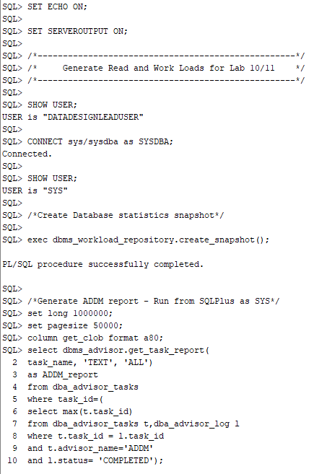

Figure 1. The ADDM report code execution.

We can see from the report, see figure 2, there is currently no findings.

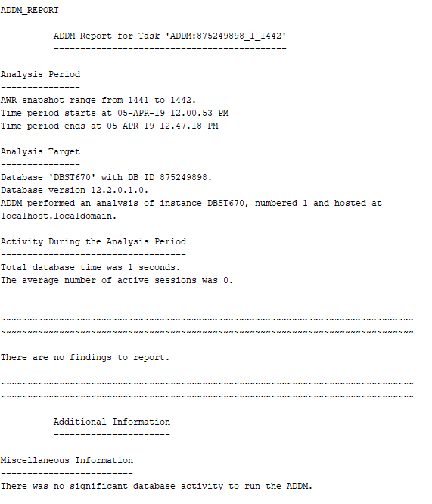

Figure 2. Initial ADDM report.

We then run an overly complex SELECT statement with multiple layers of correlated subqueries and full joins on the entire database. This statement is then repeated 200 times to create at least a 60-second database read load, see figure 3.

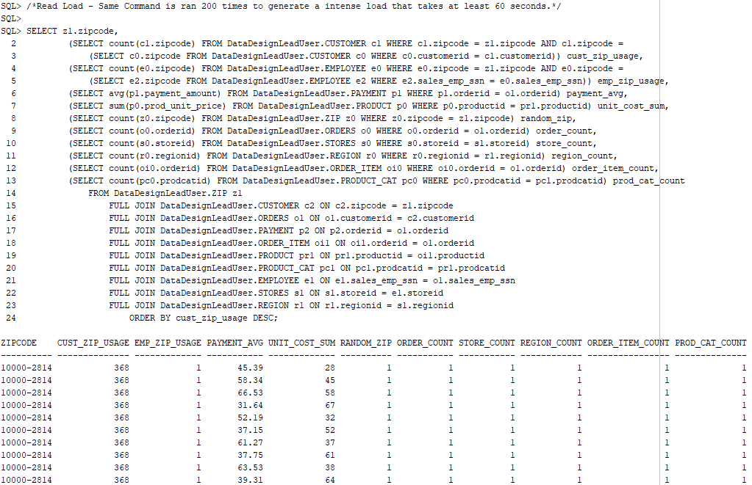

Figure 3. Read load SQL SELECT statement.

We then take another snapshot and run our ADDM report again see figure 4.

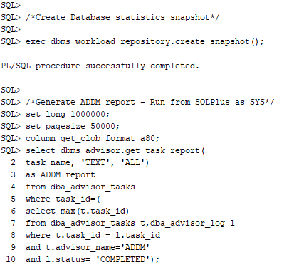

Figure 4. The ADDM report code execution.

The report, see figure 5, shows our database ran for 62 seconds and there were still no findings or recommended actions to improve performance.

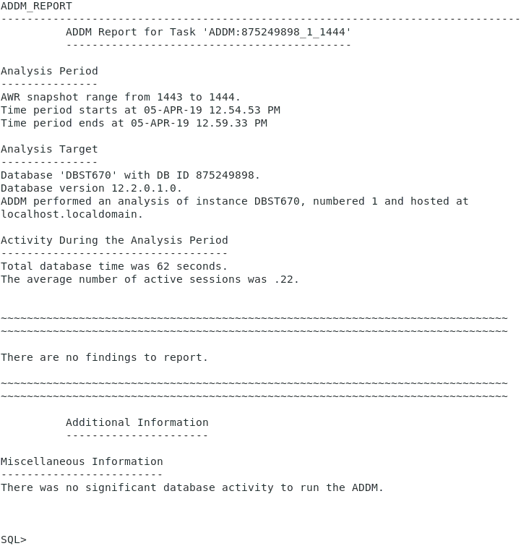

Figure 5. The ADDM report with no findings from the read load.

## **Write Load Results**

The next test runs the same ADDM reports, but this time with a write load. First, we generate the report, see figure 6.

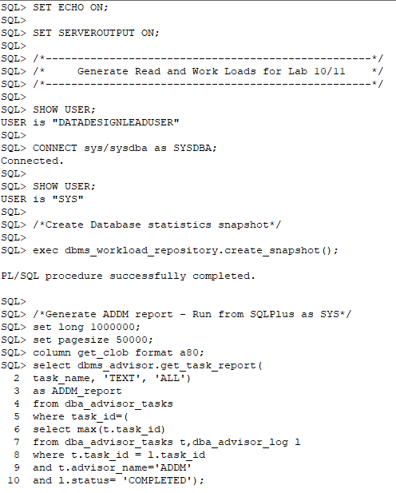

Figure 6. The ADDM report code execution.

The ADDM report, see figure 7, shows no current findings or recommendations.

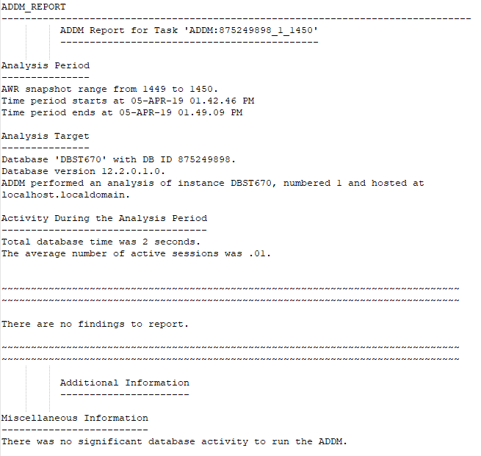

Figure 7. The ADDM report.

We can now apply the write load. For this test, we create a new table and populate it with data from the REGION table. We then run a loop to add additional rows of data to the table with 1 million rows in total. After verifying the data is there, we purposely create an inefficient DELETE loop to remove each row once per loop cycle. After this entire process is complete, we run through the entire process a second time to further increase the load. See figures 8,9 and 10.

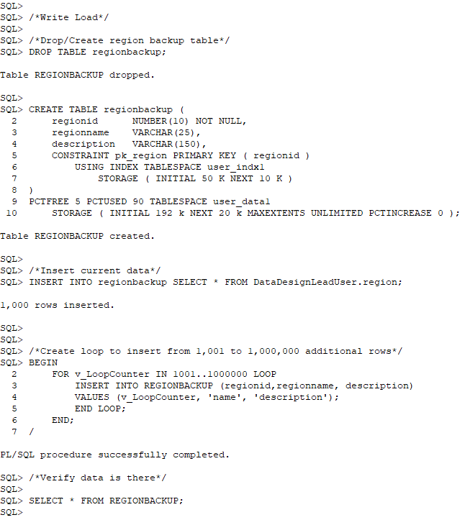

Figure 8. Create the write load table and insert 1 million rows of data.

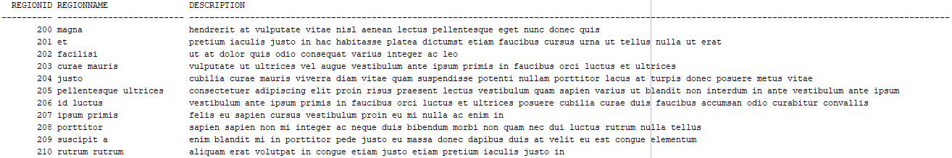

Figure 9. Verify the data is in the table.

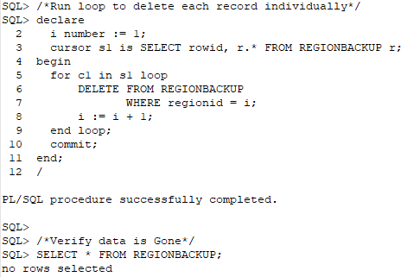

Figure 10. Run expensive loop operation to delete each record.

After this is complete, we run our ADDM report again, see figure 11.

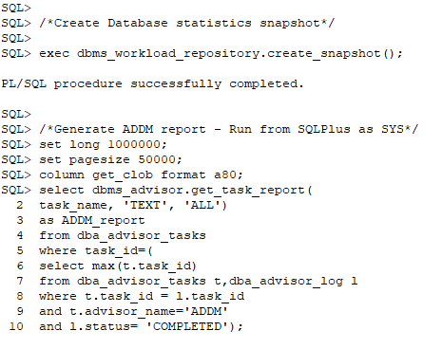

Figure 11. The ADDM report code execution.

The ADDM report, see figures 12 through 15, highlights five findings. It found an issue with the sequence cache, inefficient SQL statements, slow archivers, and some unusual wait events.

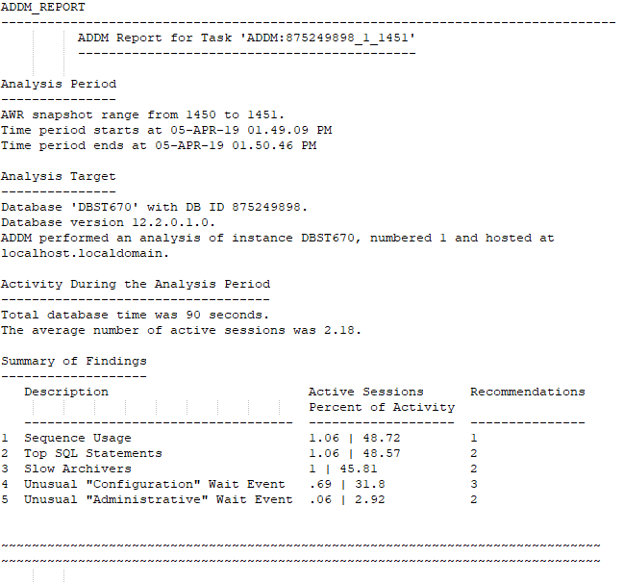

Figure 12. The ADDM report summary.

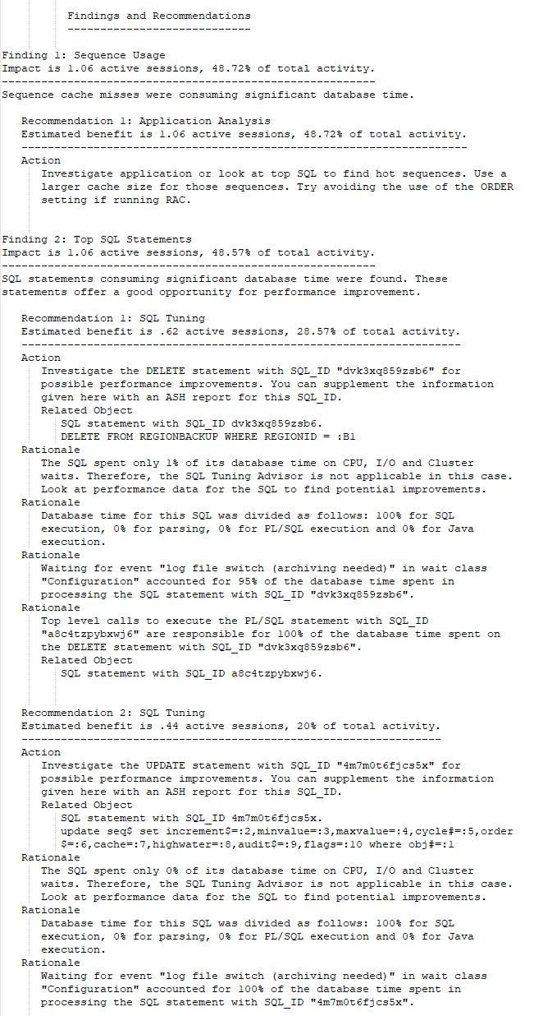

Figure 13. The ADDM report findings 1 and 2.

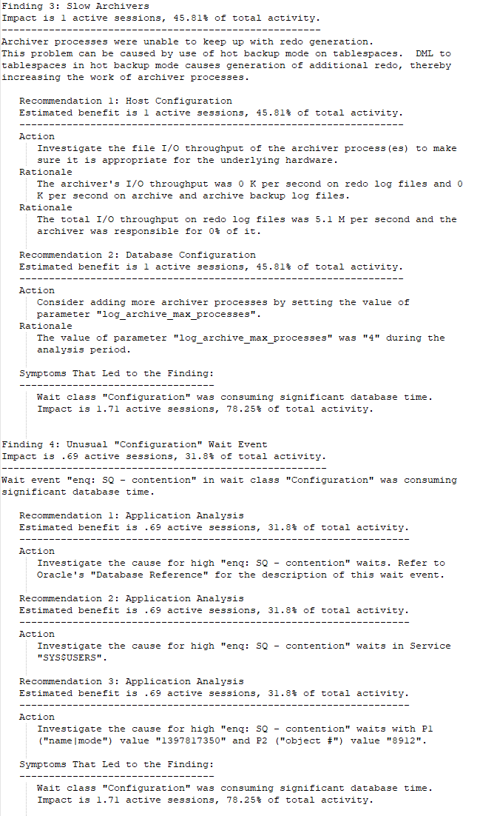

Figure 14. The ADDM report findings 3 and 4.

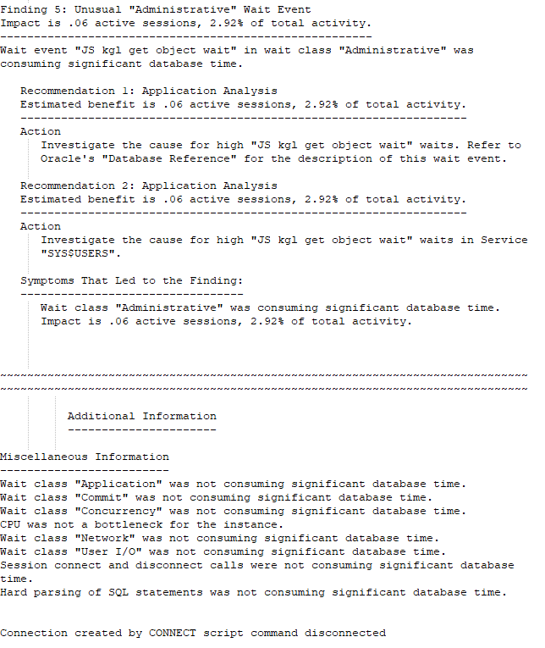

Figure 15. The ADDM report finding 5 and miscellaneous information.

For this project, we will focus on finding 2 recommendation 1 for tuning the DELETE statement. To correct the issue, we comment out the DELETE loop and add a single DELETE statement to delete all rows in the table. We then run a new ADDM report, see figure 16.

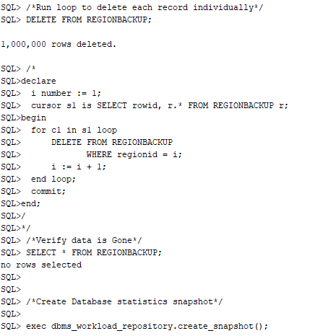

Figure 16. The ADDM report code execution.

As we can note in figure 17, our database time was reduced from 90 seconds to 55 seconds. Additionally, there are no findings or performance recommendations. This test highlights the capabilities of the ADDM utility and how we can use it to find performance improvements in our database.

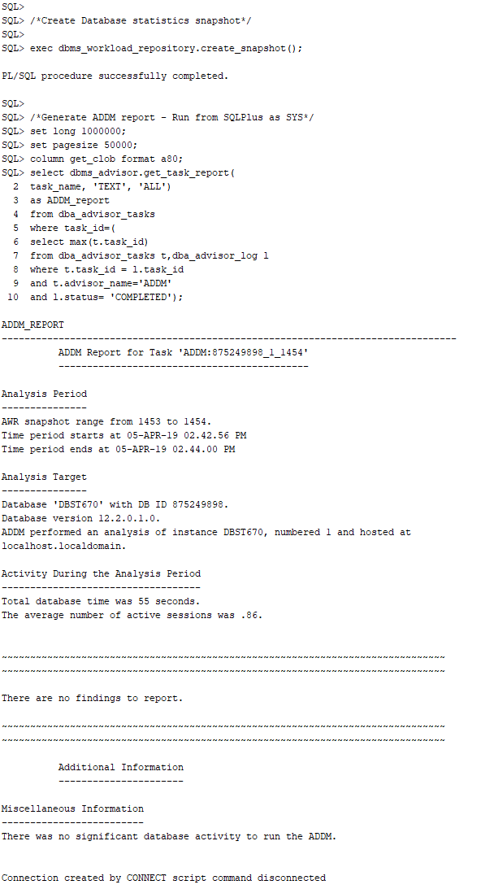

# **Part 2 – Checklist 7 – Performance Test Matrix**

|  |  |  |
| --- | --- | --- |
| Static Test 1 – Requests to/from client | Read | Write |
| Before: 276359  After: 957072 | Before: 957086  After: 957185 |
| Static Test 2 – CPU used when call started | Before: 16330  After: 19507 | Before: 19524  After: 27014 |
| Static Test 3 – Concurrency wait time | Before: 453  After: 453 | Before: 453  After: 454 |
| Static Test 4 – physical reads | Before: 1022845  After: 1026832 | Before: 1026841  After: 1197247 |
| Static Test 5 – physical writes | Before: 403321  After: 404598 | Before: 406240  After: 520579 |
| Dynamic ADDM Read Test | There are no findings to report. | |
| Dynamic ADDM Write Test | A number of issues were found, to include sequence usage, SQL statement inefficiencies, a slow archiver, and unusual wait events. Focusing on the SQL statement inefficiencies, we found an inefficient DELETE loop causing performance issues. After replacing this with a single DELETE DML statement performance improved significantly. | |