Table of Contents

ERD 2

Calculations for Sizing Objects 2

Data Definition Language (DDL) Scripts 6

Drop Objects 6

Create Users 12

Drop Tablespaces 17

Create Tablespaces and Alter Users 18

Create Tables and Indexes 21

Load Data 32

SQL Control File Loaders 32

Query Tables 44

Analyze Tables 50

Check Object Status in Catalog 56

Query Row Numbers from Catalog 57

# **ERD**

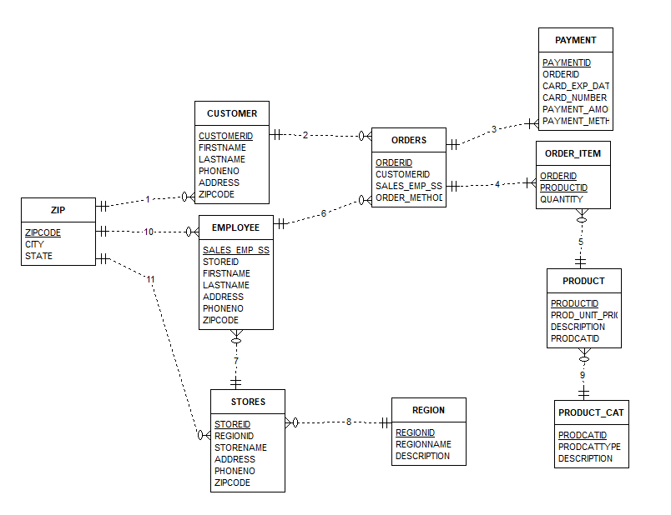

# **Calculations for Sizing Objects**

UserData 1 = 2184K + 120K + 100K+120K+96K+192K+192K = 3,004K

UserData 2 = 2184K + 168K + 16K+40K = 2,408K

|  |  |  |
| --- | --- | --- |
| Zip 5/90  _______  2476K - Split in User_Data1&2  Zipcode = 10 Varchar  City = 25 Varchar  State = 2 Char  data space = (8108 - 2*R) - ((8108 - 2*R) * 5/100)  data space = (8108 - 2*R) - (405.4 - .1*R)  data space = 8108 - 2*R - 405.4 + .1*R  data space = 7702.6 - 1.9*R  Total Bytes = 40  7702.6 - 1.9*R/ 40  192.57 - 0.048R  1.048R = 192.57  R = 183.75  ceiling(50000/183.75) = ceiling(273)  273*8K blocks  = 2184K | Customer Size 20/40  -----  120K - User_Data1  CUSTOMERID = Integer = log(500)/Log(2)/8 = 1  Firstname = 15 varchar  Lastname = 15 varchar  phoneno = 15 char  address = 35 varchar  zipcode 10 char  data space = (8108 - 2*R) - ((8108 - 2*R) * 20/100)  data space = (8108 - 2*R) - (1621.6 - .4*R)  data space = 8108 - 2*R - 1621.6 + .4*R  data space = 6486.4 - 1.6*R  Total Bytes = 94  6486.4 - 1.6*R/ 94  69 - 0.017R  1.017R = 69  R = 67.85  ceiling(1000/67.85) = ceiling(15)  15*8K blocks  = 120 Kilobytes | Orders 5/60  -----  100K - User_Data1  OrderID = Integer = log(500)/Log(2)/8 = 1  CustomerId = Integer = log(500)/Log(2)/8 = 1  Sales_emp_ssn = Integer log(199,606,147)/log(2)/8 = 4  Order_Method = 10 char  data space = (8108 - 2*R) - ((8108 - 2*R) * 5/100)  data space = (8108 - 2*R) - (405.4 - .1*R)  data space = 8108 - 2*R - 405.4 + .1*R  data space = 7702.6 - 1.9*R  Total Bytes = 19  7702.6 - 1.9*R/ 19  405.4 - 0.001R  1.001R = 405.4  R = 405  ceiling(1000/405) = ceiling(3)  3*8K blocks  = 24K kilobytes |

|  |  |  |
| --- | --- | --- |
| Product 5/90  ----  150K - User_Data2  ProductId = Integer = Log(7000)/Log(2)/8 = 2  Prod_Unit_Price = Log(80)/Log(2)/8 = 1  Description = 150 varchar  data space = (8108 - 2*R) - ((8108 - 2*R) * 5/100)  data space = (8108 - 2*R) - (405.4 - .1*R)  data space = 8108 - 2*R - 405.4 + .1*R  data space = 7702.6 - 1.9*R  Total Bytes = 156  7702.6 - 1.9*R/ 156  49.38 - 0.01R  1.010R = 49.38  R = 48.89  ceiling(1000/49) = ceiling(21)  21*8K blocks  = 168 Kilobytes | Order_Item 5/90  ------  50K - User_Data2  Orderid = Integer = log(500)/Log(2)/8 = 1  ProductID = Integer = log(500)/Log(2)/8 = 1  Quantity = Integer = log(2)/Log(2)/8 = 1  data space = (8108 - 2*R) - ((8108 - 2*R) * 5/100)  data space = (8108 - 2*R) - (405.4 - .1*R)  data space = 8108 - 2*R - 405.4 + .1*R  data space = 7702.6 - 1.9*R  Total Bytes = 6  7702.6 - 1.9*R/ 6  1283.77 - 0.32R  1.31R = 1283.77  R = 979.98  ceiling(1000/980) = ceiling(2)  2*8K blocks  = 16 Kilobytes | Payment 20/40  -----  100K - User_Data 2  PaymentId = Integer = log(500)/Log(2)/8 = 1  OrderID = Integer = log(500)/Log(2)/8 = 1  Car_Exp_Date = date = 7  card_number = Integer = log(1851851849647260)/log(2)/8 = 7  payment_amount = Integer = Log(80)/Log(2)/8 = 1  payment_method = 5 varchar  data space = (8108 - 2*R) - ((8108 - 2*R) * 20/100)  data space = (8108 - 2*R) - (1621.6 - .4*R)  data space = 8108 - 2*R - 1621.6 + .4*R  data space = 6486.4 - 1.6*R  Total Bytes = 25  6486.4 - 1.6*R/ 25  259.46 - 0.064R  1.064R = 259.46  R = 243.9  ceiling(1000/243.9) = ceiling(5)  5*8K blocks  = 40 Kilobytes |

|  |  |  |
| --- | --- | --- |
| Employee – UserData1  -------  20/40...like Customer table  Address = 35 Varchar  Firstname = 15 Varchar  Lastname = 15 Varchar  PhoneNo = 15 Varchar  Sales_emp_ssn = Integer = log(199,606,147)/log(2)/8 = 4  storeid - Integer = avg(500) = 1  zipcode = char 5  ---  data space = (8108 - 2*R) - ((8108 - 2*R) * 20/100)  data space = (8108 - 2*R) - (1621.6 - .4*R)  data space = 8108 - 2*R - 1621.6 + .4*R  data space = 6486.4 - 1.6*R  Total Bytes = 93  6486.4 - 1.6*R/ 93  69.74 - 0.017R  1.017R = 69.74  R = 68.57  ceiling(1000/15) = ceiling(15)  15*8K blocks  = 120 Kilobytes | Store – UserData1  -----  5/90  Address = 35  phoneno= 15  regionid = int = avg(500) = 1  storename =varchar 25  zipcode = char 5  data space = (8108 - 2*R) - ((8108 - 2*R) * 5/100)  data space = (8108 - 2*R) - (405.4 - .1*R)  data space = 8108 - 2*R - 405.4 + .1*R  data space = 7702.6 - 1.9*R  Total Bytes = 84  7702.6 - 1.9*R/ 84  91.7 - 0.022R  1.022R = 91.7  R = 89.72  ceiling(1000/90) = ceiling(12)  12*8K blocks  = 96K kilobytes | Region – UserData1  ------  5/90  description = varchar 150  regionid = int = avg(500) = 1  regionname = vharchar 25  data space = (8108 - 2*R) - ((8108 - 2*R) * 5/100)  data space = (8108 - 2*R) - (405.4 - .1*R)  data space = 8108 - 2*R - 405.4 + .1*R  data space = 7702.6 - 1.9*R  Total Bytes = 179  7702.6 - 1.9*R/ 179  43.03 - 0.01R  1.010R = 43.03  R = 42.6  ceiling(1000/43) = ceiling(24)  12*8K blocks  = 192 Kilobytes |

|  |
| --- |
| ProdCat – UserData1  ------  5/90  description = varchar 150  prodcatid = int = avg(500) = 1  prodcattype = varchar 25  data space = (8108 - 2*R) - ((8108 - 2*R) * 5/100)  data space = (8108 - 2*R) - (405.4 - .1*R)  data space = 8108 - 2*R - 405.4 + .1*R  data space = 7702.6 - 1.9*R  Total Bytes = 179  7702.6 - 1.9*R/ 179  43.03 - 0.01R  1.010R = 43.03  R = 42.6  ceiling(1000/43) = ceiling(24)  12*8K blocks  = 192 Kilobytes |

# **Data Definition Language (DDL) Scripts**

## **Drop Objects**

SQL> SET ECHO ON;

SQL>

SQL> SET SERVEROUTPUT ON;

SQL>

SQL> /*---------------------------------------------------*/

SQL> /* DROP OBJECTS */

SQL> /*---------------------------------------------------*/

SQL>

SQL> SHOW USER;

USER is "SYSTEM"

SQL>

SQL> CONNECT DataDesignLeadUser/abc123;

Connected.

SQL>

SQL> SHOW USER;

USER is "DATADESIGNLEADUSER"

SQL>

SQL> /*Drop Indexes*/

SQL>

SQL> DROP INDEX fk_zip;

Index FK_ZIP dropped.

SQL>

SQL> DROP INDEX fk_customerid;

Index FK_CUSTOMERID dropped.

SQL>

SQL> DROP INDEX fk_order_id1;

Index FK_ORDER_ID1 dropped.

SQL>

SQL> DROP INDEX fk_product_id;

Index FK_PRODUCT_ID dropped.

SQL>

SQL> DROP INDEX fk_order_id2;

Index FK_ORDER_ID2 dropped.

SQL>

SQL> DROP INDEX fk_emp_storeid;

Index FK_EMP_STOREID dropped.

SQL>

SQL> DROP INDEX fk_emp_zip;

Index FK_EMP_ZIP dropped.

SQL>

SQL> DROP INDEX fk_store_region;

Index FK_STORE_REGION dropped.

SQL>

SQL> DROP INDEX fk_store_zip;

Index FK_STORE_ZIP dropped.

SQL>

SQL> DROP INDEX fk_prodcatid;

Index FK_PRODCATID dropped.

SQL>

SQL> DROP INDEX fk_emp_ssn;

Index FK_EMP_SSN dropped.

SQL>

SQL> /*Drop Tables*/

SQL>

SQL> DROP TABLE payment;

Table PAYMENT dropped.

SQL>

SQL> DROP TABLE order_item;

Table ORDER_ITEM dropped.

SQL>

SQL> DROP TABLE orders;

Table ORDERS dropped.

SQL>

SQL> DROP TABLE product;

Table PRODUCT dropped.

SQL>

SQL> DROP TABLE customer;

Table CUSTOMER dropped.

SQL>

SQL> DROP TABLE employee;

Table EMPLOYEE dropped.

SQL>

SQL> DROP TABLE stores;

Table STORES dropped.

SQL>

SQL> DROP TABLE zip;

Table ZIP dropped.

SQL>

SQL> DROP TABLE region;

Table REGION dropped.

SQL>

SQL> DROP TABLE product_cat;

Table PRODUCT_CAT dropped.

SQL>

SQL>

SQL> /*Disconnect DataDesignLeadUser, Login as system to drop users and create other objects*/

SQL>

SQL> DISCONNECT;

Disconnected from Oracle Database 12c Enterprise Edition Release 12.2.0.1.0 - 64bit Production

SQL>

SQL> SHOW USER;

USER is ""

SQL>

SQL> CONNECT system/sysdba;

Connected.

SQL>

SQL> SHOW USER;

USER is "SYSTEM"

SQL>

SQL> /*Drop Users*/

SQL>

SQL> DROP USER jkamando CASCADE;

User JKAMANDO dropped.

SQL>

SQL> DROP USER tokusanya CASCADE;

User TOKUSANYA dropped.

SQL>

SQL> DROP USER joluwadamilare CASCADE;

User JOLUWADAMILARE dropped.

SQL>

SQL> DROP USER brussell CASCADE;

User BRUSSELL dropped.

SQL>

SQL> DROP USER rseyoum CASCADE;

User RSEYOUM dropped.

SQL>

SQL> DROP USER dbauser CASCADE;

User DBAUSER dropped.

SQL>

SQL> DROP USER datadesignleaduser CASCADE;

User DATADESIGNLEADUSER dropped.

## **Create Users**

SQL>

SQL> /*---------------------------------------------------*/

SQL> /* CREATE USERS */

SQL> /*---------------------------------------------------*/

SQL>

SQL> /*Create DBA User and grant necessary permissions*/

SQL> CREATE USER dbauser IDENTIFIED BY abc123

2 DEFAULT TABLESPACE users

3 TEMPORARY TABLESPACE temp;

User DBAUSER created.

SQL>

SQL> GRANT dba TO dbauser;

Grant succeeded.

SQL>

SQL> /*Disconnect from System and connect to DBAUser*/

SQL> SELECT 'alter system kill session '''

2 || sid

3 || ','

4 || serial#

5 || ''';'

6 FROM v$session

7 WHERE username = 'SYSTEM';

'ALTERSYSTEMKILLSESSION'''||SID||','||SERIAL#||''';'

--------------------------------------------------------------------------------------------------------------

alter system kill session '388,50053';

alter system kill session '394,35833';

SQL>

SQL> DISCONNECT;

Disconnected from Oracle Database 12c Enterprise Edition Release 12.2.0.1.0 - 64bit Production

SQL>

SQL> SHOW USER;

USER is ""

SQL>

SQL> CONNECT DBAUser/abc123;

Connected.

SQL>

SQL> SHOW USER;

USER is "DBAUSER"

SQL>

SQL>

SQL> CREATE USER jkamando IDENTIFIED BY abc123

2 DEFAULT TABLESPACE users

3 TEMPORARY TABLESPACE temp;

User JKAMANDO created.

SQL>

SQL> CREATE USER tokusanya IDENTIFIED BY abc123

2 DEFAULT TABLESPACE users

3 TEMPORARY TABLESPACE temp;

User TOKUSANYA created.

SQL>

SQL> CREATE USER joluwadamilare IDENTIFIED BY abc123

2 DEFAULT TABLESPACE users

3 TEMPORARY TABLESPACE temp;

User JOLUWADAMILARE created.

SQL>

SQL> CREATE USER brussell IDENTIFIED BY abc123

2 DEFAULT TABLESPACE users

3 TEMPORARY TABLESPACE temp;

User BRUSSELL created.

SQL>

SQL> CREATE USER rseyoum IDENTIFIED BY abc123

2 DEFAULT TABLESPACE users

3 TEMPORARY TABLESPACE temp;

User RSEYOUM created.

SQL>

SQL>

SQL> CREATE USER datadesignleaduser IDENTIFIED BY abc123

2 DEFAULT TABLESPACE users

3 TEMPORARY TABLESPACE temp;

User DATADESIGNLEADUSER created.

SQL>

SQL> /*Grant necessary permissions*/

SQL>

SQL> GRANT connect,resource TO jkamando;

Grant succeeded.

SQL>

SQL> GRANT connect,resource TO tokusanya;

Grant succeeded.

SQL>

SQL> GRANT connect,resource TO joluwadamilare;

Grant succeeded.

SQL>

SQL> GRANT connect,resource TO brussell;

Grant succeeded.

SQL>

SQL> GRANT connect,resource TO rseyoum;

Grant succeeded.

SQL>

SQL> GRANT connect,resource TO datadesignleaduser;

Grant succeeded.

SQL>

SQL> GRANT UNLIMITED TABLESPACE TO datadesignleaduser;

Grant succeeded.

## **Drop Tablespaces**

SQL>

SQL> /*DROP TABLESPACES*/

SQL>

SQL> DROP TABLESPACE "USER_DATA1" INCLUDING CONTENTS;

TABLESPACE "USER_DATA1" dropped.

SQL>

SQL> DROP TABLESPACE "USER_DATA2" INCLUDING CONTENTS;

TABLESPACE "USER_DATA2" dropped.

SQL>

SQL> DROP TABLESPACE "USER_INDX1" INCLUDING CONTENTS;

TABLESPACE "USER_INDX1" dropped.

SQL>

SQL> DROP TABLESPACE "USER_TEMP" INCLUDING CONTENTS;

TABLESPACE "USER_TEMP" dropped.

## **Create Tablespaces and Alter Users**

SQL>

SQL> /*---------------------------------------------------*/

SQL> /* CREATE TABLESPACE AND ASSIGN TO USERS */

SQL> /*---------------------------------------------------*/

SQL>

SQL> CREATE TABLESPACE "USER_DATA1" LOGGING DATAFILE '/u01/app/oracle/oradata/DBST670/user_data101.dbf' SIZE 3004K REUSE AUTOEXTEND ON NEXT 512K MAXSIZE 65536K EXTENT MANAGEMENT LOCAL;

TABLESPACE "USER_DATA1" created.

SQL> CREATE TABLESPACE "USER_DATA2" LOGGING DATAFILE '/u01/app/oracle/oradata/DBST670/user_data201.dbf' SIZE 2408K REUSE AUTOEXTEND ON NEXT 512K MAXSIZE 65536K EXTENT MANAGEMENT LOCAL;

TABLESPACE "USER_DATA2" created.

SQL> CREATE TABLESPACE "USER_INDX1" LOGGING DATAFILE '/u01/app/oracle/oradata/DBST670/user_indx01.dbf' SIZE 4210K REUSE AUTOEXTEND ON NEXT 512K MAXSIZE 65536K EXTENT MANAGEMENT LOCAL;

TABLESPACE "USER_INDX1" created.

SQL> CREATE TEMPORARY TABLESPACE "USER_TEMP" TEMPFILE '/u01/app/oracle/oradata/DBST670/user_temp01.dbf' SIZE 16384K REUSE AUTOEXTEND ON NEXT 512K MAXSIZE 65536K EXTENT MANAGEMENT LOCAL;

TABLESPACE "USER_TEMP" created.

SQL>

SQL> /*Alter unprivileged user tablespace*/

SQL> ALTER USER JKamando DEFAULT TABLESPACE user_data1 TEMPORARY TABLESPACE user_temp;

User JKAMANDO altered.

SQL> ALTER USER TOkusanya DEFAULT TABLESPACE user_data1 TEMPORARY TABLESPACE user_temp;

User TOKUSANYA altered.

SQL> ALTER USER JOluwadamilare DEFAULT TABLESPACE user_data1 TEMPORARY TABLESPACE user_temp;

User JOLUWADAMILARE altered.

SQL> ALTER USER BRussell DEFAULT TABLESPACE user_data1 TEMPORARY TABLESPACE user_temp;

User BRUSSELL altered.

SQL> ALTER USER RSeyoum DEFAULT TABLESPACE user_data1 TEMPORARY TABLESPACE user_temp;

User RSEYOUM altered.

SQL> ALTER USER DBAUser DEFAULT TABLESPACE user_data1 TEMPORARY TABLESPACE user_temp;

User DBAUSER altered.

SQL> ALTER USER DataDesignLeadUser DEFAULT TABLESPACE user_data1 TEMPORARY TABLESPACE user_temp;

User DATADESIGNLEADUSER altered.

SQL>

SQL> /*Disconnect from DBAUser, Login as DataDesignLeadUser*/

SQL> SELECT 'alter system kill session '''

2 || sid

3 || ','

4 || serial#

5 || ''';'

6 FROM v$session

7 WHERE username = 'DBAUSER';

'ALTERSYSTEMKILLSESSION'''||SID||','||SERIAL#||''';'

--------------------------------------------------------------------------------------------------------------

alter system kill session '268,10717';

SQL>

SQL> DISCONNECT;

Disconnected from Oracle Database 12c Enterprise Edition Release 12.2.0.1.0 - 64bit Production

SQL>

SQL> SHOW USER;

USER is ""

SQL>

SQL> CONNECT DataDesignLeadUser/abc123;

Connected.

SQL>

SQL> SHOW USER;

USER is "DATADESIGNLEADUSER"

## **Create Tables and Indexes**

SQL>

SQL> /*---------------------------------------------------*/

SQL> /* CREATE TABLES */

SQL> /*---------------------------------------------------*/

SQL>

SQL> CREATE TABLE zip (

2 zipcode CHAR(10) NOT NULL,

3 city CHAR(25),

4 state CHAR(2),

5 CONSTRAINT pk_zip PRIMARY KEY ( zipcode )

6 USING INDEX TABLESPACE user_indx1

7 STORAGE ( INITIAL 1000 K NEXT 120 K )

8 )

9 PARTITION BY RANGE (

10 state

11 )

12 ( PARTITION zip_part1

13 VALUES LESS THAN ( 'N' )

14 PCTFREE 5 PCTUSED 90 TABLESPACE user_data1

15 STORAGE ( INITIAL 1092 k NEXT 200 k MAXEXTENTS UNLIMITED PCTINCREASE 0 ),

16 PARTITION zip_part2

17 VALUES LESS THAN ( MAXVALUE )

18 PCTFREE 5 PCTUSED 90 TABLESPACE user_data2

19 STORAGE ( INITIAL 1092 k NEXT 200 k MAXEXTENTS UNLIMITED PCTINCREASE 0 )

20 );

Table ZIP created.

SQL>

SQL> CREATE TABLE customer (

2 customerid NUMBER(10) NOT NULL,

3 firstname VARCHAR2(15),

4 lastname VARCHAR2(15),

5 phoneno CHAR(15),

6 address VARCHAR2(35),

7 zipcode CHAR(10),

8 CONSTRAINT pk_customer_id PRIMARY KEY ( customerid )

9 USING INDEX TABLESPACE user_indx1

10 STORAGE ( INITIAL 50 K NEXT 10 K ),

11 CONSTRAINT fk_zip FOREIGN KEY ( zipcode )

12 REFERENCES zip

13 )

14 PCTFREE 20 PCTUSED 40 TABLESPACE user_data1

15 STORAGE ( INITIAL 120 k NEXT 10 k MAXEXTENTS UNLIMITED PCTINCREASE 0 );

Table CUSTOMER created.

SQL>

SQL> CREATE TABLE product (

2 productid NUMBER(10) NOT NULL,

3 prod_unit_price NUMBER(10),

4 description VARCHAR2(150),

5 CONSTRAINT pk_productid PRIMARY KEY ( productid )

6 USING INDEX TABLESPACE user_indx1

7 STORAGE ( INITIAL 50 K NEXT 10 K )

8 )

9 PCTFREE 5 PCTUSED 90 TABLESPACE user_data2

10 STORAGE ( INITIAL 168 k NEXT 20 k MAXEXTENTS UNLIMITED PCTINCREASE 0 );

Table PRODUCT created.

SQL>

SQL> CREATE TABLE region (

2 regionid NUMBER(10) NOT NULL,

3 regionname VARCHAR(25),

4 description VARCHAR(150),

5 CONSTRAINT pk_region PRIMARY KEY ( regionid )

6 USING INDEX TABLESPACE user_indx1

7 STORAGE ( INITIAL 50 K NEXT 10 K )

8 )

9 PCTFREE 5 PCTUSED 90 TABLESPACE user_data1

10 STORAGE ( INITIAL 192 k NEXT 20 k MAXEXTENTS UNLIMITED PCTINCREASE 0 );

Table REGION created.

SQL>

SQL> CREATE TABLE stores (

2 storeid NUMBER(10) NOT NULL,

3 regionid NUMBER(10),

4 storename VARCHAR2(15),

5 address VARCHAR2(35),

6 phoneno CHAR(15),

7 zipcode CHAR(10),

8 CONSTRAINT pk_stores PRIMARY KEY ( storeid )

9 USING INDEX TABLESPACE user_indx1

10 STORAGE ( INITIAL 50 K NEXT 10 K ),

11 CONSTRAINT fk_store_region FOREIGN KEY ( regionid )

12 REFERENCES region,

13 CONSTRAINT fk_store_zip FOREIGN KEY ( zipcode )

14 REFERENCES zip

15 )

16 PCTFREE 5 PCTUSED 90 TABLESPACE user_data1

17 STORAGE ( INITIAL 96 k NEXT 10 k MAXEXTENTS UNLIMITED PCTINCREASE 0 );

Table STORES created.

SQL>

SQL> CREATE TABLE employee (

2 sales_emp_ssn NUMBER(9) NOT NULL,

3 storeid NUMBER(10),

4 firstname VARCHAR2(15),

5 lastname VARCHAR2(15),

6 address VARCHAR2(35),

7 phoneno CHAR(15),

8 zipcode CHAR(10),

9 CONSTRAINT pk_sales_emp_ssn PRIMARY KEY ( sales_emp_ssn )

10 USING INDEX TABLESPACE user_indx1

11 STORAGE ( INITIAL 50 K NEXT 10 K ),

12 CONSTRAINT fk_emp_storeid FOREIGN KEY ( storeid )

13 REFERENCES stores,

14 CONSTRAINT fk_emp_zip FOREIGN KEY ( zipcode )

15 REFERENCES zip

16 )

17 PCTFREE 20 PCTUSED 40 TABLESPACE user_data1

18 STORAGE ( INITIAL 120 k NEXT 10 k MAXEXTENTS UNLIMITED PCTINCREASE 0 );

Table EMPLOYEE created.

SQL>

SQL> CREATE TABLE orders (

2 orderid NUMBER(10) NOT NULL,

3 customerid NUMBER(10) NOT NULL,

4 sales_emp_ssn NUMBER(9) NOT NULL,

5 order_method CHAR(10),

6 CONSTRAINT pk_orderid PRIMARY KEY ( orderid )

7 USING INDEX TABLESPACE user_indx1

8 STORAGE ( INITIAL 50 K NEXT 10 K ),

9 CONSTRAINT fk_customerid FOREIGN KEY ( customerid )

10 REFERENCES customer,

11 CONSTRAINT fk_emp_ssn FOREIGN KEY ( sales_emp_ssn )

12 REFERENCES employee

13 )

14 PCTFREE 5 PCTUSED 60 TABLESPACE user_data1

15 STORAGE ( INITIAL 24 k NEXT 10 k MAXEXTENTS UNLIMITED PCTINCREASE 0 );

Table ORDERS created.

SQL>

SQL> CREATE TABLE order_item (

2 orderid NUMBER(10) NOT NULL,

3 productid NUMBER(10),

4 quantity NUMBER(10),

5 CONSTRAINT pk_order_item PRIMARY KEY ( orderid,

6 productid )

7 USING INDEX TABLESPACE user_indx1

8 STORAGE ( INITIAL 50 K NEXT 10 K ),

9 CONSTRAINT fk_order_id1 FOREIGN KEY ( orderid )

10 REFERENCES orders,

11 CONSTRAINT fk_product_id FOREIGN KEY ( productid )

12 REFERENCES product

13 )

14 PCTFREE 5 PCTUSED 90 TABLESPACE user_data2

15 STORAGE ( INITIAL 16 k NEXT 20 k MAXEXTENTS UNLIMITED PCTINCREASE 0 );

Table ORDER_ITEM created.

SQL>

SQL> CREATE TABLE payment (

2 paymentid NUMBER(10) NOT NULL,

3 orderid NUMBER(10),

4 card_exp_date DATE,

5 card_number NUMBER(30),

6 payment_amount NUMBER(20,2),

7 payment_method VARCHAR2(5),

8 CONSTRAINT pk_paymentid PRIMARY KEY ( paymentid )

9 USING INDEX TABLESPACE user_indx1

10 STORAGE ( INITIAL 50 K NEXT 10 K ),

11 CONSTRAINT fk_order_id2 FOREIGN KEY ( orderid )

12 REFERENCES orders

13 )

14 PCTFREE 20 PCTUSED 40 TABLESPACE user_data2

15 STORAGE ( INITIAL 40 k NEXT 10 k MAXEXTENTS UNLIMITED PCTINCREASE 0 );

Table PAYMENT created.

SQL>

SQL>

SQL> CREATE TABLE product_cat (

2 prodcatid NUMBER(10) NOT NULL,

3 prodcattype VARCHAR(25),

4 description VARCHAR(150),

5 CONSTRAINT pk_prodcat PRIMARY KEY ( prodcatid )

6 USING INDEX TABLESPACE user_indx1

7 STORAGE ( INITIAL 50 K NEXT 10 K )

8 )

9 PCTFREE 5 PCTUSED 90 TABLESPACE user_data1

10 STORAGE ( INITIAL 192 k NEXT 20 k MAXEXTENTS UNLIMITED PCTINCREASE 0 );

Table PRODUCT_CAT created.

SQL>

SQL>

SQL> /*Alter Product table to include additional Product Category ID*/

SQL> ALTER TABLE PRODUCT ADD PRODCATID NUMBER (10)

2 CONSTRAINT fk_prodcatid references PRODUCT_CAT(PRODCATID);

Table PRODUCT altered.

SQL>

SQL>

SQL> /*--------------------------------------------*/

SQL> /* INDEXES */

SQL> /*--------------------------------------------*/

SQL> CREATE INDEX fk_zip ON

2 customer (

3 zipcode

4 )

5 TABLESPACE user_indx1

6 STORAGE ( INITIAL 50 K NEXT 10 K );

Index FK_ZIP created.

SQL>

SQL> CREATE INDEX fk_customerid ON

2 orders (

3 customerid

4 )

5 TABLESPACE user_indx1

6 STORAGE ( INITIAL 50 K NEXT 10 K );

Index FK_CUSTOMERID created.

SQL>

SQL> CREATE INDEX fk_order_id1 ON

2 order_item (

3 orderid

4 )

5 TABLESPACE user_indx1

6 STORAGE ( INITIAL 50 K NEXT 10 K );

Index FK_ORDER_ID1 created.

SQL>

SQL> CREATE INDEX fk_product_id ON

2 order_item (

3 productid

4 )

5 TABLESPACE user_indx1

6 STORAGE ( INITIAL 50 K NEXT 10 K );

Index FK_PRODUCT_ID created.

SQL>

SQL> CREATE INDEX fk_order_id2 ON

2 payment (

3 orderid

4 )

5 TABLESPACE user_indx1

6 STORAGE ( INITIAL 50 K NEXT 10 K );

Index FK_ORDER_ID2 created.

SQL>

SQL> CREATE INDEX fk_emp_storeid ON

2 employee (

3 storeid

4 )

5 TABLESPACE user_indx1

6 STORAGE ( INITIAL 50 K NEXT 10 K );

Index FK_EMP_STOREID created.

SQL>

SQL> CREATE INDEX fk_emp_zip ON

2 employee (

3 zipcode

4 )

5 TABLESPACE user_indx1

6 STORAGE ( INITIAL 50 K NEXT 10 K );

Index FK_EMP_ZIP created.

SQL>

SQL> CREATE INDEX fk_store_region ON

2 stores (

3 regionid

4 )

5 TABLESPACE user_indx1

6 STORAGE ( INITIAL 50 K NEXT 10 K );

Index FK_STORE_REGION created.

SQL>

SQL> CREATE INDEX fk_store_zip ON

2 stores (

3 zipcode

4 )

5 TABLESPACE user_indx1

6 STORAGE ( INITIAL 50 K NEXT 10 K );

Index FK_STORE_ZIP created.

SQL>

SQL> CREATE INDEX fk_prodcatid ON

2 product (

3 prodcatid

4 )

5 TABLESPACE user_indx1

6 STORAGE ( INITIAL 50 K NEXT 10 K );

Index FK_PRODCATID created.

SQL>

SQL> CREATE INDEX fk_emp_ssn ON

2 orders (

3 sales_emp_ssn

4 )

5 TABLESPACE user_indx1

6 STORAGE ( INITIAL 50 K NEXT 10 K );

Index FK_EMP_SSN created.

## **Load Data**

SQL>

SQL>

SQL> /*Go to Console and Run the "RunSQLLoaders" file - Loads data into tables*/

## **SQL Control File Loaders**

Customer.ctl

OPTIONS (SKIP=3, LOAD=1000)

LOAD

INFILE customer.dat

REPLACE INTO TABLE customer

FIELDS TERMINATED BY ',' OPTIONALLY ENCLOSED BY '"'

(

CUSTOMERID

,FIRSTNAME

,LASTNAME

,PHONENO

,ADDRESS

,ZIPCODE

)

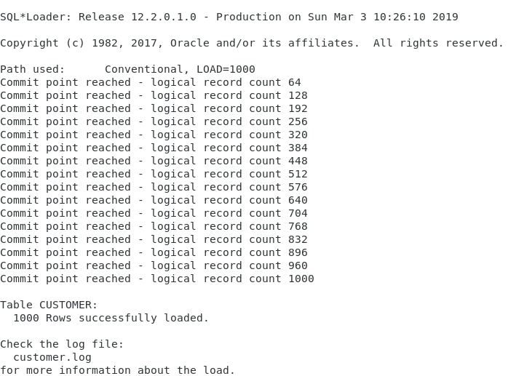

Employee.ctl

OPTIONS(LOAD=1000)

LOAD

INFILE 'DBST670_Employee.csv'

REPLACE

INTO TABLE employee

FIELDS TERMINATED BY ","

(SALES_EMP_SSN, STOREID,FIRSTNAME,LASTNAME, ADDRESS, PHONENO, ZIPCODE)

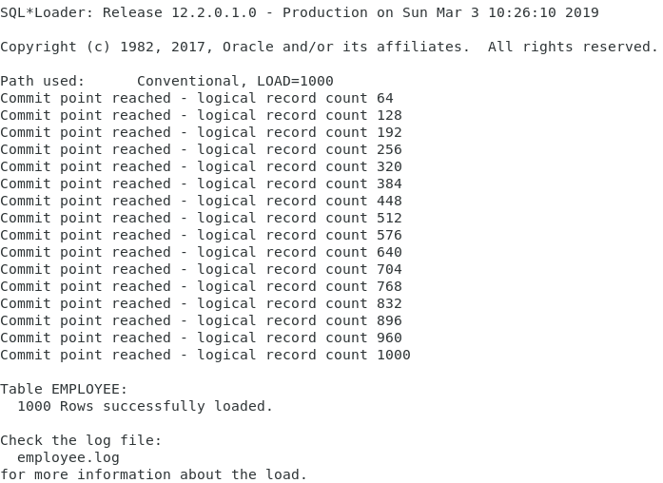

Order_item.ctl

OPTIONS (SKIP=2, LOAD=1000)

LOAD DATA

INFILE 'order_item.dat'

INTO TABLE order_item

(ORDERID TERMINATED BY WHITESPACE,

PRODUCTID TERMINATED BY WHITESPACE,

QUANTITY TERMINATED BY WHITESPACE)

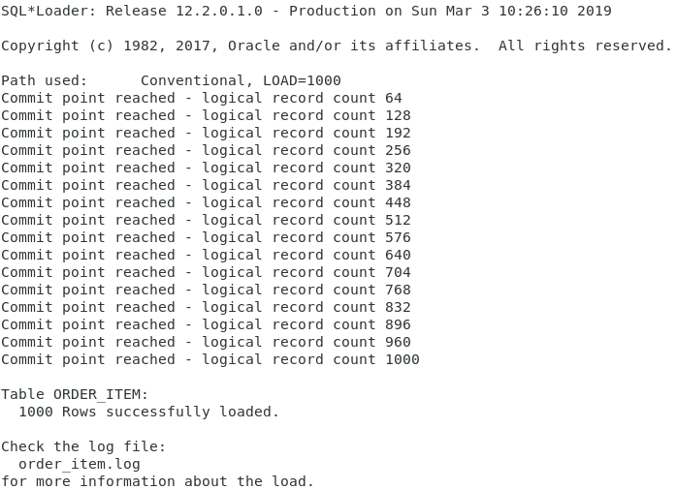

Orders.ctl

OPTIONS (SKIP=3, LOAD=1000)

LOAD DATA

INFILE 'order.dat'

REPLACE

INTO TABLE orders

(ORDERID TERMINATED BY WHITESPACE,

CUSTOMERID TERMINATED BY WHITESPACE,

SALES_EMP_SSN TERMINATED BY WHITESPACE,

ORDER_METHOD TERMINATED BY WHITESPACE

)

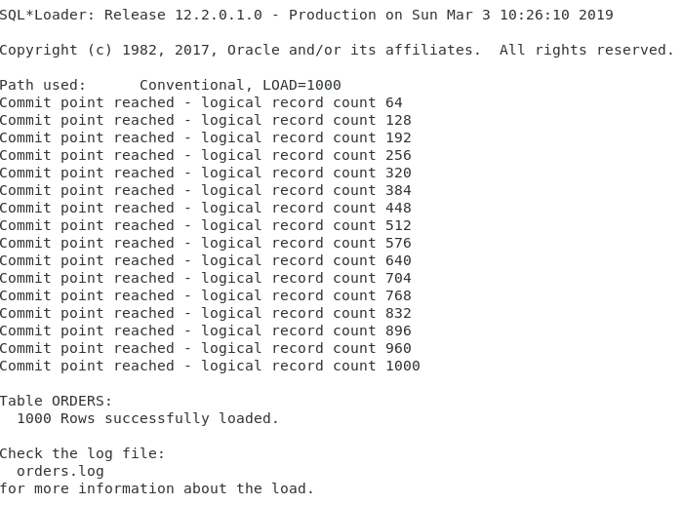

Payment.ctl

OPTIONS (SKIP=3, LOAD=1000)

LOAD DATA

INFILE payment.dat

INTO TABLE payment

FIELDS TERMINATED BY ","

(PAYMENTID,ORDERID,CARD_EXP_DATE,CARD_NUMBER,PAYMENT_AMOUNT,PAYMENT_METHOD)

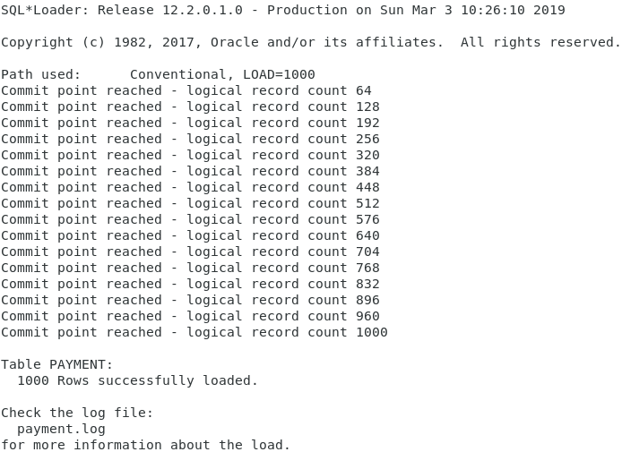

Product.ctl

OPTIONS(SKIP=3, LOAD=1000)

LOAD

INFILE 'product.dat'

REPLACE

INTO TABLE product

(PRODUCTID TERMINATED BY WHITESPACE,

PROD_UNIT_PRICE TERMINATED BY WHITESPACE,

DESCRIPTION TERMINATED BY WHITESPACE)

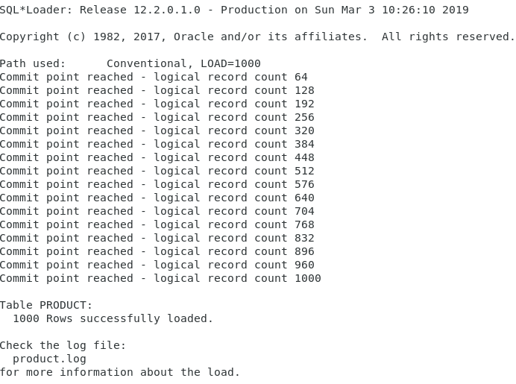

Productcat.ctl

OPTIONS(LOAD=1000)

LOAD

INFILE 'DBST670_Product_Cat.csv'

REPLACE

INTO TABLE product_cat

FIELDS TERMINATED BY ","

(PRODCATID ,PRODCATTYPE, DESCRIPTION)

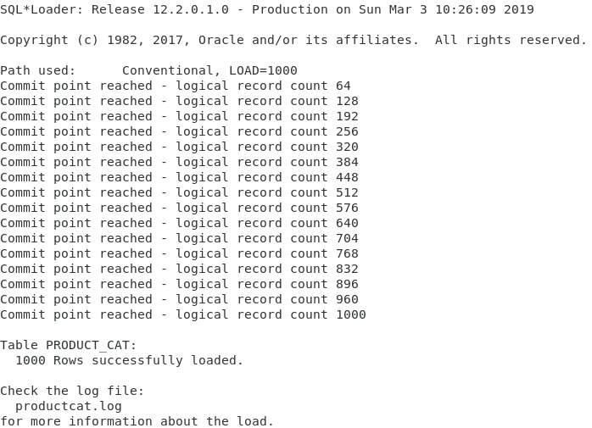

Region.ctl

OPTIONS(LOAD=1000)

LOAD

INFILE 'DBST670_Region.csv'

REPLACE

INTO TABLE region

FIELDS TERMINATED BY ","

(REGIONID,REGIONNAME,DESCRIPTION)

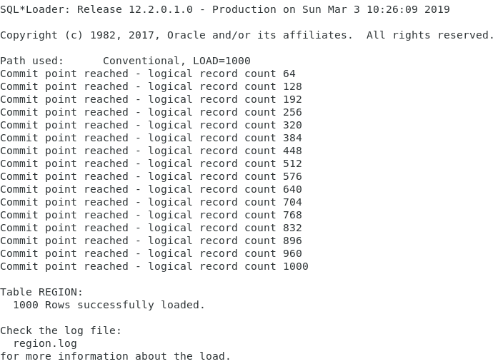

Stores.ctl

OPTIONS(LOAD=1000)

LOAD

INFILE 'DBST670_Store.csv'

REPLACE

INTO TABLE stores

FIELDS TERMINATED BY ","

(STOREID,REGIONID, STORENAME,ADDRESS, PHONENO, ZIPCODE)

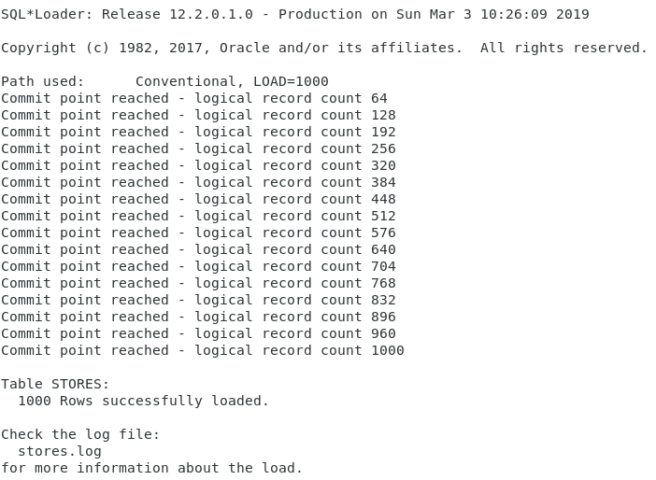

Zip.ctl

OPTIONS (SKIP=2, LOAD=50000)

LOAD DATA

INFILE hb_zip.dat

INTO TABLE zip

(

ZIPCODE POSITION(01:10) ,

CITY POSITION(11:25) ,

STATE POSITION(26:27)

)

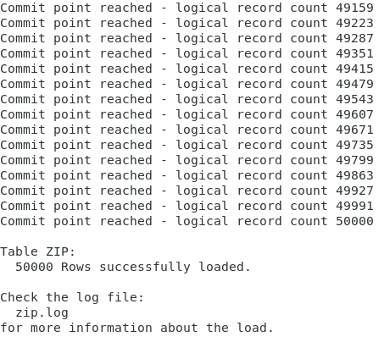

SQL> /*Fill gaps from Loader*/

SQL> /*Product table needs PRODCATID from Product_Cat table*/

SQL>

SQL> UPDATE product t1

2 SET

3 t1.prodcatid = (

4 SELECT prodcatid

5 FROM product_cat t2

6 WHERE t2.prodcatid = t1.productid

7 )

8 WHERE EXISTS (

9 SELECT NULL

10 FROM product_cat t2

11 WHERE t2.prodcatid = t1.productid

12 );

1,000 rows updated.

## **Query Tables**

SQL>

SQL> /*Verify Data is loaded */

SQL>

SQL> SELECT * FROM customer;

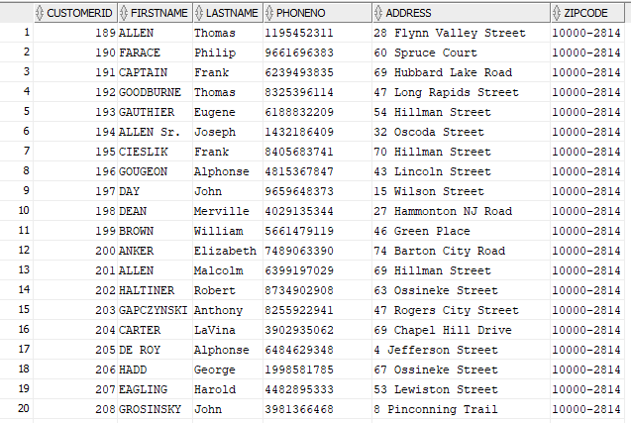

SQL>

SQL> SELECT * FROM employee;

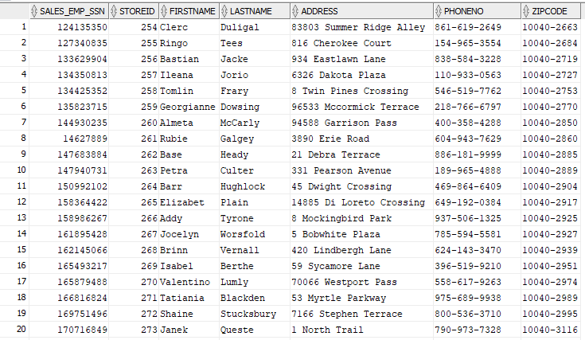

SQL>

SQL> SELECT * FROM order_item;

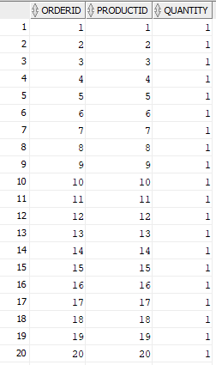

SQL>

SQL> SELECT * FROM orders;

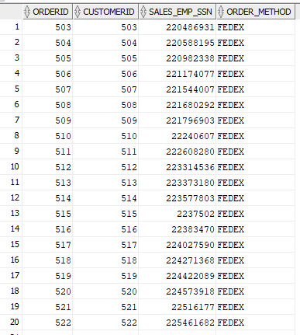

SQL>

SQL> SELECT * FROM payment;

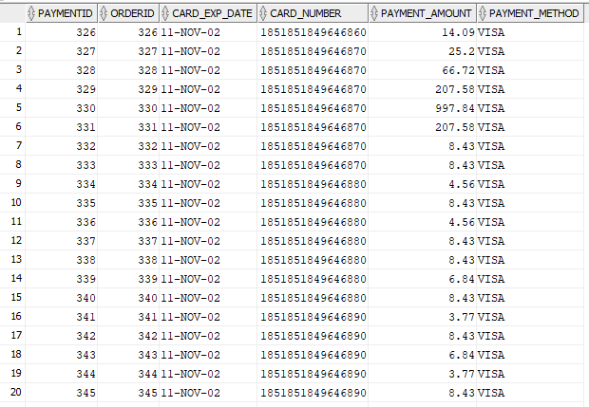

SQL>

SQL> SELECT * FROM product;

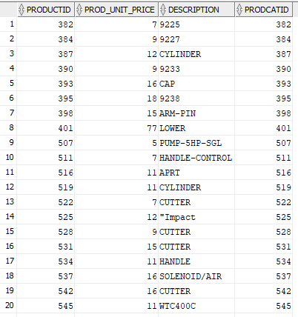

SQL>

SQL> SELECT * FROM product_cat;

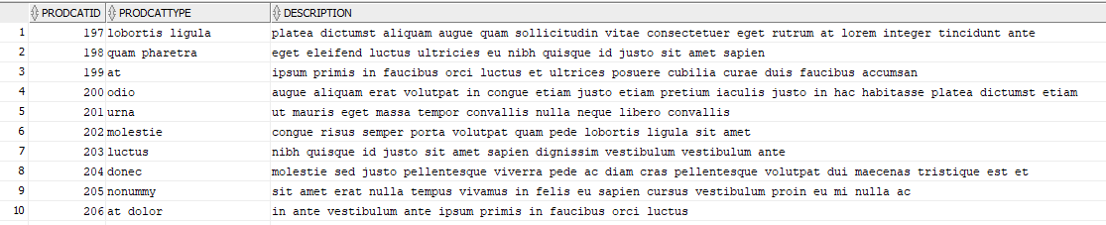

SQL>

SQL> SELECT * FROM region;

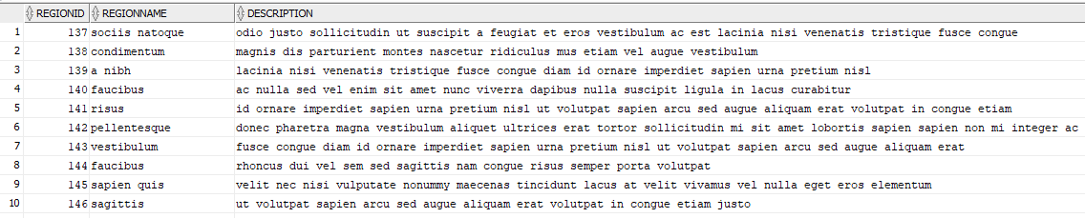

SQL>

SQL> SELECT * FROM stores;

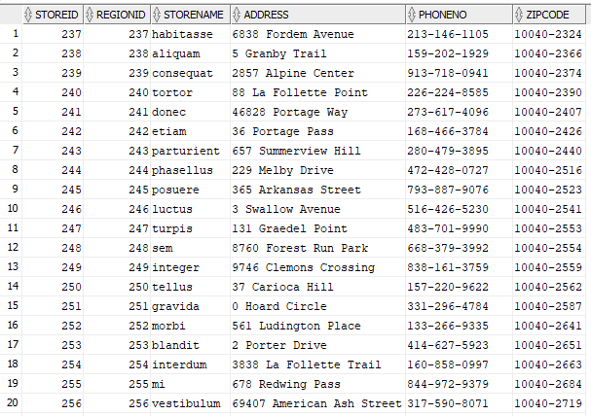

SQL>

SQL> SELECT * FROM zip;

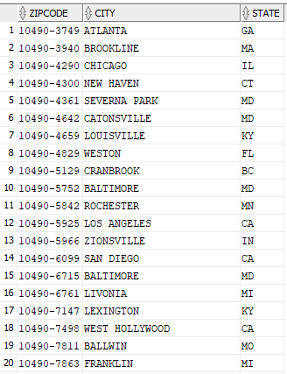

# **Analyze Tables**

SQL>

SQL> /*---------------------------------------------*/

SQL> /* ANALYZE TABLES */

SQL> /*---------------------------------------------*/

SQL>

SQL> /*Analyze with deprecated command*/

SQL>

SQL> ANALYZE TABLE customer COMPUTE STATISTICS;

Table CUSTOMER analyzed.

SQL> ANALYZE TABLE employee COMPUTE STATISTICS;

Table EMPLOYEE analyzed.

SQL> ANALYZE TABLE order_item COMPUTE STATISTICS;

Table ORDER_ITEM analyzed.

SQL> ANALYZE TABLE orders COMPUTE STATISTICS;

Table ORDERS analyzed.

SQL> ANALYZE TABLE payment COMPUTE STATISTICS;

Table PAYMENT analyzed.

SQL> ANALYZE TABLE product COMPUTE STATISTICS;

Table PRODUCT analyzed.

SQL> ANALYZE TABLE product_cat COMPUTE STATISTICS;

Table PRODUCT_CAT analyzed.

SQL> ANALYZE TABLE region COMPUTE STATISTICS;

Table REGION analyzed.

SQL> ANALYZE TABLE stores COMPUTE STATISTICS;

Table STORES analyzed.

SQL> ANALYZE TABLE zip COMPUTE STATISTICS;

Table ZIP analyzed.

SQL>

SQL> /*Check results*/

SQL>

SQL> SELECT num_rows, blocks, empty_blocks, avg_space, avg_row_len

2 FROM user_tables

3 WHERE table_name ='CUSTOMER'

4 OR table_name = 'EMPLOYEE'

5 OR table_name = 'ORDER_ITEM'

6 OR table_name = 'ORDERS'

7 OR table_name = 'PAYMENT'

8 OR table_name = 'PRODUCT'

9 OR table_name = 'PRODUCT_CAT'

10 OR table_name = 'REGION'

11 OR table_name = 'STORES'

12 OR table_name = 'ZIP';

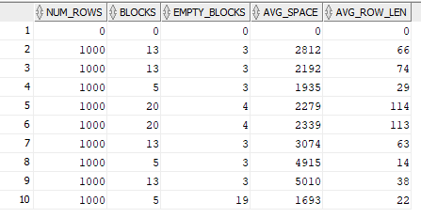

SQL>

SQL>

SQL> /*Remove gathered statistics*/

SQL>

SQL> ANALYZE TABLE customer DELETE STATISTICS;

Table CUSTOMER analyzed.

SQL> ANALYZE TABLE employee DELETE STATISTICS;

Table EMPLOYEE analyzed.

SQL> ANALYZE TABLE order_item DELETE STATISTICS;

Table ORDER_ITEM analyzed.

SQL> ANALYZE TABLE orders DELETE STATISTICS;

Table ORDERS analyzed.

SQL> ANALYZE TABLE payment DELETE STATISTICS;

Table PAYMENT analyzed.

SQL> ANALYZE TABLE product DELETE STATISTICS;

Table PRODUCT analyzed.

SQL> ANALYZE TABLE product_cat DELETE STATISTICS;

Table PRODUCT_CAT analyzed.

SQL> ANALYZE TABLE region DELETE STATISTICS;

Table REGION analyzed.

SQL> ANALYZE TABLE stores DELETE STATISTICS;

Table STORES analyzed.

SQL> ANALYZE TABLE zip DELETE STATISTICS;

Table ZIP analyzed.

SQL>

SQL> /*Run DBMS_STATS to get all stats*/

SQL>

SQL> EXEC DBMS_STATS.gather_schema_stats(ownname => 'DATADESIGNLEADUSER');

PL/SQL procedure successfully completed.

SQL>

SQL> /*Check results*/

SQL>

SQL> SELECT num_rows, blocks, empty_blocks, avg_space, avg_row_len

2 FROM user_tables

3 WHERE table_name ='CUSTOMER'

4 OR table_name = 'EMPLOYEE'

5 OR table_name = 'ORDER_ITEM'

6 OR table_name = 'ORDERS'

7 OR table_name = 'PAYMENT'

8 OR table_name = 'PRODUCT'

9 OR table_name = 'PRODUCT_CAT'

10 OR table_name = 'REGION'

11 OR table_name = 'STORES'

12 OR table_name = 'ZIP';

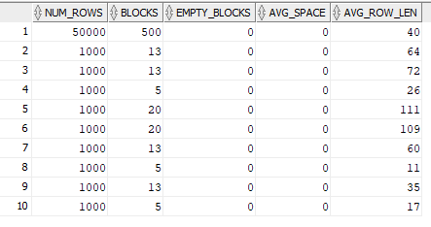

# **Check Object Status in Catalog**

SQL>

SQL> /*---------------------------------------------*/

SQL> /* CHECK CONTENT OF CATALOG */

SQL> /*---------------------------------------------*/

SQL>

SQL> /*Show valid status from all objects*/

SQL> SELECT

2 substr

3 (object_name,1,20),

4 object_type,status FROM

5 user_objects;

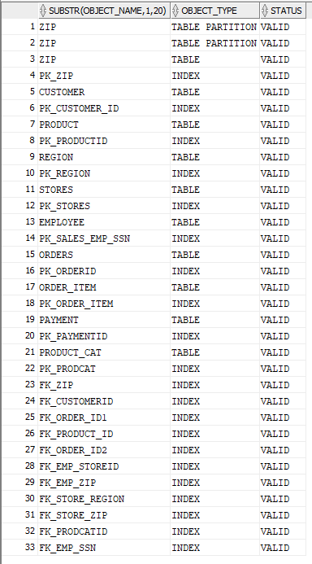

# **Query Row Numbers from Catalog**

SQL>

SQL> /*Query row numbers from catalog*/

SQL>

SQL> SELECT table_name,

2 num_rows,

3 owner

4 FROM all_tables

5 WHERE owner = 'DATADESIGNLEADUSER'

6 ORDER BY owner,

7 table_name;

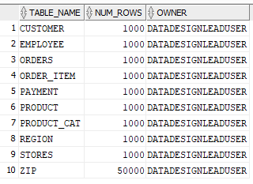

SQL>

SQL> COMMIT;

Commit complete.