Ship What You Can’t Ship

Design Specifications

User Stories/Scrum Methodology

Timeline of Project

Schema

Data Types

Additional Data

Pages: Intermediate Version

Site Map

Polina Clements

Design Specifications:

As a structured set of activities is required to develop software system design specifications is one of the most critical aspects of software development process. The overall structure of the system follows standard architecture design as main structural components of the system follow the stake holders’ requirements. System architecture was decided upon earlier development stage. Architecture was used as a focus of discussion with stakeholders and system analysis was conducted on 11/19/2020. Diagrams and charts were used to outline software design, user stories were implemented to ensure the completion of stakeholder requirements following the scrum methodology. Site map presented as a diagram to describe the web site flow and show the pages connection as diagrams. Architectural design decisions were made on the basis of stakeholder’s requirements. FedEx website was taken as a template to provide generic architecture for the system and the FedEx fundamental approach to the structure was reused. The system was assembled from existing configurable components. Overall, reuse approach was implemented to develop this particular software system. Schema done in MySQL presents and architectural view of the system. Site flow and pages presented in a site map.

User Stories/Scrum Methodology

Scrum methodology implies that there no specific format and formal documentation is omitted for the time completion of the project’s sake. However, the user stories help follow stake holders’ requirements and satisfying those requirements. As a structured set of activities is required to build a software defining the organization of the system according to stake holder requirements were implemented with user stories presented below in the form of the detailed scrum board. The scrum board captures roles which reflect responsibilities of people involved in the process, pre and post conditions that are true before and after a process activity had been enacted. The scrum board reflects incremental planning, so it is easier to change the process to reflect customer’s requirements. Specification, development, and validation are interleaved and presented in stake holder’s friendly board:

Timeline of Project

Stake holders and organizations require timely completion of the projects and it might be valuable for project managers for further training, planning, organizing sociotechnical systems and innovating. To ensure the accurate record readily presentable to stakeholders and the members of the organization the timeline of the project is included in this particular set of documentation. To make the analysis and the amount of documentation redone minimal stakeholder friendly timeline was implemented. Below in red you can see project’s milestones which is a significant, marked progress point that appears along a project timeline.

Schema

This is an intermediate schema that was done in MySQL mainly for the developer’s training purposes, however the main database that was used does not have any dependencies unlike MySQL. This schema is intermediate stage when created the main objective behind it was checking that it does what the customer wants and outlining the stakeholder’s requirements. Presented in the other parts of documents. Should be the schema is intermediate and done for training purposes, so the data types are different in actual code since it is done in Object Oriented database.

Data Types:

Data Types used in the schema to merge the Object-Oriented Data Base:

String for name

String for address

String for zip code

String for state

String for city

Error checks were implemented meaning more than one clerk cannot be assigned to one location which is one of the strategies to eliminate system faults and failures.

Data Types:

Attributes in finalized schema were used to create shipping are:

Tracking id Sender email receiver email courier company

Packages airport location receiver phone order id

Sender FirstName process safety receiver address total cost

Sender LastName receiver first name receiver city pay by

Sender Phone receiver last name receiver country

Additional Data

This additional data outlines some information about uploads to GitHub and collaborative coding environment that was used.

GitHub contributions intermediate data in stakeholder’s friendly manner:

Pages: Intermediate Version

Here are some intermediate and not finalized versions of login page, admin page and dashboard, respectively. These versions and development of pages are captured in the project timeline with milestones arrows.

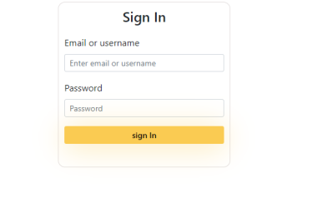

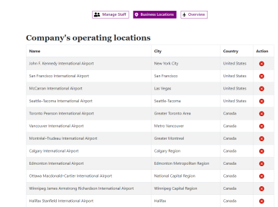

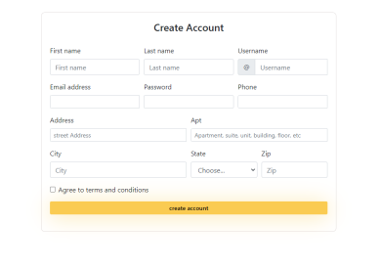

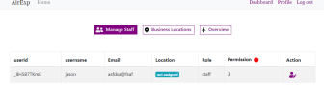

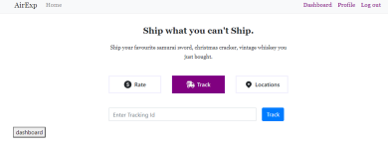

Site Map

This site map captures the most recent structure of the website which is stake holders friendly but not finalized yet. Some changes may apply. In this software system a person can log in as a user, administrator, or a clerk. Clerk enters user details and creates new shipping. The locations tab on the main page lets the user see locations available, track order history and available rates. Depending on if you logged in as a user or administrator you can create an account or profile in the case of this site map. Pressing track returns the order status. Administrator can create new locations, see existing locations, and manage staff. The administrator can assign a job to a clerk and no one clerk can be assigned to 2 locations. The website has a user-friendly architecture and follows standard business application reused model. Mongo DB used to connect databases, React and Bootstrap are used for front end development and their respective libraries. Developers testing was conducted to ensure the minimal probability of faults in the system.