Brandon Valley

# Amazon Database

My final project will emulate the behavior of Amazon’s online shop database. This database emulator will have the ability to add and delete users with differing levels of permissions. Depending on their permissions, these users will be able to interact with the database in various ways. The system will be robust, preventing illegal operations and will use verbose error reporting to keep the user informed.

## User Permission Types

This emulator will have 4 levels of permissions:

* Admin – The site administrator, only one admin will exist and it will be the only user that exists at the beginning of the simulation
* Seller – Can list multiple items for sale
* Buyer – Can purchase items
* Logged Out – Meant to represent a state where no user is logged in. Login is the only command that can be executed from this state.

The relationship between the permission type and which commands can be executed is defined in the table below:

|  |  |  |  |  |  |  |  |
| --- | --- | --- | --- | --- | --- | --- | --- |
| User type | Login | Log out | Add user | Delete user | Add Item | Delete item | Buy item |
| Admin |  | X | X | X |  |  |  |
| Seller |  | X |  |  | X | X |  |
| Buyer |  | X |  |  |  |  | X |
| Logged Out | X |  |  |  |  |  |  |

The user will start in the “Logged out” state. Since the admin will be the only user that exists at the beginning of the simulation, the admin account will need to be logged into, in order to create users of different permission types.

## Commands

Commands will only be allowed while in the “Command?” state. In this state, the user will be prompted to enter a command. Upon receiving user input, the system will check to confirm that the user has entered a valid command. If the entered command is invalid (perhaps a misspelling in their input), the user will be told so, and will need to enter a valid command to continue. If the command is valid, the permissions are checked. If the user has insufficient permissions to execute the command, they will be told so and will need to enter a different command. If the command is valid and the user has sufficient permissions, the command is executed. A description of all available commands is listed below, as well as a diagram detailing the overall system.

### Login

The only command available to the “Logged Out” permission type. Upon being prompted by the system, the user will need to enter an existing username, then its corresponding password. After login is complete, the user will be free to execute more commands.

### Log Out

This command is necessary to log out of one user account, in order to log into another user account.

### Add User

After the admin executes this command, if the maximum number of users has not been reached, upon being prompted by the system, the admin will need to enter a non-taken username, password, and valid permission type to create a new user. The only valid permission types will be “Seller” and “Buyer”, there will only ever be one admin.

### Delete User

After executing this command, and being prompted by the system, the admin will need to enter the username of an existing user, other than admin. The admin cannot delete itself. After deleting a user, if the maximum number of users had been reached, a new user can now be added. If the deleted user was a seller, all of that seller’s items will be deleted, meaning these items cannot be bought. This also frees up space to add more items.

### Add Item

After a seller executes this command, as long as the maximum number of items has not been reached, after being prompted by the system, the seller will need to enter a non-taken item name and the item’s stock.

### Delete Item

After being prompted by the system, a seller will need to enter the name of an existing item that they created. Even with seller permissions, one seller cannot delete another seller’s items.

### Buy Item

After being prompted by the system, a buyer must enter the name of an existing item from any seller that has a stock of at least one. After any buyer buys an item, its stock decrease by 1.

## Project Diagram

I know you said to just do a sketch, but mine got big enough that it was just easier to lay it out in Visio. A copy of this diagram in pdf form should have been included in the email that contained this document. Magnified images are included below.

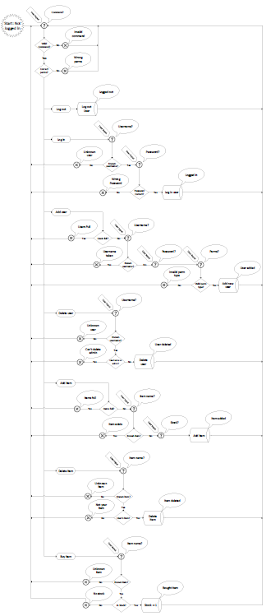

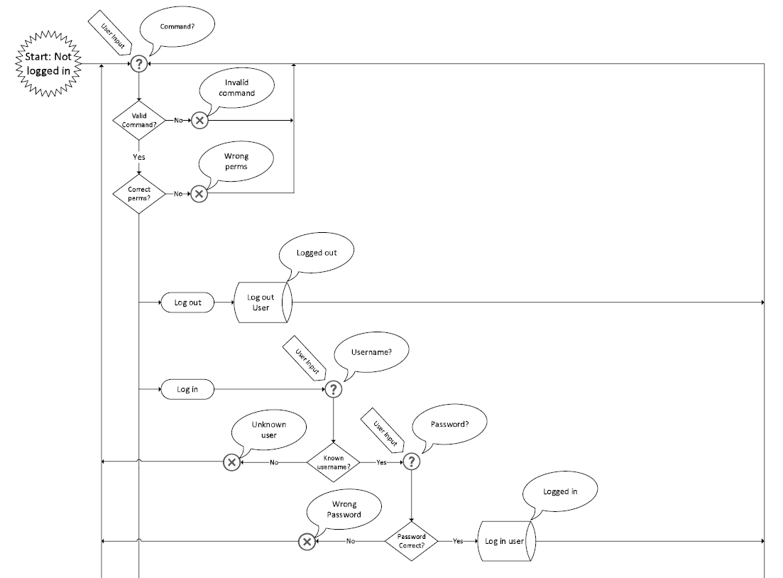

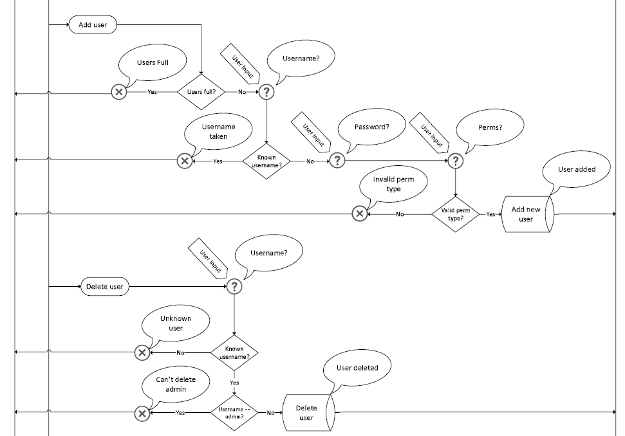

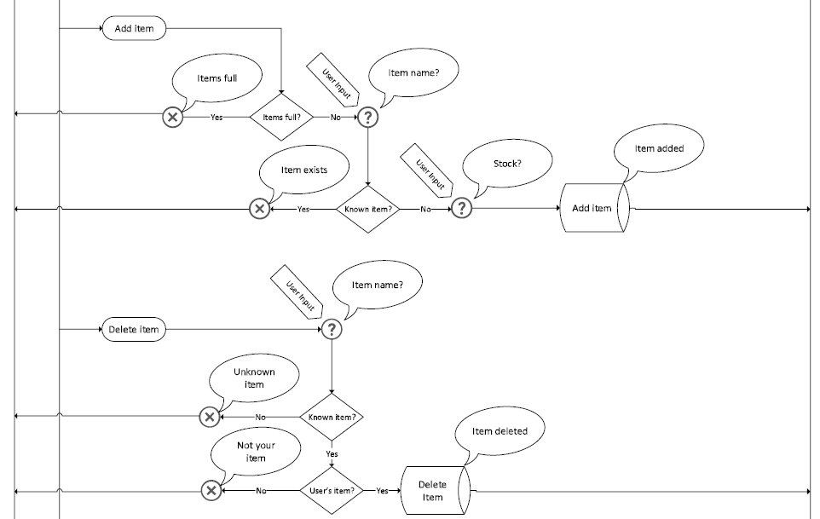 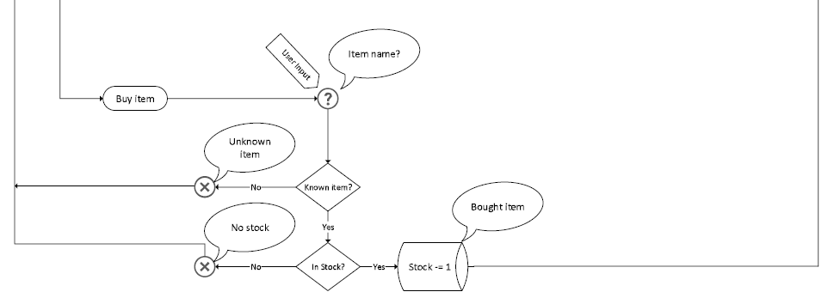

## Specifications

ASCII text for the inputs and outputs of the system will need to be displayed in Modalism’s wave viewer, so many of these specifications are for the purposes of improving readability.

* The system will have at least 2 inputs, one for ASCII text, one for unsigned numbers
* The system will have at least 1 output, for prompts and error messages
* No username will be longer than 3 ASCII chars – 24 bits
* No password will be longer than 3 ASCII chars – 24 bits
* No item name will be longer than 4 ASCII chars – 32 bits
* No item will have a stock greater than 15 – 4 bit unsigned