Complex Power

Objective:

The objective of this experiment is to understand complex power analysis and maximum power transfer theorem for a simple AC circuit.

Equipment:

1. NI ELVIS III
2. Digital Multimeter (DMM)

Components:

* 2x 1kΩ Resistor
* 150mH Inductor
* 470nF Capacitor
* 28AWG Hookup Wire
* Potentiometer (attached to ELVIS prototyping board)

# Background:

Just like the values of voltage, current, and impedance, power can be represented as a complex or

phasor quantity. The units for complex power, usually referred to as ‘S’, are Volt-Amps.

Complex power in rectangular form can be represented by the following:

$$S=P+jQ =V⋅I^{*}$$

Where:

P = real power, or Watts (W), the power from resistive elements

Q = reactive power, or Volt-Amps-Reactive (VAR), the power from reactive elements

S = complex power, Volt-Amps (VA)

V = Voltage in complex form (V)

I* = Complex conjugate of the Current (A)

## Power Factor:

When referring to complex power, loads and sources are usually labeled with the magnitude of their complex power and their power factor, or pF. Power factor represents the ratio of real to reactive power, with 1 being a load that draws only real power, and 0 being a load that draws only reactive power. The power factor is also labeled as leading or lagging. This refers to the lead or lag of voltage to current and can tell you if the load is capacitive or inductive. We will stick with your textbook and say leading indicates a capacitive load and lagging indicates an inductive load. This relationship comes from the power triangle. The power triangle can be drawn as below:





$$pf=\frac{Real Power\left(W\right)}{Complex Power\left(VA\right)}$$

## Maximum Power Transfer:

Just as the Thevenin Equivalent circuit was used to determine the ideal load for maximum power transfer in DC circuits, it is also used to determine the load for maximum power transfer in AC circuits. However, as there is an impedance, the equations change and there become two main cases. The ideal case is when the load can be made any impedance needed. In this case, the resistance of the load should match the Thevenin resistance, however the reactance of the load should cancel the Thevenin reactance (Capacitors and inductors can cancel each other out). The second case applies if only a resistive load with a fixed or 0 reactance can be used.

The ideal case where the load is the conjugate of the Thevenin impedance:

$$Z_{L}=Z_{Th}^{*}$$

The load resistance value for maximum power transfer:



Procedure:

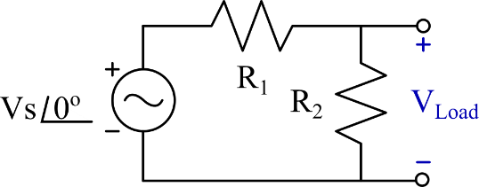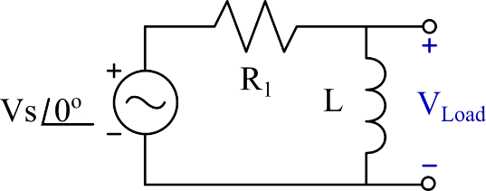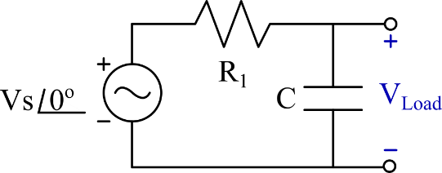

Circuit 1

Circuit

Circuit 3

R1 = 1KΩ R2 = 1KΩ C = 470nF L=150mH

1. Measure your components, record the values in table 1.
2. Determine the Thevenin equivalent impedance for each circuit at the nodes labeled +/- VLoad.
3. Draw the Thevenin equivalent of the given circuit.
4. Using the Thevenin equivalent circuit values, calculate the value of the load resistor for maximum power transfer: RPmax. Log the value in table 2**.**
5. Solve for the load voltage when RPmax is inserted.
6. Construct *Circuit 1*
7. Energize the circuit at 3VRMS at 2kHz.
8. Using the Oscilloscope, measure the source voltage and the load voltage. Check that the phase of VLoad matched your calculated value for the Norton equivalent source. Record your measured values in the corresponding “Unloaded” row of Table 3.
9. Using the potentiometers on the front edge of the ELVIS-III Prototyping Board, and the DMM Leads, adjust the potentiometer so that the ‘A’ and ‘W’ terminals measure to approximately the calculated load resistance RPmax, Record the value in Table 2.
10. Connect the load resistor to the load nodes, measure the load voltage and phase delay. Record the value in the corresponding “Loaded” row of Table 3.
11. Using $P={|V|}^{2}/Z$, Calculate the power in the components connected to the load node. Record the values in Table 4.
12. Using the voltage across R1, Calculate the current and power consumed by the parallel elements using $S=V⋅I^{*}$, and compare to the previously recorded in table 4. Record the values in Table 5.
13. Construct *Circuit 2*, and repeat steps 7 through 12.
14. Construct *Circuit 3*, and repeat steps 7 through 12.
15. Draw Phasor and diagrams for each circuit in the unloaded and loaded configurations.
16. Draw a power triangle for each circuit in the loaded configuration. Discuss the similarities and differences in your report.

Questions:

1. Determine the power factor for each Thevenin circuit, was the pf leading or lagging?
2. For circuits 2 and 3, what would the value of the resistor / capacitor be to completely cancel out the reactive element?
3. How could you adjust the frequency of each circuit into thinking the load was shorted? Is it possible?

Conclusions:

Write a paragraph on your findings in the lab. It should include information about your results and if they are what was expected. Include calculated and measured values, and include your hand/python calculations as is. This should be a qualitative analysis of the lab and a quantitative analysis of the results. Be sure to include any changes you think would be appropriate to the lab.

Data Tables:

|  |  |  |  |  |
| --- | --- | --- | --- | --- |
| Table 1: Measured Component Values | | | | |
| Component: | R1 | R2 | C | L |
| Nominal Value: | 1kΩ | 1kΩ | 470nF | 150mH |
| Measured Value: |  |  |  |  |

|  |  |  |  |
| --- | --- | --- | --- |
| Table 2: RPmax  Values | | | |
| Circuit | Calculated | Measured | Error (%) |
| 1 |  |  |  |
| 2 |  |  |  |
| 3 |  |  |  |

|  |  |  |  |  |  |  |
| --- | --- | --- | --- | --- | --- | --- |
| Table 3: Measured Load Terminal Voltage | | | | | | |
|  | Calculated | | Measured | | Error | |
|  | Magnitude | Phase | Magnitude | Phase | Magnitude | Phase |
| Source Voltage |  |  |  |  |  |  |
| Circuit 1 (Unloaded) |  |  |  |  |  |  |
| Circuit 1 (Loaded) |  |  |  |  |  |  |
| Circuit 2 (Unloaded) |  |  |  |  |  |  |
| Circuit 2 (Loaded) |  |  |  |  |  |  |
| Circuit 3 (Unloaded) |  |  |  |  |  |  |
| Circuit 3 (Loaded) |  |  |  |  |  |  |

|  |  |  |  |  |
| --- | --- | --- | --- | --- |
| Table 4 : Power Calculations | | | | |
| Circuit | Load Voltage  (Rectangular) | R2, C, L Power | Load Power | Complex Power  (Rectangular) |
| 1 |  |  |  |  |
| 2 |  |  |  |  |
| 3 |  |  |  |  |

|  |  |  |  |  |
| --- | --- | --- | --- | --- |
| Table 5: Alternative Power Calculation | | | | |
| Circuit | Measured Voltage Across R1 | Calculated Current | Complex Power | Percent Error between Prev. Calc. |
| 1 |  |  |  |  |
| 2 |  |  |  |  |
| 3 |  |  |  |  |