**Brandon White**

**MAE 5010 – Autopilot Design and Test**

**Homework #1 (Due 08/29/2019)**

**==========================================================================**

**2.** Write a function that converts between quaternions and 3-2-1 Euler angles and one that converts back. These should look like EP = Euler3212EP([heading,pitch,roll]) EA = EP2Euler321([q0,q1,q2,q3]) Include an example of running your code to convert [ψ, θ, φ] = [150◦ , 15◦ , −30◦ ] to quaternions and ~q = [0.82205,0.26538,0.05601,0.50066] to Euler angles.

See Appendix for angle conversion code.

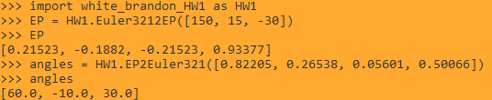

*Figure 1. Command Line I/O for Problem 2*

**3.** Implement the kinematics and dynamics equations (using the quaternion formulation) in an integrator that takes in forces and moments. You should have a function that takes in state and returns xdot = derivatives(self, state, FM, MAV) where state = [pn,pe,pd, u,v,w, e0,e1,e2,e3, p,q,r] FM = [Fx,Fy,Fz, Ell,M,N] The function will contain computations of each state derivative, e.g.,

% position kinematics

pn_dot = pe_dot = pd_dot =

% position dynamics

u_dot = v_dot = w_dot =

% rotational kinematics

e0_dot = e1_dot = 1 e2_dot = e3_dot =

% rotational dynamics

p_dot = q_dot = r_dot =

% collect all the derivaties of the states

xdot = [pn_dot; pe_dot; pd_dot; u_dot; v_dot; w_dot;... e0_dot; e1_dot; e2_dot; e3_dot; p_dot; q_dot; r_dot];

Include a gravitational force vector mg ˆfz. To make this into a simulation, you need to add initial conditions, vehicle parameters, forces and moments, and then integrate it. You’ll add the first two in the step below.

See Appendix for derivative scripts.

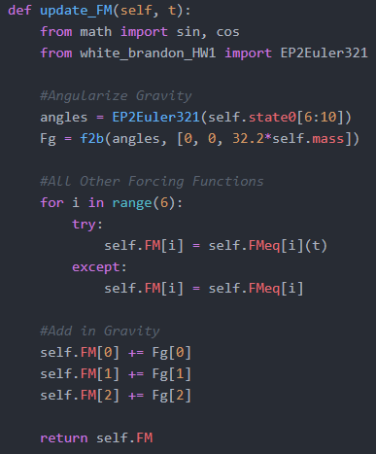

*Figure 2. Gravity Force Code*

**4.** Select a candidate air vehicle you may use in your research, and approximate the mass and inertia of this vehicle. Define these in a separate file as terms like MAV.mass, MAV.Ix, MAV.Iy, MAV.Iz MAV.Ixz, and also define initial conditions for position, orientation, and rates. Move your definition of gravitational constant g here. Use consistent units.

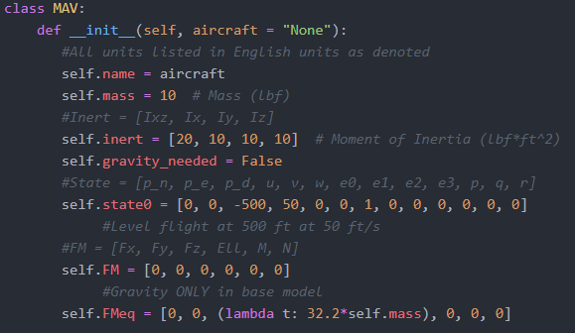

*Figure 3. MAV Class Object Code*

*The rate of descent was verified for the gravity only case through solving the ODE via WolframAlpha.com.*

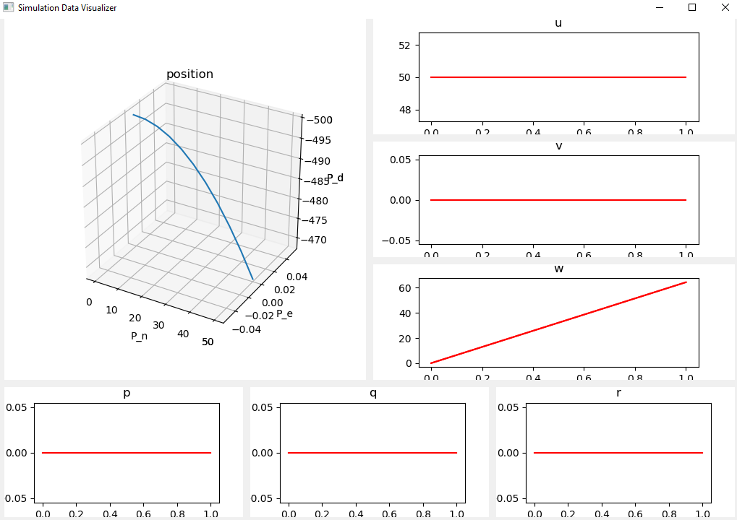

*Figure 4. Gravity Only Simulation Results*

**5.** Choose an integrator (you could try a Runge-Kutta integrator, or ode23 ), and connect it to the above dynamics function, having it read in the parameters to form a simple dynamics simulator. Simulate this vehicle from an initial condition of x, y, z = [100, 200, −500], ψ, θ, φ = [90, 15, 20]◦ (1) with F and M set to zero. Plot the positions, Euler angles, and rates. Does this make sense? Do you need to choose a different integrator? Simulate the system from the same initial conditions but use F = [sin(t),0,0] and M = [0,1e-4,0] Include plots of the output from these two cases and label your axes.

Selected integrator: scipy.integation.odeint()

The overall flight patterns make sense. As M is made non-zero, we see a resultant change in angular speed and quaternions not present in the purely translational motion of the first test. All axis are in terms of ft/s or rad/s as applicable.

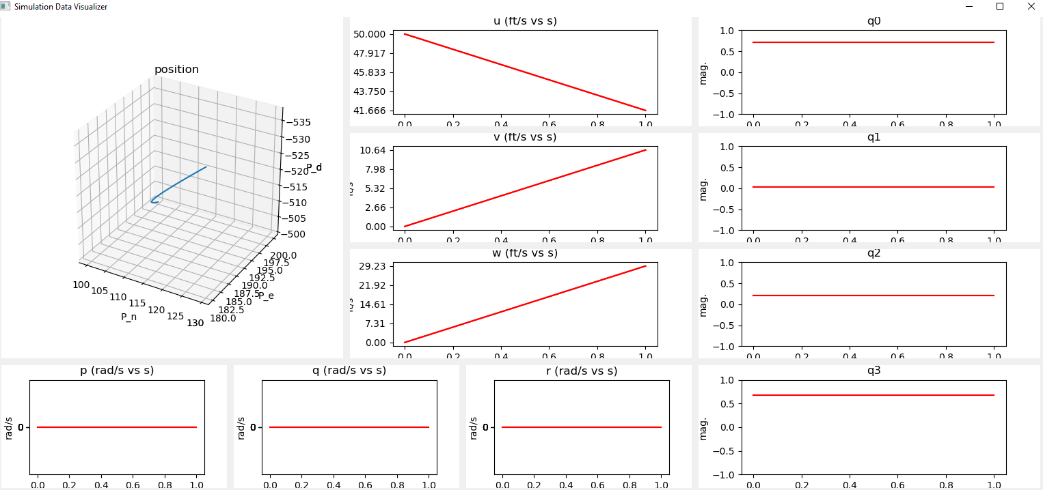

Figure 5. Outputs for Initial Condition with M = <0, 0, 0>

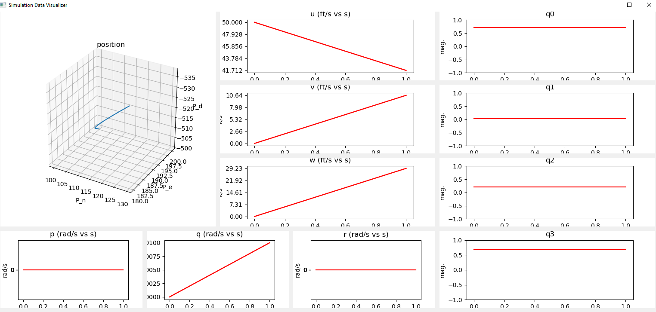

Figure 6. Outputs for Initial Condition with M = <0, 1e-4, 0>

**6.** Create a visualization scheme that shows the simulator states and rates, including a 3D visulation. You may use any interface or method you are happy with (displaying Euler angles is usually more intuitive that other parameterizations). Include a screen capture of its interface.



Figure 7. 3D and Parameter Visualization

**Appendix A**

**Contents**

**Main Simulator Code ………………………………………………………………………………… 7**

**MAV Class Code ………………………………………………………………………………… 11**

**Rotation Module Code ………………………………………………………………………………… 13**

**State Variable Visualizer Code …..…………………………………………………………………… 15**