GHG Inventory Report

Enter Company Name Here

December 05, 2022

#### Purpose of this Document

We recognize that tracking, measuring, and reporting Greenhouse Gas (GHG) emissions is essential to understand risks and explore opportunities related to climate change and the transition towards a renewable energy economy. This document is an annual inventory of all relevant emissions from our operations, pursuant to the standards set by WRI’s GHG Protocol Corporate Standard.

#### Reporting Boundary

The following GHG Inventory accounts for all relevant energy-related emissions as a result of business operations. Direct emissions from the combustion of fossil fuels, i.e. natural gas, are accounted for as *Scope 1* emissions. Indirect emissions from the consumption of electricity, steam, or other district heat/cooling are accounted for as *Scope 2* emissions. Other Indirect emissions from upstream and downstream value chain activities, accounted for as *Scope 3* emissions, are excluded from this report.

All emissions are reported for the calendar year of 2019

All emissions are calculated using AR5 global warming potentials

#### About *Enter Company Name Here*

This is a description of our company and how much we care about the environment.

# Overview of 2019 GHG emissions

GHG Emissions by Service Type

| Scope | ServiceType | MTCO2e |
| --- | --- | --- |
| Scope 1 | Gasoline | 15,480 |
| Scope 1 | Natural Gas | 145,018 |
| Scope 1 | Propane | 2,259 |
| Scope 2 | Electric | 144,193 |

GHG Emissions by Region

| Region | MTCO2e |
| --- | --- |
| Midwest | 44,187 |
| Northeast | 5,882 |
| Pacific | 82,335 |
| South | 104,728 |
| US Territories | 1,197 |
| West | 49,207 |
| West North Central | 19,414 |

# Charts of 2019 GHG emissions

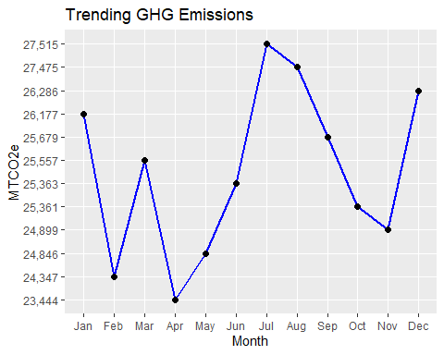

## More to come! The GHG Inventory report is still in development

*Generated by* [ghgtools.io](https://www.ghgtools.io/)