**Group member:**   
**Deng BaiDa 邓柏达，240144665**

**Yang Yongxin 杨永欣，240244326**

**Tan XiuHao 谭修灏，240253372**

**Lin Yueying 林悦莹，240444846**

**Project Topic:**

**Chinese Book Recommendation**

Table of Content

Introduction 3

Structure 4

Page Features 5

# Introduction

The **Chinese Book Recommendation** project is a web-based system designed to analyze and recommend Chinese books to users. It includes user authentication (login/registration), interactive dashboards, and data visualizations such as word clouds for book titles and summaries. The system provides personalized book recommendations and displays key metrics like the highest-rated and most expensive books. Built with a responsive design, it offers an intuitive interface for navigation for different analytical views.

Key functionalities include:

* Personalized book recommendations
* Display of key metrics (highest-rated books, most expensive titles)
* Word cloud visualizations (for both book titles and summaries)
* Statistical analysis of book ratings and prices
* User registration trend tracking for admin insights

Built with responsive design, the system offers an intuitive interface supporting multi-dimensional data analysis. By incorporating Chinese text processing technology, it generates valuable reading insights to help book enthusiasts discover titles of interest.

# Page Features

Login and Register Page

The login and register pages form a cohesive authentication system for the Douban Book Data Analysis platform. The login page serves as the primary entry point for existing users, featuring email/password authentication and a prominent link to the registration page for new users. This creates a clear user journey where unregistered visitors can seamlessly transition to account creation. The registration page includes a return login option, establishing a bidirectional relationship between these authentication components.

(登录和注册页面构成了豆瓣图书数据分析平台的统一身份验证系统。登录页面是现有用户的主要入口，提供邮箱/密码身份验证，并为新用户提供醒目的注册页面链接。这创造了清晰的用户旅程，让未注册的访客可以无缝过渡到账户创建页面。注册页面则包含一个返回登录的选项，从而在这些身份验证组件之间建立了双向关系)

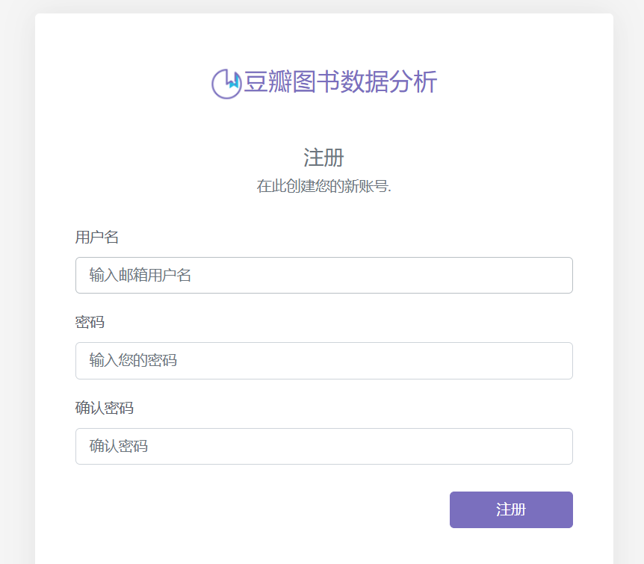

Home Page

The homepage is the core analysis center of Douban's book data analysis platform. Users can view data on the most expensive books, analyze rating trends through dynamic visualization charts, and view detailed user registration patterns. The interactive interface displays key performance indicators, including popular books ranked by user ratings, book scoring analysis, and user registration timeline tracking. Complex data sets are presented through intuitive bar charts, pie charts, and trend lines, allowing users to quickly interpret platform activities.

(首页是豆瓣图书数据分析平台的核心分析中心。用户可以查看最贵图书的数据，通过动态可视化图表分析评分趋势，并查看详细的用户注册模式。交互式界面展示了关键绩效指标，包括用户评分热门图书排名、图书评分分析以及用户注册时间线追踪。 复杂的数据集通过直观的条形图、饼图和趋势线呈现，方便用户快速解读平台活动)

, 图片

|  |  |
| --- | --- |
| 图表, 条形图  描述已自动生成, 图片 | 图片 1, 图片 |

User information

The UserInformation page designed for users to manage their personal information. Users can view their username and update their password through a form that requires the old password, a new password, and confirmation. Overall, the page provides a user-friendly interface for account management, ensuring a seamless experience for users.(UserInformation 页面，旨在让用户管理自己的个人信息。用户可以通过需要旧密码、新密码和确认的表单查看其用户名并更新其密码。总体而言，该页面为帐户管理提供了一个用户友好的界面，确保为用户提供无缝体验。)

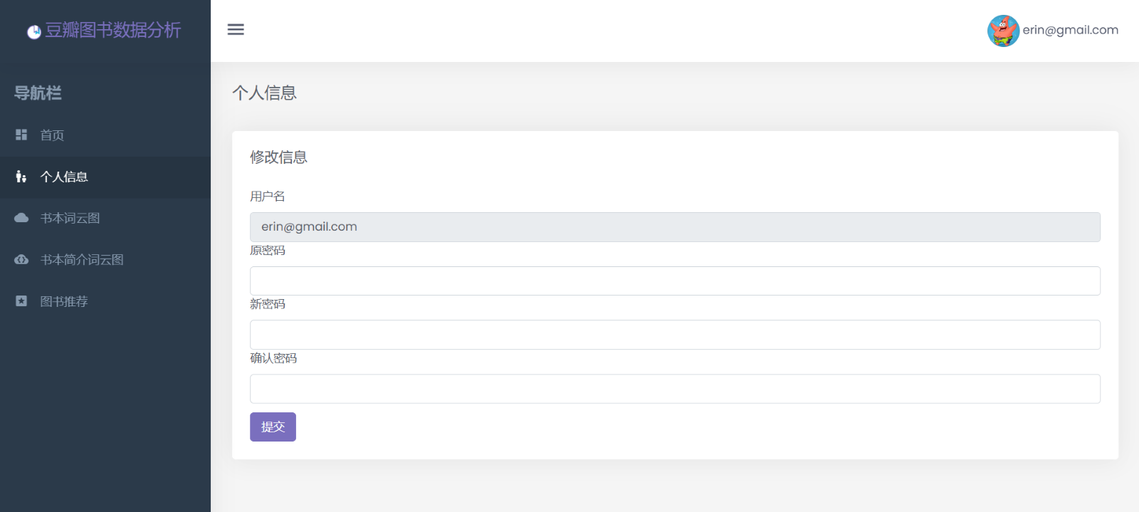

Title WordCloud Page

The TitleWordCloud Page is part of a Douban book data analysis application. It displays a word cloud generated from book titles, allowing users to visualize the most frequently used words in titles.(TitleWordCloud 页面是 Douban 图书数据分析应用程序的一部分。它显示从书名生成的词云，允许用户可视化书名中最常用的单词)

, 图片

Summary WordCloud Page

The Summary WordCloud Page serves a similar function within the Douban book data analysis application. It showcases a word cloud derived from book summaries, helping users visualize key themes and frequently used words.(SummaryWordCloud 页面在豆瓣图书数据分析应用中也有类似的功能。它展示了从书籍摘要派生的词云，帮助用户可视化关键主题和常用词。)

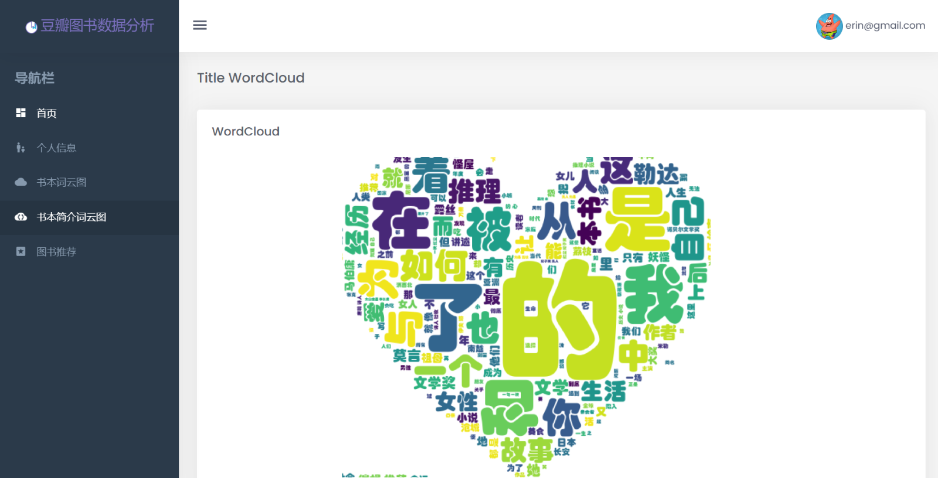

Book Recommendation

The Book Recommendation page showcases recommended books based on the most discussed phrases in Douban comments .The page displays book cards and will be change every time when the user refreshed, each book cards featuring an book cover, title, author, publisher, rating, and price. Users can browse through the recommendations visually and get essential details at a glance. The page aims to enhance user experience by making book recommendations easily accessible and visually appealing. ( 书籍推荐页面根据豆瓣评论中讨论最多的短语展示推荐的书籍。该页面显示书籍卡片，每次用户刷新时都会更改，每个书籍卡片都包含书籍封面、书名、作者、出版商、评级和价格。用户可以直观地浏览推荐，并一目了然地获得基本详细信息。该页面旨在通过使书籍推荐易于访问且具有视觉吸引力来增强用户体验 )

