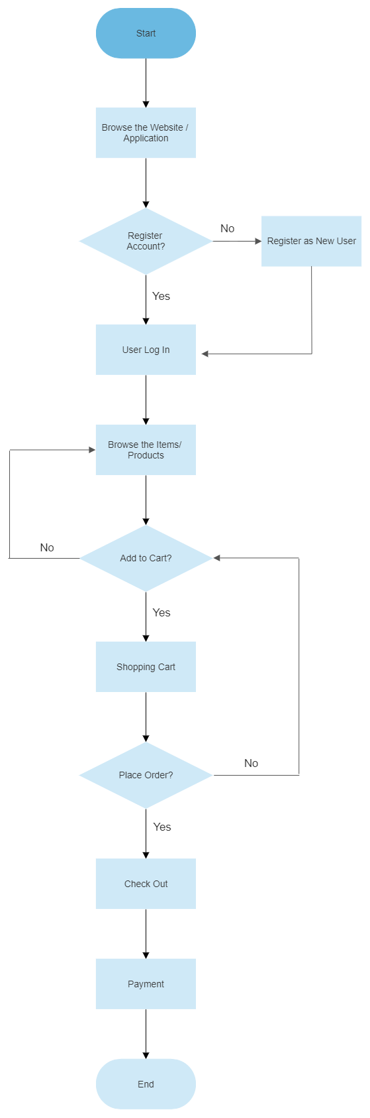**E-BUYan: WEB-BASED E-COMMERCE OF TUY PUBLIC MARKET AMIDST COVID-19**

**ALGORITHM AND DATA ANALYSIS**

This is the 30% range flowchart of the system application which is the customer module which includes account registration, user log in, adding or deleting of orders customer’s managing orders and mode of payment.