Software Requirements Specification

for

E-BUYan: Web Based E-Commerce of Tuy Public Market Amidst COVID-19

**Version 1.0 approved**

**Prepared by Brandon Cabatian**

**Alexandra Gheil Emaas**

**Rizzalyn Ramirez**

**Team B.A.R.**

**07/08/2021**

**Table of Contents**

**Table of Contents ii**

**Revision History ii**

**1. Introduction 1**

1.1 Purpose 1

1.2 Document Conventions 1

1.3 Intended Audience and Reading Suggestions 1

1.4 Project Scope 1

1.5 References 1

**2. Overall Description 2**

2.1 Product Perspective 2

2.2 Product Features 2

2.3 User Classes and Characteristics 2

2.4 Operating Environment 2

2.5 Design and Implementation Constraints 2

2.6 User Documentation 2

2.7 Assumptions and Dependencies 3

**3. System Features 3**

3.1 System Feature 1 3

3.2 System Feature 2 (and so on) 4

**4. External Interface Requirements 4**

4.1 User Interfaces 4

4.2 Hardware Interfaces 4

4.3 Software Interfaces 4

4.4 Communications Interfaces 4

**5. Other Nonfunctional Requirements 5**

5.1 Performance Requirements 5

5.2 Safety Requirements 5

5.3 Security Requirements 5

5.4 Software Quality Attributes 5

**6. Other Requirements 5**

**Appendix A: Glossary 5**

**Appendix B: Analysis Models 6**

**Appendix C: Issues List 6**

**Revision History**

|  |  |  |  |
| --- | --- | --- | --- |
| **Name** | **Date** | **Reason For Changes** | **Version** |
|  |  |  |  |
|  |  |  |  |

# Introduction

## Purpose

The Software Requirement Specification (SRS) is intended to analyze and understand some features and system interfaces of the system application and how it works. The project is E-BUYan Web Application E-Commerce of Tuy Public Market. The purpose of this project is to let the residents of the Municipality of Tuy avoid physical contact with other people, while they want to buy their needs and wants.

**1.2 Document Convention**

To make the entire document to be understandable and readable we use the font theme Arial for the main headings and subheadings and for the body or rest of the document. As for the font size we use size 18 for main headings, size 14for the sub headings and size 13 for the body. We use Bold Text to emphasize the important details, Main heading and subheadings. The entire document paragraph indention was justified.

**1.3 Intended Audience and Reading Suggestions**

The project is the prototype of E-BUYan Web Application E-Commerce of Tuy Public Market. We have a collaboration with the tricycle and public drivers that enable the residents of Municipality of Tuy (consumers) to buy their needs from the comfort of their homes and let the drivers pay and deliver it in front of their house.

**1.4 Project Scope**

This project has four (4) modules such as admin, vendor, customer and delivery driver. The scope of this project is Customer Module which includes login, register, make orders, management orders and the payment. And also the entire system interfaces of the system application. The purpose of this project is to lessen the problems of the customer when it comes to buying their needs and wants.

## 1.5 References

# Overall Description

## Product Perspective

The E-BUYan app is a development of the stores in the Tuy Public Market in a form of E-Commerce or online shop implementation. With this, the restrictions from the traditional operation in the market will be less. The E-BUYan app offers additional revenue to the vendors as well as the delivery driver and comfort to the customers or consumers.

## Product Features

The following are the features of the system:

* Account Registration
* Add/Modify order
* Manage order

## User Classes and Characteristics

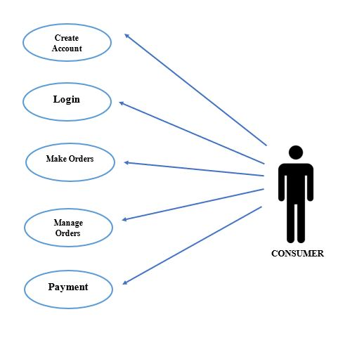

## Operating Environment

The E-BUYan will be deployed on both web and mobile platforms whereas in the web platform, the minimum required specification for computer operating system is Windows 7, 2GB to 4GB of ram and must have an installed web browser. On the mobile platform, it must have an operating system of at-least Android 7 Nougat and for Apple users, iOS 13 and must have at-least 2GB to 4GB of ram. To handle the data, MYSQL relational database will be used. This app will be for community utilization.

## Design and Implementation Constraints

The following are the constraints in the development of the E-BUYan. Further constraints will be added accordingly as the development continues:

* Hardware specifications of the device in which the system will be developed is on minimum requirements and have other issues
* Time will be an issue as tools such as framework that will be used must be learned first
* Actual UI design that must be user friendly especially on the aged user

## User Documentation

The following are the documents that will come with in the deployment of the E-BUYan App:

* How-To Guide
* Terms and Condition
* FAQs
* User Assistance

## Assumptions and Dependencies

On the 30% covered on the project only the UI will be developed and there will be no dependencies since it covers only a part of the actual system

# System Features

As only the UI is covered on the 30% of the system, the features are limited to the consumer modules.

## Account Registration

3.1.1 Description and Priority

In order to access the system account must be registered first. There are four main account types in the system but this only covers the consumer account type. This feature is a medium priority.

3.1.2 Stimulus/Response Sequences

If the user will register an account, the user will input the required information. If invalid information the system will prompt the user to input correct information. After succeeding to create the account the user will be then redirected to login.

3.1.3 Functional Requirements

REQ-1: Information inputted on the account registration is saved to the database

REQ-2: Successfully created accounts is saved to the database as well as the other credentials

## Add/Modify Order

3.2.1 Description and Priority

Selection of items that the user intends to purchase are added to the cart. The total amount payable will be then shown. Modification of the order allows addition and deduction of item quantity. This feature is a high priority.

3.2.2 Stimulus/Response Sequences

If the user intends to add an item, a modal will prompt the user to ask for the quantity of the item and notification that the item is added to the cart. The user can now view the cart to verify the order.

3.2.3 Functional Requirements

REQ-1: The items added on the cart can be deleted and updated.

REQ-2: Successfully made orders are saved to the database.

## Manage Order

3.3.1 Description and Priority

If the user has made an order the user can either proceed to the transaction or cancel the transaction. This feature is a high priority.

3.3.2 Stimulus/Response Sequences

If the user proceeds to the transaction, the user will now view the details of the ongoing transaction, status of delivery and amount payable.

3.3.3 Functional Requirements

REQ-1: Orders can be canceled if the order is still not in the process of shipment.

# External Interface Requirements

## User Interfaces



This serves as the opening of the application, in order to access the application, the user must click the logo to go to the next form.

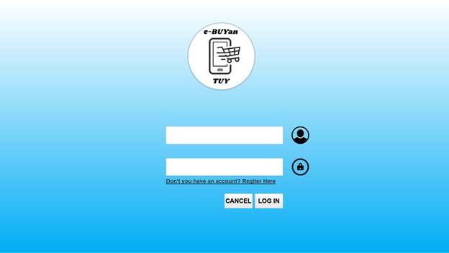

After clicking the logo, the login form will appear. Here, if the user has an existing account, they just need to put their username and password on the two text fields and click the login button to proceed to the next form. If the user doesn't have an account, the user just needs to click the button below the second text field. If the user clicks it, it will proceed to the next form. But, if the user doesn't want to login or register, the user can just click the Cancel button.

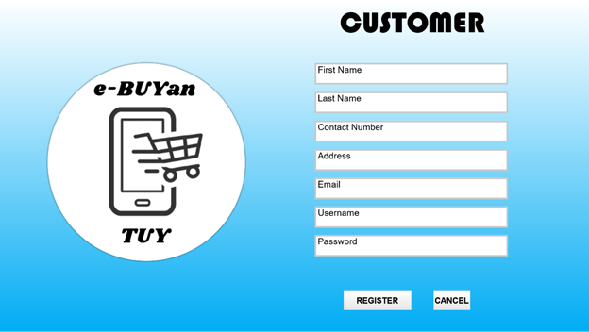

If the user wants to register as a customer, the user must enter their personal details like their name, contact number, address, their active email, their desired username and password. Entering their personal details are required, if the user didn’t complete the details, the user cannot proceed to the next form. After filling up, the user can now click the Register button below. And if the user doesn't want to register, the user can just click the Cancel button.

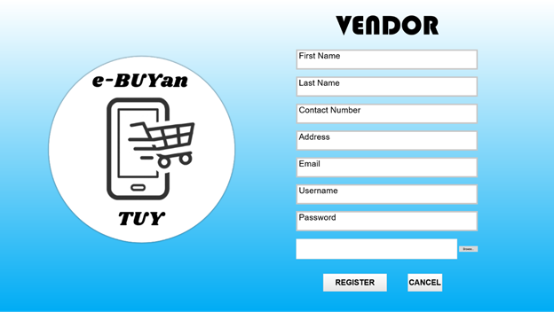

If the user wants to register as a Vendor, the user will proceed in here and the user needs to fill in their personal details like name, contact number, address, active email, their chosen username and password. Another requirement to be a vendor here is the business permit. The user must upload their business permit below the Password text field. To browse the files of the user, they just need to click the Browse button beside. After filling up the form, users can now click the Register button below. And if the user doesn't want to register as a vendor, they can just click the Cancel button.

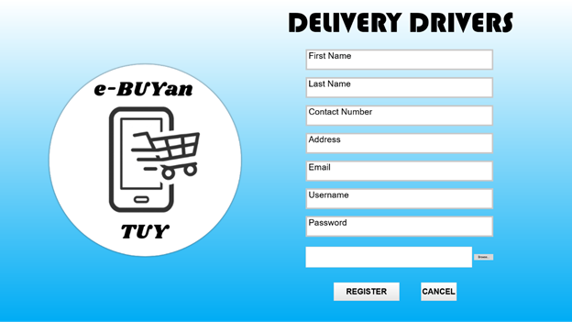

If the user wants to register as a driver, the user will proceed here at the Delivery Drivers form and the user will input the information about them. Last to input is the driving license of the driver. In this part, the driver’s license must be a picture. To browse the files of the device, the user must click the Browse button, click the file and upload it. After filling up, the user can just click the Register button and proceed to the next form. If the user doesn't want to register as a driver, the user can just click the Cancel button to go back to the previous form.

After filling up the registration form, there will be a pop-up message that says that the user successfully registered the account. The user will click the OK button to proceed.

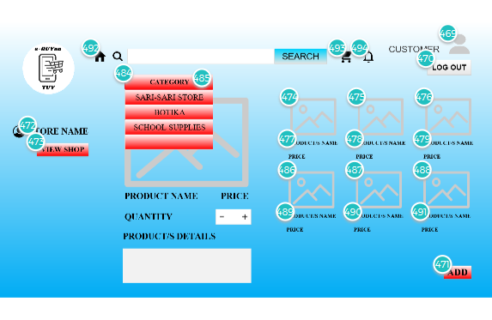

If the user is a Customer, this will be the home page. There are a lot of buttons that can help the user to navigate the system. If the user clicks the icon in the number 492, the user will see the home page. It is useful because if the user accesses another page, the user can just click this icon to go back to the home page. The cart icon on number 493 can access the customer’s cart. At the notification bell at number 494, the user can see the past transactions, or on-going transactions. At number 465 is the icon for customer, if the customer clicks that, they will proceed to the Customer’s Profile. Number 470 is the Logout button, if the user wants to logout the account for a certain reason, the user can just click this. At numbers 474 to 476 and numbers 486 to 488 is the photo of the items, under that, the user can see the product’s name and price. And if the user clicks it, the picture will be shown besides and if the user likes it, they can put the quantity, and the store will be visible at the left side of the screen and they can pay a visit with this. After clicking the item, customers can click the Add button below to put it on the shopping cart. Lastly is the drop-down box where the user can just click it, to see the items, categorically.



Another pop-up message will appear, saying that they successfully added the items to the cart. To proceed, the user can just click the OK button. And the user will be redirected to the home page, after clicking the button.

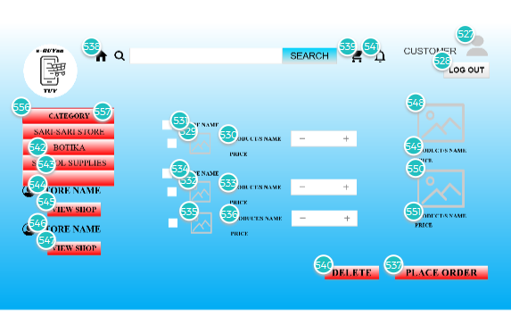

This is the cart section where the user can delete or add items in the product. There are checkboxes where the user just needs to click to delete items all at once. After clicking it, the user can just click the Delete button below.



This will show up after clicking the Delete button from the previous page. Customer needs to click the OK button to proceed to the next step.

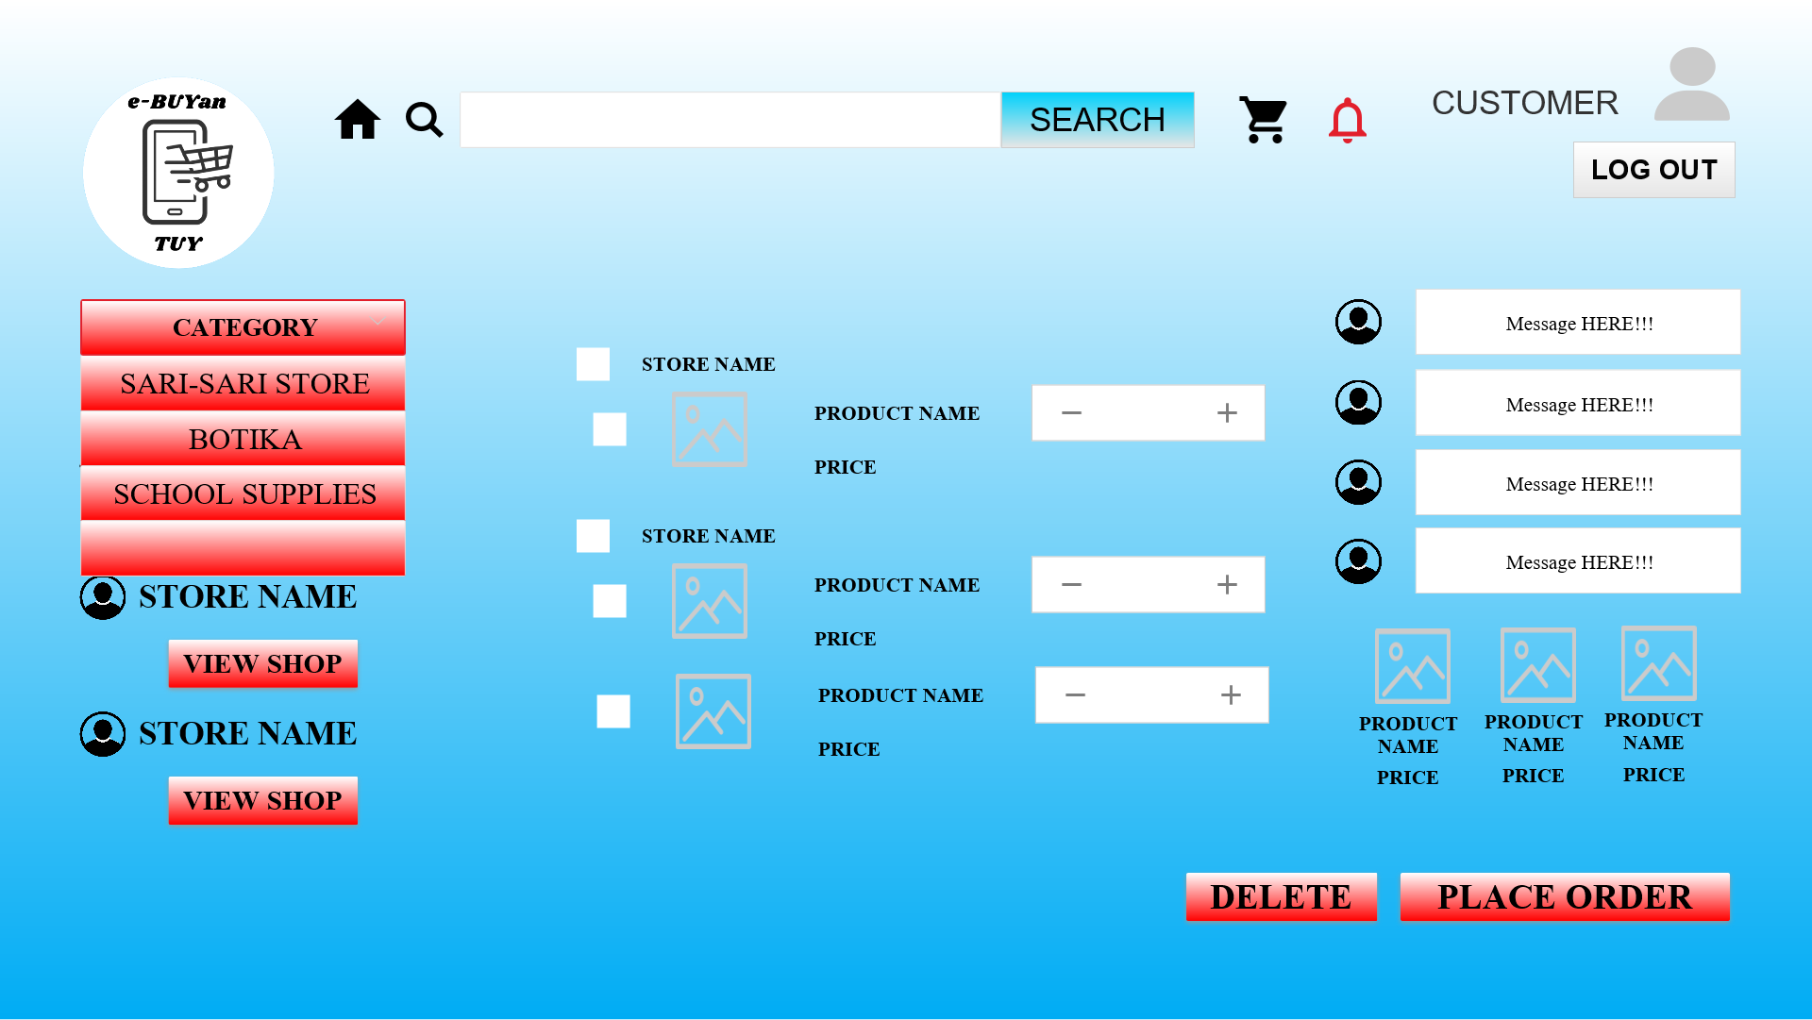

This will be the Notification page, where the customer can interact with the vendor about the items, inform them about the shipment or to know the other information about an item.

## Hardware Interfaces

For the logical and physical characteristics, the system will use device components, For accessing the web browser, the system will use the monitor for the system to display the Graphic User Interface (GUI), System will also require the device’s operating system is Windows. Random Access Memory (RAM) with a minimum of 512MB. And Read-Only Memory (ROM) with a minimum of 40GB.

## Software Interfaces

* Window OS
* MySQL for the database
* Python IDE for a better creation of the user interaction

## Communications Interfaces

The system will use email as the backup contact of the user, in case their contact number is not active anymore. In using the web application of the system, the data that is protected by HTTPS to encrypt the data for the requests and responses so that the user can guarantee that their data is secured. And of course, the basic requirement to use this is to have an internet connection.

# Other Nonfunctional Requirements

## Performance Requirements

In this project we will use a test case to list all the actions that we will perform in the testing process. So that, we will easily locate or determine the problems and if the system application is working efficiently, meets the reliability parameters and accurate functions or processes.

## Safety Requirements

Customers cannot cancel their order once they order, it is to be fair with the rider’s efforts and money. For the database, since the database cannot handle big data on some times, database administrators are required to back-up the database if something unexpected happens, they can recover the data as fast as possible.

## Security Requirements

The user can access the system, if the user has an account on the system. The system requires the user to use a username that is unique, if the system detects a nickname that is the same with what the user entered, the new user needs to think of another username that they will use. Regarding the password, it must have one capital letter (A-Z), a number (0-9) and one special character. Failure to do so, can result in failure to access the system.

## Software Quality Attributes

The project has two (2) forms such as web application and mobile application. The web application can access thru desktop or in laptop thru google chrome, edge and etc., and mobile application to easily and be comfortable while using it by users. Mobile application UI is the same as web application. The Admin will be the one who can access all the modules and make some changes of the entire system. The customers will only view his/her module, he/she can add, update, and delete their orders from the cart and they can’t do some changes of other modules.

# Other Requirements

**Appendix A: Glossary**

**Appendix B: Analysis Models**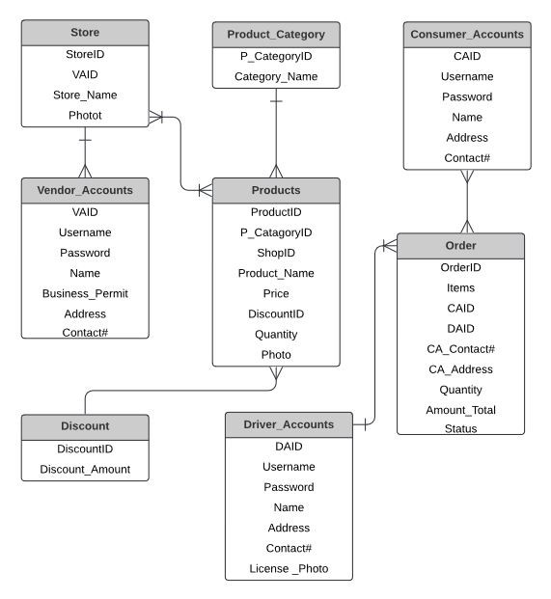

**Appendix C: Issues List**