Intergal 2 2
Integral3 Lab assignment 2
%Brandon Ramirez Lopez
%ME 203
clc,clear all,format compact
x=linspace(0,pi,100);
y=sin(x);
a=trapz(x,y)
ca=cumtrapz(x,y)
plot(x,y,x,ca)
f=@(x) (sin(x));
integral(f,0,pi)
a =
1.9998
ca =
Columns 1 through 7
0 0.0005 0.0020 0.0045 0.0080 0.0126 0.0181
Columns 8 through 14
0.0246 0.0320 0.0405 0.0499 0.0603 0.0716 0.0839
Columns 15 through 21
0.0971 0.1112 0.1261 0.1420 0.1587 0.1763 0.1947
Columns 22 through 28
0.2139 0.2339 0.2547 0.2762 0.2985 0.3215 0.3451
Columns 29 through 35
0.3694 0.3944 0.4199 0.4460 0.4727 0.5000 0.5277
Columns 36 through 42
0.5559 0.5845 0.6136 0.6431 0.6729 0.7030 0.7335
Columns 43 through 49
0.7642 0.7951 0.8263 0.8576 0.8891 0.9207 0.9523
Columns 50 through 56
0.9841 1.0158 1.0475 1.0792 1.1107 1.1422 1.1735
Columns 57 through 63
1.2047 1.2357 1.2664 1.2968 1.3270 1.3568 1.3862
Columns 64 through 70
1.4153 1.4439 1.4721 1.4999 1.5271 1.5538 1.5799
Columns 71 through 77
1.6055 1.6304 1.6547 1.6784 1.7013 1.7236 1.7451
Columns 78 through 84
1.7659 1.7859 1.8051 1.8235 1.8411 1.8578 1.8737
Columns 85 through 91
1.8887 1.9028 1.9159 1.9282 1.9395 1.9499 1.9593
Columns 92 through 98
1.9678 1.9753 1.9818 1.9873 1.9918 1.9953 1.9978
Columns 99 through 100
1.9993 1.9998
ans =
2.0000
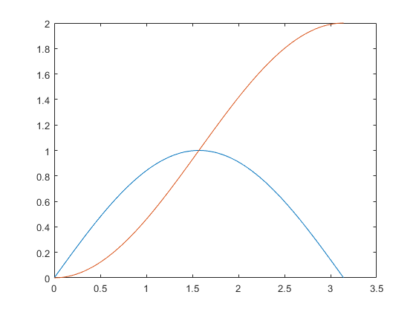

Intergal 2
xmin=pi; xmax=2*pi;
ymin=0; ymax=pi;
f=@(x,y) (y.*sin(x)+x.*cos(y));
integral2(f,xmin,xmax,ymin,ymax)
ans =
-9.8696

Integral3 Lab assignment
xmin=pi; xmax=2*pi;
ymin=0; ymax=@(x) (x);
zmin=0; zmax=@(x,y) (x+y);
f=@(x,y,z) (z.*(y.*sin(x)+x.*cos(y)));
I=integral3(f,xmin,xmax,ymin,ymax,zmin,zmax)
I =
-1.2577e+03
Published with MATLAB® R2021a

