example 2 1
example 3 2
%Brandon Ramirez Lopez
% ME 203
% Lab 22 examples 2 & 3

example 2
clear all; clc; close all; format compact
xrange=[0 2];
initial=[0 0];
[x,s]=ode45('second_order_ex2',xrange,initial);
subplot(1,2,1)
plot(x,s(:,1))
xlabel('x')
ylabel('y')
subplot(1,2,2)
plot(x,s(:,2))
xlabel('x')
ylabel('dy/dx')
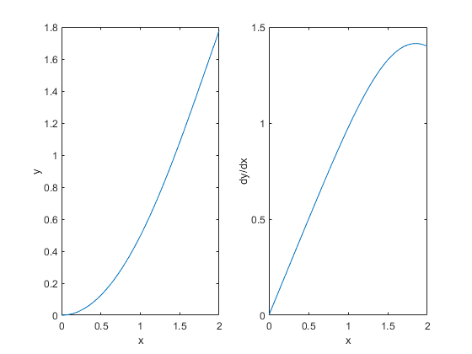

example 3
clear all; clc; close all; format compact
xrange=[0 5];
initial=[0 4];
[x,s]=ode45('second_order_ex3',xrange,initial);
subplot(1,2,1)
plot(x,s(:,1))
xlabel('x')
ylabel('y')
subplot(1,2,2)
plot(x,s(:,2))
xlabel('x')
ylabel('dy/dx')
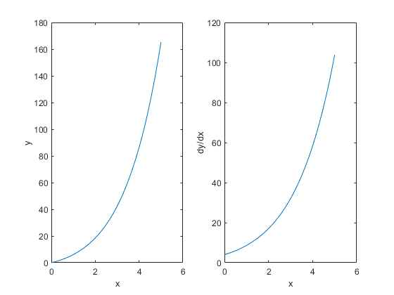
Published with MATLAB® R2021a

