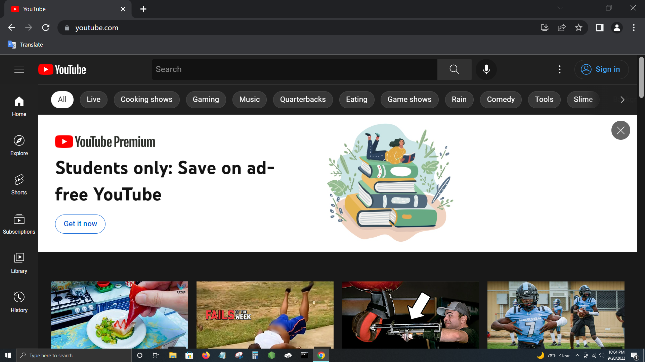

http://www.flashcarma.com/sign_up

Sign Up

Re-enter Password

Password

Email

Username

Sign Up

Flash Carma



10/20

2000 pts

3

Biology Midterm Rev…

How many bones are in the human body?