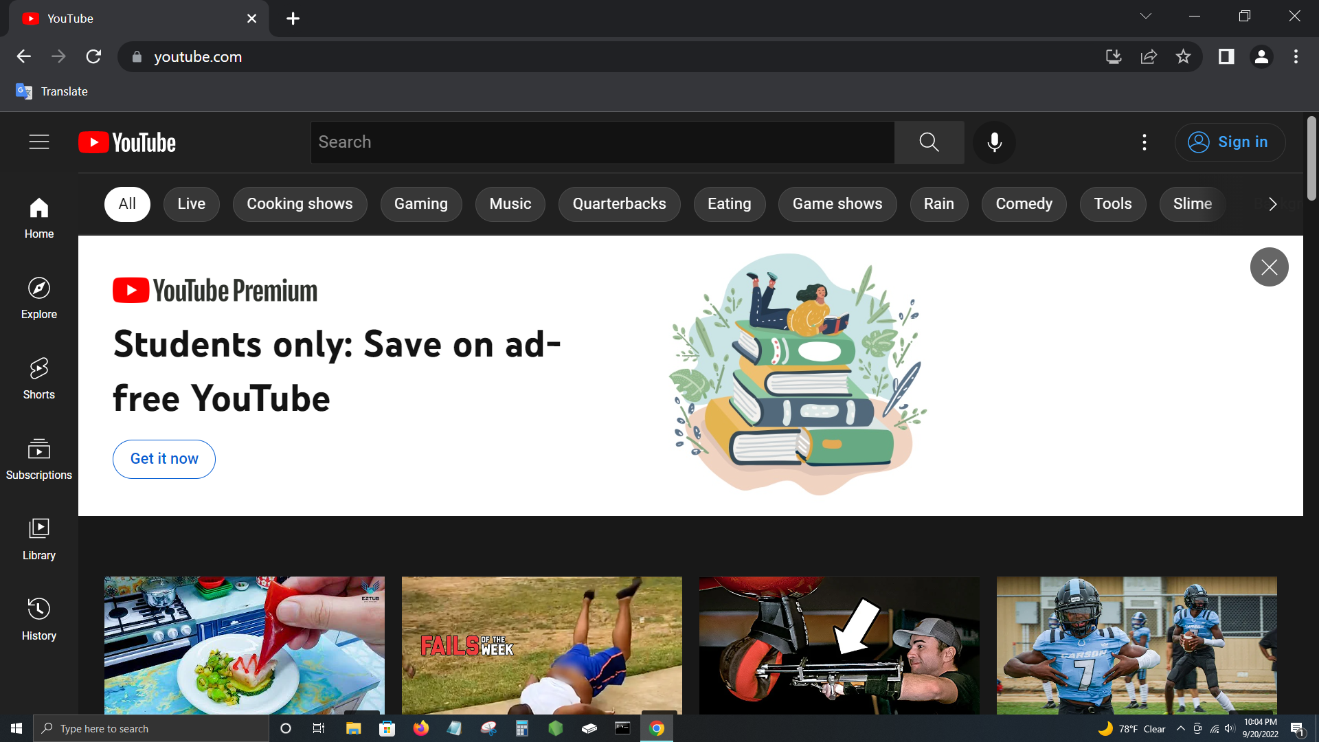

Replay

Home

3

12/25

2,400 pts

Results

View Study Decks

Study Session

Settings

Profile

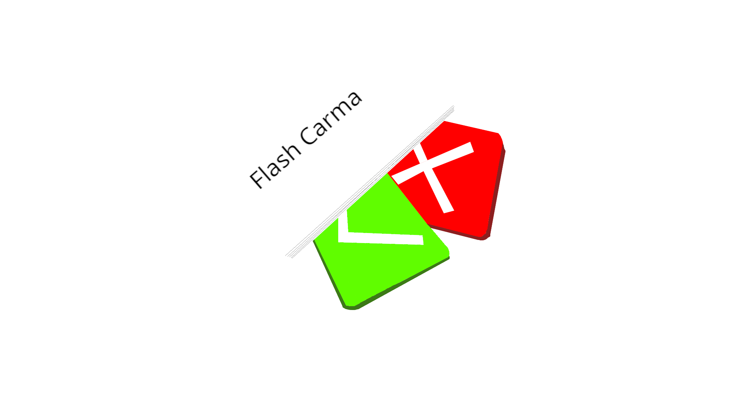

Search

http://www.flashcarma.com/study_session/results

Flash Carma



10/20

2000 pts

3

Biology Midterm Rev…

How many bones are in the human body?