

Study Decks

Biology Midterm Review

200

Cool Words

CSCI 1010 Terms

View Study Decks

Study Session

Settings

Profile

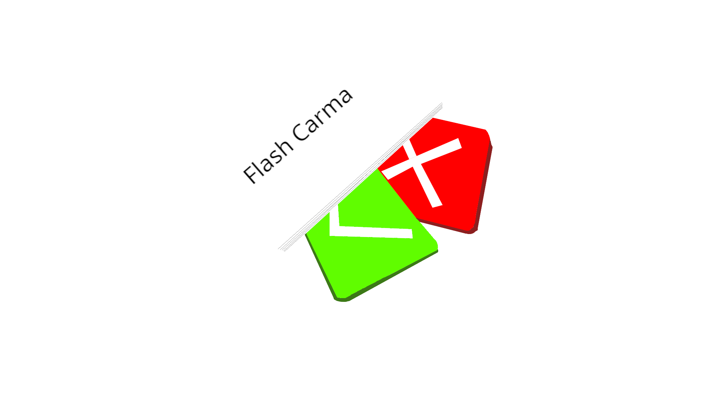

Search

http://www.flashcarma.com/view_study_decks

Flash Carma



10/20

2000 pts

3

Biology Midterm Rev…

How many bones are in the human body?