HW2-report

资工四 常博爱 408410086

Problem 1.

a.When pivot choose ‘mrc’ :

n_max=13

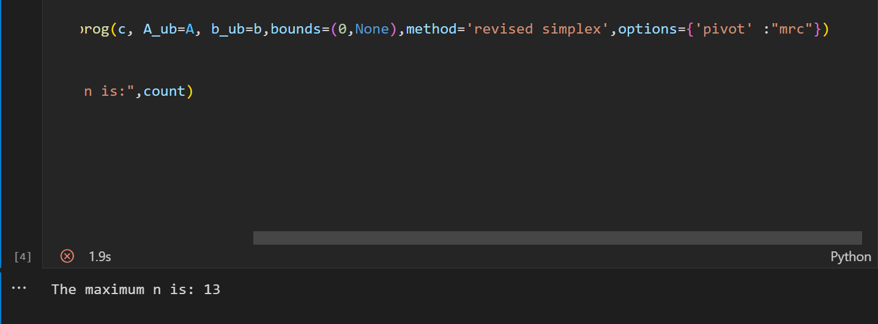

When pivot choose ‘bland’ :

n_max=10

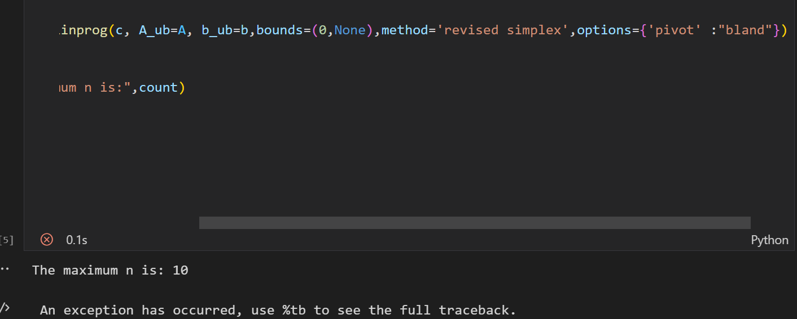

Conclusion:

Use simplex method ,use mrc pivot will get **bigger** feasible solution.

Problem 2.

When options choose dantizg:

Minmum:1.570312971592117

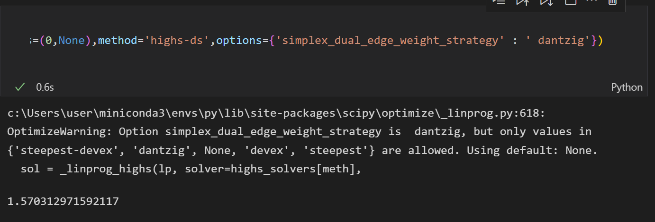

When options choose devex:

Minmum:1.570312971592117

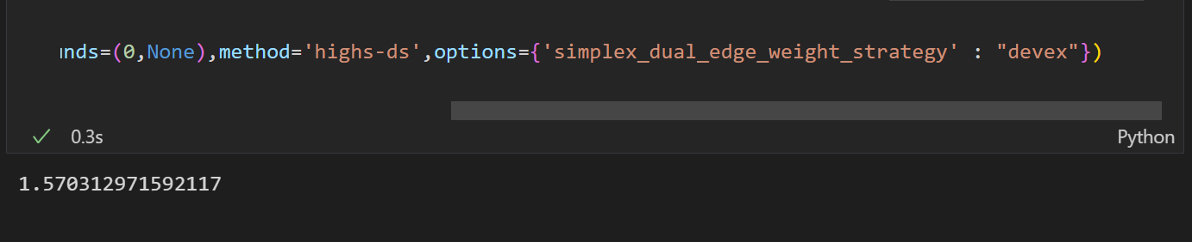

When options choose steepest:

Minmum:1.570312971592117

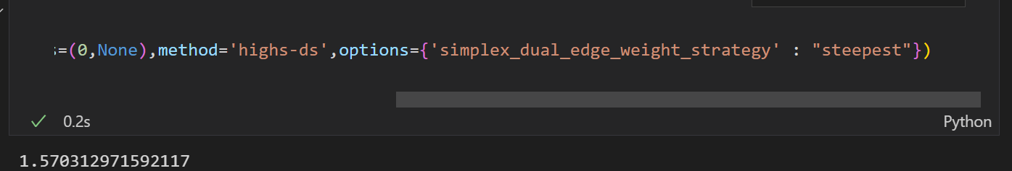

Conclusion:

三種options對比結果相同

做法：提取A and b,

由于s.t. Ax>=b,max &min cTx

So ,将A&b变成-A&-b,代入公式即可