# Assignment #1

1. Use the column-row expansion of 𝐴𝐵 to express this product as a sum of matrix products.

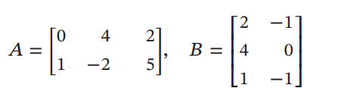

Column row expansion :

AB=C1R1+C2R2+C3R3 Ci: ith column of A, R: ith row of B

=

1. Simplify the expression assuming that 𝐴, 𝐵, 𝐶, and 𝐷 are invertible .



CD-1

1. show that the matrices 𝐴 and 𝐵 are row equivalent by finding a sequence of elementary row operations that produces 𝐵 from 𝐴, and then use that result to find a matrix 𝐶 such that 𝐶𝐴 = B

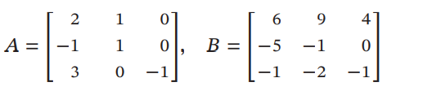

C=E31(-4)E31(-2)E21(-2) =

要按題目要求解，不能用 C=BA-1!方法不對 -5

1. Consider the matrices

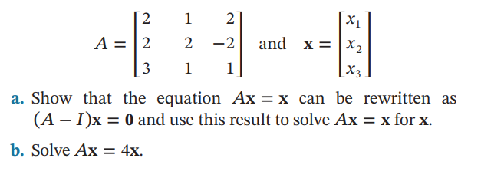

a.)Ax=Ix 🡺(A-I)x=0

A-I=Solve x=

b.)(A-4I)x=0 A-4I=🡺rref

let x3=t ,x2=0,x1=t

🡺=