# Assignment #3

1. Consider the following 3 vectors in R3 : **u** = (1, 2, 3), **v** = (2, 0, 1), **w** = (3, 1, 0)
2. (5 points) Project vector w orthogonally onto vector v.

Proj**vw=(0,)**

(b) (5 points) Find the vector that is the reflection of w on v

**w**⊥= **w**- Proj**vw=(1,)**

**reflection w’ =-w**⊥ + Proj**vw=(-1,)**

2. Let T1(x1, x2) = (x1 − x2, 2x2 − x1, 3x1) and T2(x1, x2, x3) = (4x2, x1 + 2x2).

(a) (4 points) Find the standard matrices for T1 and T2.

(b) (3 points) Find the standard matrix for T1 ◦ T2

(c) (3 points) Use the matrix obtained in part(b) to find formular for T1(T2(x1, x2, x3))

(a) T1 T2

(b) T1 ◦ T2=

(c) T1(T2(x1, x2, x3))=(-x1+2x2,2x1,12x2)

1. Consider the following 3 vectors in R3 :

**u1** = (a, 2, −1), **u2** = (4, 1, 0), **u3** = (1, 5, −2)

Where a is an unspecified real number.

1. (4 points) Find the possible value(s) of a, such that the volume of the parallelepiped described by the given vectors **u1** ,**u2** , and **u3** is one

V=| ,a=-2or-1

(b) (6 points) Find the area of each face of the parallelepiped which is

determined by the above given vectors **u1** ,**u2** , and **u3** for a = 0

||u1 x u2 ||=||(1,-4,-8)||=9

||u2 x u3 ||=||(-2,8,19)||=

||u1 x u3 ||=||(1,-1,-2)||=

1. Determine whether each set equipped with the given operations is a vector space. For those that are not vector spaces identify the vector space axioms that fail.(10 points)

The set of polynomials of the form a0 + a1 x with the operations

(a**0** + a**1** x) + (b**0** + b**1** x) = (a**0** + b**0**) + (a**1** + b**1** )x

and

k(a**0** + a**1** x) = (ka**0** ) + (ka**1** )x

Yes,It’s a vector space !

Step1：identify the set V of objects that will become vectors

Step2:identify the addition and scalar multipulication operations on V.

Step3: verify axiom1,6(1.close addition and 6.close multipulity)

Step4:verify axiom2,3,4,5,7,8,9 and 10 hold!

5. Use the Subspace Test to determine which of the sets are subspaces of 𝑅3 .

a. (3 points)All vectors of the form (a, 0, 0).

b. (3 points)All vectors of the form (a, 1, 1).

c. (4 points)All vectors of the form (a, b, c), where b = a + c.

(a)Yes

(b)No

(c)Yes

1. Use the Subspace Test to determine which of the sets are subspaces of 𝑀nn.

a. (2.5 points)The set of all diagonal n × n matrices.

b. (2.5 points)The set of all n × n matrices 𝐴 such that det(𝐴) = 0.

c. (2.5 points)The set of all n × n matrices 𝐴 such that tr(𝐴) = 0.

d. (2.5 points)The set of all symmetric n × n matrices.

(a)Yes

(b)No

(c)Yes

(d)Yes

7. Express the following as linear combinations of **u** = (2, 1, 4), **v** = (1, −1, 3), and **w** = (3, 2, 5).

a. (3 points) (−9, −7, −15)

b. (3 points) (6, 11, 6)

c. (4 points) (0, 0, 0)

(a)

= 🡺 =

(b) =

(c) =

(d) =

8.Determine whether the following polynomials span **P**2 . (10 points)

**p1**= 1 − x + 2x 2 , **p2** = 3 + x,

**p3**= 5 − x + 4x2 , **p4**= −2 − 2x + 2x2

P2=a0+a1***x+*** a2***x*2** so, dim(P2) =3

Guassion elimination 🡺

So, P3=2P1+P2 ;P4=P1-P2 dim(span{P1,P2})= 2<dim(P2)

Can’t span P2!

9. In each part, determine whether the vectors are linearly independent or are linearly dependent in P2 .

a. (5 points) 2 − x + 4x2 , 3 + 6x + 2x2 , 2 + 10x − 4x2

b. (5 points) 1 + 3x + 3x2 , x + 4x2 , 5+ 6x + 3x2 , 7 + 2x – x2

(a) Guassion elimination

Linear independent ! det(A)=-32Or check det(A), if det(A)0, linear independent.

(**b**) det(A)=0, linear dependent!

10. 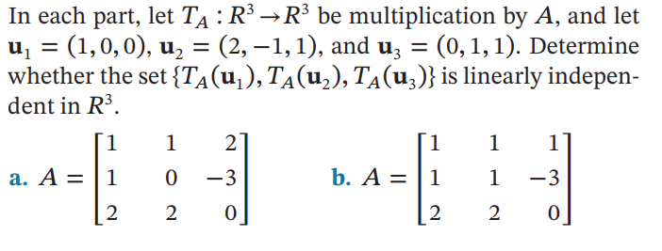

(a)TA(u1,u2,u3)= det(TA(u1,u2,u3))=-8 linear independent!

(b) TA(u1,u2,u3)= det(TA(u1,u2,u3))=0 linear dependent!

評分標準：

**每題10分，每小題配分已標注，答錯即0分。**

本次作業由于多數爲定理判斷題，所以心得不用每題都寫，寫你覺得有意義的就好，如果都沒有，也要寫一份總體的心得，心得不單獨算分，**但作業內完全無心得總成績最多-20.**可以接受打字

Note:前三題原本是老師要出的期中考題，但並未選中，請同學認真作答，謝謝！

繳交期限：10/25 （週二）0:00 遲交分數*0.8