# Assignment #2

1. Evaluate det(𝐴) by a cofactor expansion along a row or column of your choice.

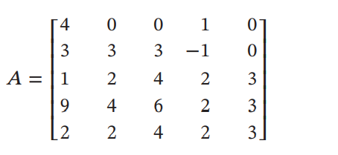

det(A)=0

1. By inspection, what is the relationship between the following determinants?

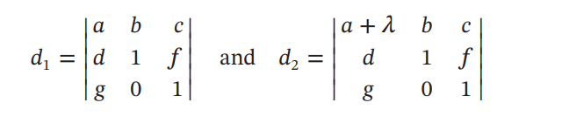

d1+λ=d2

1. Evaluate the determinant of the matrix by first reducing the matrix to row echelon form and then using some combination of row operations and cofactor expansion.

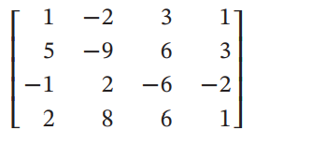

ref(A)= det(A)=1*1*(-3)*(-13)=39

1. Confirm the identities without evaluating any of the determinants directly.

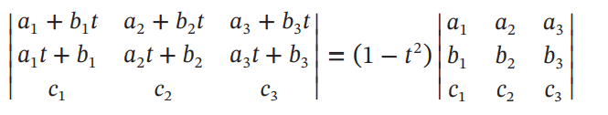

Answer:

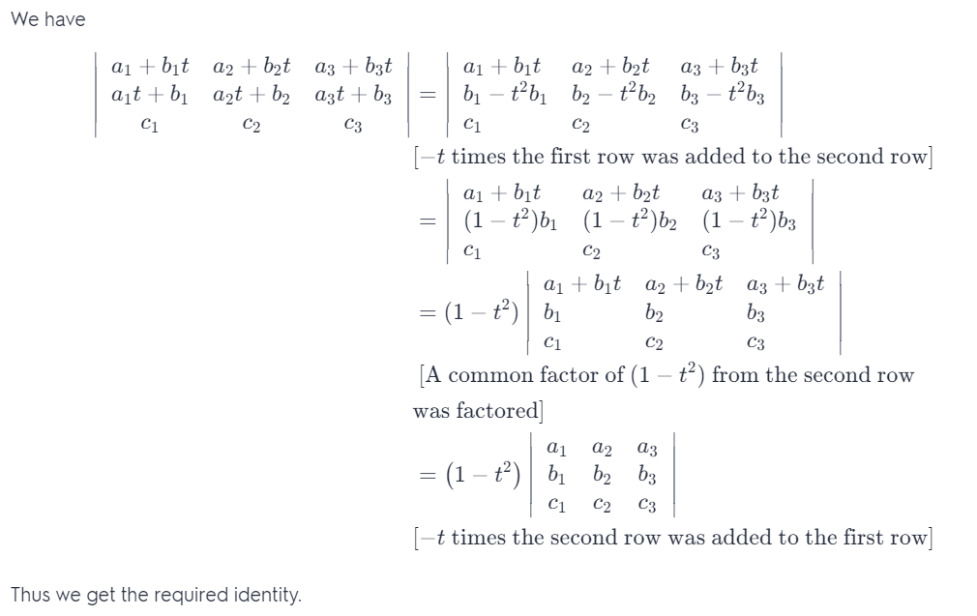

1. Find the values of k for which the matrix 𝐴 is invertible.

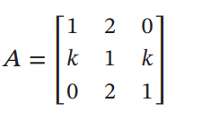

If A is invertible ,det(A) ≠0

So det(A)=1(1-2k)-2(k-0)+0(2k-0)=1-4k≠0

k≠1/4

1. Solve by Cramer’s rule, where it applies.

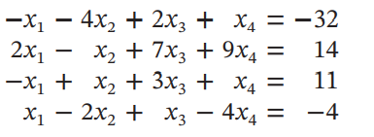

x1=5 x2=8 x3=3 x4=-1

1. Let

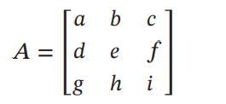

Assuming that det(𝐴) = −7,

find a. det(3𝐴) b. det(𝐴−1 ) c. det(2𝐴−1 ) d. det((2𝐴)−1 ) e.

a.-189 b.- c. - d. - e.7

1. decide whether the matrix is invertible, and if so, use the adjoint method to find its inverse.

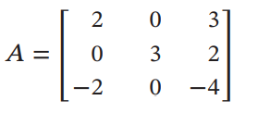

det(A)=-6 ≠0,so A is invertible .

A-1=adjA

adjA= A-1=

1. Prove that if det(𝐴) = 1 and all the entries in 𝐴 are integers, then all the entries in 𝐴−1 are integers.

det(A)=1 🡺A-1=adjA=adjA

In (adjA)T, all Confactorsare integers，because of all the entries in A are integers.

Then all the entries in 𝐴−1 are integers.

1. Verify that det(𝐴𝐵) = det(𝐵𝐴) and determine whether the equality det(𝐴 + 𝐵) = det(𝐴) + det(𝐵) holds.

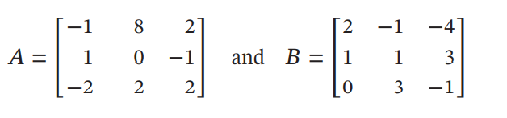

AB=，BA= A+B=

det(A)=2 det(B)=-33 det(A+B)=-75 det(A)+det(B)=-31

det(AB)=-66 det(BA)=-66

So. det(A+B) ≠det(A)+det(B) det(AB)=det(BA)

評分標準：

每題解答6分，心得4分。結果錯-2，過程或方法錯不給分.

繳交期限：10/11 （週二）0:00 遲交分數*0.8