1. Let x,y both in U and V;

1.**0** is both in U and V;

2.x+y in U; x+y in V 🡺 x+y both in U and V;

3.c is scalar in R, cx in U and cx in y ,so cx in both U and V.

2.



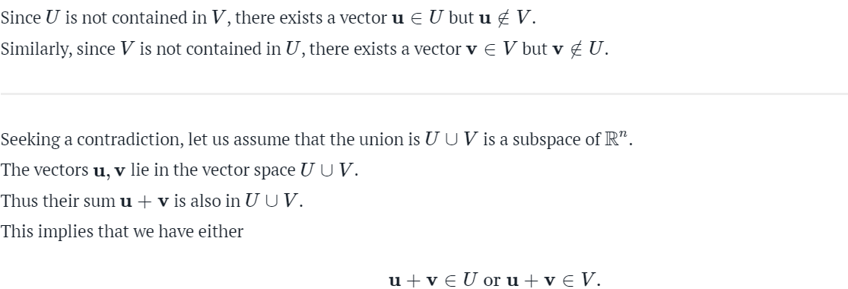

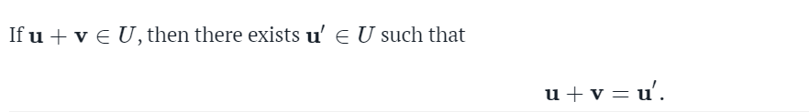



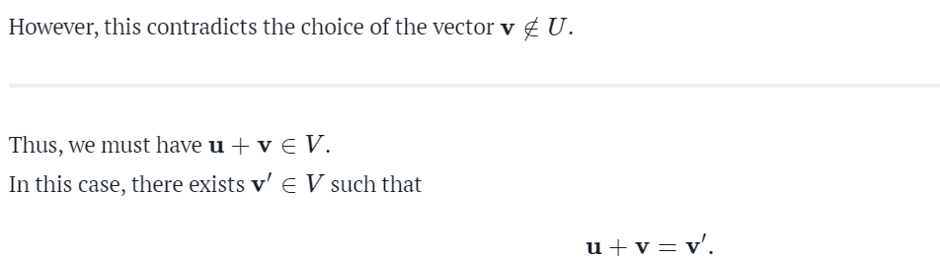







**3.**

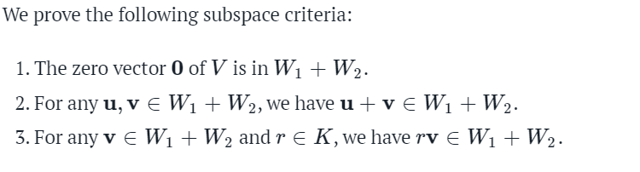



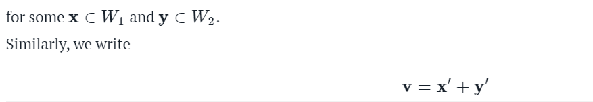

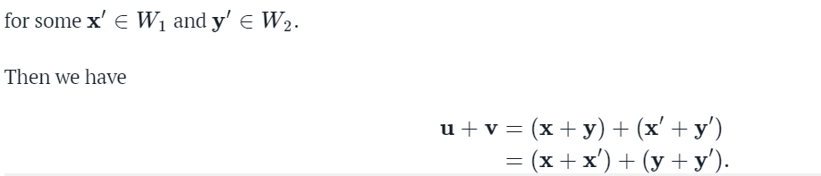





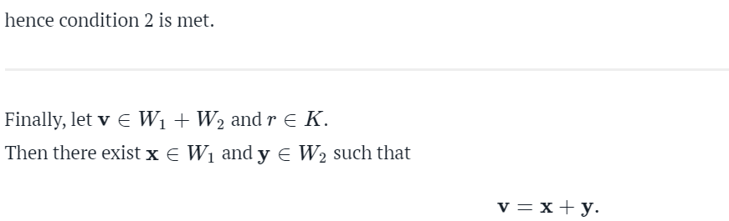

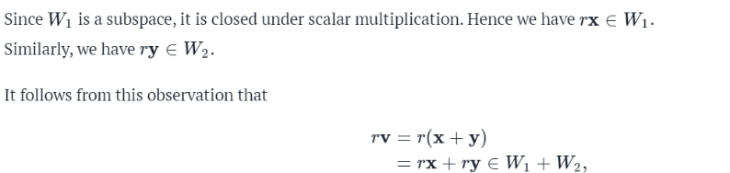

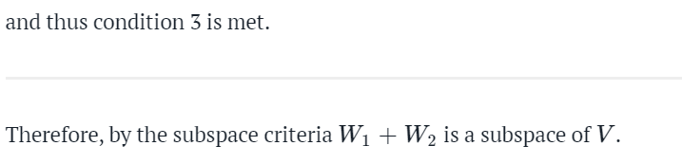

**4.**

